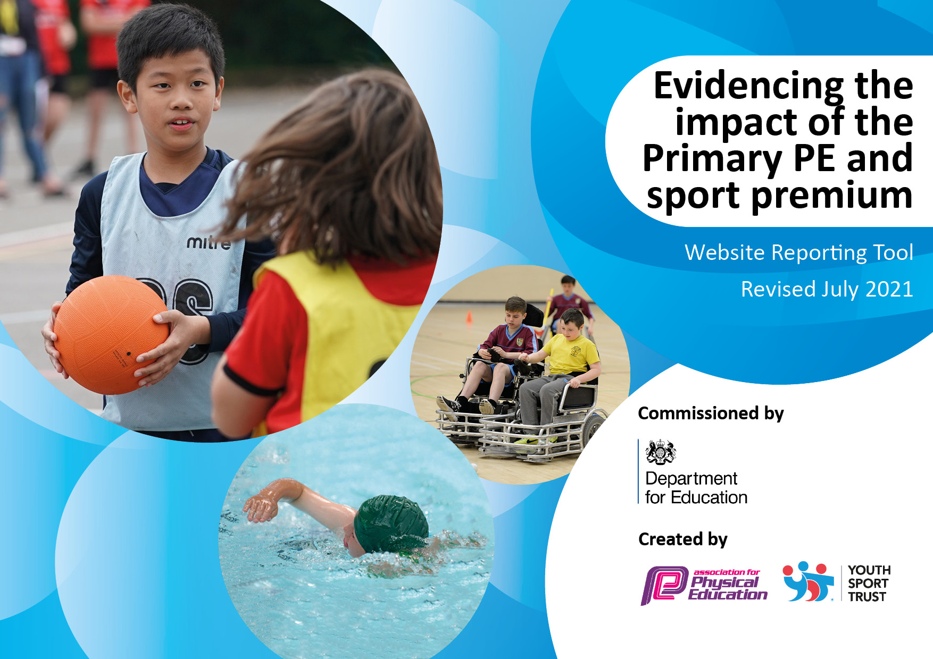
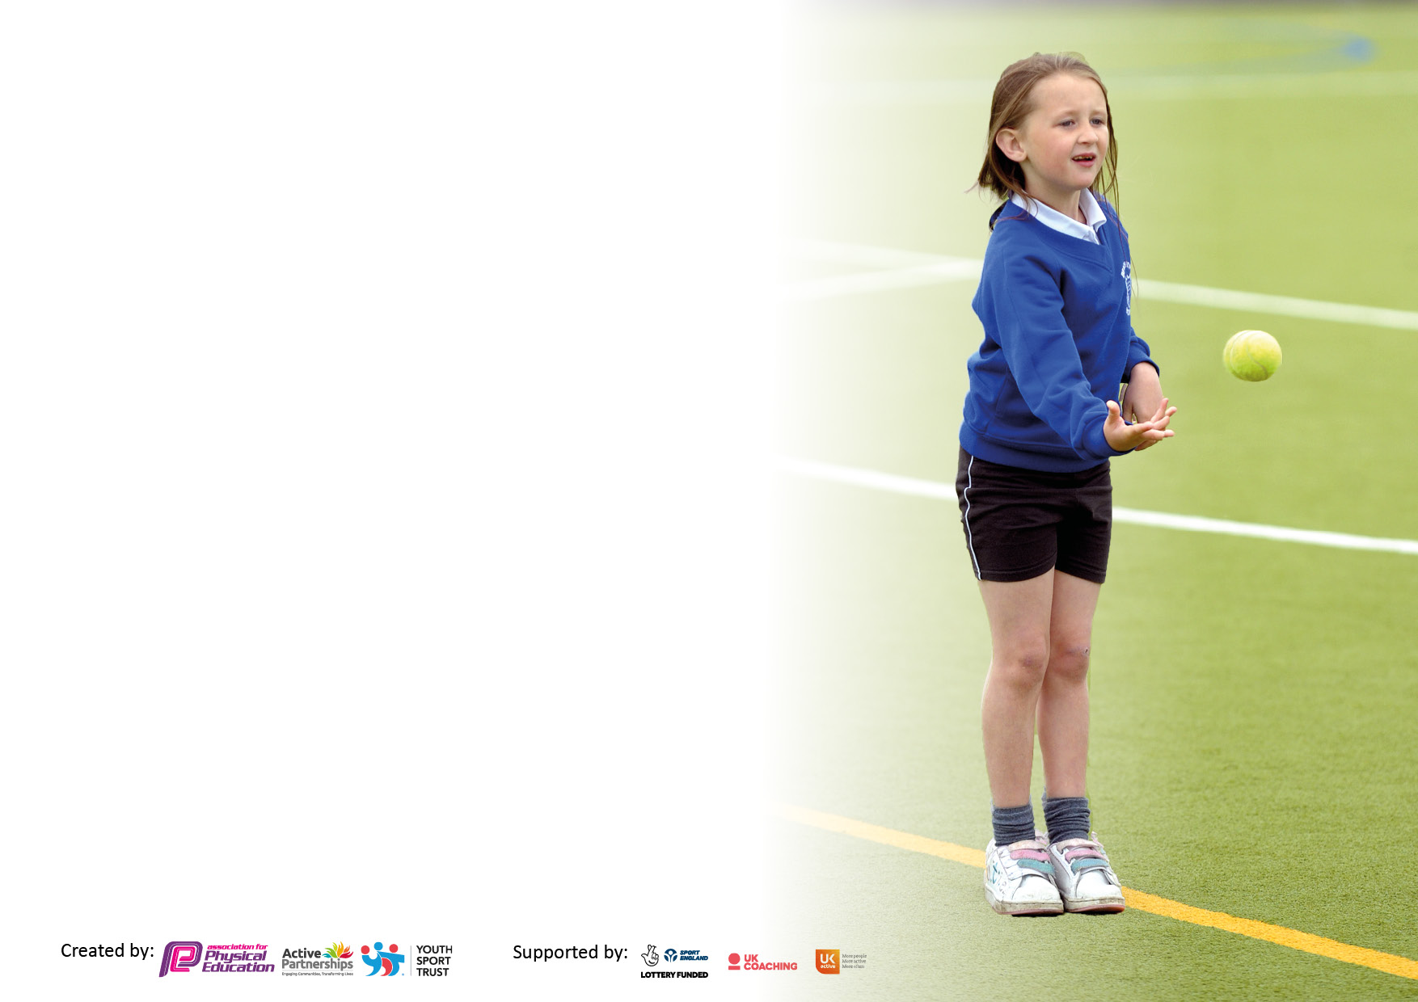

It is important that your grant is used effectively and based on school need. The Education Inspection Framework makes clear there will be a focus on ‘whether leaders and those responsible for governors all understand their respective roles and perform these in a way that enhances the effectiveness of the school’.

Under the Quality of Education Ofsted inspectors consider:
Intent - Curriculum design, coverage and appropriateness
Implementation - Curriculum delivery, Teaching (pedagogy) and Assessment
Impact - Attainment and progress

To assist schools with common transferable language this template has been developed to utilise the same three headings which should make your plans easily transferable between working documents.

Schools must use the funding to make additional and sustainable improvements to the quality of Physical Education, School Sport and Physical Activity (PESSPA) they offer. This means that you should use the Primary PE and sport premium to:

- Develop or add to the PESSPA activities that your school already offer
- Build capacity and capability within the school to ensure that improvements made now will benefit pupils joining the school in future years
- The Primary PE and sport premium should not be used to fund capital spend projects; the school’s budget should fund these.

Pleasevisitgov.ukfortherevisedDfEguidanceincludingthe5keyindicatorsacrosswhichschoolsshoulddemonstrate animprovement.Thisdocumentwillhelpyoutoreviewyourprovisionandtoreportyourspend.DfEencouragesschools to use this template as an effective way of meeting the reporting requirements of the Primary PE and sport premium.

We recommend you start by reflecting on the impact of current provision and reviewing the previous spend.

Schools are required to publish details of how they spend this funding, including any under-spend from 2019/2020, as well as on the impact it has on pupils’ PE and sport participation and attainment. All funding must be spent by 31st July 2022.

We recommend regularly updating the table and publishing it on your website throughout the year. This evidences your ongoing self-evaluation of how you are using the funding to secure maximum, sustainable impact. Final copy must be posted on your website by the end of the academic year and no later than the 31st July 2021. To see an example of how to complete the table please click HERE.

Details with regard to funding
Please complete the table below.

Total amount allocated for 2022/23 | £16000
Total amount of funding for 2022/23. Spent and reported on by 31st July 2022. | £16063
Swimming Data
Please report on your Swimming Data below.

Meeting national curriculum requirements for swimming and water safety.

N.B. Complete this section to your best ability. For example you might have practised safe self-rescue techniques on dry land which you can then transfer to the pool when school swimming restarts.
Due to exceptional circumstances priority should be given to ensuring that pupils can perform safe self rescue even if they do not fully meet the first two requirements of the NC programme of study
What percentage of your current Year 6 cohort swim competently, confidently and proficiently over a distance of at least 25 metres?
N.B. Even though your pupils may swim in another year please report on their attainment on leaving primary school at the end of the summer term 2020.
Please see note above
What percentage of your current Year 6 cohort use a range of strokes effectively [for example, front crawl, backstroke and breaststroke]?
Please see note above
What percentage of your current Year 6 cohort perform safe self-rescue in different water-based situations?
Schools can choose to use the Primary PE and sport premium to provide additional provision for swimming but this must be for activity over and above the national curriculum requirements. Have you used it in this way?

Action Plan and Budget Tracking
Capture your intended annual spend against the 5 key indicators. Clarify the success criteria and evidence of impact that you intend to measure to evaluate for pupils today and for the future.

Academic Year: 2022/23 | Total fund allocated: | Date Updated:
Key indicator 1: The engagement of all pupils in regular physical activity – Chief Medical Officers guidelines recommend that primary school pupils undertake at least 30 minutes of physical activity a day in school |  |  |  | Percentage of total allocation:
 |  |  |  | 29%
Intent | Implementation |  | Impact
Add playground markings and resource break/lunch time zones. | Research companies, pick a suitable company to hire.  Arrange dates/timings for them to come and add lines discussed. | £ 1900 | Playgrounds look more appealing to use for pupils. This has increased the number of pupils taking part in sport/activity. | Find creative ways to use the new markings.
Cover duties with zones in areas of the school with sporting activities, MUGA staff x1 (Football), Sports hall staff x3 (Multi Sports), Field x2 (Cricket + Ball games), common room staff x1 (pool). | Go through with staff what zones they will be in at break/lunch on duty rota. Ensure staff are capable of delivering/facilitating these activities. | £2730 | More pupils are engaged at break and lunch times in physical activity. | Increase offer annually.
Key indicator 2: The profile of PESSPA being raised across the school as a tool for whole school improvement |  |  |  | Percentage of total allocation:
 |  |  |  | 17%
Intent | Implementation |  | Impact
To engage a variety of pupils and abilities in Sport through Art. | Workshops have been ran on different days to engage the whole school at some point, allowing them to express themselves through Art in the sports hall, creating big displays with graffiti and paint. | £ 2800 | A variety of pupils including harder to engage pupils and those of higher ability in Sport/PE have made 3 displays to be proud of.  This is created an environment that these pupils feel safe and confident in, transferring to PE/Sport/Physical activities that more pupils are now engaged and participating in. | Look into ways of using other subjects in a similar capacity to allow for those cross curricular links.

Key indicator 3: Increased confidence, knowledge and skills of all staff in teaching PE and sport |  |  |  | Percentage of total allocation:
 |  |  |  | 2%
Intent | Implementation |  | Impact
- Go on CPD courses.  - Network with other teachers.  - Attend sport/PE meetings. | Attend inclusive sport workshop, look into booking The Concept Curriculum. (Leading meaningful change in PE). £299  Arrange times to network, sort fixtures, and attend meetings. (cover costs). | £299 | Created more inclusive lessons and an idea of changing the curriculum when attending the course.  Networking is important and has made for good connections with other schools, creating more opportunities for pupils.
Key indicator 4: Broader experience of a range of sports and activities offered to all pupils |  |  |  | Percentage of total allocation:
 |  |  |  | 42%
Intent | Implementation |  | Impact
Add further opportunities to the curriculum. Resource them.  Use of PE Timetable and outside agencies.  11 class trips given to class teachers to plan (11 classes = 1 each).  Golf Sessions | Pickleball added to the curriculum and new SOW purchased. Health and fitness taken a more important role in lessons to combat COVID lifestyle changes.  Liaise with Tom (Inclusive Sport CEO) and have some of his experienced Inclusive Sport Coaches attend sessions in a leading and/or supporting role.  Class teachers planned sport trips to engage pupils in creative ways.  Have older pupils engaging in golf off-site to increase their offer and experience in Sport. | £4914  Funded  £1100  £720 | Pupils engaged in lessons, pickleball very popular amongst pupils, the variety of fitness activities have been a success.  The whole school was able to engage in an alternative sport on a trip, broadening experiences and allowing for pupils to potentially take up a sport they may not have thought of or tried.  95% of pupils have really enjoyed sessions, a couple of pupils now attend in the evening with parents/carers.
Key indicator 5: Increased participation in competitive sport |  |  |  | Percentage of total allocation:
 |  |  |  | 10%
Intent | Implementation |  | Impact
The use of Thanet Inclusive games calendar to engage in competition with other school.  Passport also used to engage higher ability pupils with mainstream colleagues.  Increase participation on sports day. | We are looking at attending all of the TIG events and will hand pick suitable events from Passport.  Events as normal and add a colour run. | £1600 | St A’s have managed to attend a minimum of 3 events a term.  Whole school participation. | Increase to four a term as a minimum.
Signed off by
Head Teacher:
Date:
Subject Leader:
Date:
Governor:
Date:

