**13th January 2023**

**Forthcoming Dates**

* Monday 30th January – INSET Day- pupils do not attend
* Friday 10th February last day of Term 3
* Monday 20th February 1st day of Term 4

**British Values**

This term we are starting the new British Values recognition awards.

British Values underpin what it is to be a citizen in a modern and diverse Great Britain valuing our community and celebrating diversity of the UK. These values are Democracy, Rule of Law, Respect and Tolerance, Individual Liberty.

Pupils who demonstrate an understanding of a British Value will earn a wristband. We have a wristband for each value and teachers will be recording and sharing, when a pupil demonstrates a value. At the end of the academic year, pupils who have been recognised for their understanding of the British Values, will be taken on trip to The Houses of Parliament.

The first pupil, this term, to be recognised for demonstrating a British Value, was Daniel Raeburn and he was nominated for 'enthusiastically clapping' pupils of the week in assembly, even though he hadn't been pupil of the week himself. Well done ***Daniel!***

**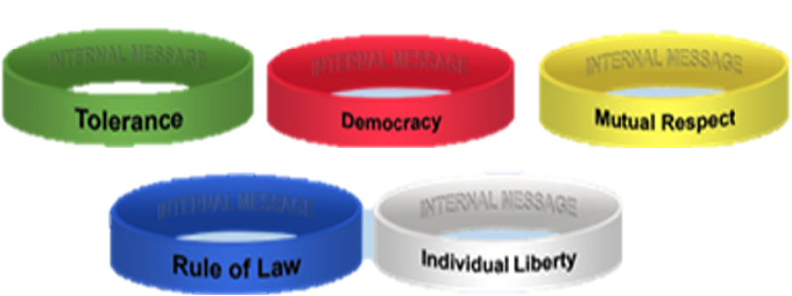**

**Walliams**

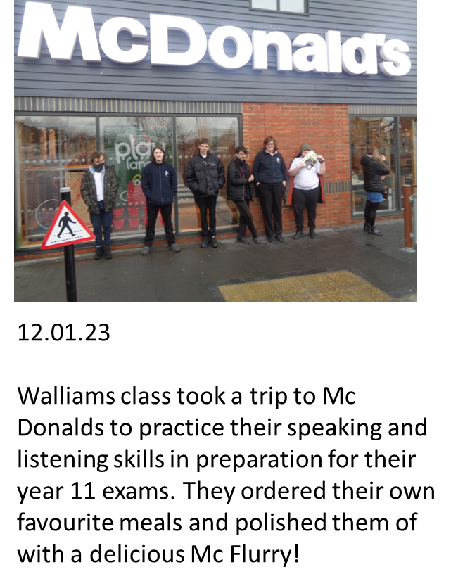 ***Conner, Aiden, Bradley, Prnjay, Jack & Ty*** waiting for the feast to begin!

Walliams class took a trip to Mc Donalds to practice their speaking and listenging skills in preparation for their year 11 exams.

The pupils orders their own faviour meals and polished them off with a delicious Mc Flurry!

**Blyton Class**

Blyton Class has started the new term working hard on their new topics. They made bow and arrows for our English topic Robin Hood.

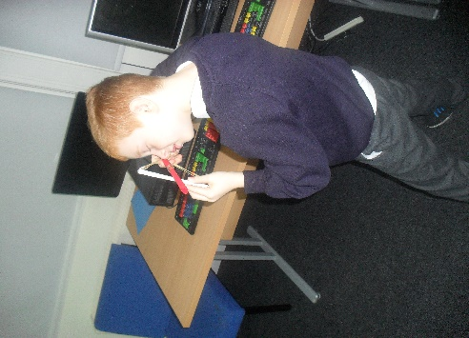  
***Junior*** & ***Lewis*** making fine archers!

They then made parachutes whilst learning about Gravity – Science.

**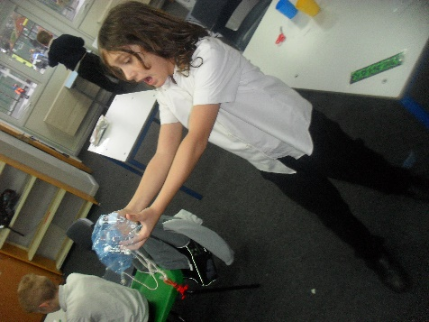  
*Rick & Ashton***

**  
*James & Isaac***

**Baby food donation**

The school has been donated some baby food, for 9 months+, if you or you know someone who could use it please contact the office.

****

**Attendance**

Whilst in mainstream schools, a Whole School Attendance of 95% is generally considered good, here at St Anthony’s we are appreciative that our pupil’s needs are likely to affect their attendance at times.

Therefore, we have set ourselves a Whole School Attendance target of **85%.** We are just two terms in and we are currently sitting at **81.72%.**

Whilst we are pleased that we are so close to our target, we would love to be able to report at the end of Term 3 that we have indeed reached our target.

As well as having a Whole School Attendance target, we also have individual targets for our pupils. Attendance is monitored weekly from Friday-Thursday and rewarded in stages:

* 90% attendance = 3 Tokens
* 100% attendance = 5 Tokens, Certificate and a shout out on DOJO.

The tokens can be exchanged in our Reward Shop, which is run by **Phoenix**, if there is nothing that your child wants to spend their tokens on, they can speak to a member of staff either from Phoenix or from SLT, about sourcing something that interests them and agree a target number of Tokens.

In order to gain a weekly attendance of 90%, your child needs to be in school for 9 half-day sessions out of 10 each week.

If your child is late and arrives after the register closes at **09:20am** then this is marked as a **U**, this is an unexplained absence and will go against your child’s attendance record.

Information about attendance can be found in our Attendance Leaflet which you can **pick up at reception, an online version will be made available via Class Dojo** and our Website in the upcoming months. If you have any questions about your child’s attendance please get in touch with the School Office, who can direct your call to the appropriate personnel.

**Community Bank – A helping hand**

If you are in need of food, clothing or other essentials, an established community bank is available in Herne Bay  
For more information please visit their facebook page:

# **Maya's community support Centre**



**Discovery Planet – Science Workshops**



****

**SPORT FOR FUN –**

Saturdays (term time) 9.00 - 10.00 at St Anthony's School. A Saturday morning sports club for children with SEND.

**BE ACTIVE -SHORT BREAK** - Saturdays (term time) 10.30 - 12.00 at Foreland Fields School

**BE ACTIVE -SHORT BREAK** - Wednesdays (term time) 4.30 - 6.00 at Foreland Fields School

Please read the PDF letter attached for more information and complete the following referral form to declare interest: <https://forms.office.com/r/EZwuMEZmEd>

**CLIP N CLIMB -** Thursdays Session 1: 4.30-5.30pm Session 2: 5.30-6.30pm.

To book please clink on this link: <https://forms.gle/EHYHiAtxWfE3XYDz6>

**MARGATE YOUTH FC KICKS 4 KIDS** - Tuesdays 5.00-5.45 at Margate FC

Inclusive football sessions delivered by Inclusive Sport. To register please visit: <https://www.margateyouthfc.co.uk/events/kick-inclusive-football-sessions>

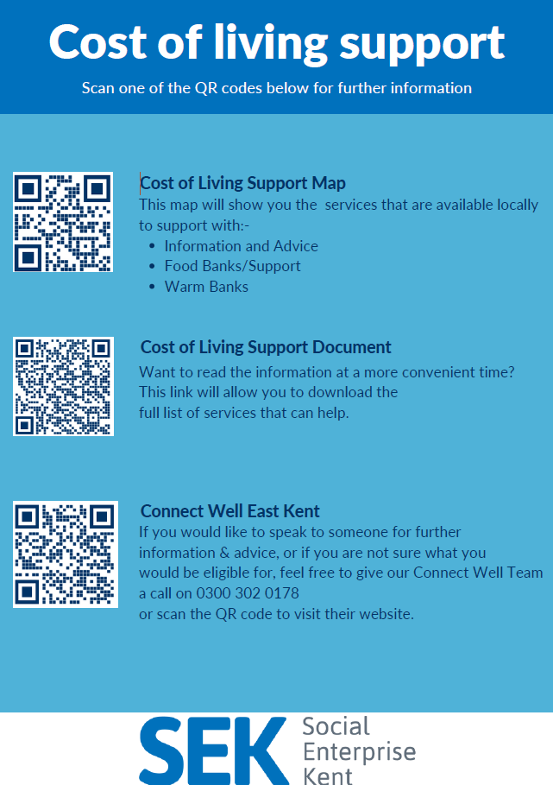

**Cost of Living Support**

With the pressures of costs around us there is a number of services that can support. If you are having troubles please contact them direct or come and talk with us.

A link below is Thanet councils community hub which can sign post to a range of support functions.

[**https://www.thanet.gov.uk/info-pages/covidcommunityadvice/**](https://www.thanet.gov.uk/info-pages/covidcommunityadvice/)

**DWP - Outreach sessions for families**

Outreach sessions are being held in local venues. Support on hand includes, benefit

advice, childcare choices and cost, finding work, cost of living, housing and any queries that our work coach can support the family with.

**Ramsgate** – The Priory Children’s Centre, Cannon Rd, Ramsgate CT11 9SQ

Outreach available every Wednesday between 9am to 12noon To book a slot to see our adviser at the Priory Children Centre in Ramsgate please contact

[jayne.conroy@dwp.gov.uk](mailto:jayne.conroy@dwp.gov.uk)

**Margate**– Six Bells Children Centre, 201 High St, Margate CT9 1WH

Outreach available every Monday between 1pm to 4pm To book a slot to see our adviser at the Six Bells in Margate please contact

[philip.raeburn@dwp.gov.uk](mailto:philip.raeburn@dwp.gov.uk) or [anita.taylor@dwp.gov.uk](mailto:anita.taylor@dwp.gov.uk" \t "_blank)

**Royal British Legion - Energy Support**

The Royal British Legion, the UK's largest charity dedicated to supporting the Armed Forces community, has today launched a new grant scheme for veterans and their families who are struggling to pay their energy bills. The initiative will provide non-repayable emergency grants of up to £2,400 a year (£200 a month) and is available across the UK.

In general, the Armed Forces community includes those who have served, or are serving, in the Royal Navy, British Army or Royal Air Force, as well as their families, dependants and carers – which can include children, current and former spouses and partners, widows and widowers.

To apply it's worth [checking your eligibility on its website](https://eur01.safelinks.protection.outlook.com/?url=https%3A%2F%2Fwww.britishlegion.org.uk%2Fget-support%2Fwho-we-help&data=05%7C01%7CJenny.Hanna%40kent.gov.uk%7C0e5a983faa7040ba13ee08dab3399c0f%7C3253a20dc7354bfea8b73e6ab37f5f90%7C0%7C0%7C638019357270836664%7CUnknown%7CTWFpbGZsb3d8eyJWIjoiMC4wLjAwMDAiLCJQIjoiV2luMzIiLCJBTiI6Ik1haWwiLCJXVCI6Mn0%3D%7C3000%7C%7C%7C&sdata=3atnAtHJUwgEaZz76bOScnj82DDHbKKLWrCX4kciIcY%3D&reserved=0) or by calling its helpline on 0808 802 8080.



Visit [Kent Resilience Hub](https://kentresiliencehub.org.uk/) where you can increase your understanding, find approaches and tools or navigate your way to support and services relating to resilience and emotional wellbeing.



[Kooth online](https://www.kooth.com/) support and counselling for 10-25 year olds across Kent and Medway. Offering 1-2-1 counselling, helpful articles, community discussion boards and daily journals.

****

[MindEd](https://www.minded.org.uk/) is a free educational resource on children and young people's mental health for all adults.

  
Find out how to tackle hate online and online trolls with internet matters advice guide for what [online hate](https://www.internetmatters.org/resources/tackling-online-hate-and-trolling/) is and how to support your child. Get tools and tips to support your child’s [digital wellbeing](https://www.internetmatters.org/?gclid=EAIaIQobChMIrbTX5_bt7AIVRuztCh33bQH_EAAYASAAEgLtifD_BwE) on Facebook, Instagram and WhatsApp.



Call NSPCC on 0808 800 5000 if you’re worried about the safety of a child. Or call the police on 999 if you think a child is in immediate danger.



Mind's [Action for Children](https://minds.actionforchildren.org.uk/self-esteem) around self esteem and helping your child. Parents with Confidence help your child to emotionally regulate.



Free and confidential advice from [Family Lives](https://www.familylives.org.uk/how-we-can-help/confidential-helpline/) on 0808 800 2222 if you’re finding it hard at home with your child and are struggling to cope**.**

[Young Minds](https://youngminds.org.uk/) have a parent’s helpline, information and resources.

