**15th July 2022 Newsletter**

We are almost to the end of the school year of what seems to have been a very long year, or maybe that is just me. Last week we had our transition day and pupils were able to visit their new classes and meet the adults that will be helping them next year.

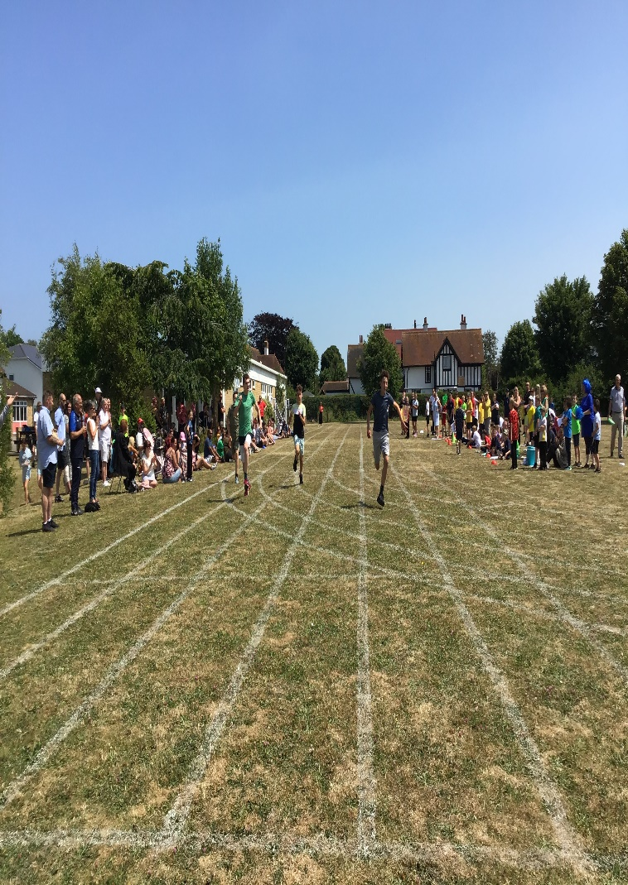**Sports Day**

We had a very successful sports day, with pupils showing their athletic skills.   
It was wonderful to be able to welcome so many parents, carers and family members.

Sports day 2022 at St Anthony's saw the return of parents and carers to the event for the first time since 2019 with over 140 visitors signing in, what a turn out! Pupils were eager to join in this year especially at key stages 2 and 3 where sign ups were made in abundance. Three main events took place before a special surprise was to take place at the end of a fantastic day.

The obstacle race was adapted this year and pupils of St Anthonys absolutely loved it, many heats took place however the overall winners and new record holders are ***Marcus M*** (KS2), ***Liam G*** (KS3) and ***Cody C*** (KS4), Well Done!

We then moved onto the tug of war events which were stacked with competition, there were many fierce battles that took place in front of the packed crowd, in fact the battles were so fierce that all four houses come out evens, all with two wins and two losses, 'you couldn't write it'.

The final event, a personal favourite, as well as a fan favourite were the sprints. A hotly contested event in the Olympics and at our own St Anthony's school, a chance to be a hero in front of a crowd, to take all the accolades, in what seems like a long hot day you can take all the attention in just ten seconds flat. We saw some great races that were contested strongly however we could only have three main winners overall so a whopping well done to ***Blaine G*** (KS2) who managed to win in 10.5 seconds, ***Harry F*** who also ran it in 10.5 seconds (KS3) and finally ***Cody C*** (KS4) who was 0.05 seconds of record at 9.68 seconds.

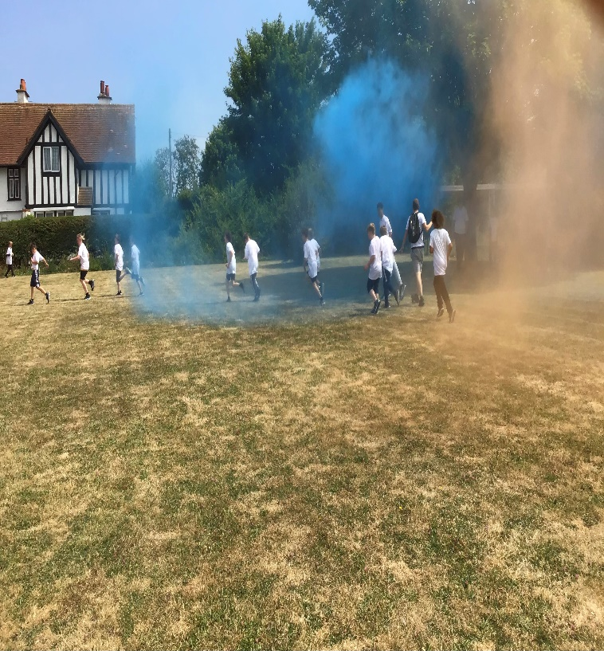

Once the races were finished, we had a surprise, a **COLOUR RUN**. A white T-shirt was provided for everyone that took part, pupils lined up at the beginning of the track and when announced got covered in paint, some ran as fast as they could to get away, others walked and enjoyed the atmosphere whilst a few rolled and crawled to get as colourful as they could. What a fun way to finish the sports day, and I am sure everyone would agree, well worth the wait!

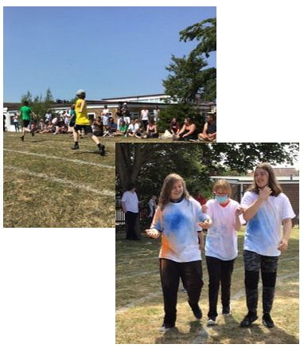

***Hayden*** going for the win whilst ***Daniel,******Holly*** & ***Aiden*** get colourful!

So, there you have it, another sports day at St Anthony's complete, more records broken, some hearts broken (they will recover) and a good time had by all involved. So, I would like to finish by just saying thank you, thank you to everyone involved, staff, pupils, parents, carers. It was AMAZING. Until next year... Mic Drop. ***Mr Kelly.***

***Feeling the heat!***Next week the Met Office has extended an amber extreme heat warning for Sunday 17th, Monday 18th and Tuesday 19th July, as temperatures will build this weekend and early next week for much of England. As Children cannot control their body temperature as efficiently as adults during hot weather because they do not sweat as much they can be at risk of ill-health from heat. Heat- related illness can range from mild heat stress to potentially life-threatening heatstroke. The main risk from heat is dehydration (not having enough water in the body).   
  
If sensible precautions are taken children are unlikely to be adversely affected by hot conditions, however, do look out for signs of heat stress, heat exhaustion and heatstroke.

Take the following steps to help your child:

* encourage children playing outdoors to stay in the shade as much as possible
* children should wear loose, light-coloured clothing to help keep cool and sunhats with wide brims to avoid sunburn
* use sunscreen (at least factor 15 with UVA protection) to protect skin if children are playing or taking lessons outdoors for more than 20 minutes
* provide children with plenty of water (such as water from a cold tap) and encourage them to drink more than usual when conditions are hot

**St Anthony’s Bake Off**

Staff showed off their baking skills this week in St Anthony’s bake off. Matt and Robert were the judges, Robert took his job very seriously and sampled a slice of all 16 entries, which was not a good idea but they were all so good.

Three winners were identified.   
**Abi C, Natalie S and Kate F.**

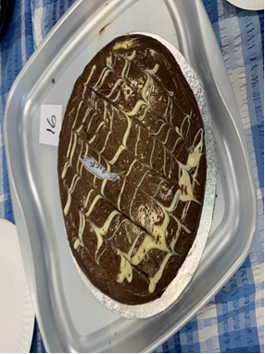





**Potter Class Visit Dover Castle**

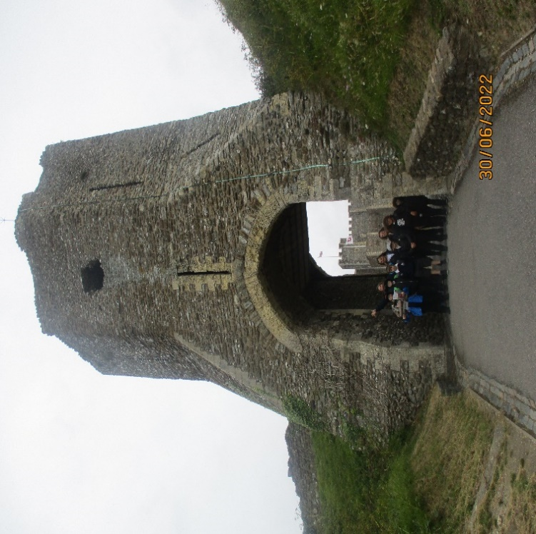

On Thursday 30th June **Potter** class had a visit to Dover Castle. It inspiried them to write a poem.

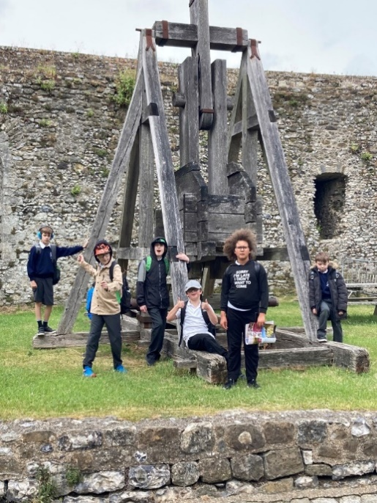

*On the 30th June twenty, twenty two,*

*We visited a castle, one with a view.*

*It was Dover Castle, it was very old,*

*It wasn’t too hot or even too cold.*

*We looked all around,*

*The tunnels and ground.*

*We looked at the shields,*

*The cannons, and fields.*

*The history was great,*

*The buildings, the gate.*

*We rolled down the mounds,*

*Then spent our pounds.*

*On ice cream, as a treat,*

*Then back on the bus to rest our poor feet****.***

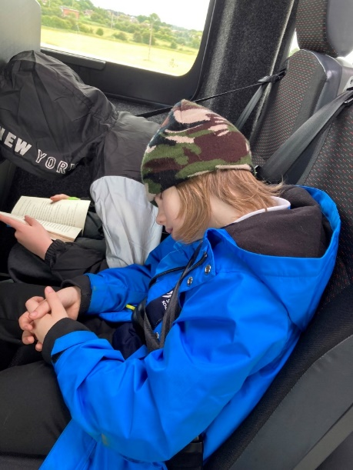

***The sign of a successful adventure!***



Kent County Council and the Reconnect Programme have funded FREE [Crest](http://www.crestawards.org/) [Awards](http://www.crestawards.org/) and resources for young people this summer.

The CREST Awards are an award for young people that demonstrates that they can think and act like scientists and engineers and are backed by the British Science Association. To earn the awards, young people complete some 45mins — 1hr science experiments or investigations and talk about what they’ve done.

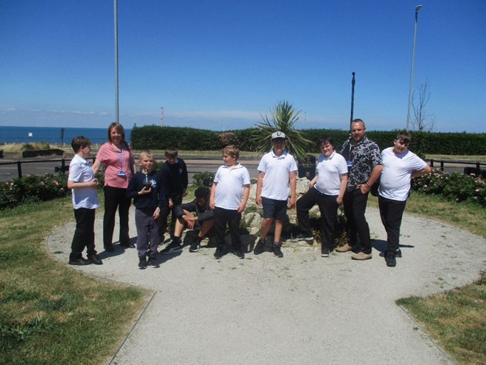

KCC and the Reconnect Programme have enabled parents and carers to have access to specially selected resources and passports for young people as well as the official awards of the CREST programme. The awards consist of a personalised certificate and badge posted to your address.

All experiments use materials that you may already have at home, or that are very cheap and easy to source. And every activity has adult instructions that explains what to do and all of the science behind it, so no need to be a science expert.

If you are interested in your children achieving a CREST Award this summer, register and find out more about the programme here:   
  
<https://thestemhub.org.uk/crest-awards>

or contact [CREST@canterbury.ac.uk](mailto:CREST@canterbury.ac.uk)

**Steve Does a Charity Run**

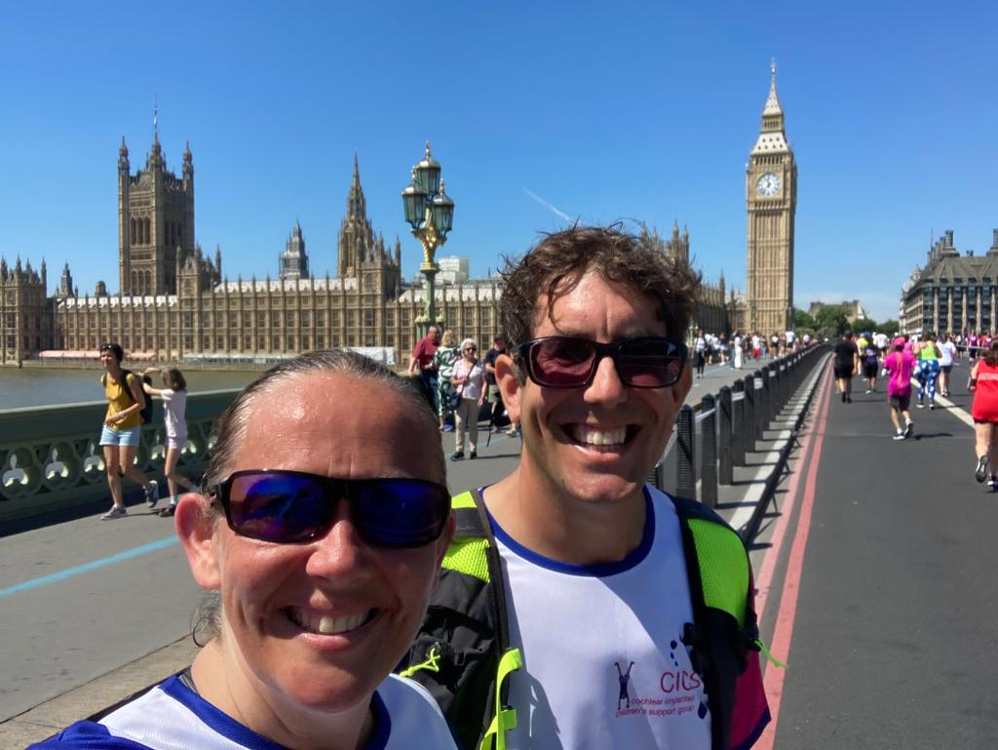

***Steve*** our site manager took part in the London 10k Run on Sunday 10th July. He joined thousands of runners as they wound their way through Central London. As well as seeing some of London's top landmarks, he also ran past the True Geographical Centre of London, down a closed Regent Street, the Strand and Embankment, and got the best views across the river of the London Eye. **Well done Steve!**

**Milton Class WBD Competition Winners**

Milton Class who were winner of this years World Book Day competition in March were finally able to claim their prize. So on 7th July they celebrated with a trip to Bugsy’s Bowling. Much fun was had by all and Lucas was a worthy winner, with a score of 121 points!

Pupil reports have gone home this week, if you have any questions please do liaise with your child’s class teacher



The GBBO was a wonderful success with a number of furry friends joining our students over the week and a successful bakesale at Sports Day saw the school raise **£65.50**. Well done all!

**Dates**

* Tues 19th July Reward Trips
* Wed 20th St Anthony’s Has Talent Show
* Thurs 21st July - Last Day of term 6

**1:30pm finish**

**Free Parent and Carer webinars on Kooth**

This session is designed to let parents and carers know how Kooth can support their children with their mental health and wellbeing.

If parents or carers have any questions, they can mail[**parentsandcarers@kooth.com**](mailto:parentsandcarers@kooth.com)

* [**Wednesday 27 July from 6pm to 7pm**](https://eur01.safelinks.protection.outlook.com/?url=https%3A%2F%2Fwww.eventbrite.co.uk%2Fe%2Fintroduction-to-kooth-for-parents-and-carers-tickets-277457000357%3Futm_campaign%3Dpost_publish%26utm_medium%3Demail%26utm_source%3Deventbrite%26utm_content%3DshortLinkNewEmail&data=05%7C01%7CMax.Edwards%40kent.gov.uk%7C457a621584cc44d5986b08da486f609e%7C3253a20dc7354bfea8b73e6ab37f5f90%7C0%7C0%7C637901940444238522%7CUnknown%7CTWFpbGZsb3d8eyJWIjoiMC4wLjAwMDAiLCJQIjoiV2luMzIiLCJBTiI6Ik1haWwiLCJXVCI6Mn0%3D%7C3000%7C%7C%7C&sdata=yppFK3Qw0t0NJQpjlOgb0NXkzehUKbZM9pzKDEcbq%2BY%3D&reserved=0)

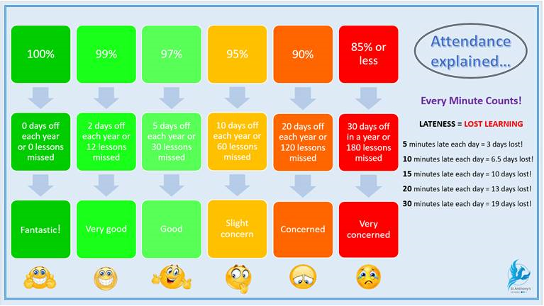**Attendance**

## A reminder for parents and carers of the importance of routine immunisations for your teens

The [national routine childhood immunisation programme](https://www.gov.uk/government/publications/the-complete-routine-immunisation-schedule?utm_source=16%20June%202022%20C19&utm_medium=Daily%20Email%20C19&utm_campaign=DfE%20C19) has a direct positive impact on the health and wellbeing of children and communities and is vital to reduce the spread of infection and prevent outbreaks.

In addition to the flu and COVID-19 vaccines that have been offered to school-aged children this academic year, teenagers are routinely offered 3 vaccines in secondary schools:

[human papillomavirus (HPV) vaccine](https://eur01.safelinks.protection.outlook.com/?url=https%3A%2F%2Fwww.nhs.uk%2Fconditions%2Fvaccinations%2Fhpv-human-papillomavirus-vaccine%2F&data=05%7C01%7CGeorgia.Featherston%40ukhsa.gov.uk%7C52fa1e5e94584356f67708da4ada4faa%7Cee4e14994a354b2ead475f3cf9de8666%7C0%7C0%7C637904598749360879%7CUnknown%7CTWFpbGZsb3d8eyJWIjoiMC4wLjAwMDAiLCJQIjoiV2luMzIiLCJBTiI6Ik1haWwiLCJXVCI6Mn0%3D%7C3000%7C%7C%7C&sdata=bSqhugrU7ubm9lHCVD7oKm4vC6z59hWd45c791VCqO4%3D&reserved=0) Yr 8 and 9  
[menACWY vaccine](https://eur01.safelinks.protection.outlook.com/?url=https%3A%2F%2Fwww.nhs.uk%2Fconditions%2Fvaccinations%2Fmen-acwy-vaccine%2F&data=05%7C01%7CGeorgia.Featherston%40ukhsa.gov.uk%7C52fa1e5e94584356f67708da4ada4faa%7Cee4e14994a354b2ead475f3cf9de8666%7C0%7C0%7C637904598749360879%7CUnknown%7CTWFpbGZsb3d8eyJWIjoiMC4wLjAwMDAiLCJQIjoiV2luMzIiLCJBTiI6Ik1haWwiLCJXVCI6Mn0%3D%7C3000%7C%7C%7C&sdata=FA9ixE3K8h2UX1DDrdlzPMUbdHhpp3wFY57YWna1i%2BI%3D&reserved=0) in Year 9  
[Td/IPV (3-in-1 booster)](https://eur01.safelinks.protection.outlook.com/?url=https%3A%2F%2Fwww.nhs.uk%2Fconditions%2Fvaccinations%2F3-in-1-teenage-booster%2F&data=05%7C01%7CGeorgia.Featherston%40ukhsa.gov.uk%7C52fa1e5e94584356f67708da4ada4faa%7Cee4e14994a354b2ead475f3cf9de8666%7C0%7C0%7C637904598749517106%7CUnknown%7CTWFpbGZsb3d8eyJWIjoiMC4wLjAwMDAiLCJQIjoiV2luMzIiLCJBTiI6Ik1haWwiLCJXVCI6Mn0%3D%7C3000%7C%7C%7C&sdata=VqjDMPXeHIw6UI8z334WQFD9nqiQDLhiY7sNuM0EPJI%3D&reserved=0) in Year 9

The delivery of these routine adolescent immunisation programmes has been significantly impacted by the COVID-19 pandemic and vaccine coverage is still not at pre-pandemic levels. The UK Health Security Agency (UKHSA) and NHS England and NHS Improvement (NHSEI) are reminding parents and carers about the important protection these immunisations provide. They are also encouraging take up and catch up of vaccinations for anybody who has missed out.

Education and childcare settings have a vital role to play in supporting the routine immunisation programme. It would be very helpful for settings to share information with parents. Further information can be found in the [UKHSA immunisation guidance](https://www.gov.uk/government/publications/health-protection-in-schools-and-other-childcare-facilities/chapter-5-immunisation#how-to-support-the-sais-before-the-immunisation-session?utm_source=16%20June%202022%20C19&utm_medium=Daily%20Email%20C19&utm_campaign=DfE%20C19).

A wide range of immunisation support resources for educational settings are available which can be shared with parents. They can be ordered on the [health publications website](https://eur01.safelinks.protection.outlook.com/?url=https%3A%2F%2Fhealthpublications.gov.uk%2F&data=05%7C01%7CGeorgia.Featherston%40ukhsa.gov.uk%7C52fa1e5e94584356f67708da4ada4faa%7Cee4e14994a354b2ead475f3cf9de8666%7C0%7C0%7C637904598749517106%7CUnknown%7CTWFpbGZsb3d8eyJWIjoiMC4wLjAwMDAiLCJQIjoiV2luMzIiLCJBTiI6Ik1haWwiLCJXVCI6Mn0%3D%7C3000%7C%7C%7C&sdata=ofR5xLdFptBfbJwvow5ibNWew5kCptRPighD86pb74Q%3D&reserved=0?utm_source=16%20June%202022%20C19&utm_medium=Daily%20Email%20C19&utm_campaign=DfE%20C19) or by calling 0300 123 1002. For further information, please email [immunisations@phe.gov.uk](mailto:immunisations@phe.gov.uk)

**Upcoming Courses at Thanet Trust**

These courses are free and for those that need to

get public transport, we will be able to provide reimbursement of these costs.

* **27 - 29 July and 2 - 5 August: New Beginnings** This course will be held at

the Hereson Family and Community Centre, Ramsgate. This course will help people seeking employment by helping them

gain accredited qualifications, soft-skills training, and guidance on the job

application process.

* **25 - 26 July: Build a Future (Fast track)**

This course will be on Monday, Tuesday, and Wednesdays. Held at the Hereson Family and

Community Centre, Ramsgate. This course

gives people the skills and qualifications they need to find employment in the construction industry.

Application for these courses must be via email or telephone at [admin@tcdt.org.uk](mailto:admin@tcdt.org.uk) / 01843

855155.

**KCC - SEND Information Hub**

**(Kent’s Local Offer)**

The SEND Information Hub (Kent’s Local Offer)

is a website about all the services and

support available for children from 0 to 25 and

their families, with special educational needs

and disabilities (SEND) from the local area and outside the area.

The website includes a directory, which is a

database containing a wide range of activities,

events and support services available to families

with SEND in their local communities. This

directory is ever changing and continuously monitored and reviewed by the SEND

Partnership and Engagement Team. This means there will always be new things added and

updates to current records.

This SEND promotional poster can be used as a handout by KCC staff to inform and

signpost families with SEND to the relevant

support and guidance.

Please contact our SEND Partnership and Engagement Team at [yourvoice2@kent.gov.uk](mailto:yourvoice2@kent.gov.uk)

If you have any queries about the SEND

Information Hub website or any tips on how

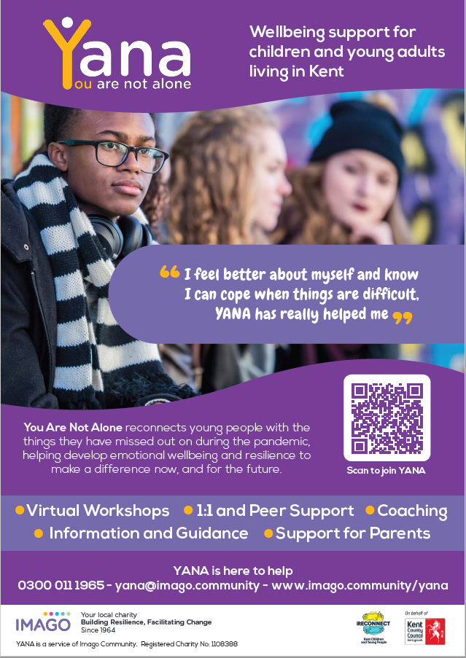 to get the word out about this!

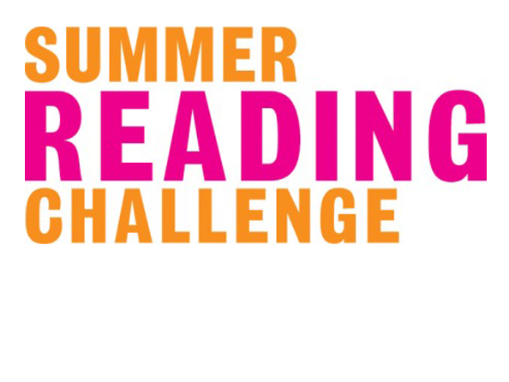

*The national curriculum for English aims to ensure that pupils develop the habit of reading   
widely and often for both pleasure and information.*

Organised by charity The Reading Agency ([www.readingagency.org.uk](http://www.readingagency.org.uk)) and the UK public library network since 1999, the **Summer Reading Challenge** is the UK’s biggest annual reading promotion for children aged 4 to 11.

The Summer Reading Challenge combines **FREE** access to books with fun, creative activities during the summer holidays. Throughout the Challenge, library staff and young volunteers support the children, helping them to discover new authors and illustrators and to explore a wide range of different types of books and ways of reading.

**How the Challenge works**

* Children sign up through their local library and receive a Gadgeteers collector poster.
* Children set a reading goal and borrow and read library books of their own choice during the summer, collecting special stickers to complete their poster and extra incentives along the way.
* Library staff and volunteers are on hand to advise and run family-friendly activities.
* Children who complete the Summer Reading Challengee’s are presented with a certificate and/or a medal.
* The official Challenge website hosts digital rewards, author videos, games and more for children to enjoy all summer: [www.summerreadingchallenge.org.uk](http://www.summerreadingchallenge.org.uk)

**How do schools benefit?**

* The Summer Reading Challenge is intrinsically inclusive and can contribute to the achievement of **ALL** your pupils including those with special educational needs, disadvantaged pupils and   
  the most able.
* It enhances and supports your school’s reading policy and your mission for all children to read more widely and for pleasure.
* It encourages parental engagement and family involvement in reading and helps your school make links with the library and the wider community.
* It allows children to become more independent in their reading when choosing books and encourages using imagination and empathy to explore a text beyond the page.
* It takes place at your local library and is a brilliant opportunity for extra-curricular activity
* It keeps your pupils reading over the summer, ready for their return to school in the autumn, and supports the successful transition between year groups and key stages.

You can find additional information and free resources to support children’s reading for pleasure in the Summer Reading Challenge School Zone:   
  
[www.summerreadingchallenge.org.uk/school-zone-src](http://www.summerreadingchallenge.org.uk/school-zone-src)

By championing the Summer Reading Challenge in your school, you will be continuing to support your pupils’ learning during the holidays, ensuring they return ready for a great start to the new academic year.

**It's FUN! It's FREE! It's LOCAL!**



Visit [Kent Resilience Hub](https://kentresiliencehub.org.uk/) where you can increase your understanding, find approaches and tools or navigate your way to support and services relating to resilience and emotional wellbeing.



[Kooth online](https://www.kooth.com/) support and counselling for 10-25 year olds across Kent and Medway. Offering 1-2-1 counselling, helpful articles, community discussion boards and daily journals.



[MindEd](https://www.minded.org.uk/) is a free educational resource on children and young people's mental health for all adults.



Find out how to tackle hate online and online trolls with internet matters advice guide for what [online hate](https://www.internetmatters.org/resources/tackling-online-hate-and-trolling/) is and how to support your child. Get tools and tips to support your child’s [digital wellbeing](https://www.internetmatters.org/?gclid=EAIaIQobChMIrbTX5_bt7AIVRuztCh33bQH_EAAYASAAEgLtifD_BwE) on Facebook, Instagram and WhatsApp.



Call NSPCC on 0808 800 5000 if you’re worried about the safety of a child. Or call the police on 999 if you think a child is in immediate danger.



Mind's [Action for Children](https://minds.actionforchildren.org.uk/self-esteem) around self esteem and helping your child. Parents with Confidence help your child to emotionally regulate.



Free and confidential advice from [Family Lives](https://www.familylives.org.uk/how-we-can-help/confidential-helpline/) on 0808 800 2222 if you’re finding it hard at home with your child and are struggling to cope**.**

[Young Minds](https://youngminds.org.uk/) have a parent’s helpline, information and resources.

