**15th September 2023**

A warm welcome back to the new school year.

The lovely weather that was an added challenge to the nerves and anxiety that our pupils already have at the start of a new school year, as they deal with new peers, teachers and systems.  I am happy to report the majority of pupils coped well with the challenges of the first week and those who struggled we have plans in place to support their needs and help them re-engage with learning.  
  
Over the summer the school completed a number of substantial building projects to ensure that the school provides our pupils and staff with excellent facilities.  As l wrote to you last week the school does not have any issues with RAAC which is causing a number of issues for schools across the UK. The pupils in Year 10 and 11 returned to freshly decorated classrooms.  The old entrance to the school has been under used the past couple of years and has now been reconfigured to provide the school with a large meeting room, with office space for staff and we also now have a purpose built Forest School room.  This will provide our pupils with even better opportunities to learn new skills.  A big thank you to ***Steve*** our site manager and ***John B*** for being at school each day over the summer holidays to ensure work was completed.

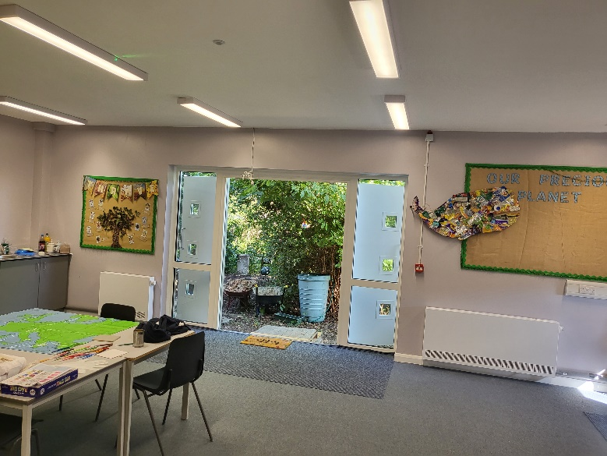

We have two new members of staff who join the school this term.  ***Kate Farrer*** is teaching Louisa Class Year 5.  She is not new to the school as she completed her teaching training with us, we clearly made an impact on her as she wished to come and work with our pupils.  ***Lauren Davis*** is a new LSA in Joss.  Though she has not previously worked in schools she brings a wide range of experiences to the school.  Welcome to both new members of staff.

   
 ***Kate Farrer Lauren Davis***

To ensure that our pupils have the best opportunity to reach their full potential we do need them to attend school each and every day.  This allows them to get into proper learning routines and develop the skills to deal with changes and peer interactions.  We understand the challenges that some of our pupils face in dealing with the complexities of school life and that is why we work closely with home and other professionals to create personal learning plans that suit these individuals with the goal of full time attendance for all. The school has set a target of 85% attendance for the year which will be a challenge so l ask your support to help us achieve this by sending your child into school every day. If you any concerns about this do come and speak with ***Kirstie*** or me.

The start of each school year sees pupils in nice school uniforms and this year has been no exception.  Thank you for your support in ensuring your child is properly dressed for school.  They should be coming into school each day in our simple uniform, if they have PE they should have a separate PE kit to change into.  Though we fully understand the pressures that parents/carers face with mounting costs, if you are struggling with the costs of school uniform or PE kits please do come and speak with us as we are able to help.

To build a school community the school is divided into four houses:

**Yellow Vikings**, **Red Romans**, **Green Saxons** and **Blue Saxons.**  Children and staff are randomly placed in houses and they can earn points for their houses each week with a House Cup being awarded in Friday assembly in light hearted competition.  We also run a number of house competitions each term with this terms competition being a draughts tournament in October.  Please ask you child about which house they are in.



We look forward to working with you all this year and helping your child reach their potential.  If you have concerns or issues please speak with the class teacher in the first instance as when we work in partnership we have much better opportunities for success.  
 ***Mr Page*, Headteacher**  
**Dates for the diary**

* **Monday 2nd October – INSET Day –** Pupils do not attend
* **Friday 20th October** – Last day of Term 1

**British Values**



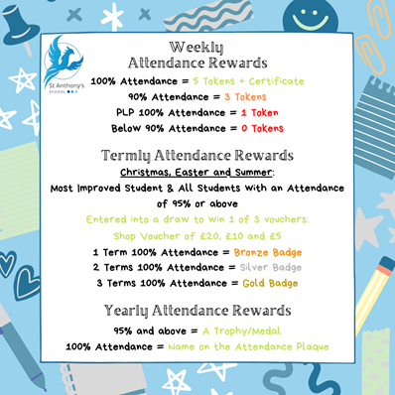**Attendance**Well done to all the children who consistently achieve a weekly attendance of 100%. We monitor attendance from Friday-Thursday allowing us to celebrate those children in our Friday Morning Assembly for their 100% attendance.   
  
Each child who achieves 100% attendance for the week gets a certificate and **5** tokens, any child who achieves 90% attendance will receive **3** tokens for the reward Shop.

**Houses of Parliament**The British Value Champions from last academic year spent the day at the Houses of Parliament! It was an amazing day and we were able to watch debates in The House of a commons and The House of Lords.

This academic year we are planning a trip to Buckingham Palace for the Champions, so ask your child about British Valves and ask them how they can be awarded a British Values wristband; it could be them on the next trip!!!   
 ***Katy Wren***



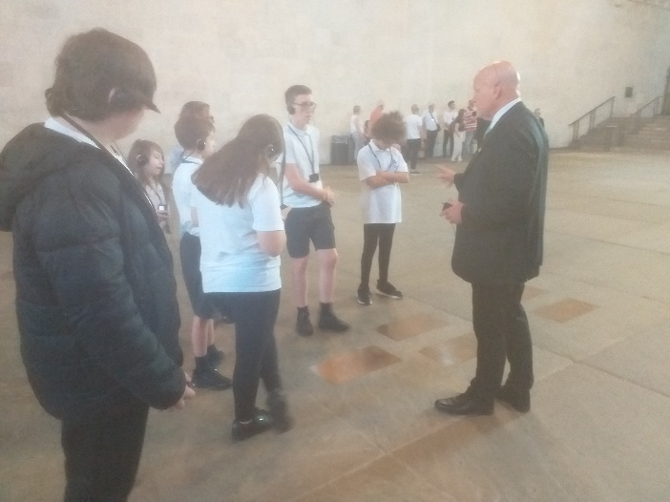  
  




**Whats on…**

**SPORT FOR FUN –** Saturdays (term time) 9.00 - 10.00 at St Anthony's School. A Saturday morning sports club for children with SEND.

**BE ACTIVE -SHORT BREAK** - Saturdays (term time) 10.30 - 12.00 at Foreland Fields School

**BE ACTIVE -SHORT BREAK** - Wednesdays (term time) 4.30 - 6.00 at Foreland Fields School

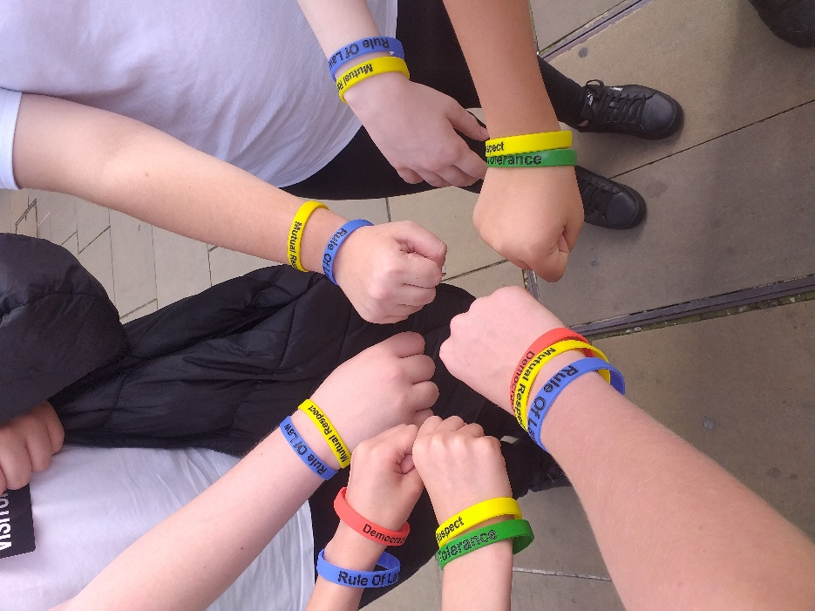Complete the following referral form to declare interest:   
<https://forms.office.com/r/EZwuMEZmEd>

**CLIP N CLIMB** - Thursdays Session 1: 4.30-5.30pm Session 2: 5.30-6.30pm.

To book please clink on this link: <https://forms.gle/EHYHiAtxWfE3XYDz6>

**MARGATE YOUTH FC KICKS 4 KIDS** - Tuesdays 5.00-5.45 at Margate FC

Inclusive football sessions delivered by Inclusive Sport. To register please visit: <https://www.margateyouthfc.co.uk/events/kick-inclusive-football-sessions>

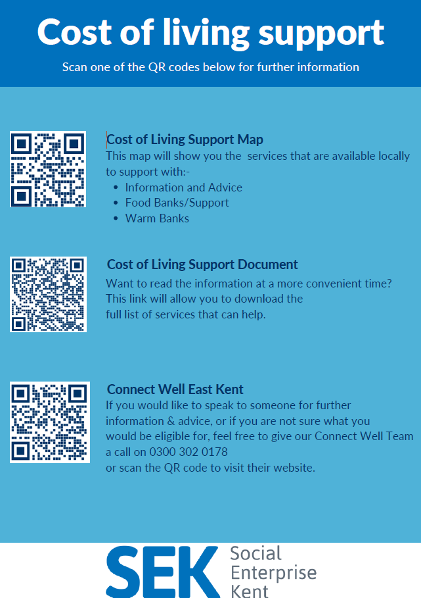**Cost of Living Support**

With the pressures of costs around us there is a number of services that can support. If you are having troubles please contact them direct or come and talk with us.

****A link below is Thanet councils community hub which can sign post to a range of support functions.

[**https://www.thanet.gov.uk/info-pages/covidcommunityadvice/**](https://www.thanet.gov.uk/info-pages/covidcommunityadvice/)

**DWP - Outreach sessions for families**

Outreach sessions are being held in local venues. Support on hand includes, benefit advice, childcare choices and cost, finding work, cost of living, housing and any queries that our work coach can support the family with.

**Ramsgate** – The Priory Children’s Centre, Cannon Rd, Ramsgate CT11 9SQ

Outreach available every Wednesday between 9am to 12noon To book a slot to see our adviser at the Priory Children Centre in Ramsgate please contact

[jayne.conroy@dwp.gov.uk](mailto:jayne.conroy@dwp.gov.uk)

**Margate**– Six Bells Children Centre, 201 High St, Margate CT9 1WH

Outreach available every Monday between 1pm to 4pm To book a slot to see our adviser at the Six Bells in Margate please contact

[philip.raeburn@dwp.gov.uk](mailto:philip.raeburn@dwp.gov.uk) or [anita.taylor@dwp.gov.uk](mailto:anita.taylor@dwp.gov.uk)

**Royal British Legion - Energy Support**

The Royal British Legion, the UK's largest charity dedicated to supporting the Armed Forces community, has today launched a new grant scheme for veterans and their families who are struggling to pay their energy bills. The initiative will provide non-repayable emergency grants of up to £2,400 a year (£200 a month) and is available across the UK.

In general, the Armed Forces community includes those who have served, or are serving, in the Royal Navy, British Army or Royal Air Force, as well as their families, dependants and carers – which can include children, current and former spouses and partners, widows and widowers.

To apply it's worth [checking your eligibility on its website](https://eur01.safelinks.protection.outlook.com/?url=https%3A%2F%2Fwww.britishlegion.org.uk%2Fget-support%2Fwho-we-help&data=05%7C01%7CJenny.Hanna%40kent.gov.uk%7C0e5a983faa7040ba13ee08dab3399c0f%7C3253a20dc7354bfea8b73e6ab37f5f90%7C0%7C0%7C638019357270836664%7CUnknown%7CTWFpbGZsb3d8eyJWIjoiMC4wLjAwMDAiLCJQIjoiV2luMzIiLCJBTiI6Ik1haWwiLCJXVCI6Mn0%3D%7C3000%7C%7C%7C&sdata=3atnAtHJUwgEaZz76bOScnj82DDHbKKLWrCX4kciIcY%3D&reserved=0) or by calling its helpline on 0808 802 8080.



Visit [Kent Resilience Hub](https://kentresiliencehub.org.uk/) where you can increase your understanding, find approaches and tools or navigate your way to support and services relating to resilience and emotional wellbeing.

[Kooth online](https://www.kooth.com/) support and counselling for 10-25 year olds across Kent and Medway. Offering 1-2-1 counselling, helpful articles, community discussion boards and daily journals.  
[MindEd](https://www.minded.org.uk/) is a free educational resource on children and young people's mental health for all adults.

Find out how to tackle hate online and online trolls with internet matters advice guide for what [online hate](https://www.internetmatters.org/resources/tackling-online-hate-and-trolling/) is and how to support your child. Get tools and tips to support your child’s [digital wellbeing](https://www.internetmatters.org/?gclid=EAIaIQobChMIrbTX5_bt7AIVRuztCh33bQH_EAAYASAAEgLtifD_BwE) on Facebook, Instagram and WhatsApp.

Call NSPCC on 0808 800 5000 if you’re worried about the safety of a child. Or call the police on 999 if you think a child is in immediate danger.

Mind's [Action for Children](https://minds.actionforchildren.org.uk/self-esteem) around self esteem and helping your child. Parents with Confidence help your child to emotionally regulate.

Free and confidential advice from [Family Lives](https://www.familylives.org.uk/how-we-can-help/confidential-helpline/) on 0808 800 2222 if you’re finding it hard at home with your child and are struggling to cope**.**[Young Minds](https://youngminds.org.uk/) have a parent’s helpline, information and resources