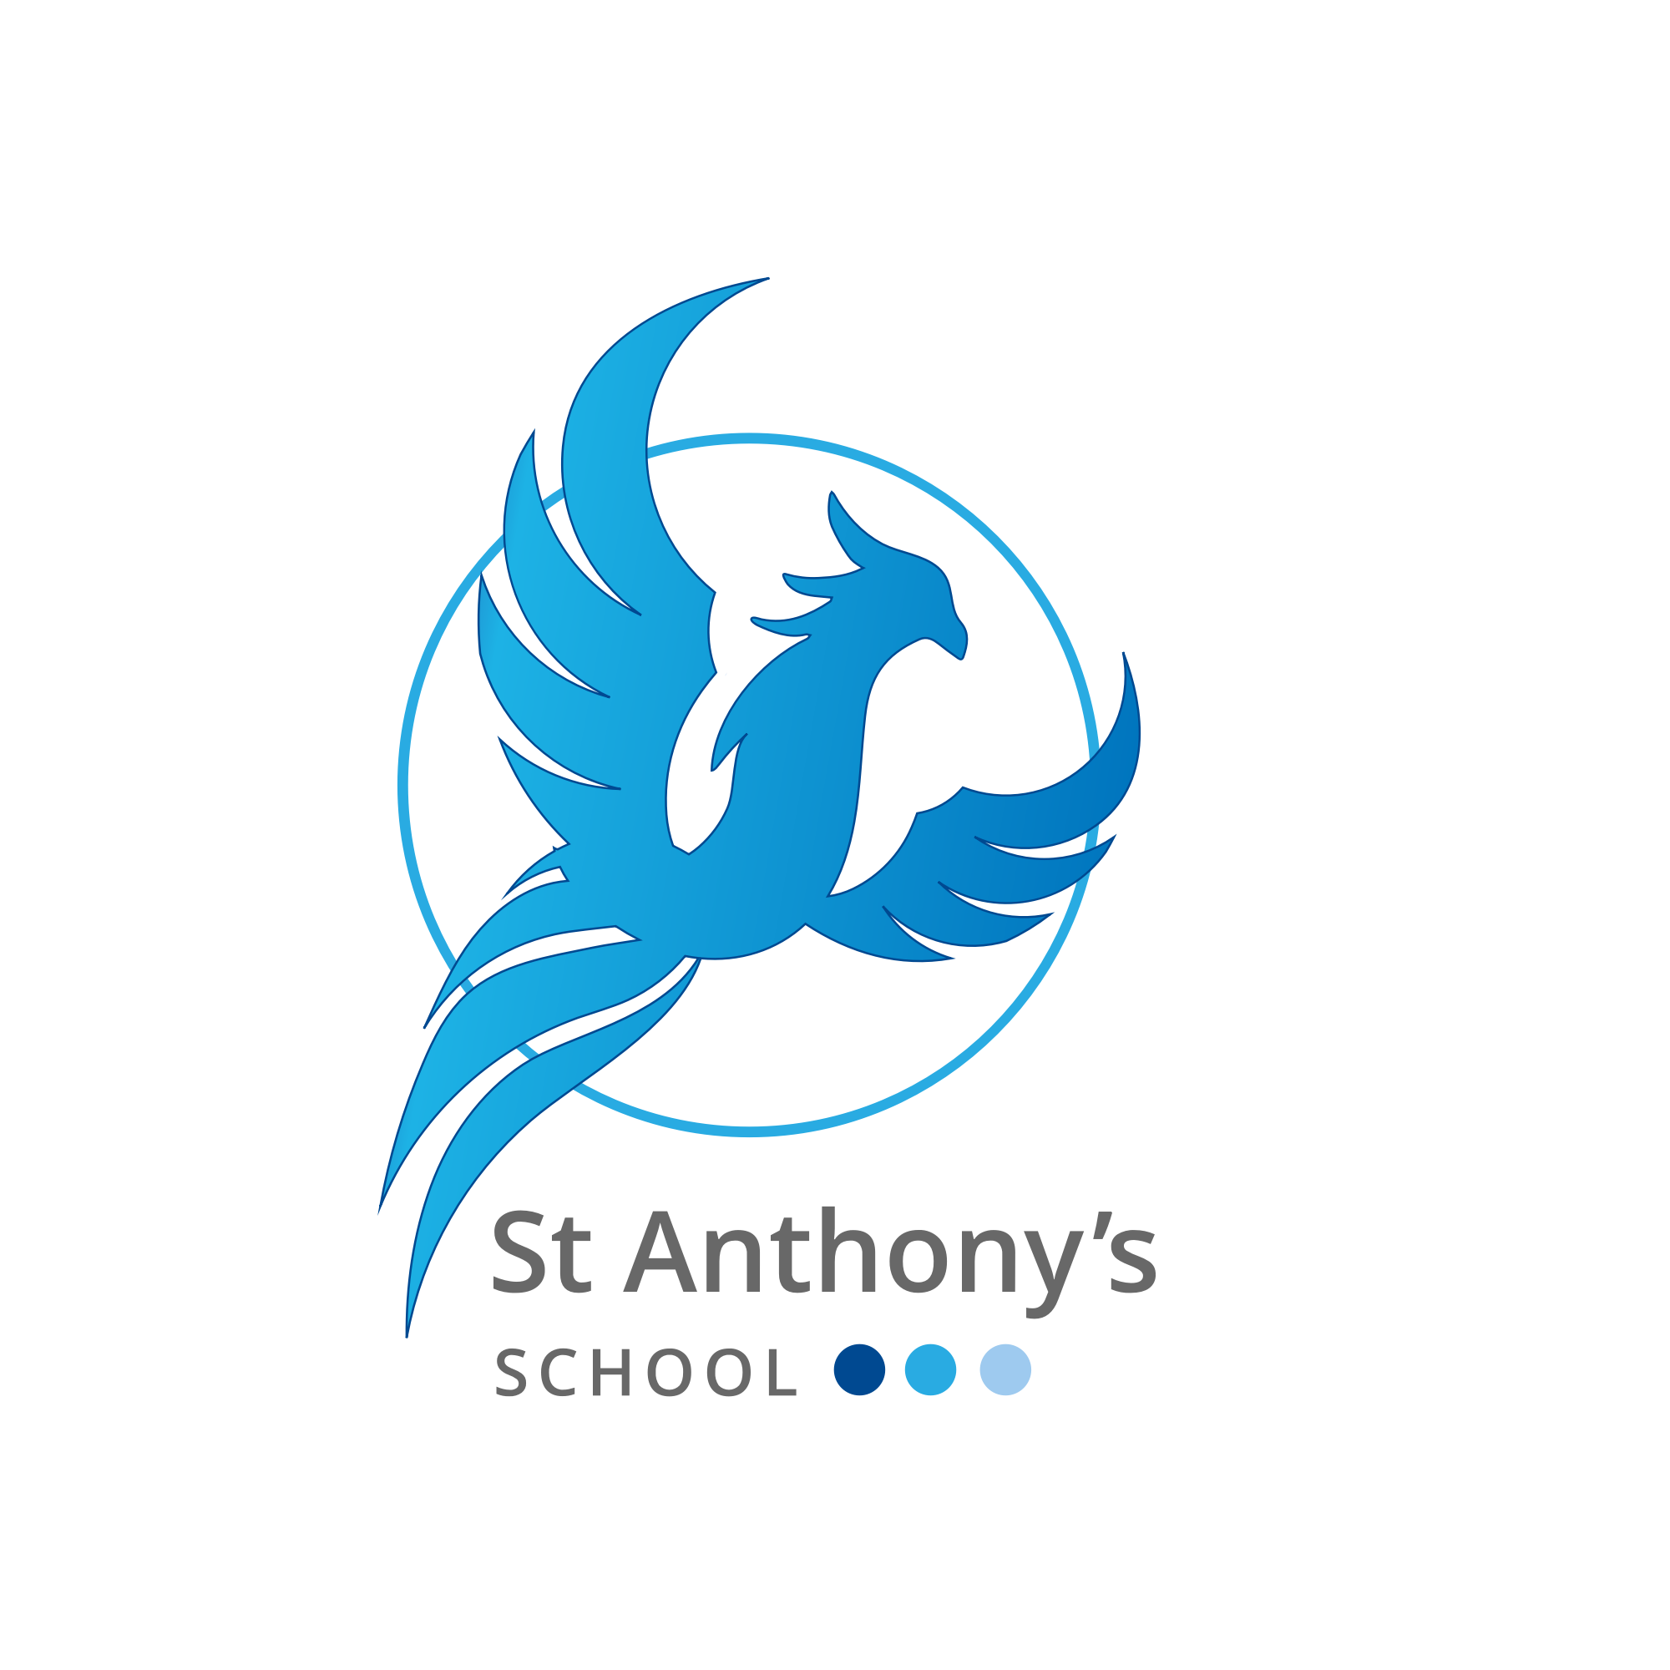

**ST. ANTHONY’S SCHOOL**

**WINTER FAYRE**

**Raffle**

**Lots of Fun Games**

**Father Christmas**

**Tombola**

**Toys**

**FRIDAY 3rd DECEMBER 2021**

**5pm - 7pm**

**Come along and enjoy! Lots of fun to be had with something for all ages. Bring Family and Friends.**

**Proceeds go to the PTFA for school projects.**

**Food**