**1st April 2022 Newsletter**

As we come to the end of another term l was really hoping to talk about how St Anthony’s was moving past COVID but this week has been significantly blighted by the return of a high number of cases in school for pupils and staff, which is reflected across Thanet. This has meant significant disruption to pupils learning again. So a very big thank you to our parents and carers for their continuing support and understanding as we deal with day to day management of COVID.

So l hope you have a healthy and safe Easter.

**School Reports**

Pupil reports go out this week. They are a comprehensive summary of your child’s behaviour, effort and progress across all parts of the curriculum.

This is the main report you will receive this academic year. We produced reports now, at the end of term 4, because we believe this is a pivotal point in the year.

Class teachers have had a chance to acquire a detailed knowledge of pupils’ needs and potential. Plus a significant proportion of the curriculum has been covered.

So we now have an accurate picture of what your child has achieved. Therefore, it is an opportunity to celebrate their success – we advise that you make a fuss of their successes.

Also, with two terms remaining, it allows time for them to focus on the suggested areas for improvement. Please pay particular attention to these elements of the report and take time to discuss them with your child.

***Antony Curry***, DHT (Teaching and Learning)

**Easter Eggs**

This year the PTFA have been fortunate enough to be able to buy Easter eggs, which means that every pupil in the school will be able to receive an egg to take home on Friday 1st April.

Any pupils who are absent will not miss out, as theirs will be waiting for them on their return after the Easter holidays.  Milne Class are very kindly going to be delivering these to every class on Friday morning.  Happy Easter and have a safe, fun Easter break.  Thank you all for your continued support. From ***Catrina Jones*** (Chair), ***Heather Leal*** (Treasurer), and all members of the PTFA



***Proposed date PTFA Summer Fayre   
Friday 24th June***

**Keep Britain Tidy**

We participated in the Great British Spring Clean (25th March – 10th April 2022)

As you are aware, litter blights our streets, parks and beaches and costs us millions of pounds to clear up every year. *Keep Britain Tidy* is about inspiring children to eliminate litter now and for future generations.

The schools aim is to change our pupil’s behaviour permanently by discussing issues with our pupils and offering creative solutions. As a school we pledged to collect 55 bags of litter this week.

Feedback from pupils has been positive and staff have mentioned the encouraging comments made by members of the public on their efforts.

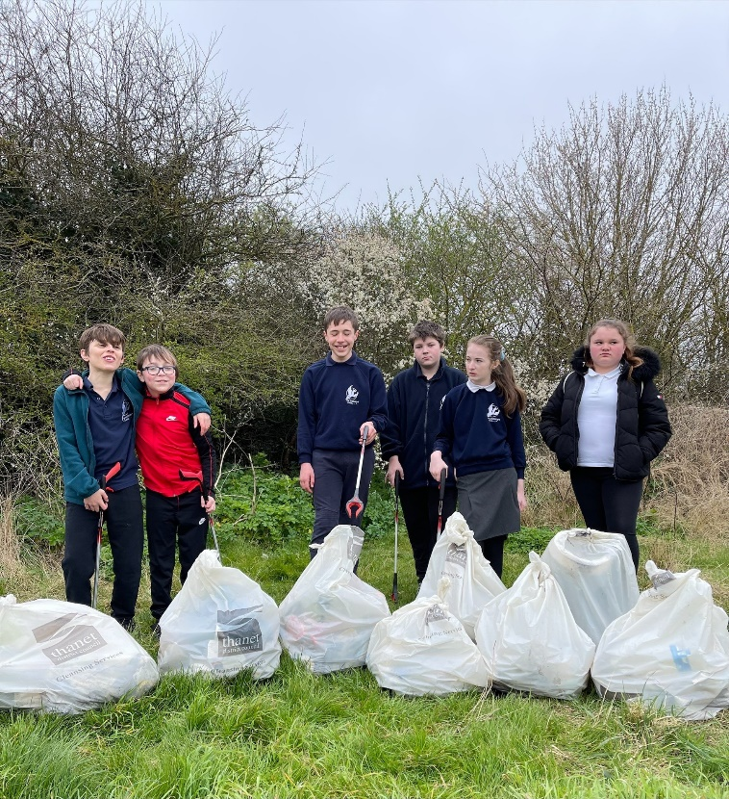

**Toby, Roy, Callum, Adam, Sophie & Ellie**

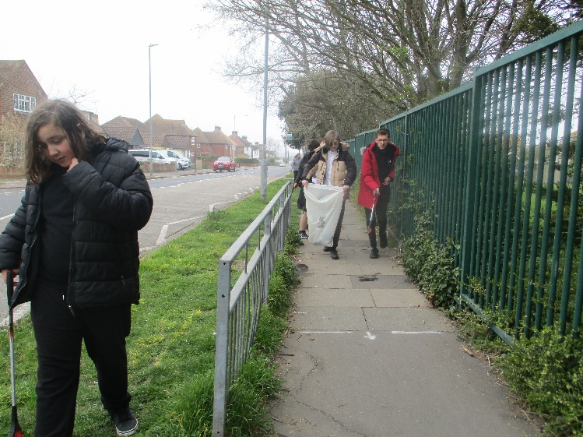

**Daniel, Jason & Taylor**

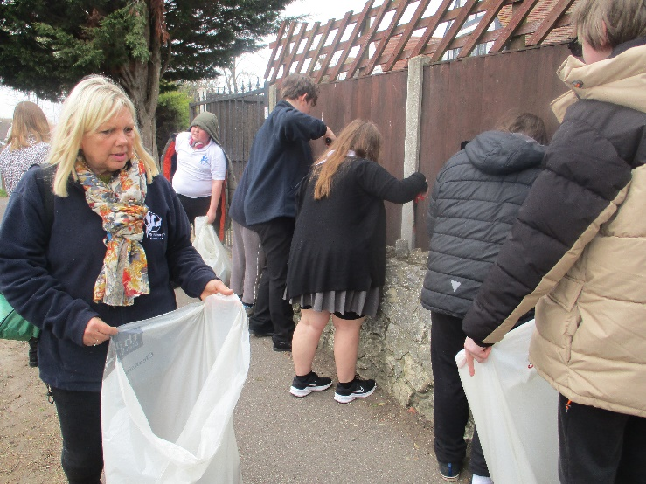

**Author Visit**



KS4 classes had the author Gareth P. Jones visit the school. He is an English children's writer, and author of the Dragon Detective Agency series of books. He is best known for his comic-gothic book The Considine Curse, which won the Blue Peter Book Award in 2012. The sessions were full of fun, with pupils having the opportunity to ask the author lots of questions around writing and writing ideas.

**Children’s University**



Our school is a Kent Children’s University (KCU) Learning Destination and our primary children earn credits for taking part in activities outside normal school time. At 3pm on **Saturday 2nd April**, KCU’s Spring Challenge launches via [www.kcuchallenges.co.uk](http://www.kcuchallenges.co.uk) The Challenge contains 24 activity ideas for children and families, to help keep everyone entertained throughout Spring. Children and families have until the end of May to complete as many activities as they would like. How many activities will you complete as a family? Keep an eye out on Social Media for more details #KCUChallenges

**Kent Reconnect HAF**

<https://www.kent.gov.uk/education-and-children/schools/reconnect>

Reconnect is a Kent County Council led, community based programme designed to get Kent’s children and young people back to enjoying the activities and opportunities they took part in before COVID-19, as well as the chance to try new things along the way. Everyone can get involved!

The Holidays Activities and Food (HAF) Programme offers families of children aged 4 to 16, who are eligible for benefits related free school meals (FSM), free opportunities to access a range of activities in the Easter, summer, and Christmas holidays. If you are not sure if you are eligible, please use the eligibility checker: <https://www.cloudforedu.org.uk/ofsm/kent/>

Where Can I Go for Information About Programmes in My Area?

<https://www.theeducationpeople.org/holiday-activities-and-food-programme-kent/welcome-information-for-families/>

**Red Nose Day**

St Anthony’s school supported Red Nose Day on Friday March 18th and we raised **£198.82**. This was achieved via a cake sale, selling red noses and non-uniform day. We have sent off a cheque to Comic Relief/Ukraine appeal.

Thank you all for your support.

**SEND Green Paper**

This week, the DfE launched its long awaited green paper on [SEND and alternative provision – right support, right place, right time](https://www.gov.uk/government/publications/send-and-ap-green-paper-responding-to-the-consultation?utm_source=29%20March%202022%20C19&utm_medium=Daily%20Email%20C19&utm_campaign=DfE%20C19).

This follows the SEND review, which was launched in acknowledgement that the system was failing to deliver improved outcomes for children and young people with SEND.

The green paper are focused on delivering improved outcomes for children and young people with SEND, or who need alternative provision, building confidence and improving experiences, within a financially sustainable system. It proposes a number of reforms, including:

* a single national SEND and alternative provision system
* excellent provision from early years to adulthood
* a reformed and integrated role for alternative provision
* system roles, funding and accountability
* delivering change for children and families

Visit the [SEND campaign](https://sendreview.campaign.gov.uk/?utm_source=29%20March%202022%20C19&utm_medium=Daily%20Email%20C19&utm_campaign=DfE%20C19) website to find a range of information and graphics setting out key proposals from the green paper. There are also details of webinars where you can find out more about the SEND consultation.

**Dates**

* Tuesday 19th April – First day term 5
* Monday 2nd May – Bank holiday
* Friday 27th May – Last Day term 5



Visit [Kent Resilience Hub](https://kentresiliencehub.org.uk/) where you can increase your understanding, find approaches and tools or navigate your way to support and services relating to resilience and emotional wellbeing.



[Kooth online](https://www.kooth.com/) support and counselling for 10-25 year olds across Kent and Medway. Offering 1-2-1 counselling, helpful articles, community discussion boards and daily journals.



[MindEd](https://www.minded.org.uk/) is a free educational resource on children and young people's mental health for all adults.



Find out how to tackle hate online and online trolls withinternet matters advice guide for what [online hate](https://www.internetmatters.org/resources/tackling-online-hate-and-trolling/) is and how to support your child. Get tools and tips to support your child’s [digital wellbeing](https://www.internetmatters.org/?gclid=EAIaIQobChMIrbTX5_bt7AIVRuztCh33bQH_EAAYASAAEgLtifD_BwE) on Facebook, Instagram and WhatsApp.

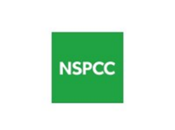

Call NSPCC on 0808 800 5000 if you’re worried about the safety of a child. Or call the police on 999 if you think a child is in immediate danger.



Mind's [Action for Children](https://minds.actionforchildren.org.uk/self-esteem) around self esteem and helping your child. Parents with Confidence help your child to emotionally regulate.



Free and confidential advice from [Family Lives](https://www.familylives.org.uk/how-we-can-help/confidential-helpline/) on 0808 800 2222 if you’re finding it hard at home with your child and are struggling to cope**.**

[Young Minds](https://youngminds.org.uk/) have a parent’s helpline, information and resources.