3rd March 2023
It has been a busy start to term 4. With pupils having a wide range of learning experiences. Margate was in the National News with an art work by Banksy appearing on a local wall. Our pupils went for a visit and put a new spin on it.
Who’s in the bin?
Today we have celebrated World Book Day with the school getting heavily involved. Each child received a book. All classes read The Hitchhiker by Roald Dahl at the same time throughout the day.
Assembly was lots of fun with pupils in costumes of characters from different Roald Dahl stories.
Winners will be announced next Friday in Assembly. With prizes for –
- Best class- Trophy and Bookshop
- Best dressed teacher prize
- Best dressed staff member prize
Forthcoming Dates
Fri 31st March 2023 last day term 4
Mon 17th April first day term 5
Friday April 28th training day no pupils in
Mon 1st May Bank Holiday
Mon 8th May Kings Coronation
British Values
Attendance
KS4 Art – London Trip
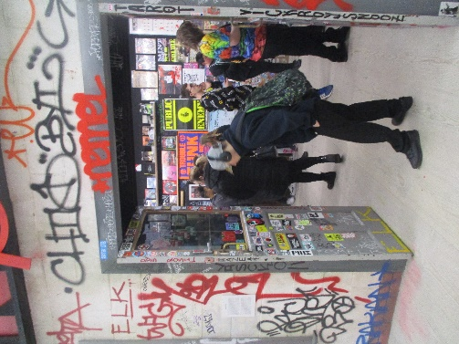
KS4 art students went to see the completely sold-out show at the Saatchi Gallery in London. The exhibition is called 'Beyond the Streets' and was a massive collection of street and graffiti art from across the globe. They had a guided tour and workshop and this is the biggest collection of graffiti and art ever held in the UK! One of the highlights was a record room where you got to choose your own records and play them, another was a street artists bedroom when they were a teenager covered in graffiti letter drawings. This was very inspiring for the students to see! Another highlight was an entire room covered in spray painted and painted neon objects!
When Daniel was asked about the trip his response was ‘awesome’
Olly Participates in Pool Comp
The school’s pool expert Olly participated in his first adult pool competition on Saturday 25th February at Frames. Though he didn’t win he looked very confident playing against adults. Olly started playing in the KS4 Common Room and progressed with enrichment trips to Frames. Who spotted this up and coming talent and are now sponsoring him and providing him with coaching. Watch out for this up and coming pool shark.
Bettshanger Trip
Blyton and Dahl had a great day at Bettshanger, at they played Battlefields in teams (nerf gun attack) and learned archery. Everybody had so much fun (including the adults who were allowed to join in). I’m not sure who enjoyed shooting each other the most- mind you the children took great pleasure in shooting and ambushing adults. The archery was much harder than it looked.
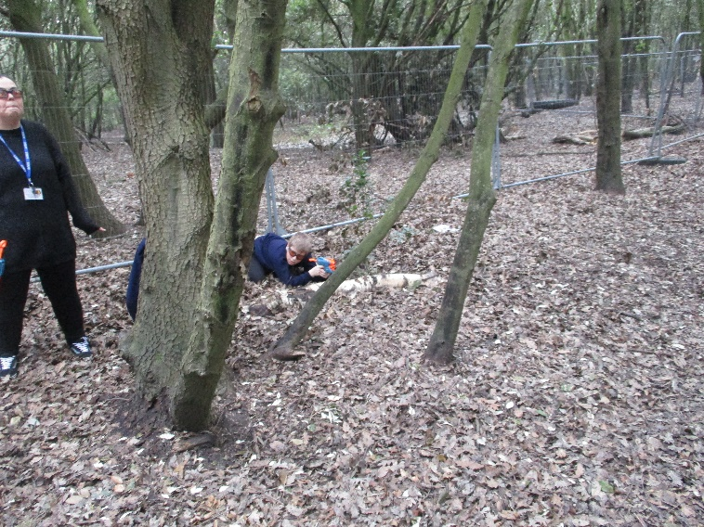
Lo
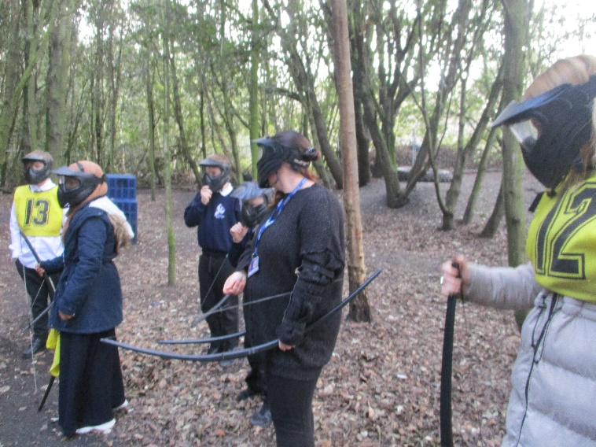
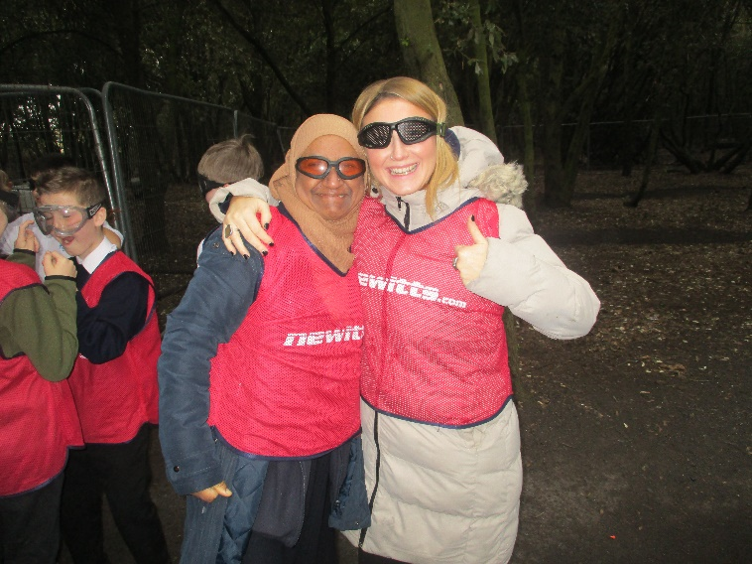
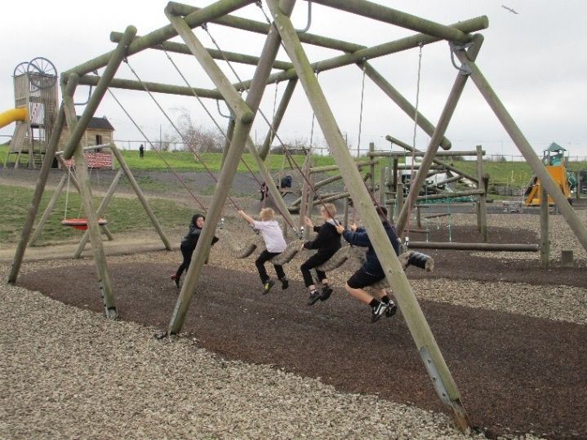
Boonies Assault Course is designed to put you through your paces, with sections constructed especially for military-style fitness (in a fun and engaging way!). But was no problem for Milne Class. Some of the more challenging obstacles include a 6ft wall climb, Vertigo ramp run, the trenches and mud pits
Those looking for an easier option can tackle balance beams; water jumps and rope walks. It’s a true team endeavour and great bonding experience.
Milne class had fab day out even though it was freezing cold, wet and muddy!!!!!!!!!!!!
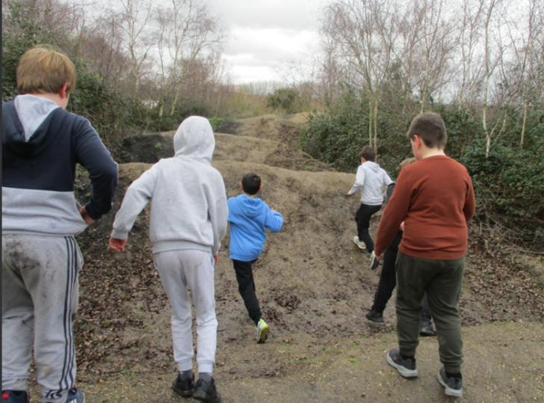
Archery for Milne Class
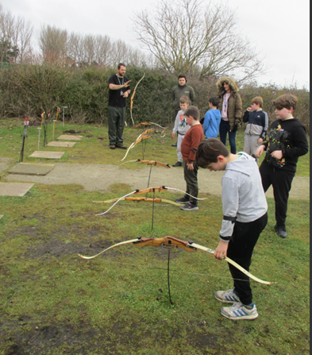

New Addition
Pearl the cat is no longer the only animal at St Anthony’s as we welcomed our 2 new students: Pinky and Perky to Walliams Class.
Strike Day March 2nd
Matchbox Challenge
Could you win our Maths Matchbox Challenge?
Take part in our Easter holiday Maths Matchbox Challenge. It’s easy! All you need to do is fill the matchbox with DIFFERENT items. Then return it to reception, at the latest on 21st April 2023.
More info from Natalie
Discovery Planet – Science Workshops
SPORT FOR FUN –
Saturdays (term time) 9.00 - 10.00 at St Anthony's School. A Saturday morning sports club for children with SEND.
BE ACTIVE -SHORT BREAK - Saturdays (term time) 10.30 - 12.00 at Foreland Fields School
BE ACTIVE -SHORT BREAK - Wednesdays (term time) 4.30 - 6.00 at Foreland Fields School
Please read the PDF letter attached for more information and complete the following referral form to declare interest:
https://forms.office.com/r/EZwuMEZmEd
CLIP N CLIMB - Thursdays Session 1: 4.30-5.30pm Session 2: 5.30-6.30pm.
To book please clink on this link: https://forms.gle/EHYHiAtxWfE3XYDz6
MARGATE YOUTH FC KICKS 4 KIDS - Tuesdays 5.00-5.45 at Margate FC
Inclusive football sessions delivered by Inclusive Sport. To register please visit: https://www.margateyouthfc.co.uk/events/kick-inclusive-football-sessions
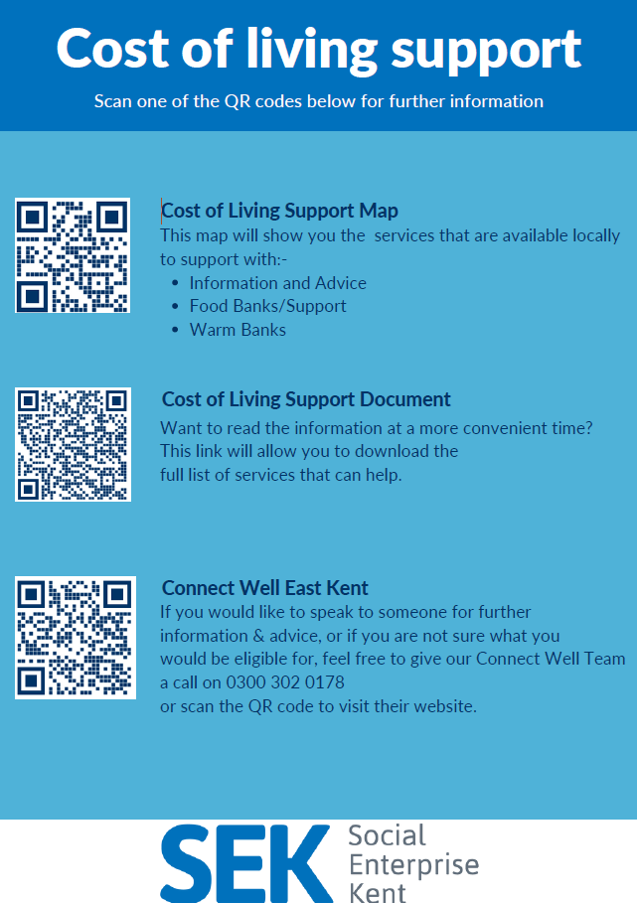
Cost of Living Support
With the pressures of costs around us there is a number of services that can support. If you are having troubles please contact them direct or come and talk with us.
A link below is Thanet councils community hub which can sign post to a range of support functions.
https://www.thanet.gov.uk/info-pages/covidcommunityadvice/
DWP - Outreach sessions for families
Outreach sessions are being held in local venues. Support on hand includes, benefit
advice, childcare choices and cost, finding work, cost of living, housing and any queries that our work coach can support the family with.
Ramsgate – The Priory Children’s Centre, Cannon Rd, Ramsgate CT11 9SQ
Outreach available every Wednesday between 9am to 12noon To book a slot to see our adviser at the Priory Children Centre in Ramsgate please contact
jayne.conroy@dwp.gov.uk

Margate – Six Bells Children Centre, 201 High St, Margate CT9 1WH
Outreach available every Monday between 1pm to 4pm To book a slot to see our adviser at the Six Bells in Margate please contact
philip.raeburn@dwp.gov.uk or anita.taylor@dwp.gov.uk
Royal British Legion - Energy Support
The Royal British Legion, the UK's largest charity dedicated to supporting the Armed Forces community, has today launched a new grant scheme for veterans and their families who are struggling to pay their energy bills. The initiative will provide non-repayable emergency grants of up to £2,400 a year (£200 a month) and is available across the UK.
In general, the Armed Forces community includes those who have served, or are serving, in the Royal Navy, British Army or Royal Air Force, as well as their families, dependants and carers – which can include children, current and former spouses and partners, widows and widowers.
To apply it's worth checking your eligibility on its website or by calling its helpline on 0808 802 8080.
Visit Kent Resilience Hub where you can increase your understanding, find approaches and tools or navigate your way to support and services relating to resilience and emotional wellbeing.
Kooth online support and counselling for 10-25 year olds across Kent and Medway. Offering 1-2-1 counselling, helpful articles, community discussion boards and daily journals.
MindEd is a free educational resource on children and young people's mental health for all adults.
Find out how to tackle hate online and online trolls with internet matters advice guide for what online hate is and how to support your child. Get tools and tips to support your child’s digital wellbeing on Facebook, Instagram and WhatsApp.
Call NSPCC on 0808 800 5000 if you’re worried about the safety of a child. Or call the police on 999 if you think a child is in immediate danger.
Mind's Action for Children around self esteem and helping your child. Parents with Confidence help your child to emotionally regulate.
Free and confidential advice from Family Lives on 0808 800 2222 if you’re finding it hard at home with your child and are struggling to cope.
Young Minds have a parent’s helpline, information and resources.

