4th March 2022 Newsletter

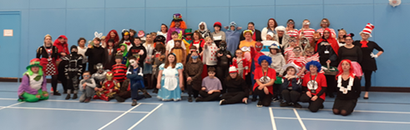
World Book Day 2022

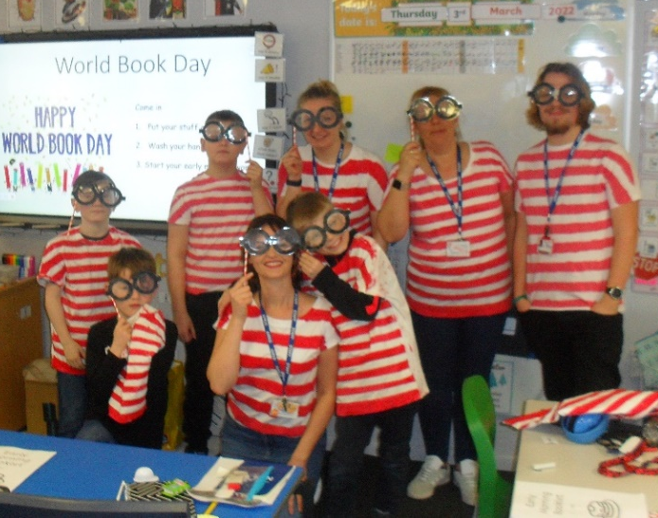
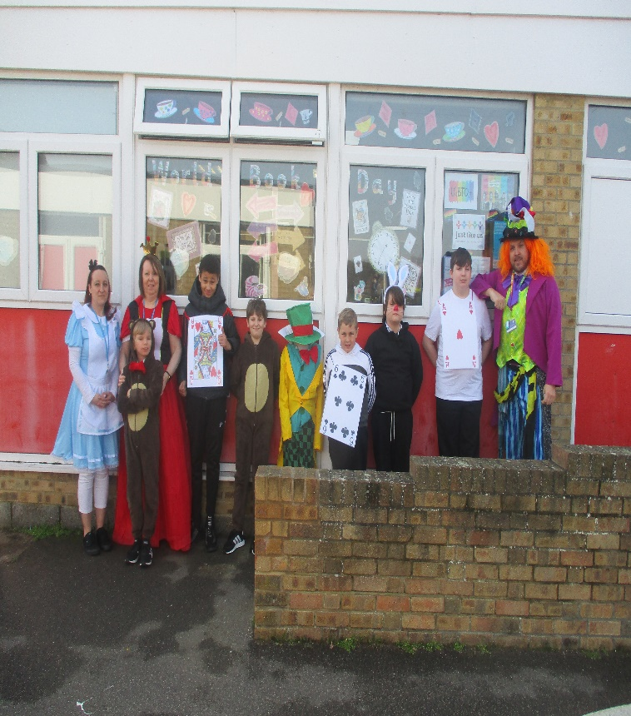
We celebrated the joys of books on
World Book Day 2022. It started with
a magical bang for KS2 pupils as we had
a magician in school, who entertained
classes with his amazing tricks!
Milton Class went down the rabbit hole
with their amazing class dress-up and
our senior leadership team were a rather
red, traditional tale, all being characters
from Little Red Riding Hood.
This year was, as always a great day
and all pupils received a free WBD book
and had lots of fun. Thank you to all
parents and carers for supporting this
event. Blyton Class
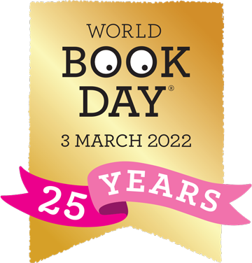

Milne Class

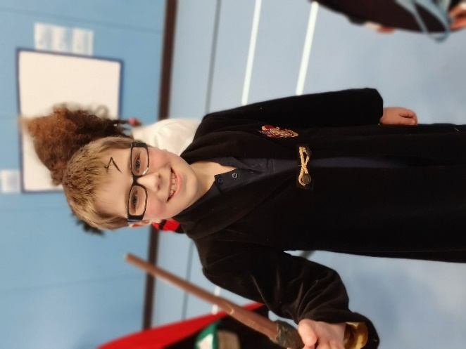
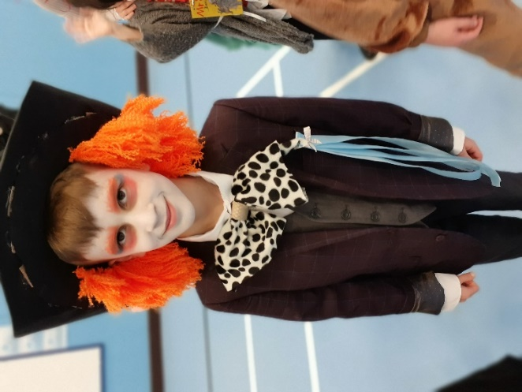
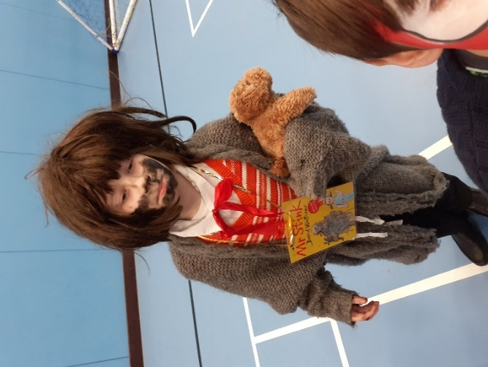

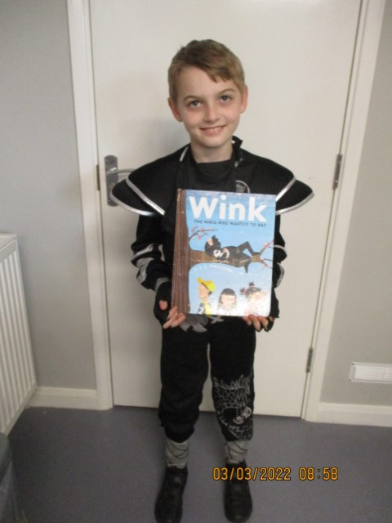
Vincent – Mr Stink Rayven – Harry Potter Matthew – The Mad Hatter
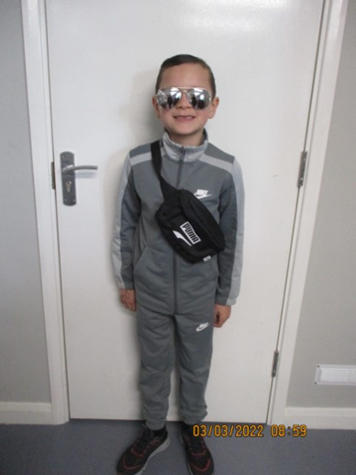
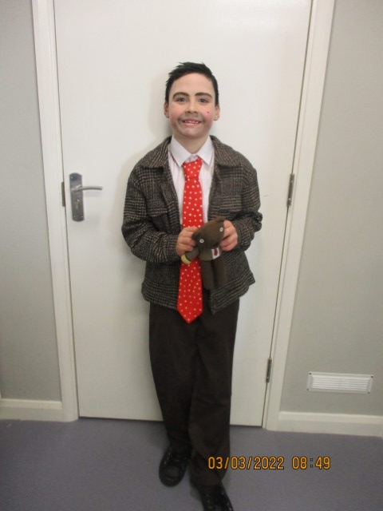
Leo – Mr Bean Logan – Stormzy Blaine – Wink the Ninja

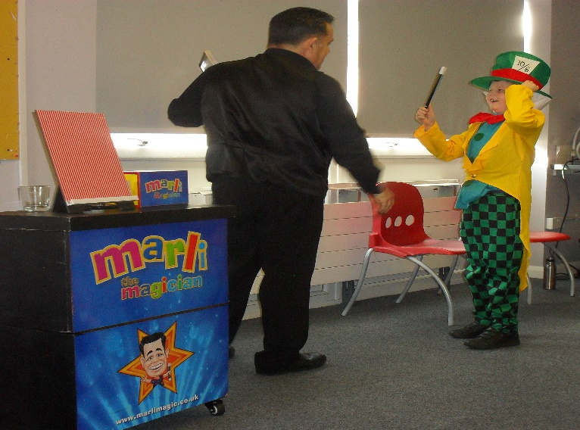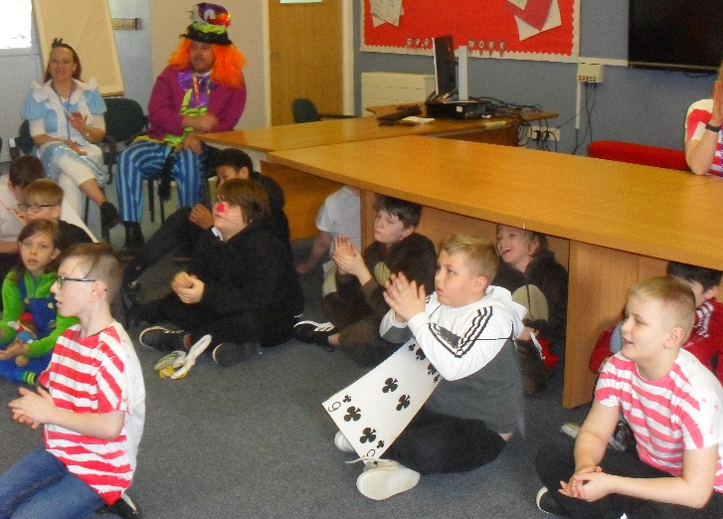

Ukraine
I am sure that, like me, you will have been closely watching the news from Ukraine over the last week or so. There is no doubt that it is a deeply worrying situation, and it has been awful to watch the impact on families and children in particular.
I have highlighted below some resources from BBC Newsround that may be useful when dealing with this issue, particularly with younger children – and Place2Be also have some expert advice to offer.
We are having a collection to support the children and families who have had to leave their homes due to the conflict.

- Advice for Children Upset about the news
https://www.bbc.co.uk/newsround/13865002?utm_campaign=2370281_NAHT%20News%202%20March%202022&utm_medium=email&utm_source=National%20Association%20of%20Head%20Teachers&dm_i=3OT7,1ESX5,1D7VEE,55G2G,1
- Newsround CBBC
https://www.bbc.co.uk/newsround
- Place2Be’s educational psychologists have also shared advice about how to discuss war and conflict with children and young people – and how you can best support them at this difficult and worrying time
https://www.place2be.org.uk/about-us/news-and-blogs/2022/march/talking-to-children-and-young-people-about-war-and-conflict/?utm_campaign=2370281_NAHT%20News%202%20March%202022&utm_medium=email&utm_source=National%20Association%20of%20Head%20Teachers&dm_i=3OT7,1ESX5,1D7VEE,55K6N,1
We are collecting -
- Tinned/packs of food
- Toothpaste
- Sanitary products
- Nappies
- Cat/dog food
- Or £1 or £2
Please bring in any items you wish to dontate and we will send off on Thursday 10th 2022.
KSENT Performance 4th March
Today St Anthony’s School Choir is working together with other KSENT Schools, to perform in the much anticipated 'Living the Dream' Production. Our students have been working extremely hard and against the odds (Covid infections), to have perfected a number of songs which they will perform throughout the show. Kaitlin, Ellie, Ryan, Christian and Kate are all looking forward to the performance and this week will see them putting the finishing touches and polishing their routines. I am sure you will wish them all the very best! More news in the next newsletter with photos. – Colin Lawton, Enrichment

School Transport
Some of you will be aware of the current difficulties in home to school transport to start the new term. An increase in demand for home to school transport of 20% led to a retendering of contracts to create more capacity in a sector, which has experienced a significant reduction in the workforce. The time taken to complete this complex task was underestimated and the KCC Transport Team are still working on procuring transport for a small cohort of children and young people. They have been encouraging families to make their own transport arrangements and they will be reimbursed.
The school was not made of the situation which has made a challenging situation more difficult. I think we have been in touch with all our families if not please contact the school we are working with KCC to sort.
Thank you for your patience and understanding.

World Sleep Day is coming up soon on the 18th March 2022. We are aware of the high number of pupils with sleep difficulties so to celebrate and raise awareness of World Sleep Day, I would like to share some information about the importance of sleep and some tips for healthy sleep in children.

Why is sleep so important?
Sleep is vital for maintaining a child’s physical and mental wellbeing. Although a good night’s sleep can be difficult for some children and young people, it can be supported by having a consistent relaxing bedtime routine in place.

The amount of sleep that children need varies, so it is important to be aware of the
recommended amount of sleep for each age group. For example, a child between 6-12
years of age will need 9-12 hours, whereas, a 13-18 year old will only need 8-10.
Making bedtime a positive experience. For example, associating it with a bedtime
story or a relaxing podcast for older children.
• Minimising screen time at least an hour before bedtime or using night time settings
on devices.
• An optimum bedroom temperature of between 16-20C.
• A dark or dimly light room to increase the natural production of melatonin (sleep
hormone).

A Good Night’s Sleep: Learning About Sleep From Autistic Adolescents’ Personal Accounts
https://www.frontiersin.org/articles/10.3389/fpsyg.2020.583868/full
https://worldsleepday.org/tips-for-children

Emotional Well Being Team

My name is Amy and I am the Emotional Wellbeing Practitioner at St Anthony’s school. I form part of the Emotional Well Being Team working across Thanet offering mental health support in schools. I am employed by the NHS and I will be working in school on Mondays to support the whole school with a focus on well-being. I look forward to meeting you!

Dates
- Monday 14th March – Training Day (no pupils)
- Friday 18th March – Red Nose Day non-uniform
- Friday 1st April – Last day term 4 early finish

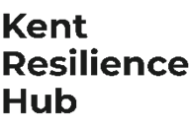
Visit Kent Resilience Hub where you can increase your understanding, find approaches and tools or navigate your way to support and services relating to resilience and emotional wellbeing.
Kooth online support and counselling for 10-25 year olds across Kent and Medway. Offering 1-2-1 counselling, helpful articles, community discussion boards and daily journals.
MindEd is a free educational resource on children and young people's mental health for all adults.

Find out how to tackle hate online and online trolls withinternet matters advice guide for what online hate is and how to support your child. Get tools and tips to support your child’s digital wellbeing on Facebook, Instagram and WhatsApp.
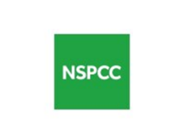
Call NSPCC on 0808 800 5000 if you’re worried about the safety of a child. Or call the police on 999 if you think a child is in immediate danger.
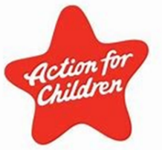
Mind's Action for Children around self esteem and helping your child. Parents with Confidence help your child to emotionally regulate.
Free and confidential advice from Family Lives on 0808 800 2222 if you’re finding it hard at home with your child and are struggling to cope.
Young Minds have a parent’s helpline, information and resources.

