Newsletter 11th November 2022
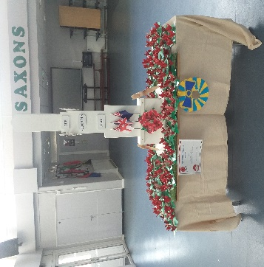
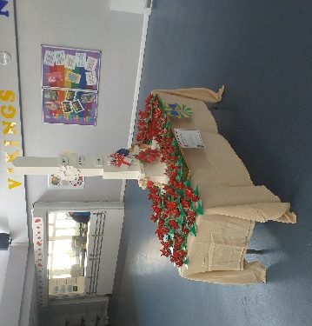
This morning we had a Remember assembly lead by Blyton and Dahl classes. We then came together as a whole school, in honour of Remembrance Day, for a two-minute silence. Students is Key Stage Design and Technology made a model Cenotaph, which was the centre piece for our gathering. Each class made individual Poppy Projects to go on the display with the cenotaph. KS4 DT students include Jayden, Ryan, Ty, Taylor, Kaleb and Damien, who did a fantastic job with support and guidance from Kevin and Trevor our DT Teacher and Technician.

Lampard Class
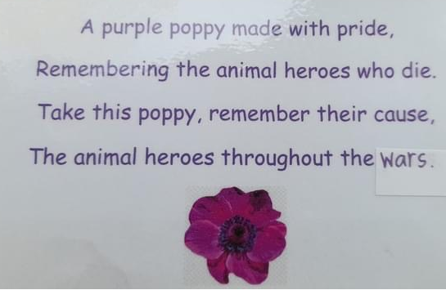
For Remembrance Day, Lampard Class decided to take part in 'Random Acts of Kindness' by leaving crochet purple poppies in St. Peters and Cliftonville for people to find and keep. Lampard class worked as a team to hide the bagged up poppies and enjoyed the dry weather. Although Lampard Class did not win the overall class competition of creating something for Remembrance Day, they did receive recognition within the wider community, from a local lady who found one.

Fantastic Fred
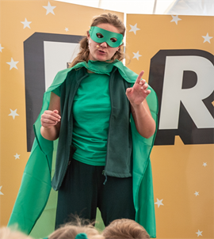
On the 3rd November, Fantastic FRED & the Professor visited us, and they had a great time with some of our classes. They left us thinking about some important messages around looking after ourselves and looking after our mental health, especially the ones about Dolphins!
Below is a link to a video they left us. It contains a summary of what the children learnt and helps to communicate the messages in a fun and engaging way so that the learning can continue at home too!
www.thefantasticfredexperience.com/for-parents-guardians
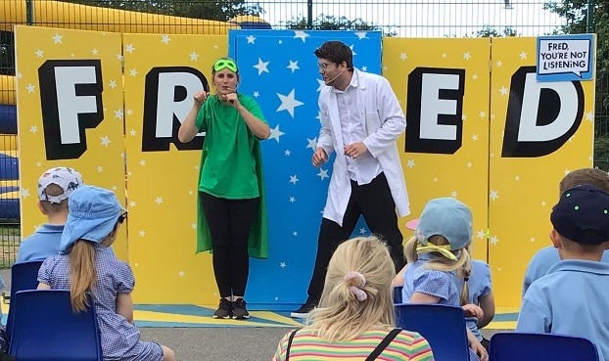
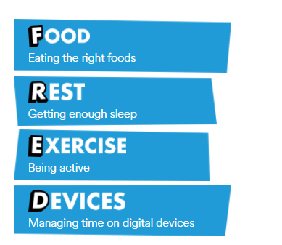

Ramsgate Tunnels
As part of the school’s Global Studies curriculum classes have been visiting Ramsgate Tunnels this term, to learn about the exciting local history of Thanet. Pupils have been captivated by the visits telling me a wide range of facts they have learnt about the tunnels.
This week l received an email about Potter Class’s visit

Yesterday I had the pleasure of leading a tour of the Ramsgate war tunnels for a group of your primary students.
I want to tell you they were a real credit to your school. They were very well behaved and polite. Please pass on our thanks to them.
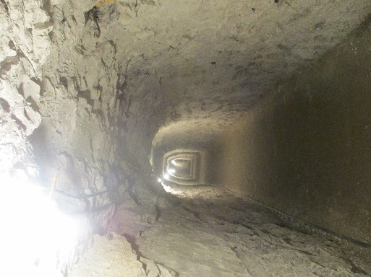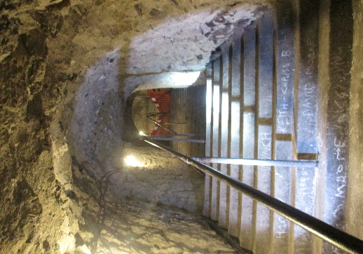
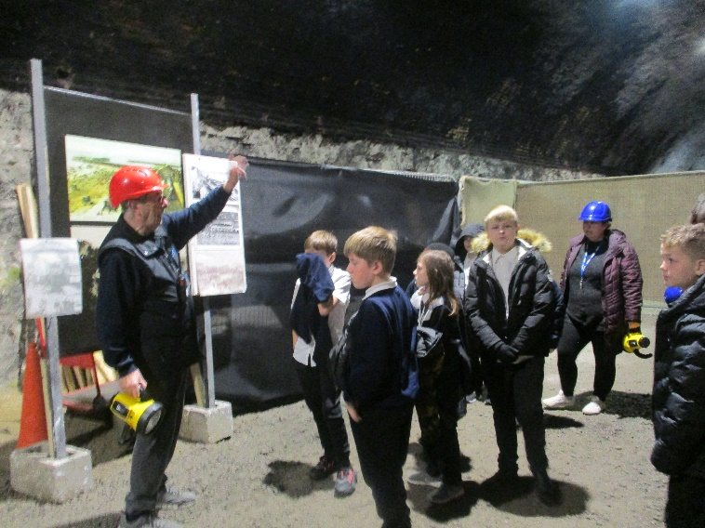
Gravity Cowell
Cowell class went to Gravity in Maidstone on Friday 4th November as a reward for their good behaviour last term. They thoroughly enjoyed themselves on the trampolines and had a flipping good time. It was bounce-tastic! It was so much fun we even forgot to take a photo!

PC Cleaver
PC Cleaver who has been working in the school for the past 18 months has sadly been reassigned posts. This is disappointing as having a direct link to Kent Police was very helpful for pupils and staff. We understand that later this month Kent Police will be launching the consultation process for a new neighbourhood policing model which will involve the school officer’s team. So watch this space
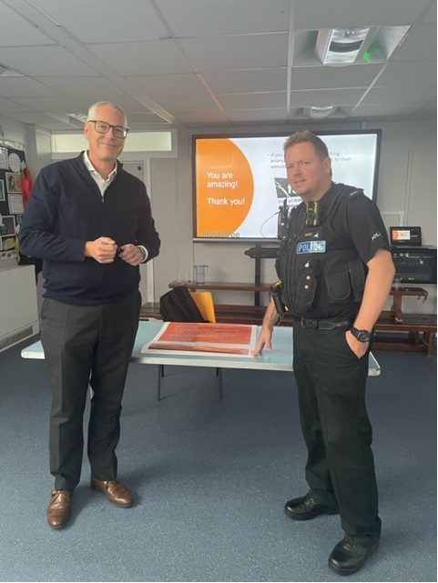
PC Cleaver and Mr Page signing the school pledge to reduce Violence.
Online Safety
This year we have been dealing with some situations in school between students, which have manifested online. We would like to take this opportunity to ask you to monitor your child’s online presence, talk to them about their online activity and how to be kind and safe whilst online. There are lots of useful resources that can assist you with this such as:
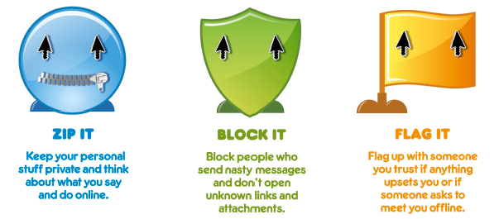
Information, Advice and Support to Keep Children Safe Online (internetmatters.org)

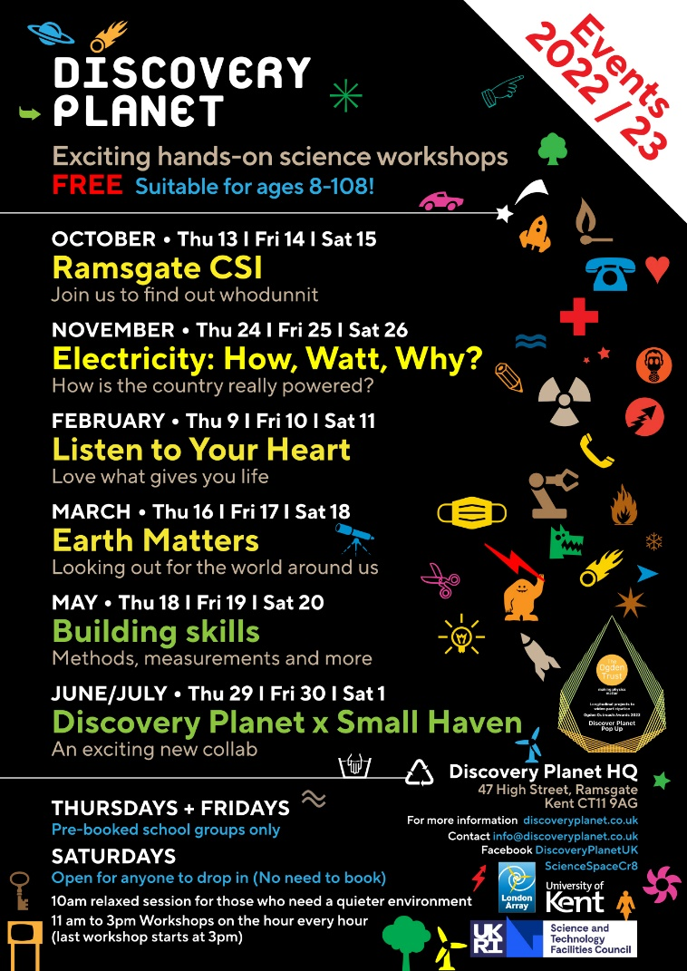
SPORT FOR FUN –
Saturdays (term time) 9.00 - 10.00 at St Anthony's School. A Saturday morning sports club for children with SEND.
BE ACTIVE -SHORT BREAK - Saturdays (term time) 10.30 - 12.00 at Foreland Fields School
BE ACTIVE -SHORT BREAK - Wednesdays (term time) 4.30 - 6.00 at Foreland Fields School
Please read the PDF letter attached for more information and complete the following referral form to declare interest:
https://forms.office.com/r/EZwuMEZmEd
CLIP N CLIMB - Thursdays Session 1: 4.30-5.30pm Session 2: 5.30-6.30pm. Due to restart Thursday 29th September.
A Clip n Climb session for children with SEND
To book please clink on this link: https://forms.gle/EHYHiAtxWfE3XYDz6
MARGATE YOUTH FC KICKS 4 KIDS - Tuesdays 5.00-5.45 at Margate FC
Inclusive football sessions delivered by Inclusive Sport.
To register please visit: https://www.margateyouthfc.co.uk/events/kick-inclusive-football-sessions
Please visit our website where you can view all our sessions in all areas
Book Online - Inclusive Sport
Visit Kent Resilience Hub where you can increase your understanding, find approaches and tools or navigate your way to support and services relating to resilience and emotional wellbeing.
Kooth online support and counselling for 10-25 year olds across Kent and Medway. Offering 1-2-1 counselling, helpful articles, community discussion boards and daily journals.
MindEd is a free educational resource on children and young people's mental health for all adults.
Find out how to tackle hate online and online trolls with internet matters advice guide for what online hate is and how to support your child. Get tools and tips to support your child’s digital wellbeing on Facebook, Instagram and WhatsApp.
Call NSPCC on 0808 800 5000 if you’re worried about the safety of a child. Or call the police on 999 if you think a child is in immediate danger.
Mind's Action for Children around self esteem and helping your child. Parents with Confidence help your child to emotionally regulate.
Free and confidential advice from Family Lives on 0808 800 2222 if you’re finding it hard at home with your child and are struggling to cope.
Young Minds have a parent’s helpline, information and resources.

