**Newsletter 16th September 2022**

Welcome back to school. We hope that you all enjoyed the summer holidays. The first two weeks of term have really flown by, with pupils settling into new classes, meeting new classmates and learning the routines of school life. Generally a very positive start to the term from my point of view.

If you have any questions or issues please do speak with school, first point of contact is the class teacher but l am also always available either on the gate or by phone.



Following the sad passing of Her Majesty Queen Elizabeth II, we at St Anthony’s reflect upon her inspirational legacy of a selfless sense of duty, commitment, and wisdom through 70 years of public service. We send our sincere condolences to The Royal Family. In carrying out Her duties, the late Queen faithfully led by example, role modelling all the values asked of us as, with the best interests of her people her aims and objectives.   
  
The Government has declared the 19 September 2022 as a bank holiday **St Anthony’s** will be closedon **Monday 19th Septmber** as a result, school will return Tuesday as per normal.

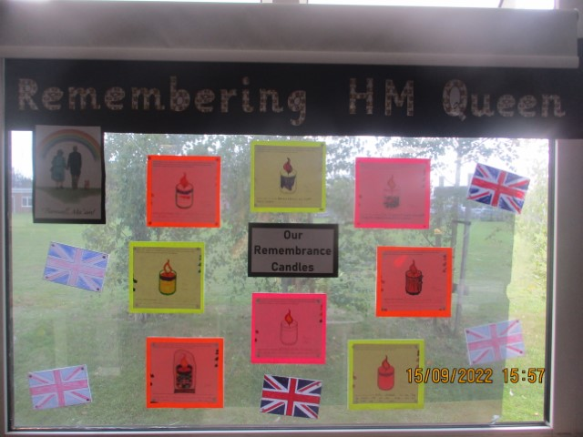

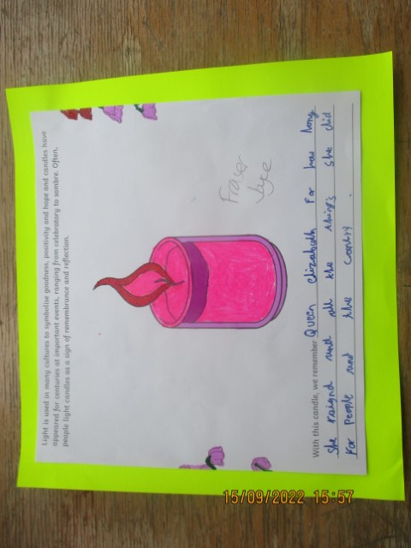

Rowling class created remembrance display and they have been watching Newsround and keeping up to date with the current events. They we have talked about Queen Elizabeth's 70-year reign and discussed emotions surrounding her death and how people are paying respect around the world. On Friday afternoon, Rowling will be having a small tea party to celebrate the life of the Queen.

**Parent Governor**

St Anthony’s currently has a vacancy for a parent governor.

Together with the Headteacher, the Governing Body has overall responsibility for the running of the school; amongst its many duties Governors are involved in deciding school policies, allocating the school’s budget and appointing senior staff.

The Governing Body has 3 core functions:

* Ensuring clarity of vision, ethos and strategic direction;
* Holding executive leaders to account for the educational performance of the organisation and its pupils, and the effective and efficient performance management of staff;
* Overseeing the financial performance of the organisation and making sure its money is well spent**.**

Governors meet as a full board 6 times a year, usually on a Tuesday at 3pm. There is also an expectation that governors can visit the school, during the school day, by arrangement with school staff. Training can be provided and governors are required to attend induction training and additional training as required.

If you are interested in this role please contact me. [Robert.page@st-anthonys.kent.sch.uk](mailto:Robert.page@st-anthonys.kent.sch.uk)



**SPORT FOR FUN** –

Saturdays (term time) 9.00am - 10.00am at   
St Anthony's School. A Saturday morning sports club for children with SEND.

Sport For Fun- Mild/Moderate needs children (5 - 16yrs) at St. Anthony's, Margate | Inclusive Sport | Powered by ClassForKids (class4kids.co.uk )

BE ACTIVE -SHORT BREAK - Saturdays (term time) 10.30 - 12.00 at Foreland Fields School

BE ACTIVE -SHORT BREAK - Wednesdays (term time) 4.30 - 6.00 at Foreland Fields School

Please read the PDF letter attached for more information and complete the following referral form to declare interest:

<https://forms.office.com/r/EZwuMEZmEd>



**CLIP N CLIMB** - Thursdays Session 1: 4.30-5.30pm Session 2: 5.30-6.30pm. Due to restart Thursday 29th September.

A Clip n Climb session for children with SEND

To book please clink on this link: <https://forms.gle/EHYHiAtxWfE3XYDz6>

**MARGATE YOUTH FC KICKS 4 KIDS** - Tuesdays 5.00-5.45 at Margate FC

Inclusive football sessions delivered by Inclusive Sport.

To register please visit: <https://www.margateyouthfc.co.uk/events/kick-inclusive-football-sessions>

Please visit our website where you can view all our sessions in all areas

Book Online - Inclusive Sport

**Coffee ‘n Chat**



Come and join us if you can!

**Flu Vaccination – Thursday 29th September**

Flu can be an unpleasant illness and can cause serious complications. Vaccinating your child will help protect them and more vulnerable family and friends by preventing the spread of flu.

The Kent and Medway School Immunisation Service will be visiting St Anthony’s on **Thursday 29th Sept’**

**Please complete the online form before 21st September to either consent or decline the vaccination at** [**www.kentcht.nhs.uk/imms**](http://www.kentcht.nhs.uk/imms)

If your child is away on this day, you can contact your GP to arrange the vaccination through them at a time suitable to you.

**Attendance Matters!**

St Anthony's School is committed to raising standards and achievement in all aspects of your child's education. We recognise that high levels of student attendance is closely linked to academic success.

As a result, we set a minimum target of **(95%)** attendance for all our students.

We have a **reward system** in place, which recognises those students who attend school consistently.

More details about the Attendance Reward Scheme will be made available this term.

We would like to work with you in maintaining the best possible attendance record for your child and we will be monitoring student attendance closely over the forthcoming months. If we can assist you, or if you have any questions, please do not hesitate to contact us. We look forward to reporting an improvement in the near future.

Thank you for your support and cooperation in this matter.

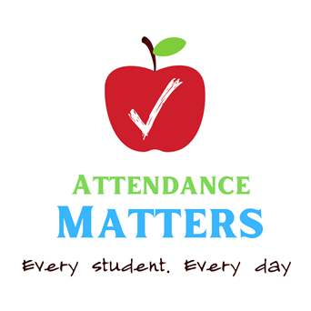



Visit [Kent Resilience Hub](https://kentresiliencehub.org.uk/) where you can increase your understanding, find approaches and tools or navigate your way to support and services relating to resilience and emotional wellbeing.



[Kooth online](https://www.kooth.com/) support and counselling for 10-25 year olds across Kent and Medway. Offering 1-2-1 counselling, helpful articles, community discussion boards and daily journals.



[MindEd](https://www.minded.org.uk/) is a free educational resource on children and young people's mental health for all adults.



Find out how to tackle hate online and online trolls with internet matters advice guide for what [online hate](https://www.internetmatters.org/resources/tackling-online-hate-and-trolling/) is and how to support your child. Get tools and tips to support your child’s [digital wellbeing](https://www.internetmatters.org/?gclid=EAIaIQobChMIrbTX5_bt7AIVRuztCh33bQH_EAAYASAAEgLtifD_BwE) on Facebook, Instagram and WhatsApp.

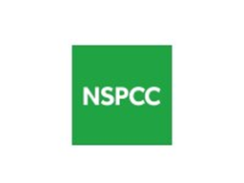

Call NSPCC on 0808 800 5000 if you’re worried about the safety of a child. Or call the police on 999 if you think a child is in immediate danger.



Mind's [Action for Children](https://minds.actionforchildren.org.uk/self-esteem) around self esteem and helping your child. Parents with Confidence help your child to emotionally regulate.



Free and confidential advice from [Family Lives](https://www.familylives.org.uk/how-we-can-help/confidential-helpline/) on 0808 800 2222 if you’re finding it hard at home with your child and are struggling to cope**.**[Young Minds](https://youngminds.org.uk/) have a parent’s helpline, information and resources.