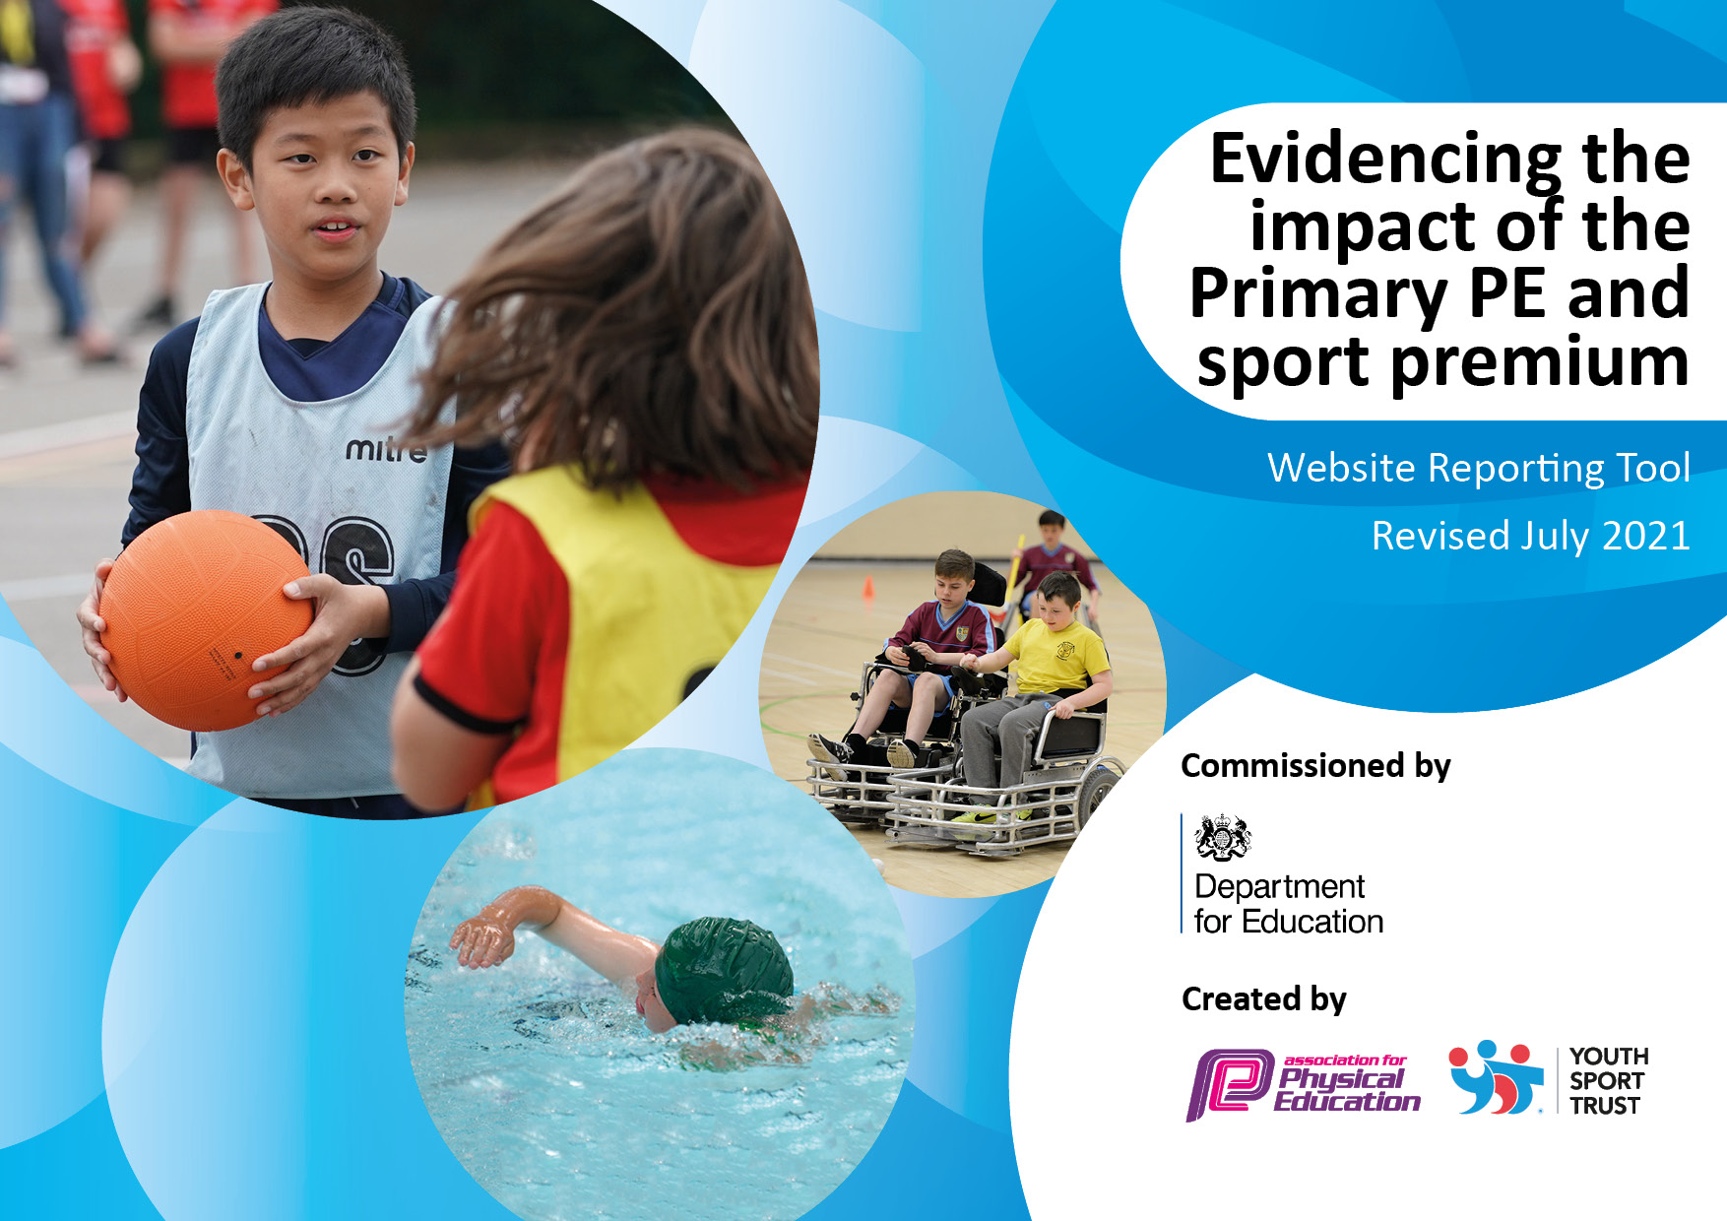
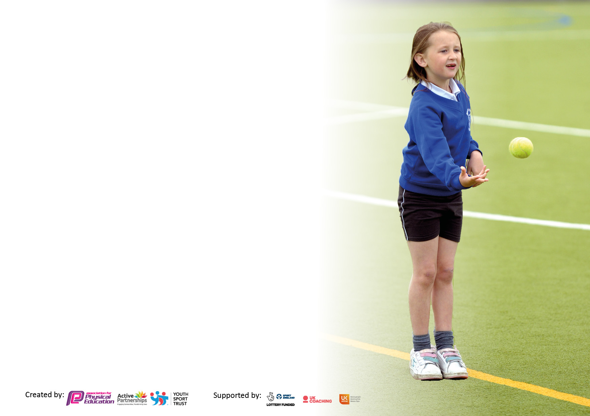

It is important that your grant is used effectively and based on school need. The Education Inspection Framework makes clear there will be a focus on ‘whether leaders and those responsible for governors all understand their respective roles and perform these in a way that enhances the effectiveness of the school’.

Under the Quality of Education Ofsted inspectors consider:
Intent - Curriculum design, coverage and appropriateness
Implementation - Curriculum delivery, Teaching (pedagogy) and Assessment
Impact - Attainment and progress

To assist schools with common transferable language this template has been developed to utilise the same three headings which should make your plans easily transferable between working documents.

Schools must use the funding to make additional and sustainable improvements to the quality of Physical Education, School Sport and Physical Activity (PESSPA) they offer. This means that you should use the Primary PE and sport premium to:

- Develop or add to the PESSPA activities that your school already offer
- Build capacity and capability within the school to ensure that improvements made now will benefit pupils joining the school in future years
- The Primary PE and sport premium should not be used to fund capital spend projects; the school’s budget should fund these.

Pleasevisitgov.ukfortherevisedDfEguidanceincludingthe5keyindicatorsacrosswhichschoolsshoulddemonstrate animprovement.Thisdocumentwillhelpyoutoreviewyourprovisionandtoreportyourspend.DfEencouragesschools to use this template as an effective way of meeting the reporting requirements of the Primary PE and sport premium.

We recommend you start by reflecting on the impact of current provision and reviewing the previous spend.

Schools are required to publish details of how they spend this funding, including any under-spend from 2019/2020, as well as on the impact it has on pupils’ PE and sport participation and attainment. All funding must be spent by 31st July 2022.

We recommend regularly updating the table and publishing it on your website throughout the year. This evidences your ongoing self-evaluation of how you are using the funding to secure maximum, sustainable impact. Final copy must be posted on your website by the end of the academic year and no later than the 31st July 2021. To see an example of how to complete the table please click HERE.

Details with regard to funding
Please complete the table below.

Total amount allocated for 2022/23 | £16000
Spent and reported on by 31st July 2023. | £15287
Swimming Data
Please report on your Swimming Data below.

Meeting national curriculum requirements for swimming and water safety.  N.B. Complete this section to your best ability. For example you might have practised safe self-rescue techniques on dry land which you can then transfer to the pool when school swimming restarts.  Due to exceptional circumstances priority should be given to ensuring that pupils can perform safe self rescue even if they do not fully meet the first two requirements of the NC programme of study | Swimming will be restarting in 2023-24 for primary pupils.  COVID impacted our swimming lesson and then a change of PE teacher part way through the school year swimming was put off,
What percentage of your current Year 6 cohort swim competently, confidently and proficiently over a distance of at least 25 metres?  N.B. Even though your pupils may swim in another year please report on their attainment on leaving primary school at the end of the summer term.  Please see note above | Not sure
What percentage of your current Year 6 cohort use a range of strokes effectively [for example, front crawl, backstroke and breaststroke]?  Please see note above | Not sure
What percentage of your current Year 6 cohort perform safe self-rescue in different water-based situations? | Not sure
Schools can choose to use the Primary PE and sport premium to provide additional provision for swimming but this must be for activity over and above the national curriculum requirements. Have you used it in this way? | No

Action Plan and Budget Tracking
Capture your intended annual spend against the 5 key indicators. Clarify the success criteria and evidence of impact that you intend to measure to evaluate for pupils today and for the future.

Academic Year: 2022/23 | Total fund allocated: £16000 | £15287
Key indicator 1: The engagement of all pupils in regular physical activity – Chief Medical Officers guidelines recommend that primary school pupils undertake at least 30 minutes of physical activity a day in school
Intent | Implementation |  | Impact
To maximise participation in PE. | Increase the range of sports delivered in school and quality of resources:  - Dodgeball  - athletics  - Field events | £ 653.00 | 90% of pupils are taking part in most activities
To maximise participation in PE. | Increase the range of sports delivered in school and quality of resources:  - archery | £295.00 | 90% of pupils are taking part in most activities
To maximise participation in PE. | Increase the range of sports delivered in school and quality of resources:  - triple jump | £809.00 | 90% of pupils are taking part in most activities
To ensure continuity in delivering the curriculum. | Specialist staff to cover gap before recruitment of replacement PE teacher. | £6540 | Lessons continue for all pupils.
Key indicator 2: The profile of PESSPA being raised across the school as a tool for whole school improvement
Intent | Implementation |  | Impact
Delivering activity and sport outside the PE curriculum | Games compendiums | £50 | Engagement in competitive play.
 | Trips and excursions | £500 | Pupils are given the chance to visit local parks, walking, using public play and games areas.

Key indicator 3: Increased confidence, knowledge and skills of all staff in teaching PE and sport
Intent | Implementation |  | Impact
With recruitment of new PE staff this has been deferred until 2034-24.
Key indicator 4: Broader experience of a range of sports and activities offered to all pupils
Intent | Implementation |  | Impact
Use of PE Timetable and outside agencies.  To introduce pupils to new sports and activities. | Liaise with Tom (Inclusive Sport CEO) and have some of his experienced Inclusive Sport Coaches attend sessions in a leading and/or supporting role.  All classes have sessions at Revolution Skatepark  Four sessions at Fowlmead archery | £3447  £775.00  £613.00 | More pupils are introduced to a wider range of activities by creating smaller groups or 1:1 provision.  90% engagement in skate and climb activities.  90% engagement
Key indicator 5: Increased participation in competitive sport
Intent | Implementation |  | Impact
The use of Thanet Inclusive games calendar to engage in competition with other school.  Increase participation on sports day. | We are looking at attending all of the TIG events.  A range of new equipment to facilitate sports day. | £605.00  £1000.00 | St A’s have managed to attend a minimum of 3 events a term.  Whole school participation.
Signed off by
Head Teacher: | R Page
Date: | 1st October 2023
Subject Leader: | Gen Saunders/Antony Curry
Date: | September 2023
Governor:
Date:

