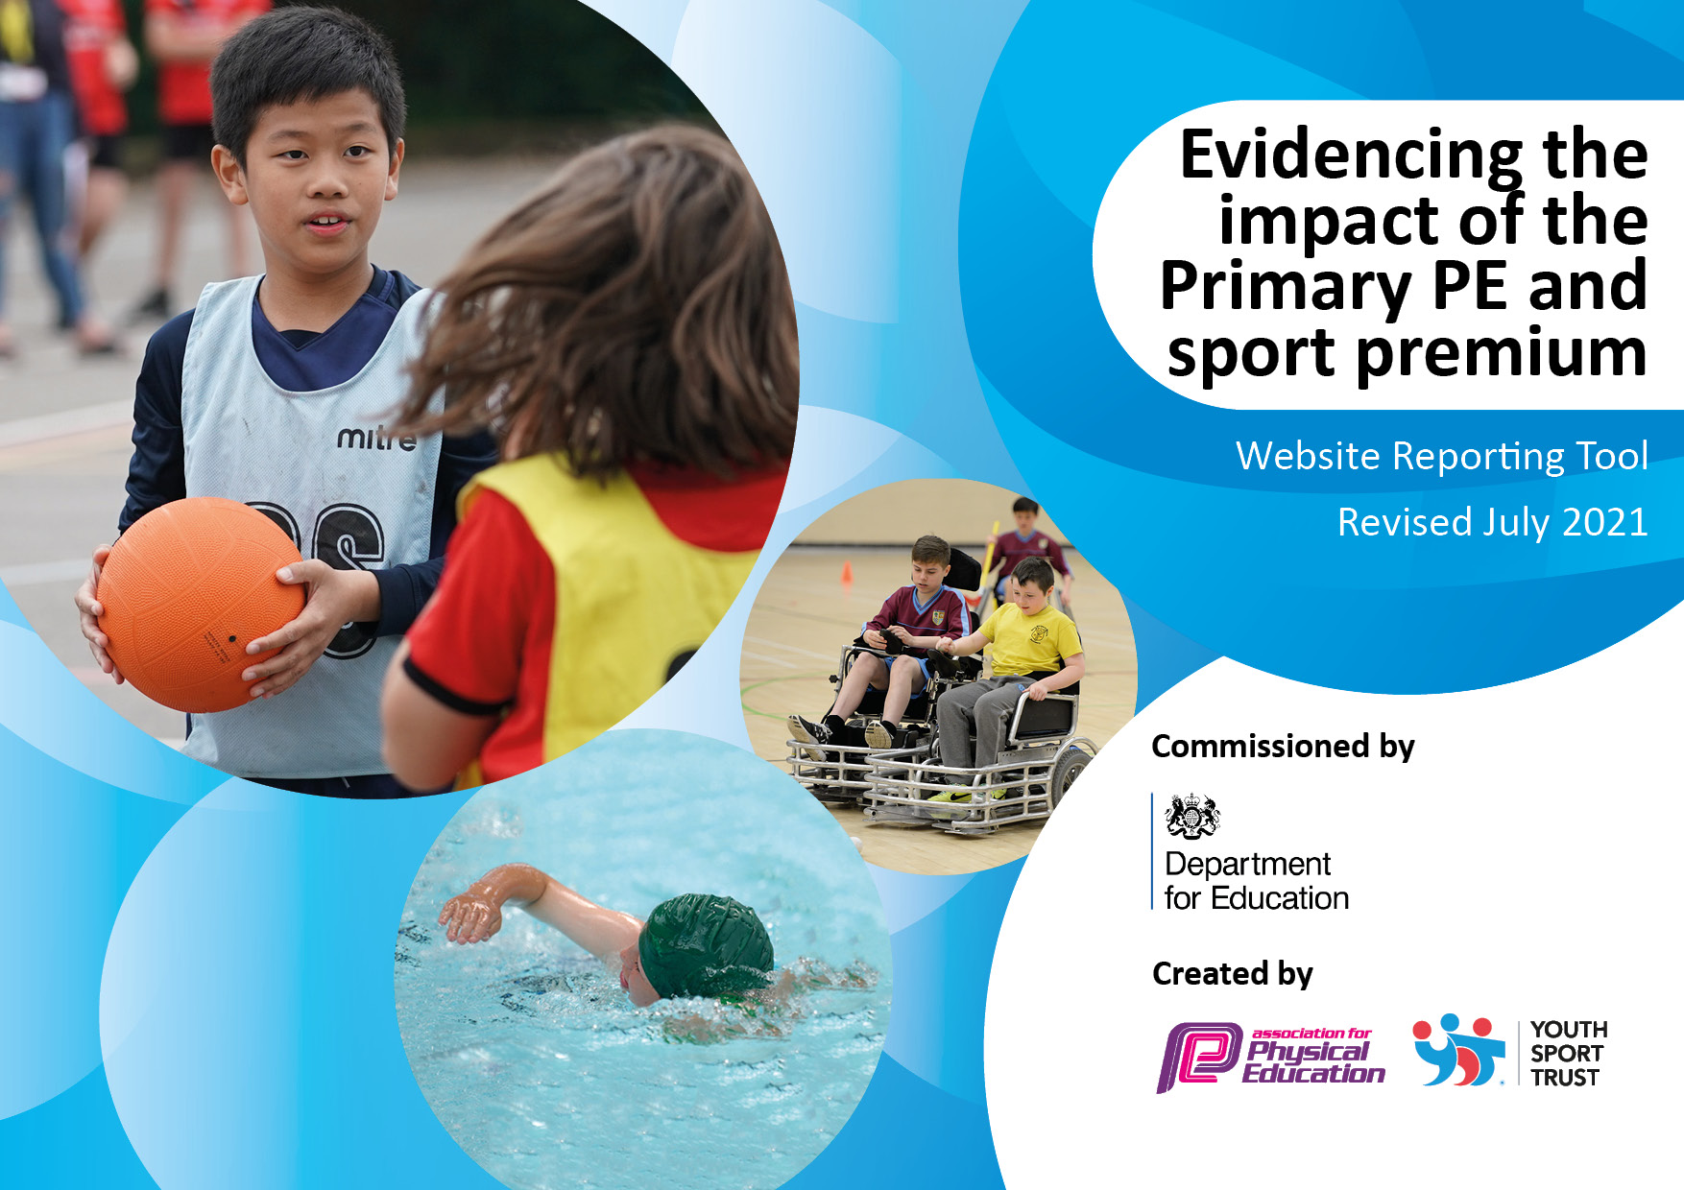
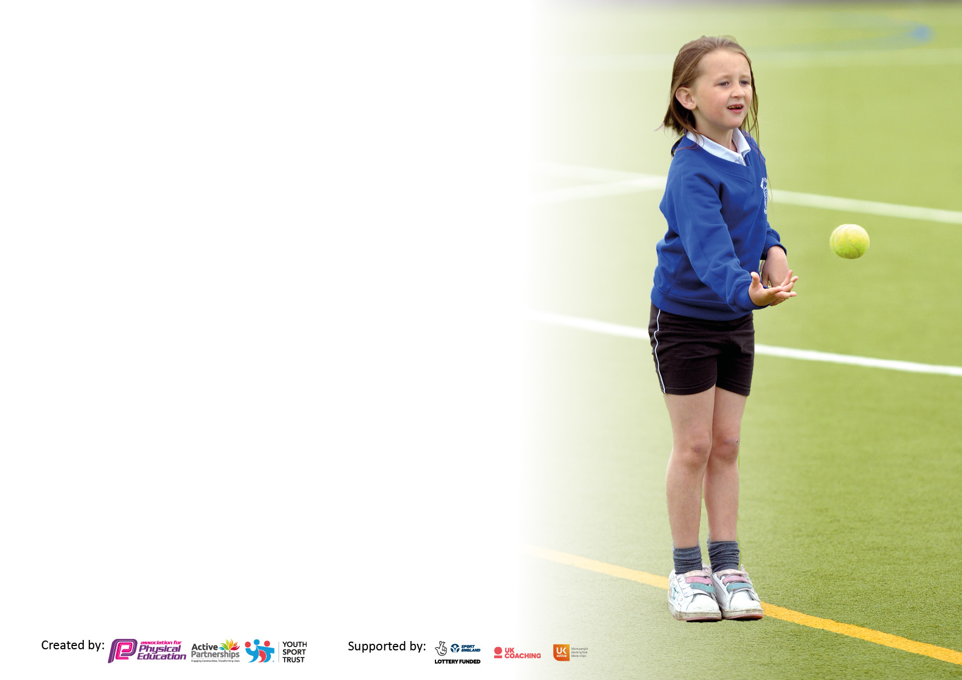

It is important that your grant is used effectively and based on school need. The Education Inspection Framework makes clear there will be a focus on ‘whether leaders and those responsible for governors all understand their respective roles and perform these in a way that enhances the effectiveness of the school’.

Under the Quality of Education Ofsted inspectors consider:
Intent - Curriculum design, coverage and appropriateness
Implementation - Curriculum delivery, Teaching (pedagogy) and Assessment
Impact - Attainment and progress

To assist schools with common transferable language this template has been developed to utilise the same three headings which should make your plans easily transferable between working documents.

Schools must use the funding to make additional and sustainable improvements to the quality of Physical Education, School Sport and Physical Activity (PESSPA) they offer. This means that you should use the Primary PE and sport premium to:

- Develop or add to the PESSPA activities that your school already offer
- Build capacity and capability within the school to ensure that improvements made now will benefit pupils joining the school in future years
- The Primary PE and sport premium should not be used to fund capital spend projects; the school’s budget should fund these.

Pleasevisitgov.ukfortherevisedDfEguidanceincludingthe5keyindicatorsacrosswhichschoolsshoulddemonstrate animprovement.Thisdocumentwillhelpyoutoreviewyourprovisionandtoreportyourspend.DfEencouragesschools to use this template as an effective way of meeting the reporting requirements of the Primary PE and sport premium.

We recommend you start by reflecting on the impact of current provision and reviewing the previous spend.

Schools are required to publish details of how they spend this funding, including any under-spend from 2019/2020, as well as on the impact it has on pupils’ PE and sport participation and attainment. All funding must be spent by 31st July 2022.

We recommend regularly updating the table and publishing it on your website throughout the year. This evidences your ongoing self-evaluation of how you are using the funding to secure maximum, sustainable impact. Final copy must be posted on your website by the end of the academic year and no later than the 31st July 2021. To see an example of how to complete the table please click HERE.


Details with regard to funding
Please complete the table below.

Total amount allocated for 2025/26 | £16000
Spent and reported on by 31st July 2026. | £16000
Swimming Data
Please report on your Swimming Data below.

Meeting national curriculum requirements for swimming and water safety.  N.B. Complete this section to your best ability. For example, you might have practised safe self-rescue techniques on dry land which you can then transfer to the pool when school swimming restarts.  Six sessions of swimming for primary classes | £2500
What percentage of your current Year 6 cohort swim competently, confidently and proficiently over a distance of at least 25 metres? | 20-30%
Schools can choose to use the Primary PE and sport premium to provide additional provision for swimming but this must be for activity over and above the national curriculum requirements. Have you used it in this way?  Kayaking, canoeing, paddle boarding and rafting. | £4000 (as below)

Action Plan and Budget Tracking
Capture your intended annual spend against the 5 key indicators. Clarify the success criteria and evidence of impact that you intend to measure to evaluate for pupils today and for the future.

Academic Year: 2025/26 | Total fund allocated: £16000 | Total Spent £16000
Key indicator 1: The engagement of all pupils in regular physical activity – Chief Medical Officers guidelines recommend that primary school pupils undertake at least 30 minutes of physical activity a day in school
Intent | Implementation |  | Impact
To maximise participation in PE. | Water sports – SUP/Kayaking | £4000 | Having new experiences and developing new skills. The school can provide opportunities that would otherwise not be had by young people.  Experiencing the sea in a different way. Learning to enjoy where we live and live safely.
To maximise participation in PE. | Adventure sports - Rock climbing | £1000 | Learning about and experiencing adventure sports. Providing opportunities that would otherwise be missed.  Experiencing a range of different activities that promote lifelong engagement in activity.
To maximise participation in PE. | Experiences/visits in the local area/community | £300 | Students can learn what is available in their local community. Promoting healthy living and activity.
To maximise participation in PE. | Essential resources:  Footballs  Tennis balls  Pickleball sets  Basketballs | £500 | Students have access to a wide range of quality resources
Key indicator 2: The profile of PESSPA being raised across the school as a tool for whole school improvement
Intent | Implementation |  | Impact
To raise interest in PE. | Guest coaches/speakers  Specialist workshops  Sports events | £4500 | Experiencing sport in the wider world, hearing from specialists in the field including career opportunities. Enjoyment.
To raise interest in PE. | Trips and excursions  Class trips | £1000 | Pupils are given the chance to visit local parks, walking, using public play and games areas.

Key indicator 3: Increased confidence, knowledge and skills of all staff in teaching PE and sport
Intent | Implementation |  |  | Impact
To increase skill and confidence of PE staff |  | Kent Cricket coaching |  | PE staff have opportunity to work with professional coaches
Key indicator 4: Broader experience of a range of sports and activities offered to all pupils
Intent | Implementation |  |  | Impact
Wider and more varied types of sport available | Water sports – SUP/Kayaking |  | £4000 | Having new experiences and developing new skills. The school can provide opportunities that would otherwise not be had by young people.  Experiencing the sea in a different way. Learning to enjoy where we live and live safely.
Wider and more varied types of sport available | Adventure sports - Rock climbing |  | £1000 (rock climbing included in indicator 1) | Learning about and experiencing adventure sports. Providing opportunities that would otherwise be missed.  Experiencing a range of different activities that promote lifelong engagement in activity.
Wider and more varied types of sport available | Experiences/visits in the local area/community |  | £2000 (as above) | Students can learn what is available in their local community. Promoting healthy living and activity.
Wider and more varied types of sport available | Boxing |  | £900 | Highly disciplined activity that focuses on fitness and fun.
Wider and more varied types of sport available | Scootering |  | £500 | Providing opportunities that would otherwise be missed.  Experiencing a range of different activities that promote lifelong engagement in activity.
Proper resourcing for full participation | Handballs |  | £200 | Students can access a range of sports. Multiuse balls are used to differentiate for varying abilities.
Proper resourcing for full participation | Footballs and other equipment |  | £250 | As a school we can provide suitable equipment for all ages and enough equipment so all students can participate.
Proper resourcing for full participation | Basketballs |  | £100 | Students are able to play table tennis at school. We have all of the equipment but no tables.
Key indicator 5: Increased participation in competitive sport
Intent | Implementation |  | Impact
Extend competitive opportunities | Inter-house competitive competitions.  Inter-school competitions Laleham, The Old Priory | Admin/transport costs  £100 | Increased participation in competitive sport
Head Teacher: | Antony Curry
Date: | September 2026
Subject Leader: | Kyle Adams

