11th February Newsletter

Term 3 is a short term but it has felt like a very long term as we continued to deal with the challenges of COVID. Though l am very pleased to report that we have had, no new reported cases this week so let us hope that Term 4 allows the school to get back into the normal routines that the pupils need ib order to achieve their best.
Have a safe break.
Robert
Safer Internet Day 8th February 2022
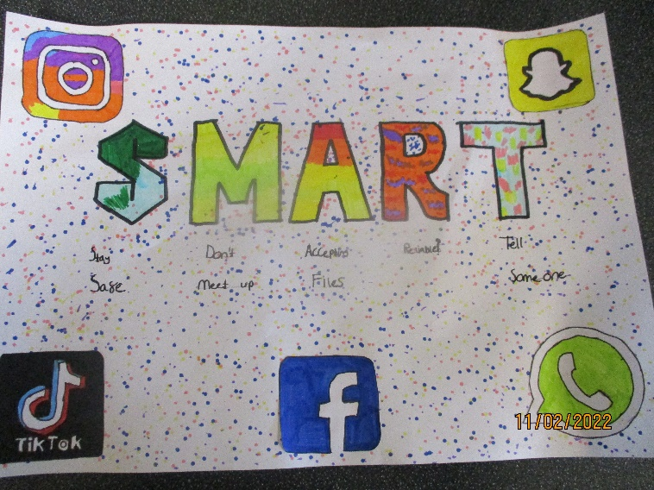
Donaldson Class Poster
Safer Internet Day is celebrated globally in February each year to promote the safe and positive use of digital technology for children and young people, and to inspire a national conversation about using technology responsibly, respectfully, critically, and creatively. The theme for Safer Internet Day 2022 is ‘All fun and games? Exploring respect and relationships online’. From gaming and chat, to streaming and video, young people are shaping the interactive entertainment spaces they are a part of.
Safer Internet Day 2022 celebrates young people’s role in creating a safer internet, whether that is whilst gaming and creating content or interacting with their friends and peers.
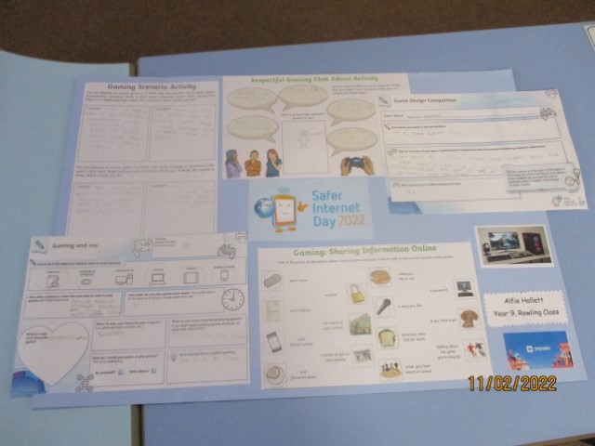
Rowling Class Work
As a parent or carer, you play a key role in helping your child to stay safe online and you do not need to be an expert on the internet to help keep your child safe online. Advice and resources are available to support you as you support your child to use the internet safely, responsibly and positively. Tips, advice, guides and resources to help keep your child safe online are available on our school website and within our online safety policy.
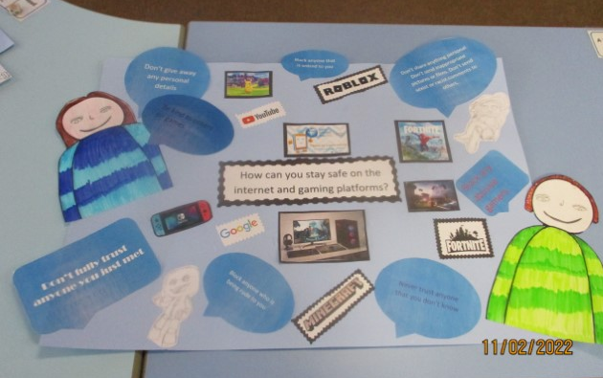
Mental Health Support Team
The government have now set up Mental Health Support Teams (MHST), which are teams of professionals that have been trained to deliver low-level mental health interventions to schools.
Amy Adkins is a Senior EWP (Emotional Wellbeing Practitioner) within the Kent Emotional Wellbeing Team. We are lucky enough to have Amy as the lead for St Anthony's and she will be coming into school for a day, every week. We are the first SEN school in Thanet to be a part of this, which is very exciting.
Amy will be working with some of our young people that we identify as needing support with their mental health and wellbeing. Where they cannot support, they will be able to signpost us to other agencies who may be able to help our children and young people and their families.
The service is going to be supporting with targeted interventions; 1-1, in groups and can also support with parent workshops.
Talking Futures
When it comes to education and careers parents, carers and guardians are the biggest influence in young people’s lives. Talking Futures is a resource created to help you have constructive conversations with your child about the different training and education pathways available to them. It is never too early to talk about careers so have a look.
https://www.talkingfutures.org.uk/

Work Experience
Marshall on his first day of work experience at Mills and Barr Estate Agents Ramsgate.
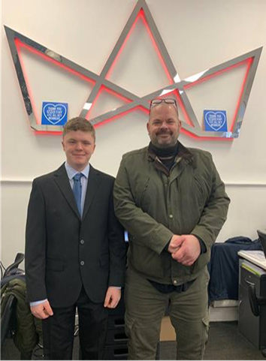
Student Council
At the School Council meeting this term they had an excellent discussion about how to get the most from Internet Safer Day; new markings for the playground in secondary; the general popularity of the salad bar that has been introduced at lunchtimes; and Red Nose Day.
It was agreed that we should do something for Red Nose Day. The theme will be announced at the start of next term.
Potter Class
Potter class visited Bugsy’s Bowling for a sports trip. (Luckily we managed to have our lunch there too). We had lots of fun and practised our newfound bowling skills.

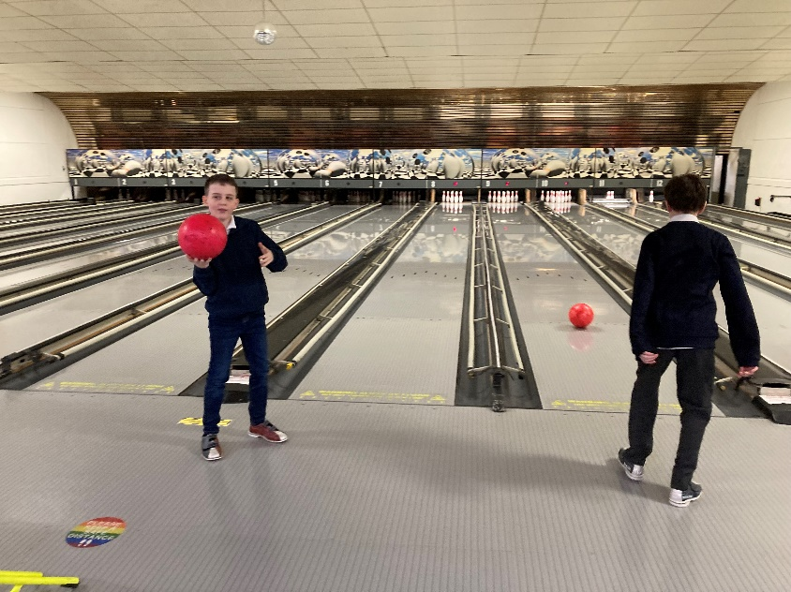
There were even a couple of strikes involved. The children really enjoyed themselves and behaved beautifully even the adults were not too bad.
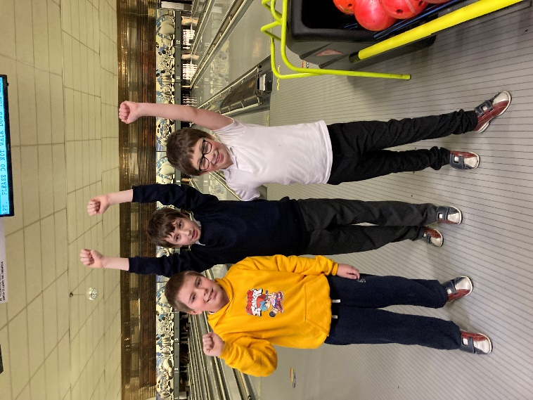
We had a great time and cannot wait for our next adventure.
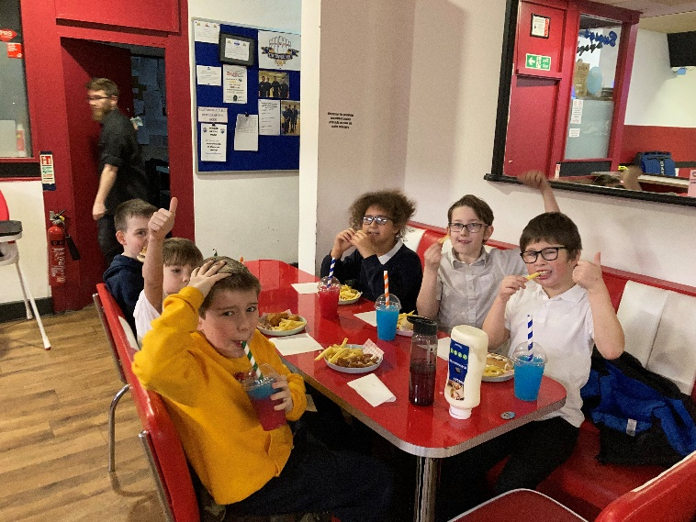
The lunch was soon eaten up and washed down with slush Puppies. (Only one child got brain freeze)
Rachel
Missing Card
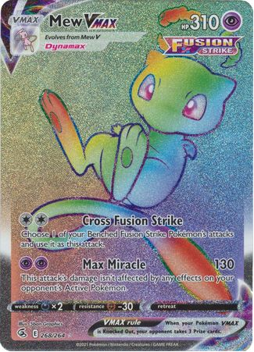
We have lost a valuable Pokémon card. If you see it please let Robert know.

Lampard Class
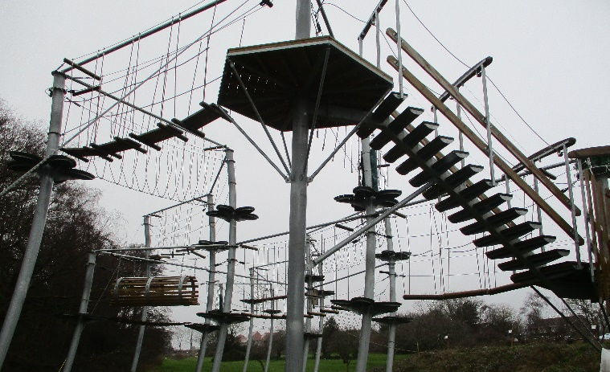
Lampard class used the money from the 'sport fund' to encourage students to take part in a sporting activity to experience a skywalk at Folkestone. The weather turned wet and windy, but the students were not deterred. The staff there were friendly and encouraging, the students thoroughly enjoyed their first 'skywalk' and are desperate to go back. They have arranged with staff there to attempt a time challenge to see who really is the fastest. An amazing experience for the students, and one of the most rewarding days of my teaching career.
Gill
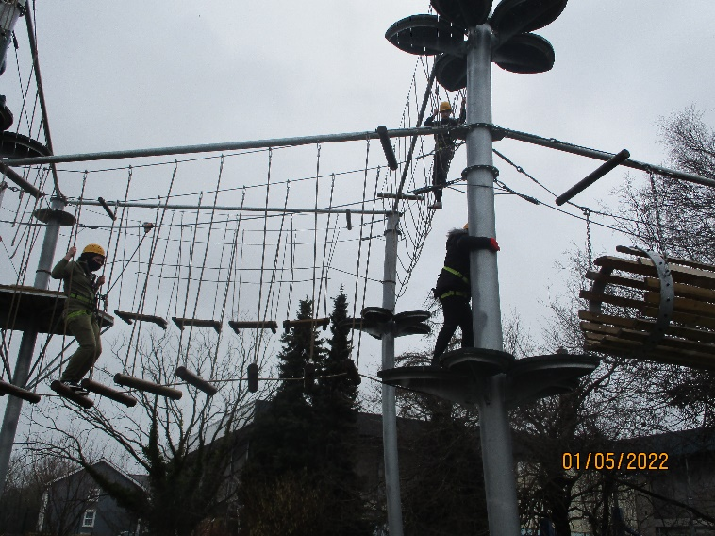

Sports KS4
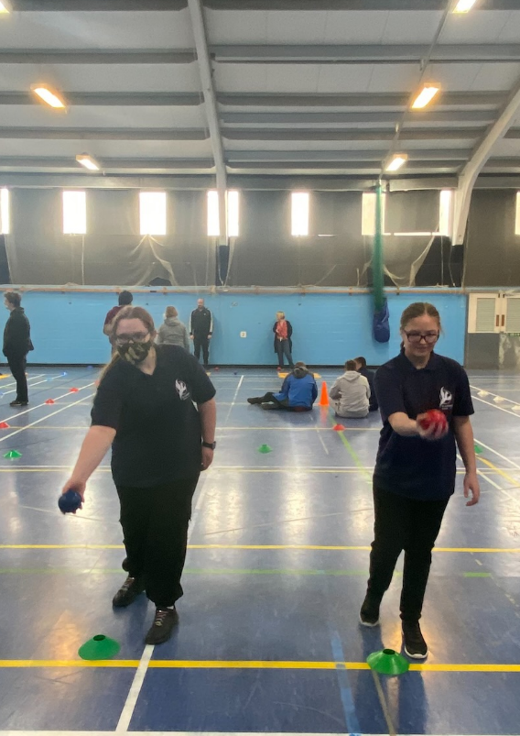
Boccia - KS4 girls took part in Boccia at Baypoint Sports Club. They were competing against Broadstairs College, Bradstow, Life Skills manor and Foreland Fields. There was a carousel of events to practice before a tournament at the end. St Anthony's were great through-out and come up trumps in the tournament winning all their games. Well Done Bethany, Nicole, Lillie and Kate.
Fishing
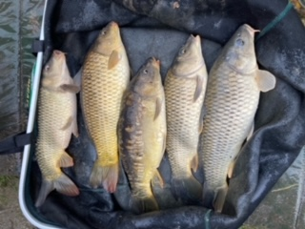

The Thursday fishing group had a bumper catch. They caught the biggest catch this week, more than any other school, weighing in at more than 30lbs.
House Competitions
A fiercely competitive dodgeball competition took place at St Anthony's on 9/2/22 in the sports hall. The four houses' Vikings, Saxons, Romans and Normans, all battled it out for the prize of being Dodgeball Champions. Players fought hard and showed great sportsmanship however, a team had to come out victorious and this year it was... a draw at the top, yes you read it right Vikings and Saxons took 1st prize together.
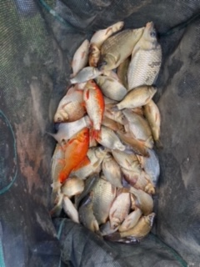
Draughts
The second and final house competition this term was Draughts. The games were played with great respect shown by all. All players received house points for participating. The winners got 10 HPs for their team. Well done to Adam B for not losing a single game and showing awesome sportsmanship.
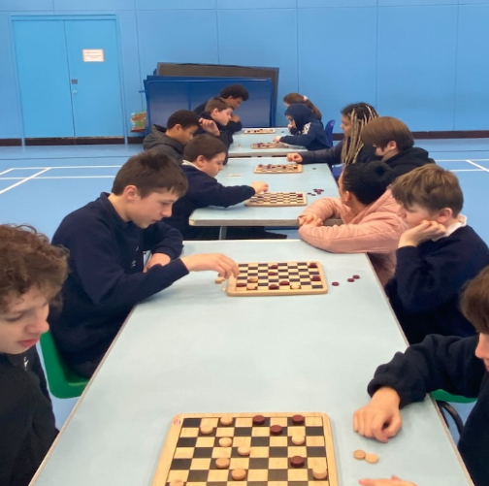

World Book Day
Just a reminder that World Book Day is coming up on Thursday 3rd March 2022.
Start planning a costume.
Dates
- Monday 21st February – First Day term 4
- Thursday 3rd March –World Book Day
- Monday 14th March – Training Day (no pupils)
- Friday 1st April – Last day term 4 early finish
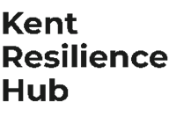
Visit Kent Resilience Hub where you can increase your understanding, find approaches and tools or navigate your way to support and services relating to resilience and emotional wellbeing.
Kooth online support and counselling for 10-25 year olds across Kent and Medway. Offering 1-2-1 counselling, helpful articles, community discussion boards and daily journals.
MindEd is a free educational resource on children and young people's mental health for all adults.

Find out how to tackle hate online and online trolls withinternet matters advice guide for what online hate is and how to support your child. Get tools and tips to support your child’s digital wellbeing on Facebook, Instagram and WhatsApp.
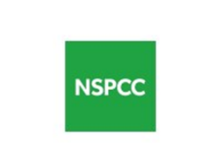
Call NSPCC on 0808 800 5000 if you’re worried about the safety of a child. Or call the police on 999 if you think a child is in immediate danger.
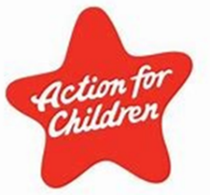
Mind's Action for Children around self esteem and helping your child. Parents with Confidence help your child to emotionally regulate.
Free and confidential advice from Family Lives on 0808 800 2222 if you’re finding it hard at home with your child and are struggling to cope.
Young Minds have a parent’s helpline, information and resources.

