**12th January 2024**

Welcome back after what I hope was a relaxing and peaceful break over the festive period.

As the new term begins, pupils have enjoyed swapping holiday stories with their friends and getting back into the school routine. Like you, I want as many pupils as possible through the school gates this term relaxed, refreshed and ready to learn.   I know how hard you are working to ensure that you child attends school each day and l thank you for your efforts.  The schools target for attendance is **85%** for the year and we are close at **82.42%** after term 2, so please help us with ensuring your child attends each and every day.  I have had a number of requests for term time holidays, l know that the prices are cheaper and resorts are quieter but it is important for your child to attend school each day, so l will not grant permission.

As the weather has taken a turn please also ensure that your child comes to school with a coat and hat, as the school curriculum still involves outdoor learning.  
 ***Robert Page, Headteacher***  
**Dates for the diary**

* **Monday 29th January – INSET** Day (Children do not attend)
* **Friday 9th February** – Last day of term 3
* **Monday 19th February** – First day of term 4

**British Values**

* **Democracy** - have the right to have your voice heard
* **Individual Liberty** - Promote freedom of choice
* **Rule of Law** - The importance of law and rules
* **Mutual Respect & Tolerance** - to respect those from different backgrounds

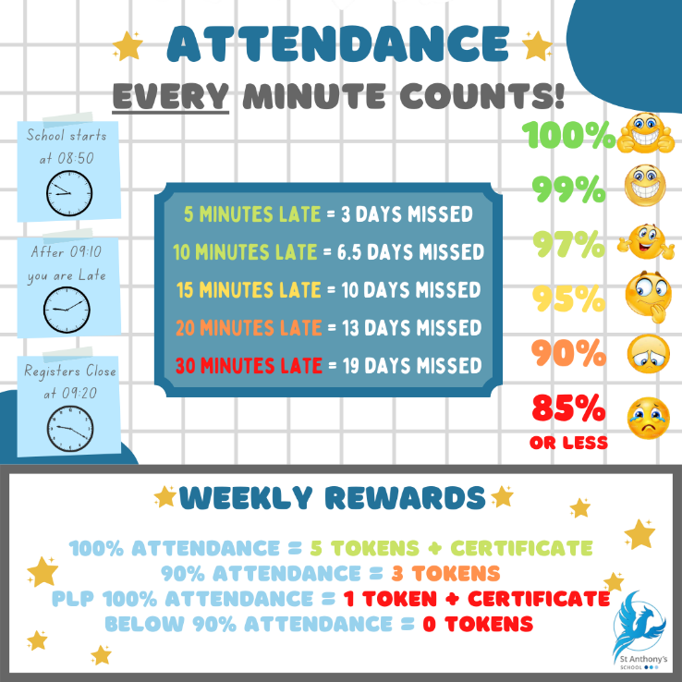**Attendance**Did you know your child’s attendance affects your child’s success? Being in school, on time, every day is vital for student’s well-being, not just their educational growth but for their development in so many other areas such as social and emotional development. We understand that our students needs are far different from the students in mainstream school, so this year we are aiming for a whole school attendance of at **least 85%.** To achieve this, we are continuing our promotion and praise of individual school attendance.

**How is Attendance at St Anthony’s rewarded?**

We monitor and reward attendance on a weekly, termly and yearly basis with a variety of rewards up for grabs. Our weekly attendance is monitored from a Friday to a Thursday, this allows us to celebrate that week’s attendance achievements in our school assembly on a Friday morning.

Students who obtain 100% attendance from the Friday to Thursday will receive a certificate and 5 Reward Shop Tokens. Students who receive 90% attendance in the same period will receive 3 Reward Shop Tokens. We also recognise that our students who have a Personal Learning Plan (or a PLP) will never obtain 100% or 90% attendance due to their learning plan. Therefore, students on a PLP who attend 100% of their PLP during the weekly time-frame are rewarded with a certificate and 1 Reward Shop Token.

The Termly monitoring is based upon the old 3 term school year, Term 1 running until Christmas, Term 2 until Easter and Term 3 until Summer. For every student who achieves 100% attendance for the Term will receive a pin badge and a certificate. The colour of the pin badge is determined by how many TERMS the student has achieved 100%. Bronze will be awarded for all students who have achieved 1 Term of 100% attendance. Silver is awarded to all students who have achieved 2 TERMS of 100% attendance and Gold is awarded to all students who have achieved all 3 TERMS of 100% attendance. Also, ALL students with an attendance of 95% or above will be entered into a draw to win 1 of 3 vouchers worth £20, £10 and £5.

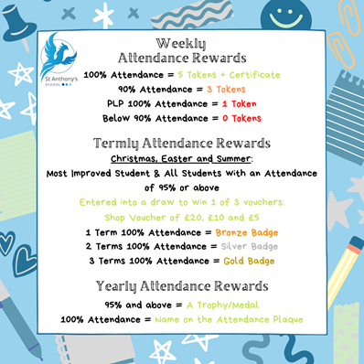The Yearly monitoring is quite simple, all students who receive 95% attendance or above will be presented with a certificate and medal. Students who receive 100% attendance for the year will receive a certificate and medal to take home and their name will be etched onto our Attendance Plaque.  **Uniform**

As the colder days continue to dust our playground with frost we ask that all students come prepared for the lower temperatures. This includes

**Jumpers, coats, hats, scarves & gloves.**

Whilst we understand many children do not like to wear additional layers it makes it very challenging to take the children out for their PSHE sessions when they are not appropriately dressed.

We also have a number of nearly new school jumpers for those who haven’t managed to get one yet. Please call the office to find out more.

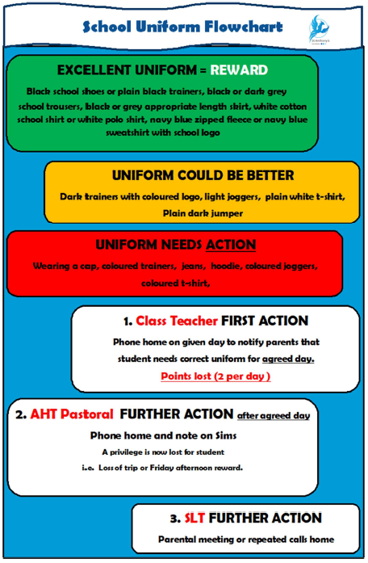

**Science**

This term's science topic is *'What do scientists do?*' pupils will be looking at the different jobs that scientists do and the skills and qualities they need. This week they learnt about forensic science and classes investigated which member of staff stole the biscuits by looking at fingerprints.

***Claire Foley, Head of Science***

**Pegwell & Joss on the case!**

Today we had to investigate who had stolen our class biscuits and left a mess. The 2 culprits left their finger prints at the crime scene!

First, we made a prediction of who it could be based on 6 suspects (adults around the school). Then we went around the school to interrogate these specific adults by asking them a series of questions and collecting any evidence we could find. We then took their index finger print for our database.

Once we had collected all 6 samples, we used magnifying glasses to examine the prints to compare with the culprits’ prints.

***Kyle Adams, Joss Teacher***

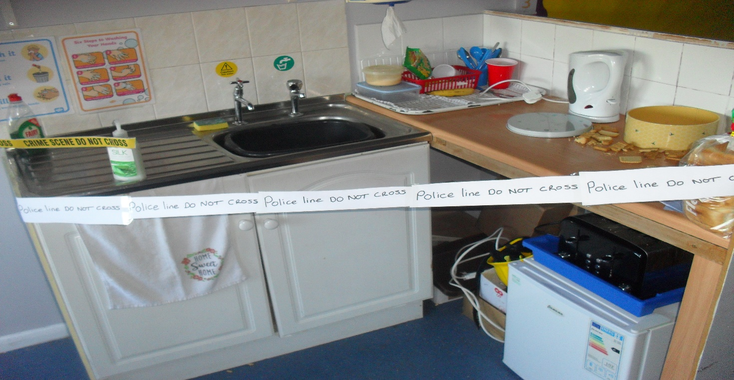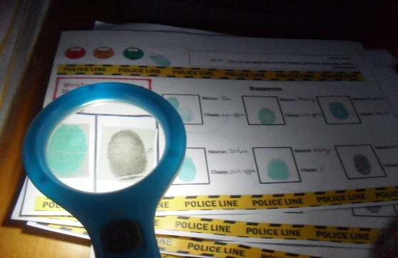

**Internet and Gaming Safety**

***If you want to read on more ways to keep them safe please visit:***   
<https://pegi.info/page/tips-parents>

It’s so important that we keep our young people safe whilst they are online. Below is an explanation of what age ratings mean on games

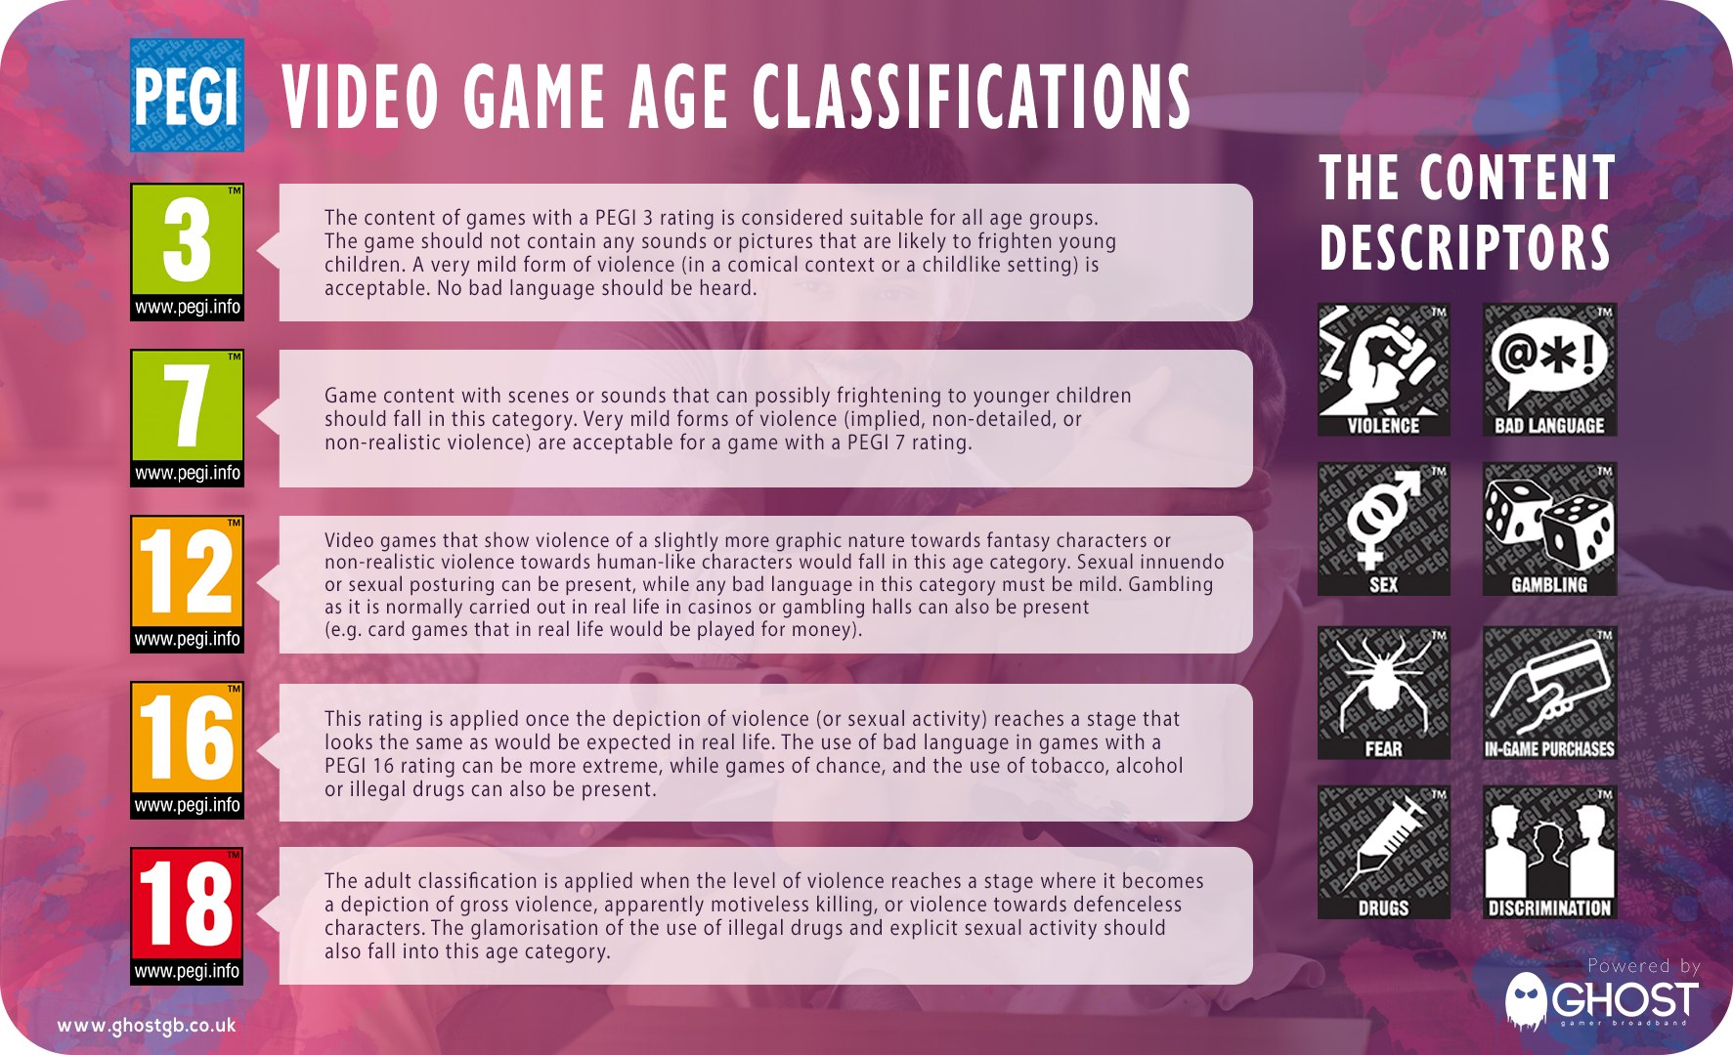

Some of the games children commonly ask to play and their ratings:

**Grand Theft Auto Call of Duty Halo Fortnite Minecraft  
 /GTA /COD**

   




**Robox** is rated as **Parental Guidance.** Roblox then groups games into four age-based categories to indicate appropriateness: **All Ages,** **9+, 13+,** and **17+.** The platform's parental settings give you the ability to curate the content your kids may have access to when playing based on these age groups with **Allowed Experiences** controls.

**Parent Survey 2024**

If you haven’t already, please take some time to complete our annual parent survey.   
Completing the survey will only take a few minutes of your time, but the information you provide will be instrumental in shaping the future of our school. We value your input and believe it is crucial for building a strong relationship between our school and our families.  
  
Your honest feedback will help us understand what is working well and identify areas for improvement.

<https://s.surveyplanet.com/aqlqdcqn>

**Whats on…  
  
SPORT FOR FUN –** Saturdays (term time) 9.00 - 10.00 at St Anthony's School. A Saturday morning sports club for children with SEND.

**BE ACTIVE -SHORT BREAK** - Saturdays (term time) 10.30 - 12.00 at Foreland Fields School

**BE ACTIVE -SHORT BREAK** - Wednesdays (term time) 4.30 - 6.00 at Foreland Fields School

complete the following referral form to declare interest: <https://forms.office.com/r/EZwuMEZmEd>

**CLIP N CLIMB** - Thursdays Session 1: 4.30-5.30pm Session 2: 5.30-6.30pm.

To book please clink on this link: <https://forms.gle/EHYHiAtxWfE3XYDz6>

**MARGATE YOUTH FC KICKS 4 KIDS** - Tuesdays 5.00-5.45 at Margate FC   
Inclusive football sessions delivered by Inclusive Sport. To register please visit: <https://www.margateyouthfc.co.uk/events/kick-inclusive-football-sessions>   
 **Cost of Living Support**

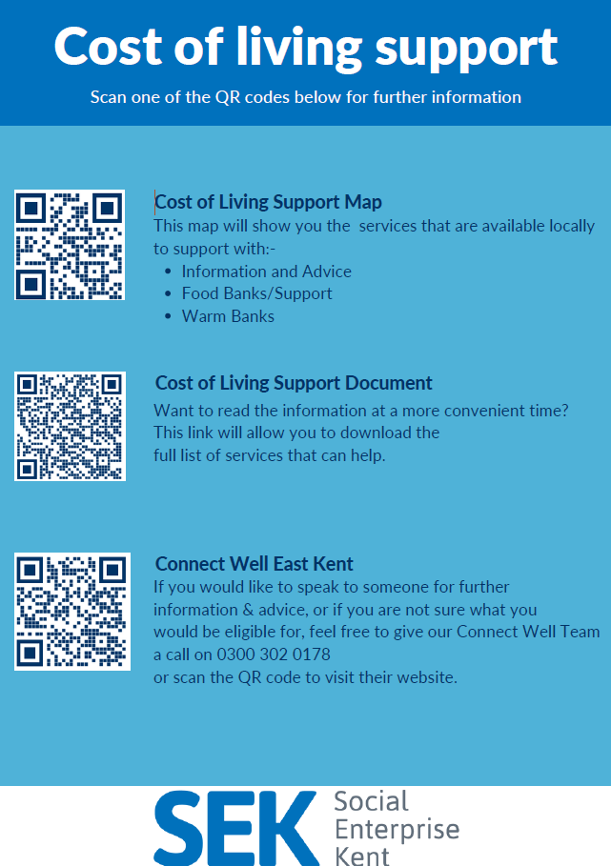

With the pressures of costs around us there is a number of services that can support. If you are having troubles please contact them direct or come and talk with us.

A link below is Thanet councils community hub which can sign post to a range of support functions.

[**https://www.thanet.gov.uk/info-pages/covidcommunityadvice/**](https://www.thanet.gov.uk/info-pages/covidcommunityadvice/)

**DWP - Outreach sessions for families**

Outreach sessions are being held in local venues. Support on hand includes, benefit advice, childcare choices and cost, finding work, cost of living, housing and any queries that our work coach can support the family with.

**Ramsgate** – The Priory Children’s Centre, Cannon Rd, Ramsgate CT11 9SQ

Outreach available every Wednesday between 9am to 12noon. To book a slot to see our adviser at the Priory Children Centre in Ramsgate please contact [jayne.conroy@dwp.gov.uk](mailto:jayne.conroy@dwp.gov.uk)

**Margate**– Six Bells Children Centre, 201 High St, Margate CT9 1WH

Outreach available every Monday between 1pm to 4pm. To book a slot to see our adviser at the Six Bells in Margate please contact

[philip.raeburn@dwp.gov.uk](mailto:philip.raeburn@dwp.gov.uk) or [anita.taylor@dwp.gov.uk](mailto:anita.taylor@dwp.gov.uk)

Visit [Kent Resilience Hub](https://kentresiliencehub.org.uk/) where you can increase your understanding, find approaches and tools or navigate your way to support and services relating to resilience and emotional wellbeing.

****[Kooth online](https://www.kooth.com/) support and counselling for 10-25 year olds across Kent and Medway. Offering 1-2-1 counselling, helpful articles, community discussion boards and daily journals.  
[MindEd](https://www.minded.org.uk/) is a free educational resource on children and young people's mental health for all adults.

Find out how to tackle hate online and online trolls with internet matters advice guide for what [online hate](https://www.internetmatters.org/resources/tackling-online-hate-and-trolling/) is and how to support your child. Get tools and tips to support your child’s [digital wellbeing](https://www.internetmatters.org/?gclid=EAIaIQobChMIrbTX5_bt7AIVRuztCh33bQH_EAAYASAAEgLtifD_BwE) on Facebook, Instagram and WhatsApp.

Call NSPCC on 0808 800 5000 if you’re worried about the safety of a child. Or call the police on 999 if you think a child is in immediate danger.

Mind's [Action for Children](https://minds.actionforchildren.org.uk/self-esteem) around self esteem and helping your child. Parents with Confidence help your child to emotionally regulate.

Free and confidential advice from [Family Lives](https://www.familylives.org.uk/how-we-can-help/confidential-helpline/) on 0808 800 2222 if you’re finding it hard at home with your child and are struggling to cope**.**[Young Minds](https://youngminds.org.uk/) have a parent’s helpline, information and resources