**12th November 2021**

**Dear Parents/Carers**

It has been another hectic start to what is always a very busy term in school, in the lead up to the Christmas holidays. I am pleased to say we still have had only a couple reported cases of COVID and these have had limited impact on the school. However, it is also the season of colds and flu and we have been dealing with a high level of staff absence to start the new term. We know that our pupils don’t like change, so when staff are absent we work to cover classes with familiar faces, but this at times means that interventions or programmes that are in place for your child, are not able to take place. This also means that some of our pupil’s levels of anxiety rise and we deal with higher numbers of challenges which has an impact on all. Please support the school in ensuring that your child is fit and well to be in school, if not, please keep them at home.

Next Friday 19th November will be a **non-uniform day** as we support Children in Need. Children will be asked to make a £2 donation to not wear uniform. Staff and KS4 students will be also be raising money by having a cycle challenge. More information and pictures will be in the next newsletter.

We have also started planning for the Winter Fayre on 3rd December 5–7pm. We hope to see all of our children and families attend and have a good time that evening. More information will be forthcoming but we will be having non-uniform days on 26th November and 3rd December to receive donations.

The school is always interested in what our parents and carers think, as this informs the school in what we need to do to support your children. We recently sent out a questionnaire, if you could fill it out and return it, l would be grateful. If you did not receive one please contact the office.

Pupils and staff have been busy so please read on.

Mr R Page Headteacher

**A reminder about the importance of reporting test results**

Thank you for continuing to support our pupils to test twice-weekly for COVID-19 at home. Reporting your tests, whether positive, negative or void, is as important as taking the test itself, as reporting results helps us understand the spread of the virus in local areas.

Lateral flow device (LFD) tests have been widely and successfully used to detect asymptomatic COVID-19 cases. A recent [report](https://www.dovepress.com/getfile.php?fileID=74968) has shown that the accuracy of LFD tests was more than 80% effective at detecting any level of COVID-19 infection and likely to be more than 90% effective at detecting the most infectious people at the point of testing.

**Science Trips**

Cowell, Milton, Rowling and Potter Classes are very excited to have the opportunity to take part in an exciting science workshop in Ramsgate today. ‘Go for Green’ is being hosted by Discovery Planet, and the University of Kent will be sharing awareness of the global issues that are at the forefront of the media at present. There will be lots of practical resources and equipment to engage the pupils with raising awareness and knowledge to support science in school. We will have a full report in the next newsletter. They have open sessions on Saturday if you are interested in attending.

<https://www.discoveryplanet.co.uk/>

**Fishing**

**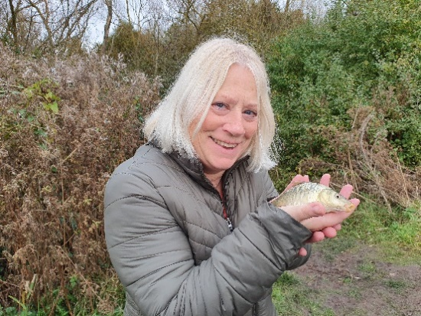**

A small select group of our pupils have started a trial of a new intervention. Five pupils and three staff attended a fishing intervention on Tuesday at Nethergong Campsite and caught between 2 and 15 fish, they tell me. They will be attending this provision for a total of 12 weeks. This intervention is run by a qualified level 3 Forest School Instructor and qualified level 2 Angling Coach. They had a great time and are all looking forward to going again next week!

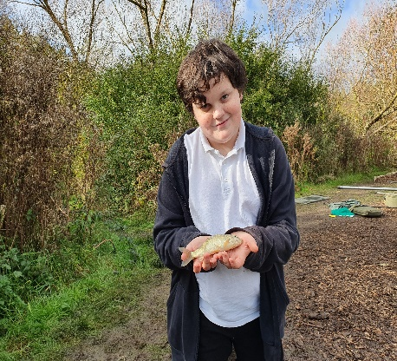

**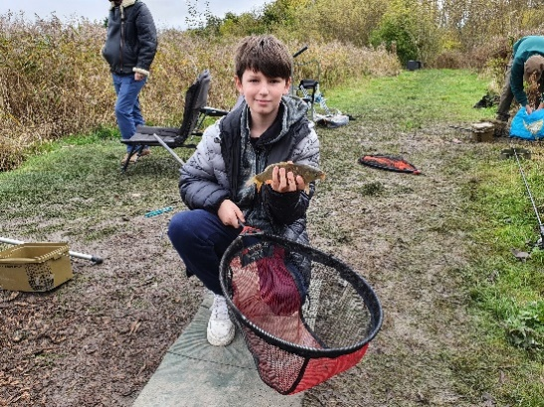**

**Remembrance Assembly**

****

On Thursday 11th November 2021, pupils and staff took time to remember the sacrifice of the Armed Forces from Britain and the Commonwealth, who are serving across the world. We also paid tribute to the emergency services who also continue to put service before themselves and make sacrifices to ensure the safety of civilians. We came together at 11am to collectively remember and held a two minute silence.

**Be You Project**

The Be You project are running meet-ups at Dreamland Margate, Marine Terrace, CT9 1XJ for LGBTQ youths every Wednesday 4.00 – 5.30. This is a safe space for anyone who thinks they may be LGBTQ+ can come along to. You can meet new people who share some of the same feelings and experiences as you, socialise and just hang out in a non- judgemental setting. Under 14’s must be accompanied by an adult. For more information or advice visit – thebeyouproject.co.uk or email [beyou@porchlight.org.uk](mailto:beyou@porchlight.org.uk) .

**Kent SEND Information Hub - Update October 2021**

The [What happens during an education, health and care needs assessment](https://eur01.safelinks.protection.outlook.com/?url=https%3A%2F%2Fwww.kent.gov.uk%2Feducation-and-children%2Fspecial-educational-needs%2Feducation-health-and-care-plans%2Fwhat-happens-during-a-needs-assessment%2Fhealth-coordinators&data=04%7C01%7CJenny.Hanna%40kent.gov.uk%7C3afcef87b4114a28b5de08d98e602944%7C3253a20dc7354bfea8b73e6ab37f5f90%7C0%7C0%7C637697365918214633%7CUnknown%7CTWFpbGZsb3d8eyJWIjoiMC4wLjAwMDAiLCJQIjoiV2luMzIiLCJBTiI6Ik1haWwiLCJXVCI6Mn0%3D%7C1000&sdata=uhFZiv%2B9HookfhAP8NNPMLGHPCOwA4z8tcpbXtGII0s%3D&reserved=0) page has been

updated to incorporate the work undertaken on the Who Does What project, and now

includes a [process map](https://eur01.safelinks.protection.outlook.com/?url=https%3A%2F%2Fwww.kent.gov.uk%2F__data%2Fassets%2Fpdf_file%2F0005%2F125717%2FRequest-an-EHC-plan-process-map.pdf&data=04%7C01%7CJenny.Hanna%40kent.gov.uk%7C3afcef87b4114a28b5de08d98e602944%7C3253a20dc7354bfea8b73e6ab37f5f90%7C0%7C0%7C637697365918214633%7CUnknown%7CTWFpbGZsb3d8eyJWIjoiMC4wLjAwMDAiLCJQIjoiV2luMzIiLCJBTiI6Ik1haWwiLCJXVCI6Mn0%3D%7C1000&sdata=y6shEF9LhSeuEdO7wZMP0FRT6WTQA%2FH7gOvLkRk7EGU%3D&reserved=0) of the assessment stages. There is also a new [SEND teams and](https://eur01.safelinks.protection.outlook.com/?url=https%3A%2F%2Fwww.kent.gov.uk%2Feducation-and-children%2Fspecial-educational-needs%2Fwho-to-contact%2Fsend-teams-and-their-roles&data=04%7C01%7CJenny.Hanna%40kent.gov.uk%7C3afcef87b4114a28b5de08d98e602944%7C3253a20dc7354bfea8b73e6ab37f5f90%7C0%7C0%7C637697365918224630%7CUnknown%7CTWFpbGZsb3d8eyJWIjoiMC4wLjAwMDAiLCJQIjoiV2luMzIiLCJBTiI6Ik1haWwiLCJXVCI6Mn0%3D%7C1000&sdata=kOook715rdAeRQT0yjBunOR8FF7VIKrXE20fqecu25Y%3D&reserved=0" \t "_blank)

[their roles](https://eur01.safelinks.protection.outlook.com/?url=https%3A%2F%2Fwww.kent.gov.uk%2Feducation-and-children%2Fspecial-educational-needs%2Fwho-to-contact%2Fsend-teams-and-their-roles&data=04%7C01%7CJenny.Hanna%40kent.gov.uk%7C3afcef87b4114a28b5de08d98e602944%7C3253a20dc7354bfea8b73e6ab37f5f90%7C0%7C0%7C637697365918224630%7CUnknown%7CTWFpbGZsb3d8eyJWIjoiMC4wLjAwMDAiLCJQIjoiV2luMzIiLCJBTiI6Ik1haWwiLCJXVCI6Mn0%3D%7C1000&sdata=kOook715rdAeRQT0yjBunOR8FF7VIKrXE20fqecu25Y%3D&reserved=0" \t "_blank) page, which outlines the main teams involved in the SEND service and their partners.

You can get to this page through the ‘Our SEND teams’ tab on the Contact SEND teams

and support services page and there are also links to this from the [What happens during an education, health and care needs assessment](https://eur01.safelinks.protection.outlook.com/?url=https%3A%2F%2Fwww.kent.gov.uk%2Feducation-and-children%2Fspecial-educational-needs%2Feducation-health-and-care-plans%2Fwhat-happens-during-a-needs-assessment%2Fhealth-coordinators&data=04%7C01%7CJenny.Hanna%40kent.gov.uk%7C3afcef87b4114a28b5de08d98e602944%7C3253a20dc7354bfea8b73e6ab37f5f90%7C0%7C0%7C637697365918214633%7CUnknown%7CTWFpbGZsb3d8eyJWIjoiMC4wLjAwMDAiLCJQIjoiV2luMzIiLCJBTiI6Ik1haWwiLCJXVCI6Mn0%3D%7C1000&sdata=uhFZiv%2B9HookfhAP8NNPMLGHPCOwA4z8tcpbXtGII0s%3D&reserved=0) page. There is also a new page on [Health](https://eur01.safelinks.protection.outlook.com/?url=https%3A%2F%2Fwww.kent.gov.uk%2Feducation-and-children%2Fspecial-educational-needs%2Feducation-health-and-care-plans%2Fwhat-happens-during-a-needs-assessment%2Fhealth-coordinators&data=04%7C01%7CJenny.Hanna%40kent.gov.uk%7C3afcef87b4114a28b5de08d98e602944%7C3253a20dc7354bfea8b73e6ab37f5f90%7C0%7C0%7C637697365918224630%7CUnknown%7CTWFpbGZsb3d8eyJWIjoiMC4wLjAwMDAiLCJQIjoiV2luMzIiLCJBTiI6Ik1haWwiLCJXVCI6Mn0%3D%7C1000&sdata=RCOVgM8WRdt7vE5M6wGH6Z9Q87jNed6MZl9QZQDywMg%3D&reserved=0" \t "_blank)

[Co-ordinators](https://eur01.safelinks.protection.outlook.com/?url=https%3A%2F%2Fwww.kent.gov.uk%2Feducation-and-children%2Fspecial-educational-needs%2Feducation-health-and-care-plans%2Fwhat-happens-during-a-needs-assessment%2Fhealth-coordinators&data=04%7C01%7CJenny.Hanna%40kent.gov.uk%7C3afcef87b4114a28b5de08d98e602944%7C3253a20dc7354bfea8b73e6ab37f5f90%7C0%7C0%7C637697365918224630%7CUnknown%7CTWFpbGZsb3d8eyJWIjoiMC4wLjAwMDAiLCJQIjoiV2luMzIiLCJBTiI6Ik1haWwiLCJXVCI6Mn0%3D%7C1000&sdata=RCOVgM8WRdt7vE5M6wGH6Z9Q87jNed6MZl9QZQDywMg%3D&reserved=0" \t "_blank) and what their role is.

**Margate Early Learning Community (MELC) - Update October 2021**

Established in 2018, the Margate Early Learning Community brings together the collective

capacity and knowledge of local services, organisations and families to improve early

learning outcomes for children growing up in Margate. The MELC is supported by Save the Children UK, who have made [this short video](https://eur01.safelinks.protection.outlook.com/?url=https%3A%2F%2Fvimeo.com%2F565607704%2F476c7268a8&data=04%7C01%7CJenny.Hanna%40kent.gov.uk%7Cf9c99ec03b164db29e6208d99e0c8b68%7C3253a20dc7354bfea8b73e6ab37f5f90%7C0%7C0%7C637714598973356738%7CUnknown%7CTWFpbGZsb3d8eyJWIjoiMC4wLjAwMDAiLCJQIjoiV2luMzIiLCJBTiI6Ik1haWwiLCJXVCI6Mn0%3D%7C1000&sdata=a%2BXIDpT5%2BGWHIs1WlvGPejxckDDzURMb4SwJbluRnJA%3D&reserved=0) summarising the work of the Community and the impact it has had on the lives of families in Margate to date. If you would like to learn more about the Margate Early Learning Community, including on how to refer eligible families to our current initiatives, contact Freya Nowell at [f.nowell@savethechildren.org.uk](mailto:f.nowell@savethechildren.org.uk).

**MELC - Current initiatives**

All families in Thanet are currently able to access the [EasyPeasy app](https://eur01.safelinks.protection.outlook.com/?url=https%3A%2F%2Fwww.easypeasyapp.com%2F&data=04%7C01%7CJenny.Hanna%40kent.gov.uk%7Cf9c99ec03b164db29e6208d99e0c8b68%7C3253a20dc7354bfea8b73e6ab37f5f90%7C0%7C0%7C637714598973356738%7CUnknown%7CTWFpbGZsb3d8eyJWIjoiMC4wLjAwMDAiLCJQIjoiV2luMzIiLCJBTiI6Ik1haWwiLCJXVCI6Mn0%3D%7C1000&sdata=p8RgnryD8WeQqx5ApkacTrWn4RrOO%2BpPWdXGLn6xfy8%3D&reserved=0), which contains

parenting tips and activities from a wide community of parents and experts, for free until the

end of 2021 using the code: lego2021. The app can be downloaded via the App Store and

Google Play.

The Margate Early Learning Community are currently working with [Fegans](https://eur01.safelinks.protection.outlook.com/?url=https%3A%2F%2Fwww.fegans.org.uk%2F&data=04%7C01%7CJenny.Hanna%40kent.gov.uk%7Cf9c99ec03b164db29e6208d99e0c8b68%7C3253a20dc7354bfea8b73e6ab37f5f90%7C0%7C0%7C637714598973366736%7CUnknown%7CTWFpbGZsb3d8eyJWIjoiMC4wLjAwMDAiLCJQIjoiV2luMzIiLCJBTiI6Ik1haWwiLCJXVCI6Mn0%3D%7C1000&sdata=3zlaDp%2Bv5EUk6AG1l4G%2FGLweoyKLMpUT7gTA7XugQIc%3D&reserved=0) to offer 10

weeks of free professional counselling to eligible parents/carers in Margate, and offering

free places on an 8-week peer support programme run by [The Education People](https://eur01.safelinks.protection.outlook.com/?url=https%3A%2F%2Fwww.theeducationpeople.org%2F&data=04%7C01%7CJenny.Hanna%40kent.gov.uk%7Cf9c99ec03b164db29e6208d99e0c8b68%7C3253a20dc7354bfea8b73e6ab37f5f90%7C0%7C0%7C637714598973366736%7CUnknown%7CTWFpbGZsb3d8eyJWIjoiMC4wLjAwMDAiLCJQIjoiV2luMzIiLCJBTiI6Ik1haWwiLCJXVCI6Mn0%3D%7C1000&sdata=CF6W04RlyZk7LRZf1AoIsHnBAibUUvsw2wMdi2%2BWmXc%3D&reserved=0). From

later this year, we will also be distributing financial grants worth £340 to eligible families.

On Friday 26th November (10:30am - 12:00pm), the Margate Early Learning Community will

be hosting a free festive family crafts event for families and children aged 0-5, in

partnership with Thanet Children's Centres. The event will be held at the Turner

Contemporary gallery and all attendees will receive small craft packs to take away and

continue crafting at home. Families can register to attend this event [here](https://eur01.safelinks.protection.outlook.com/?url=https%3A%2F%2Fforms.office.com%2Fr%2Fp8jB5s0HNU&data=04%7C01%7CJenny.Hanna%40kent.gov.uk%7Cf9c99ec03b164db29e6208d99e0c8b68%7C3253a20dc7354bfea8b73e6ab37f5f90%7C0%7C0%7C637714598973376729%7CUnknown%7CTWFpbGZsb3d8eyJWIjoiMC4wLjAwMDAiLCJQIjoiV2luMzIiLCJBTiI6Ik1haWwiLCJXVCI6Mn0%3D%7C1000&sdata=DC6pFG5WqYvVbOVqJ3Ovdq8g0oExWGCWHTlQKP8piSw%3D&reserved=0).

**Author Visit**



Pop-Up Literacy comes to St Anthony's again! This week we have had three amazing people in school, working with our pupils. Dahl and Potter had the amazing children's author Will Mabbitt take them on a journey with his character Mabel Jones. Blyton and Milne Class had Garry Parsons, the fantastic illustrator of The Dinosaur Who Pooped a Planet, so they spent the session listening to the story and then drawing dinosaurs. Last but not least, Milton and Cowell Class had Chris Hill, the author of *What Manor of Murder?* and *Osbert The Avenger*, to name just two of his books! The feedback from staff and pupils was fantastic, everyone thoroughly enjoyed the visits, and we cannot wait for the next Pop-Up event!

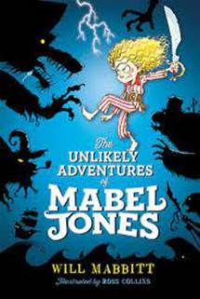

**Police Liaison with St Anthony’s School**

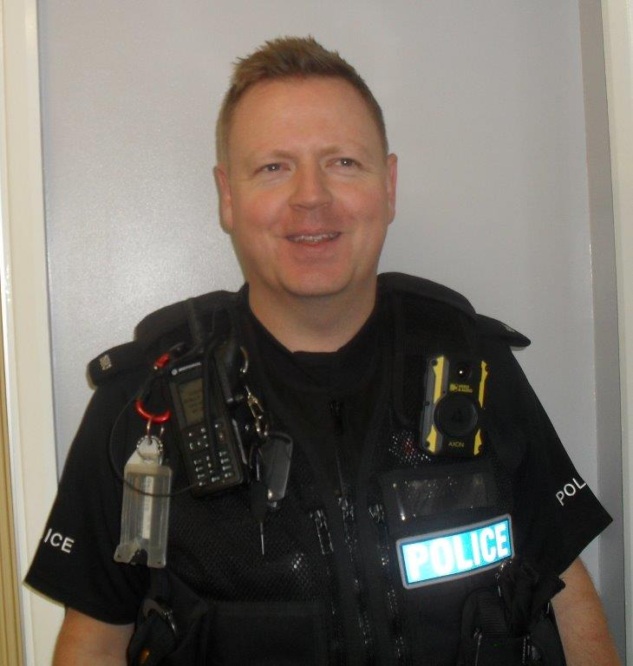

KCC Education and Kent Police have worked to develop a new initiative to have a named PC working with schools. St Anthony’s will be working with PC Lee Cleaver. We are still designing how we can use the skills of PC Cleaver to better support our school community. If you see PC Cleaver around school please say hello.

**PC Lee Cleaver**

**SCHOOL RECEIVES BREAKFAST BOOST FROM KELLOGG’S**

Kellogg’s has awarded St Anthony’s School in Margate £1,000 to enhance its Healthy Eating Programme and provide breakfast for pupils. St Anthony’s was selected to receive this boost, as Kellogg’s announced it is donating more money than ever to support Healthy Eating, as more and more schools struggle to find the budget to fund this service for their pupils.

Eating healthily in the morning helps with everything from attendance and attainment to alleviating hunger and providing pre-school care. 68 per cent of teachers believe pupils would struggle to concentrate in class without access to healthy foods in the morning, according to Kellogg’s research.

Head Teacher Robert Page said: “We are so grateful to receive this generous donation. We have since been able to purchase fresh fruit and healthy morning snacks for each class. These resources will help us to continue to provide our children with these foods thanks to the support from Kellogg’s.”

Kate Prince, corporate social responsibility manager at Kellogg’s, said “We’re proud to have spent over 20 years supporting so many schools across the UK. We believe all children should have the opportunity to have a good start to the day, and we know that equipment and resources are just as important to schools as the food itself.”

Kellogg’s has supported 4,000 schools with funds, food and training over the last 23 years – that’s 70 million bowls of cereal to children all over the UK since 1998.

**Dates**

Friday 19th Non-uniform day -£2 Children in Need

Friday 26th Non-uniform day – Donations for School Fayre

Monday 29th November Training Day - no pupils to attend

Friday 3rd December Non-uniform day – Donations for School Fayre

Friday 3rd December Winter Fayre 5 – 7pm

Wednesday 15th December – Christmas Lunch

Thursday 16th December – Panto at Theatre Royal

Friday 17th December last day of term – pupils finish 1:30pm

Robert Page

Headteacher