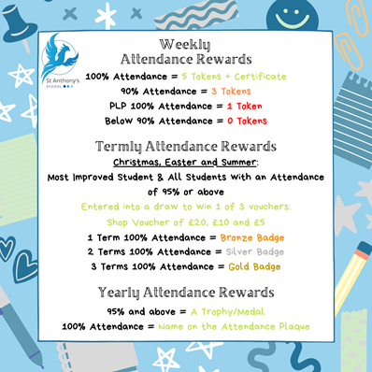

**17th March 2023**

What a term 4 we have had so far, with so many wonderful trips, visits and learning experiences for the pupils, which you will read about below.   
  
With only two weeks until the Easter Break, I am sure everyone is getting excited and will have more news to share.   
  
**Forthcoming Dates**

* **Fri 31st March 2023** last day term 4
* **Mon 17th April** first day term 5
* **Friday April 28th** training day (no pupils)
* **Mon 1st** **May** Bank Holiday
* **Mon 8th** **May** Kings Coronation

**British Values**



**Attendance**Well done to all the children who consistently achieve a weekly attendance of 100%. We monitor attendance from Friday-Thursday allowing us to celebrate those children in our Friday Morning Assembly for their 100% attendance.   
  
Each child who achieves 100% attendance for the week gets a certificate and **5** tokens, any child who achieves 90% attendance will receive **3** tokens for the reward Shop.   
  
We also celebrate our students on a personal learning plan, these students are highly unlikely to achieve an attendance of 90% due to the nature of their timetable, therefore those students on PLP’s who attend 100% of their timetable that week will also receive a certificate and **1** token to spend in the reward shop.

**KS4 Theatre London Trip – Mousetrap**

What a day had by us: the KS4 drama group and friends!  
Our day started at school for tea and toast before the big off to our capital, London. We had 7 excited pupils at Ramsgate train station, waiting eagerly to get to Charring Cross to start our adventure.   
  
Upon our arrival (with full tummies) we headed off to our first stop, Trafalgar Square where the children were in amazement by the fountains and famous statues standing tall and proud (some since the 1840s!) Surrounded by the pigeons like the scene from Mary Poppins. All sat on the benches and steps to eat their lunch, listening to the calming fountains and people watching. Most had their first experience of seeing the famous London underground before continuing our walk to Leister Square.   
It was here that we met the famous playwright's statue of Sir William Shakespeare holding the scroll of his famous quote "*there is no darkness but ignorance*" which took the children a while to pick apart- introducing them nicely to our next project, Midsummer Night's Dream.   
The children also spotted Batman perched on top of the Oden cinema, Mr. Bean and Charlie Chaplin who they had previously studied during the last year when they were introduced to the genre of Slap Stick comedy.  
  
We had time to visit the Lego store to see the **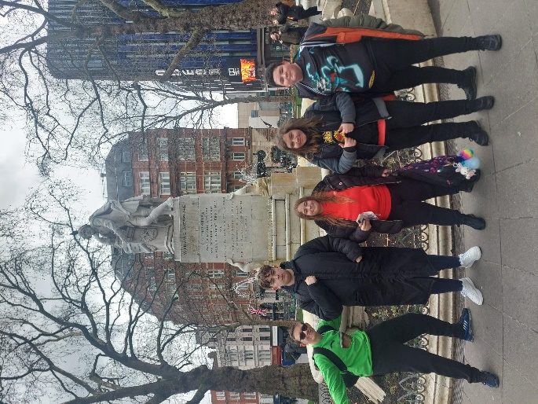**amazing, huge models and (expensive) sets, we even had some time for some building!  
Across the road stood the famous M&M store and the premier of the new Shazam waiting for the celebrities to arrive that evening- unfortunately, we were not allowed to step on the red carpet!  
  
After grabbing the essential souvenirs, we finally arrived at St. Martin's Theatre. What a beautiful theatre for the students to visit, to watch Agatha Christie's longest running show (for 70 years!) The Mousetrap. Unfortunately, we have been sworn to secrecy to tell you anything about this show, especially who the killer is... but we can tell you that it is a very funny, thrilling, and exciting show and recommend anyone to watch it.  
  
Since Christmas, our drama students have been working hard and learning about the Whodunnit genre. They have been exploring the game Cluedo, the characters and characteristics of this terms genre by creating their own characters and building their own board games alongside drama activities. I am so proud of every one of **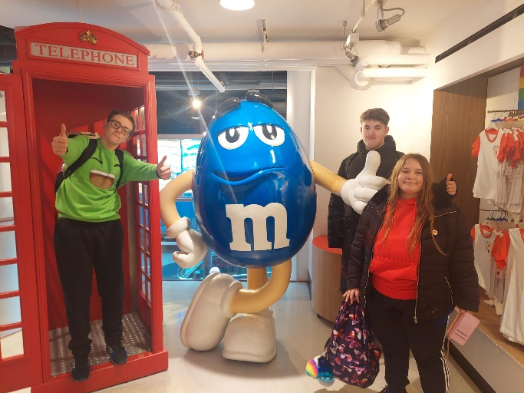**our drama students work they have produced and know that they are very excited to share their hard work with the school and to you at home.

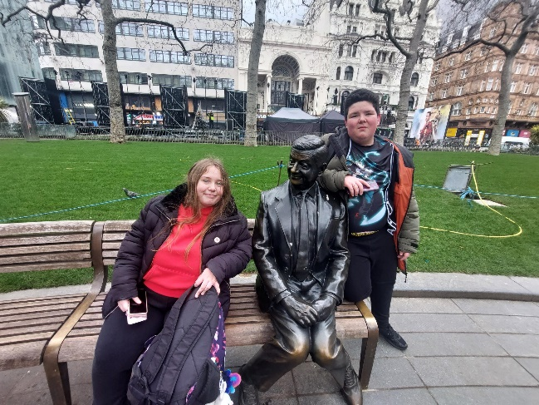****Our day was polished off with a McDonald's and a long journey home.  
Thank you to those that came, staff that supported the trip and to parents, carers and guardians making the trip possible, collecting the students from the train station late at night.   
  
Behaviour was impeccable, and all children really were fantastic ambassadors, representing St. Anthony's School. Well done.  
 ***-Leanne Lloyd***

**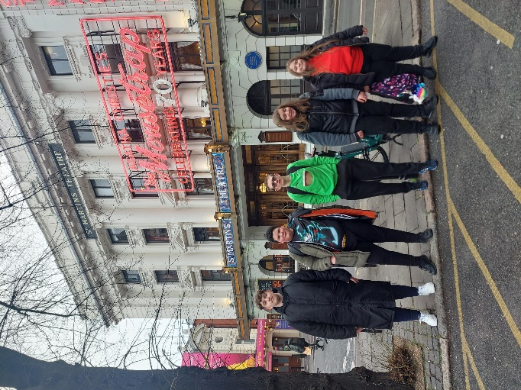**

**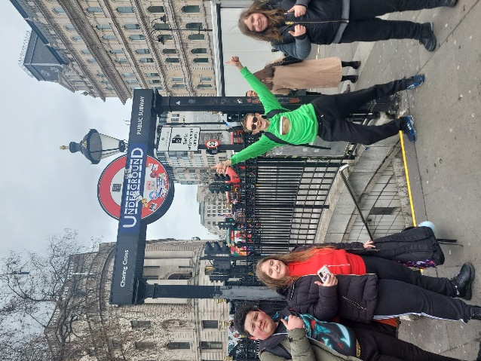**

**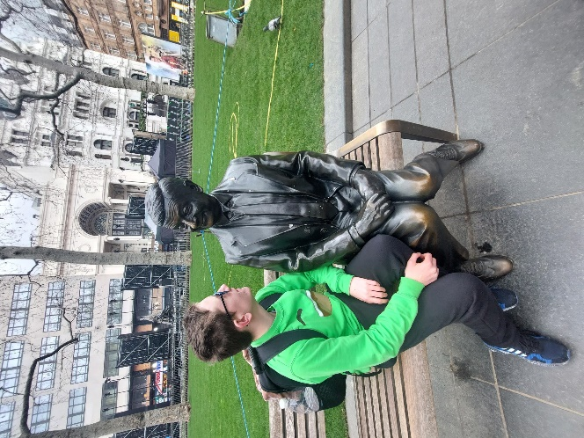**

**World Book Day**

**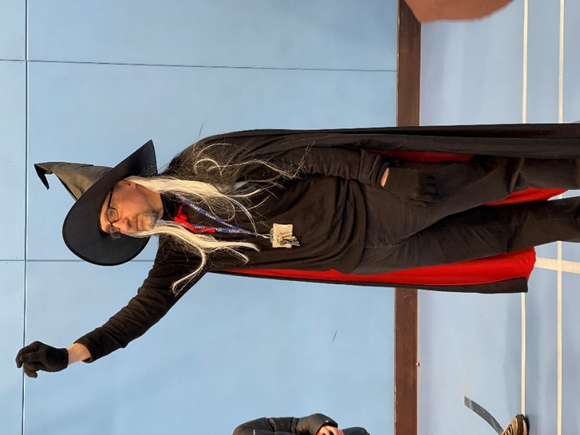**

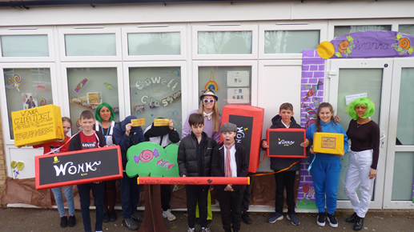

*Mr Curry thought he’d missed out on pictures!*

As the previous newsletter highlighted we had a very successful world book day on March 3rd.

Choosing the contest winners was a very difficult job, so l passed this task over to ***Pat Warnecke*** our Chair of Governors.



**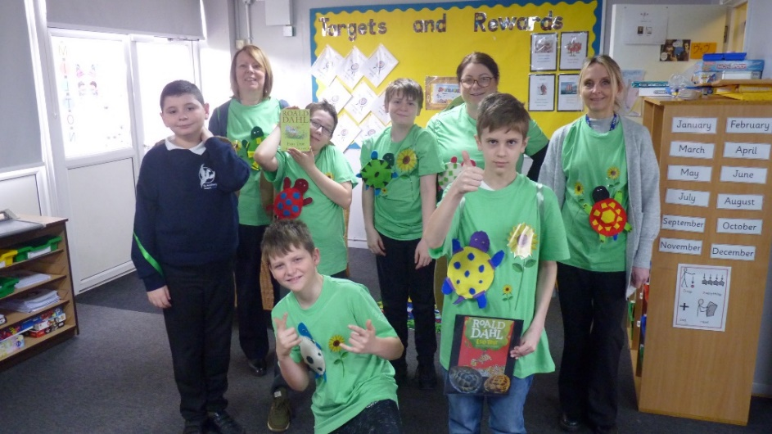**

**Best Class – Milton**

**Best Teacher – Kyle Blyton**

**Best LSA Amy and Danielle P in Cowell**



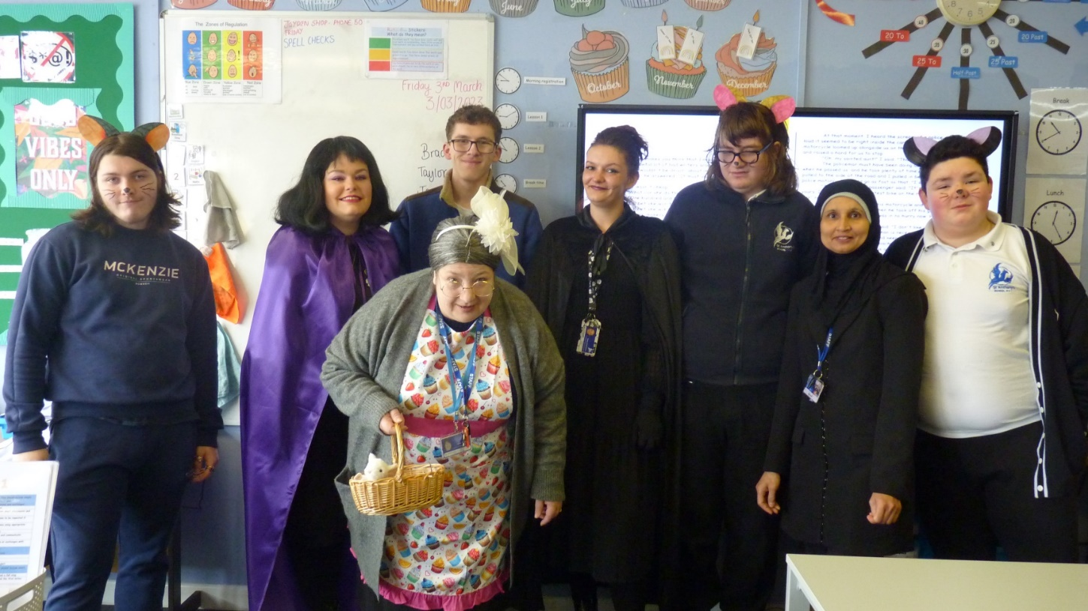**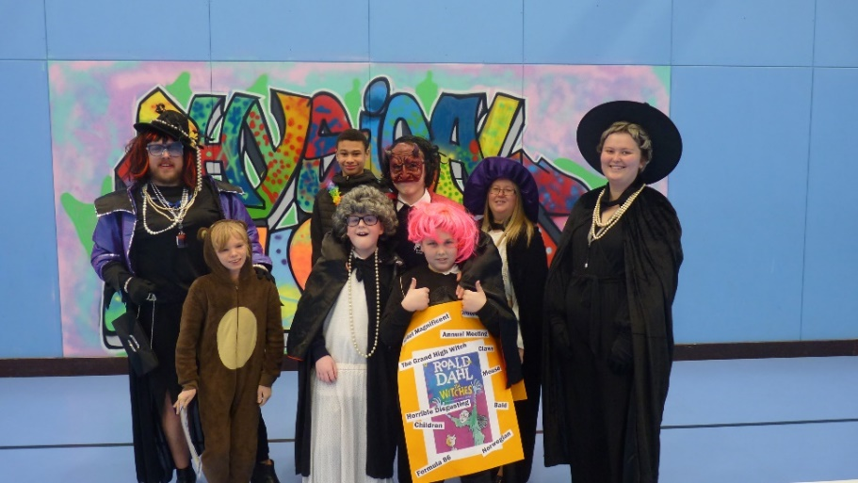**x

***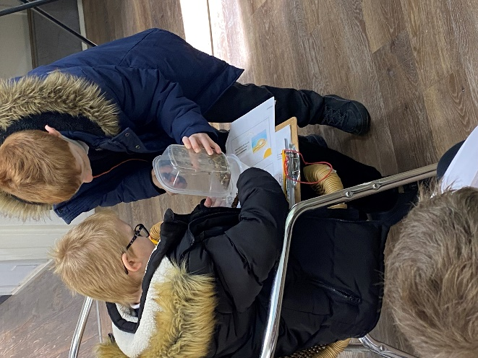***

**Rowling RE Day**

Rowling Class produced some great Hindu Holi Festival splatter painting during our School RE day learning all about Hinduism. ***–Gavin Jones***  
  
Amazing art produced! Well done boys!

**Blyton – Monkton Trip**Blyton visited Monkton Nature this week, the children looked at different types of rock, fossils, stuffed animals and insects. They also went on a hike around the reserve looking for special plaques, fairy houses, trees, leaves and animal/insect spotting. – ***Kyle Adams***

***James & Lewis*** looking at some of the different types of stones available along our coastline!

***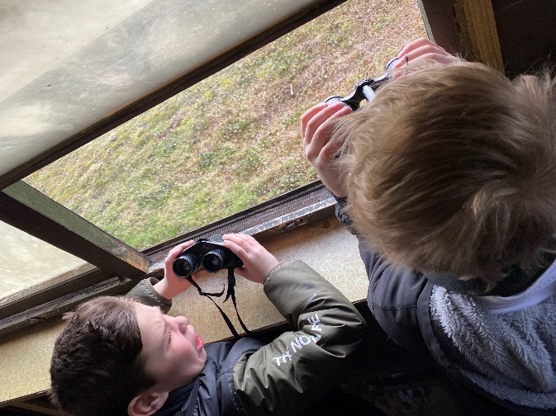***

***Leo & Blaine*** keeping their eyes peeled for wildlife!

**  
*Ricki, Junior, Blaine, Ashton, James & Leo***in their wooden den

**Isaac’s Anderson Shelter**

***Isaac*** from Blyton Class has been making an Anderson Shelter during is DT sessions with Kevin. Isaac has been working hard since the beginning of January and it really shows.

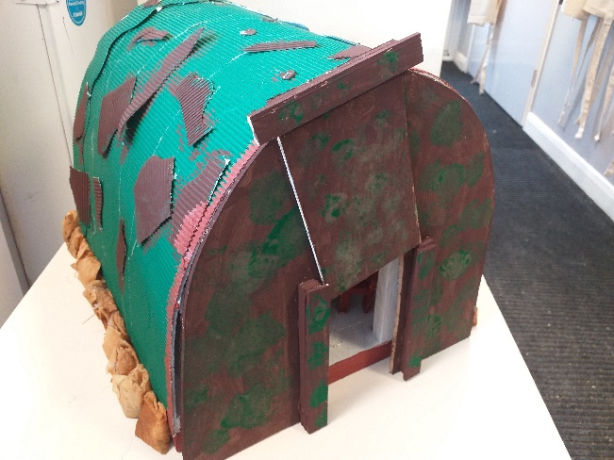It is made of wood, card, corrugated paper to resemble the crinkly tin sheets, tea bags for the sand bags and pillows and felt for the bed roles.   
Isaac is very knowledgeable regarding the history and use of the shelters and can answer any questions you have. **Well done Isaac!**

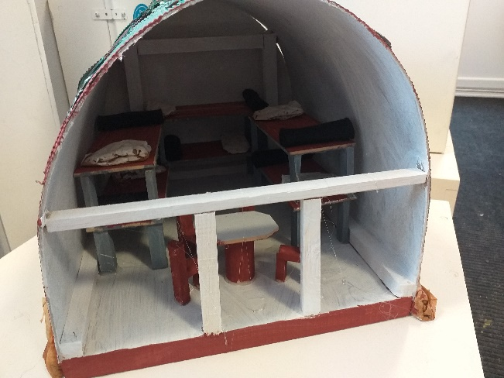

**Matchbox Challenge**

Could you win our Maths Matchbox Challenge?  
  
Take part in our Easter holiday Maths Matchbox Challenge. It’s easy! All you need to do is fill the matchbox with DIFFERENT items. Then return it to the office, at the latest on **21st April 2023.**  
  
For more information please see Natalie

****

**Discovery Planet – Science Workshops**

****

**SPORT FOR FUN –** Saturdays (term time) 9.00 - 10.00 at St Anthony's School. A Saturday morning sports club for children with SEND.

**BE ACTIVE -SHORT BREAK** - Saturdays (term time) 10.30 - 12.00 at Foreland Fields School

**BE ACTIVE -SHORT BREAK** - Wednesdays (term time) 4.30 - 6.00 at Foreland Fields School

Please read the PDF letter attached for more information and complete the following referral form to declare interest:

<https://forms.office.com/r/EZwuMEZmEd>

**CLIP N CLIMB** - Thursdays Session 1: 4.30-5.30pm Session 2: 5.30-6.30pm.

To book please clink on this link: <https://forms.gle/EHYHiAtxWfE3XYDz6>

**MARGATE YOUTH FC KICKS 4 KIDS** - Tuesdays 5.00-5.45 at Margate FC

Inclusive football sessions delivered by Inclusive Sport. To register please visit: <https://www.margateyouthfc.co.uk/events/kick-inclusive-football-sessions>

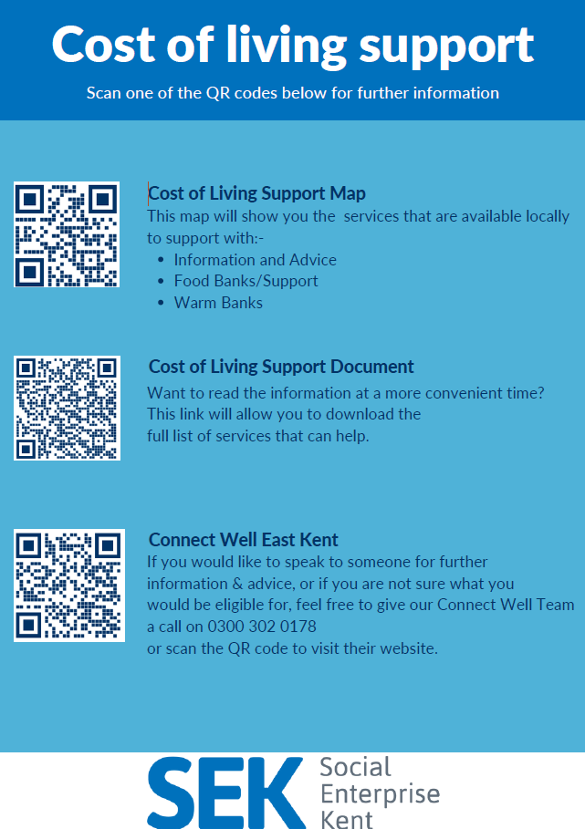

**Cost of Living Support**

With the pressures of costs around us there is a number of services that can support. If you are having troubles please contact them direct or come and talk with us.

A link below is Thanet councils community hub which can sign post to a range of support functions.

[**https://www.thanet.gov.uk/info-pages/covidcommunityadvice/**](https://www.thanet.gov.uk/info-pages/covidcommunityadvice/)

**DWP - Outreach sessions for families**

Outreach sessions are being held in local venues. Support on hand includes, benefit advice, childcare choices and cost, finding work, cost of living, housing and any queries that our work coach can support the family with.

**Ramsgate** – The Priory Children’s Centre, Cannon Rd, Ramsgate CT11 9SQ

Outreach available every Wednesday between 9am to 12noon To book a slot to see our adviser at the Priory Children Centre in Ramsgate please contact

[jayne.conroy@dwp.gov.uk](mailto:jayne.conroy@dwp.gov.uk)

**Margate**– Six Bells Children Centre, 201 High St, Margate CT9 1WH

Outreach available every Monday between 1pm to 4pm To book a slot to see our adviser at the Six Bells in Margate please contact

[philip.raeburn@dwp.gov.uk](mailto:philip.raeburn@dwp.gov.uk) or [anita.taylor@dwp.gov.uk](mailto:anita.taylor@dwp.gov.uk" \t "_blank)

**Royal British Legion - Energy Support**

The Royal British Legion, the UK's largest charity dedicated to supporting the Armed Forces community, has today launched a new grant scheme for veterans and their families who are struggling to pay their energy bills. The initiative will provide non-repayable emergency grants of up to £2,400 a year (£200 a month) and is available across the UK.

In general, the Armed Forces community includes those who have served, or are serving, in the Royal Navy, British Army or Royal Air Force, as well as their families, dependants and carers – which can include children, current and former spouses and partners, widows and widowers.

To apply it's worth [checking your eligibility on its website](https://eur01.safelinks.protection.outlook.com/?url=https%3A%2F%2Fwww.britishlegion.org.uk%2Fget-support%2Fwho-we-help&data=05%7C01%7CJenny.Hanna%40kent.gov.uk%7C0e5a983faa7040ba13ee08dab3399c0f%7C3253a20dc7354bfea8b73e6ab37f5f90%7C0%7C0%7C638019357270836664%7CUnknown%7CTWFpbGZsb3d8eyJWIjoiMC4wLjAwMDAiLCJQIjoiV2luMzIiLCJBTiI6Ik1haWwiLCJXVCI6Mn0%3D%7C3000%7C%7C%7C&sdata=3atnAtHJUwgEaZz76bOScnj82DDHbKKLWrCX4kciIcY%3D&reserved=0) or by calling its helpline on 0808 802 8080.



Visit [Kent Resilience Hub](https://kentresiliencehub.org.uk/) where you can increase your understanding, find approaches and tools or navigate your way to support and services relating to resilience and emotional wellbeing.

[Kooth online](https://www.kooth.com/) support and counselling for 10-25 year olds across Kent and Medway. Offering 1-2-1 counselling, helpful articles, community discussion boards and daily journals.

****[MindEd](https://www.minded.org.uk/) is a free educational resource on children and young people's mental health for all adults.

Find out how to tackle hate online and online trolls with internet matters advice guide for what [online hate](https://www.internetmatters.org/resources/tackling-online-hate-and-trolling/) is and how to support your child. Get tools and tips to support your child’s [digital wellbeing](https://www.internetmatters.org/?gclid=EAIaIQobChMIrbTX5_bt7AIVRuztCh33bQH_EAAYASAAEgLtifD_BwE) on Facebook, Instagram and WhatsApp.

Call NSPCC on 0808 800 5000 if you’re worried about the safety of a child. Or call the police on 999 if you think a child is in immediate danger.

Mind's [Action for Children](https://minds.actionforchildren.org.uk/self-esteem) around self esteem and helping your child. Parents with Confidence help your child to emotionally regulate.

Free and confidential advice from [Family Lives](https://www.familylives.org.uk/how-we-can-help/confidential-helpline/) on 0808 800 2222 if you’re finding it hard at home with your child and are struggling to cope**.**[Young Minds](https://youngminds.org.uk/) have a parent’s helpline, information and resources.