18th March 2022 Newsletter

Red Nose
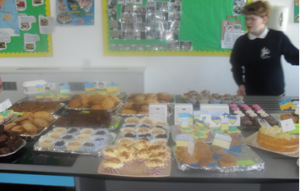
On Thursday (17th) we held a Bake Sale to raise money for Red Nose Day. Pupils made a wide assortment of cakes and cookies earlier in the week which were then sold on Thursday at break time raising approx. £80. Thank you to Cody who was a super baker!
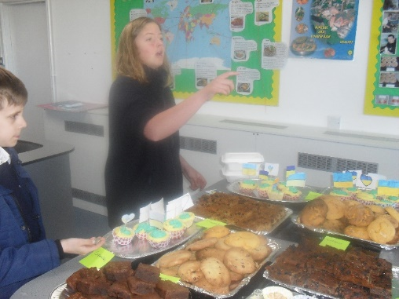

On Friday it was non-uniform day, the theme was superhero’s or the colour red, but we also allowed yellow and blue to show the school’s support for Ukraine.
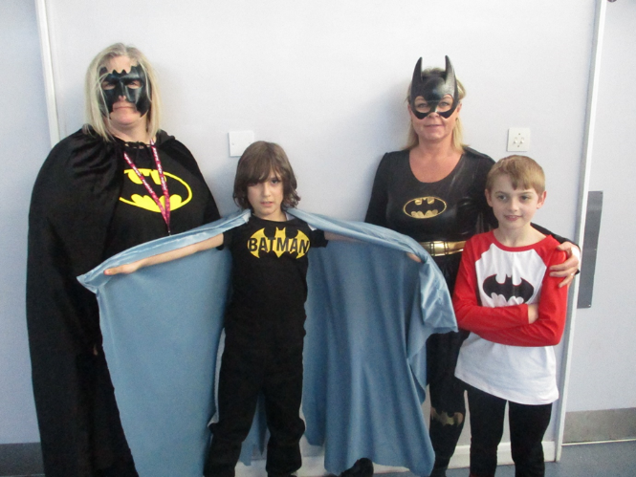
Maths Day
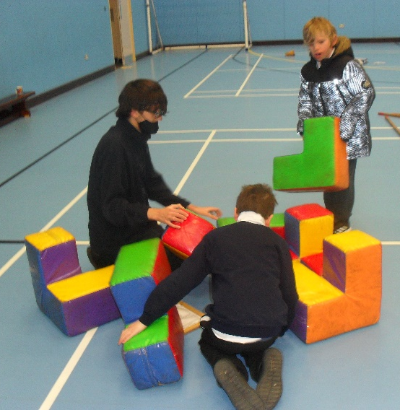
On the 8th March the Problem Solving Company came to our school. They brought over 30 different mathematics problems, some involved physical activities, others needed good math's skills and the rest needed both. The aim of the day was to 'develop thinking skills, mathematical concepts and dialogue'. We hoped the math's activities would foster a 'can do' attitude for our students and allow them to solve math's problems in a fun way. The day was a huge success, with all the students and staff getting involved.
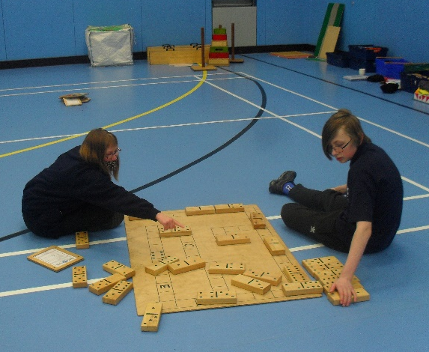
We all had fun, learnt lots, worked together to solve the problems and look forward to enjoying another day like this soon!
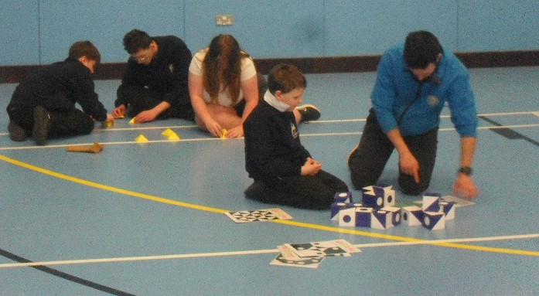
Potter Class Erupts!
Potter class are currently learning about volcanoes in Global studies. They have shown a keen interest and could not wait to create their own. Over the last two weeks, they have been working extremely hard on their model volcanoes. First they used paper to create a base mountain, then they covered it in Modroc. Next they painted the models, the children used photos of volcanoes such as Mount Fuji, Vesuvius and Mount Etna as inspiration. Once completed the children created their own erupting volcanoes using a science experiment to make a chemical reaction. The children thoroughly enjoyed their ‘eruptions’, complete with flowing lava.
Rachel, Potter Teacher.
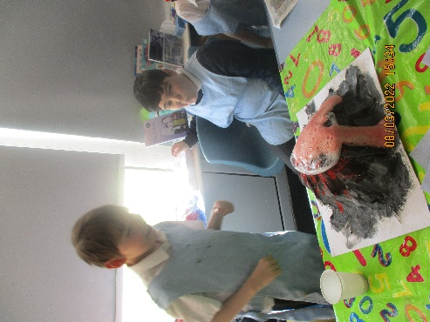
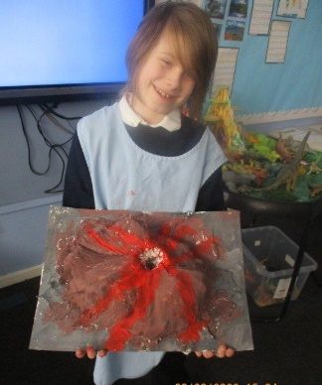
Donations for Ukraine
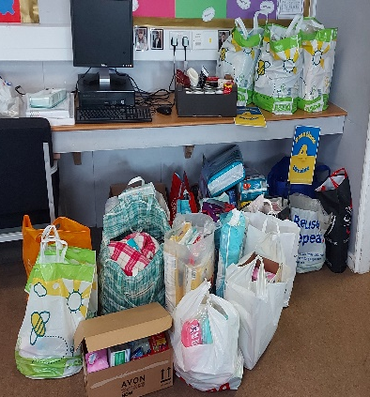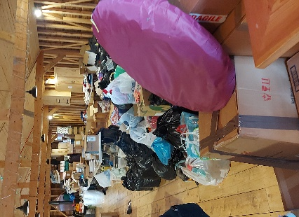
Thank you to those of you who were able to make a donation for Ukraine. The school was able to amass a large amount of goods, which were then taken to the local collection point at Quex before being shipped. Thank you!
Science
Milton, Rowling and Lampard students were able to visit a ‘pop-up’ science workshop in Ramsgate last week. Everyone felt it was amazing that a ‘pop-up’ could be so well equipped and organised. Lampard were a bit early, but they were welcomed in and explained what they were going to do. The first task was to make our own ‘periscope’ – all the materials were provided, we were all very pleased when they actually worked! The second activity was about light and how it could be ‘reflected’ and ‘diffracted’. The students thoroughly enjoyed this activity, and Gill was really amazed that they knew so much about this and were able to complete the tasks set quickly with such knowledge.
We are looking forward to visiting the next workshop.
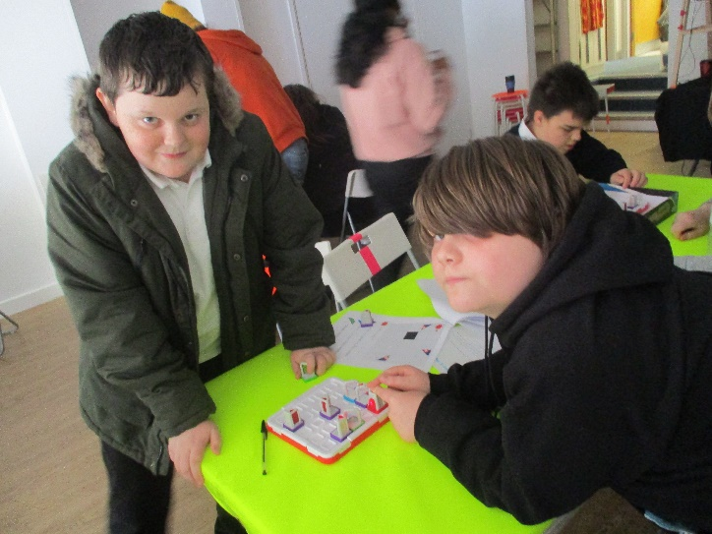
Memphis and Tom at Science Workshop

St Anthony’s Sports
KS2 pupils attended a badminton and short tennis event at Hartsdown Leisure Centre, where a plethora of events was hosted by Inclusive Sport. Pupils enjoyed the variety of activities that took place and all participants received a certificate for their efforts and participation with inclusivity at the heart of the event. Well Done.
Craig, PE Lead
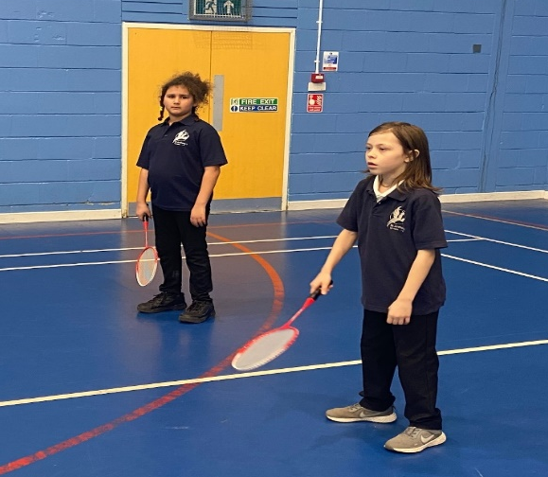
Students exhibit their Art!
The exhibition is open from 5th to 22nd March at The Wooden Box Gallery on Kings Street. The gallery focuses on portraits and the theme of this exhibition is 'Eyes' and is called 'The Eyes Have It'. Our students submitted a piece each which were chosen to hang in the exhibition. On Friday 5th March there was an Artist's Opening where our students and their adults attended and saw their art displayed and looking wonderful! Well done to Ty V, Yr 9 and Nicole R, Yr 11
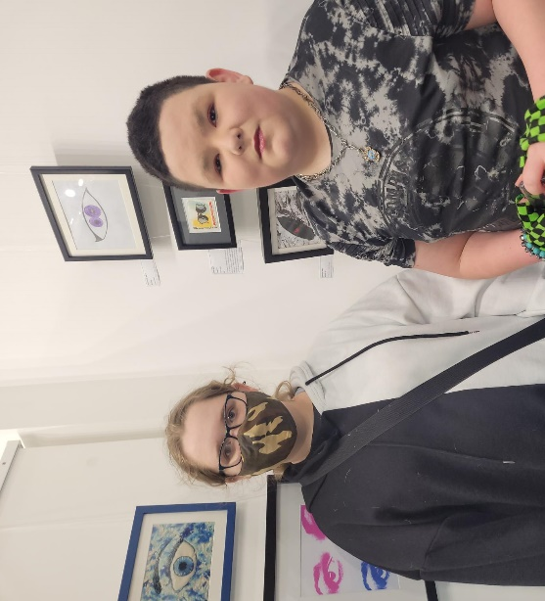
Dates
- Friday 1st April – Last day Term 4 finish 1:30
- Tuesday 19th April – First day Term 5
- Monday 2nd May – Bank Holiday
- Friday 27th May – Last Day Term 5
Visit Kent Resilience Hub where you can increase your understanding, find approaches and tools or navigate your way to support and services relating to resilience and emotional wellbeing.
Kooth online support and counselling for 10-25 year olds across Kent and Medway. Offering 1-2-1 counselling, helpful articles, community discussion boards and daily journals.
MindEd is a free educational resource on children and young people's mental health for all adults.
Find out how to tackle hate online and online trolls withinternet matters advice guide for what online hate is and how to support your child. Get tools and tips to support your child’s digital wellbeing on Facebook, Instagram and WhatsApp.
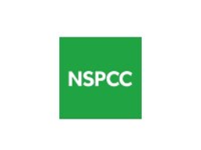
Call NSPCC on 0808 800 5000 if you’re worried about the safety of a child. Or call the police on 999 if you think a child is in immediate danger.
Mind's Action for Children around self esteem and helping your child. Parents with Confidence help your child to emotionally regulate.
Free and confidential advice from Family Lives on 0808 800 2222 if you’re finding it hard at home with your child and are struggling to cope.
Young Minds have a parent’s helpline, information and resources.

