**24th May 2024**

As we reach the end of another term, I want to extend my heartfelt thanks to our dedicated staff, hardworking students, and supportive families. This term has been filled with remarkable achievements, from outstanding academic performances from our Year 11 pupils exam efforts, down through the school to exceptional extracurricular activities such as Art Competition and KS3 and KS4 water sports. We’ve seen our students grow, not just in knowledge, but in character and resilience. Your support and involvement have been invaluable in making this term a success. Enjoy a well-deserved break, and we look forward to welcoming everyone back refreshed and ready for the challenges and opportunities of the next term.  
 ***Mr Robert Page, Headteacher***  
**Dates for the diary**

* 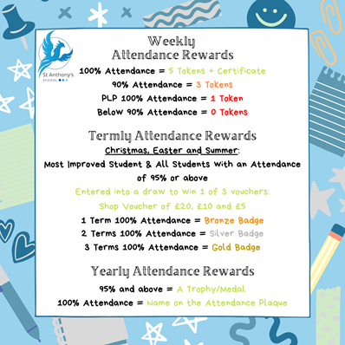**Friday 24th May –** Last day of term 5
* **Monday 3rd June –** First day of term 6
* **Friday 21st June –** Summer Fayre

**British Values**

* **Democracy** - have the right to have your voice heard
* **Individual Liberty** - Promote freedom of choice
* **Rule of Law** - The importance of law and rules
* **Mutual Respect & Tolerance** - to respect those from different backgrounds

**Attendance**Did you know your child’s attendance affects your child’s success? Being in school, on time, every day is vital for student’s well-being, not just their educational growth but for their development in so many other areas such as social and emotional development. We understand that our students needs are far different from the students in mainstream school, so this year we are aiming for a whole school attendance of at **least 85%.** To achieve this, we are continuing our promotion and praise of individual school attendance.

**How is Attendance at St Anthony’s rewarded?**

We monitor and reward attendance on a weekly, termly and yearly basis with a variety of rewards up for grabs. Our weekly attendance is monitored from a Friday to a Thursday, this allows us to celebrate that week’s attendance achievements in our school assembly on a Friday morning.

Students who obtain 100% attendance from the Friday to Thursday will receive a certificate and 5 Reward Shop Tokens. Students who receive 90% attendance in the same period will receive 3 Reward Shop Tokens. We also recognise that our students who have a Personal Learning Plan (or a PLP) will never obtain 100% or 90% attendance due to their learning plan. Therefore, students on a PLP who attend 100% of their PLP during the weekly time-frame are rewarded with a certificate and 1 Reward Shop Token.

The Termly monitoring is based upon the old 3 term school year, Term 1 running until Christmas, Term 2 until Easter and Term 3 until Summer. For every student who achieves 100% attendance for the Term will receive a pin badge and a certificate. The colour of the pin badge is determined by how many TERMS the student has achieved 100%. Bronze will be awarded for all students who have achieved 1 Term of 100% attendance. Silver is awarded to all students who have achieved 2 TERMS of 100% attendance and Gold is awarded to all students who have achieved all 3 TERMS of 100% attendance. Also, ALL students with an attendance of 95% or above will be entered into a draw to win 1 of 3 vouchers worth £20, £10 and £5.

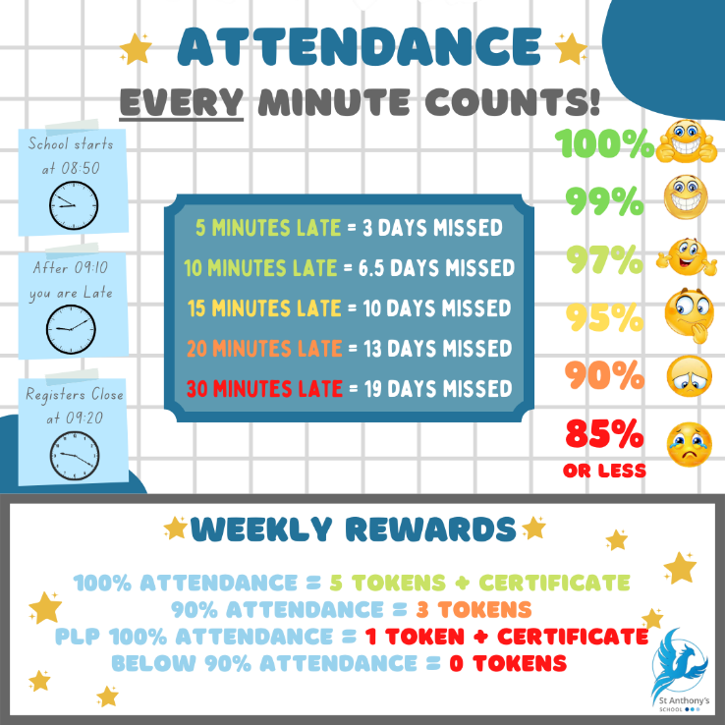The Yearly monitoring is quite simple, all students who receive 95% attendance or above will be presented with a certificate and medal. Students who receive 100% attendance for the year will receive a certificate and medal to take home and their name will be etched onto our Attendance Plaque.  **Uniform Challenge**Each week we are challenging classes to work together to win the best uniform award.

Whilst we understand uniform can be expense and come with sensory challenges for some young people we would like parents to work with us in ensuring uniform or similar colours are worn. This means:

* White logo’d or plain polo shirt
* Black plain trousers
* Navy blue logo’d or plain jumper, fleece or cardigan in the colder months.

If you are having issues with uniform please contact the school to see if there is any way we can support you.

 **Enterprise Fayre**

Last week saw the second year of the Maths Enterprise Week take place across the whole school with the grand finale being the fayre, show cased on Friday morning.

Throughout the week children researched, shopped, cooked and created their goods to sell and compete at the Maths Enterprise Week fair. Each class were proud to promote and present their products to sell.

**WOW!**

What an amazing fayre and super turnout. A massive thank you to all the families, friends and neighbours that turned up to support each classes business stall by purchasing the goodies on offer and participate in the competitions. Your support made the fayre a true success. Thank you.

All classes made a profit above their original business loan of £30. The winning class with the most profit was **Kingsgate** class, making a lucrative £190. The runners up were Stone in second place and Louisa in third.

A huge well done to every class and a special thank you to all the dedicated staff that worked so hard to ensure the children had a great immersive experience within maths. All classes will have the opportunity to take part in a maths related treat next term with the proceeds from the fayre.

***Natalie Stapley, Kingsgate Teacher***



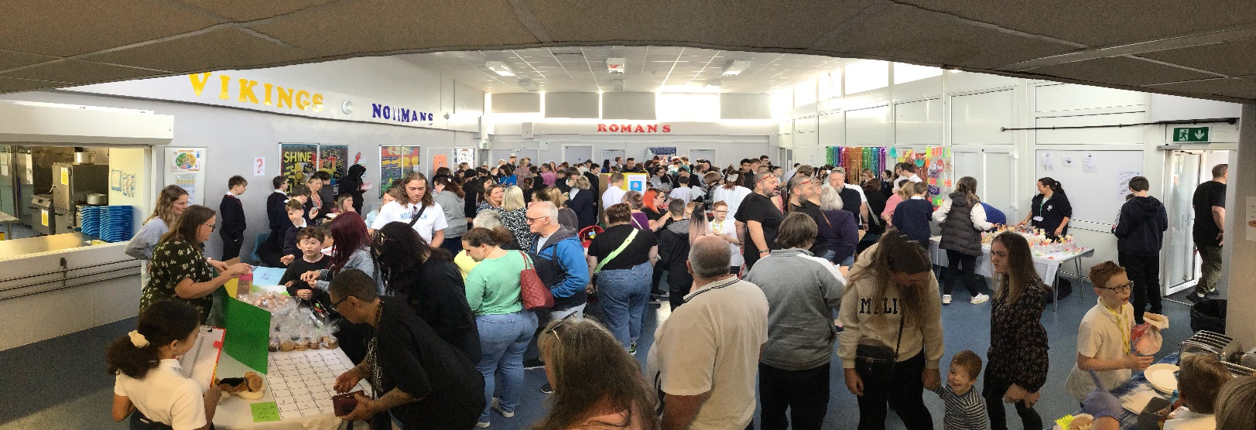

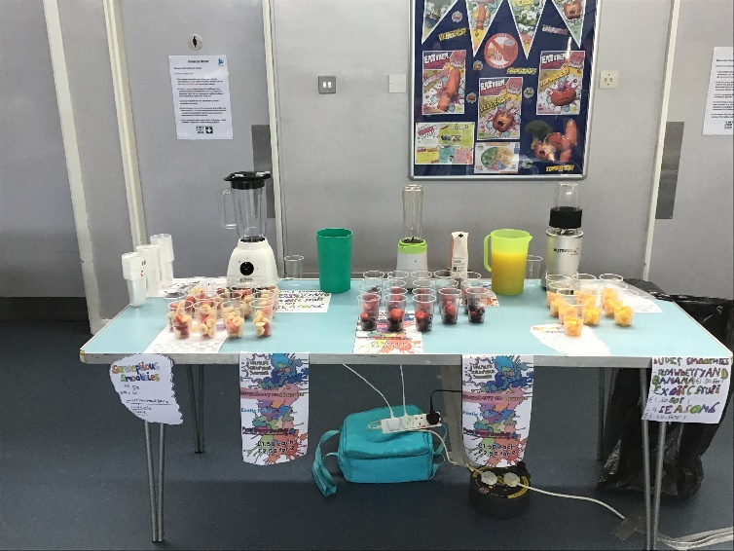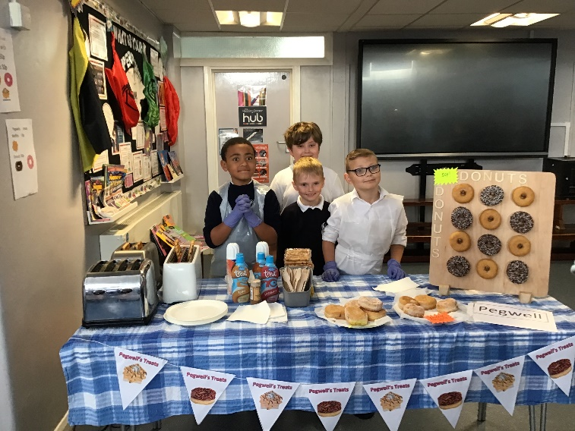

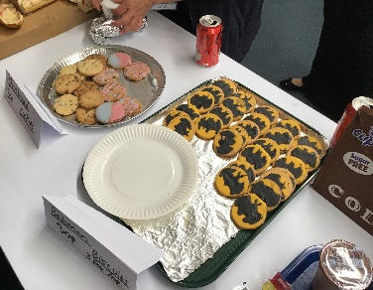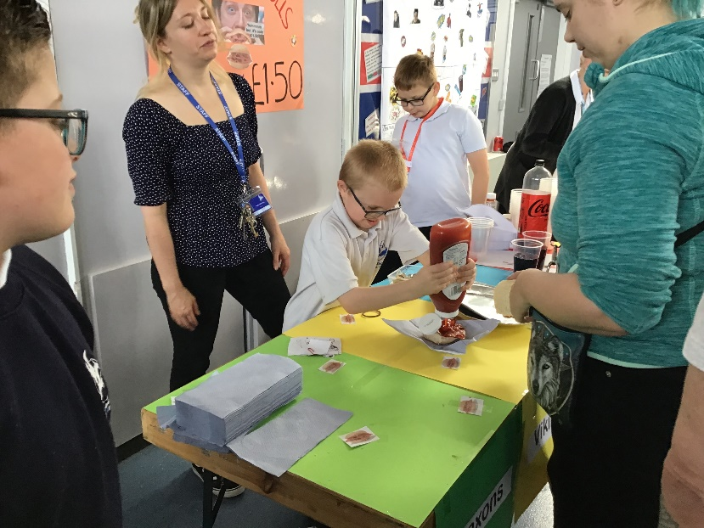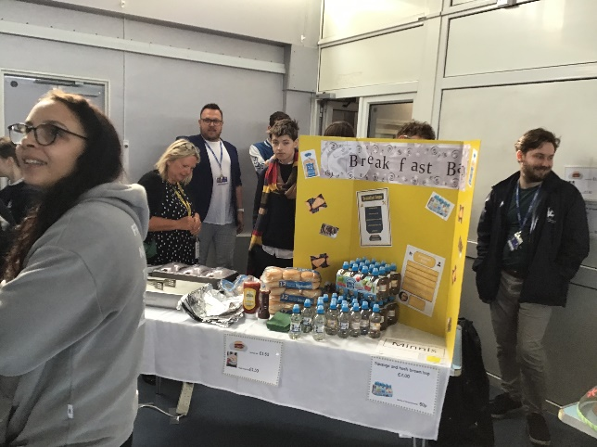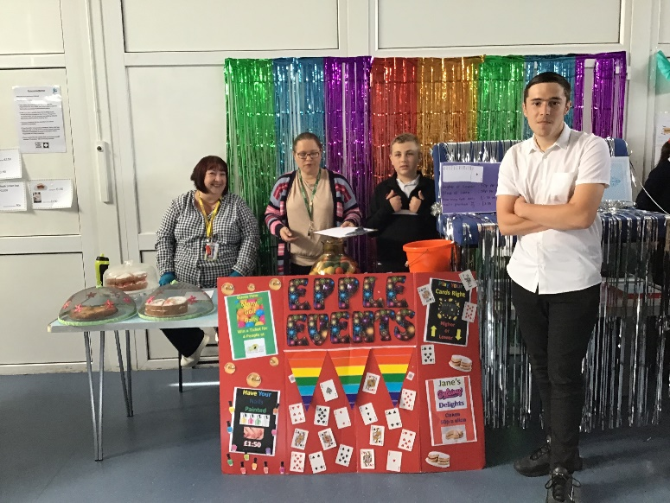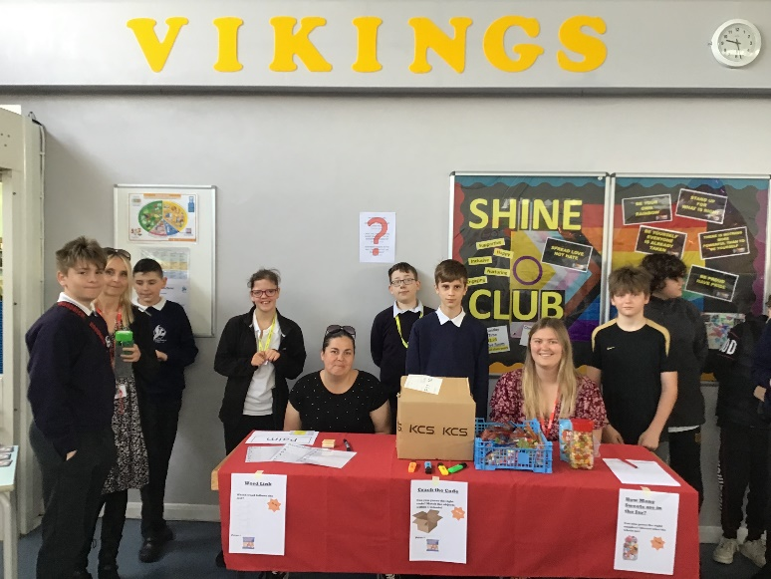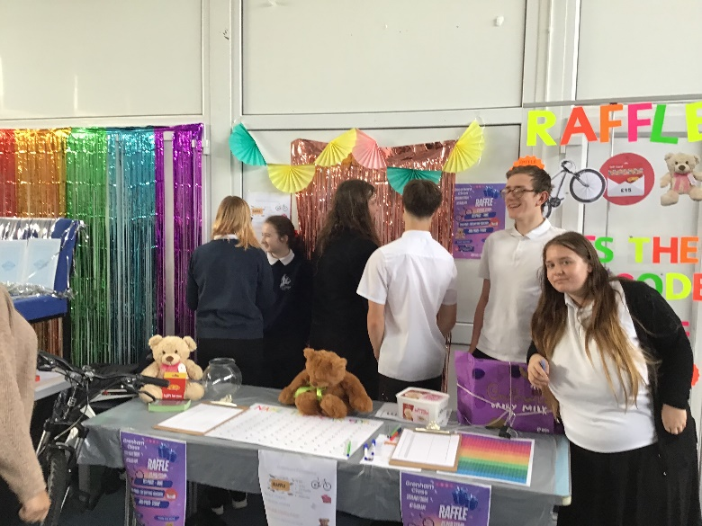

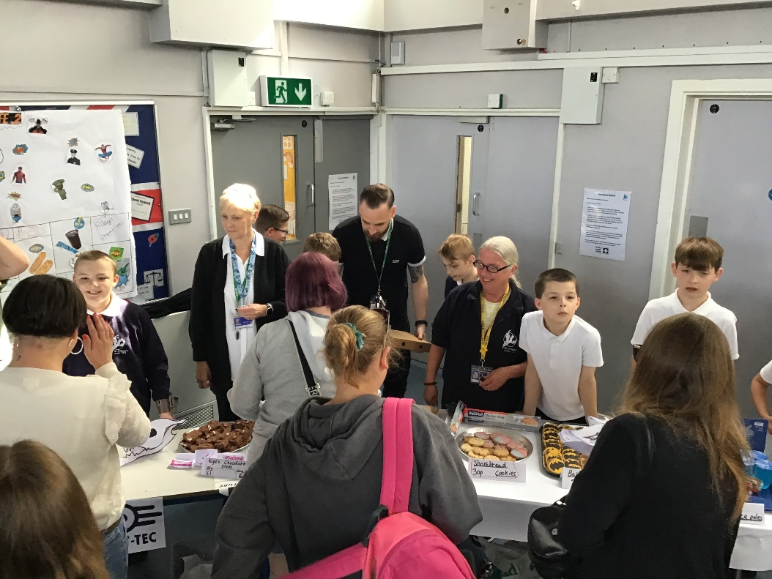  
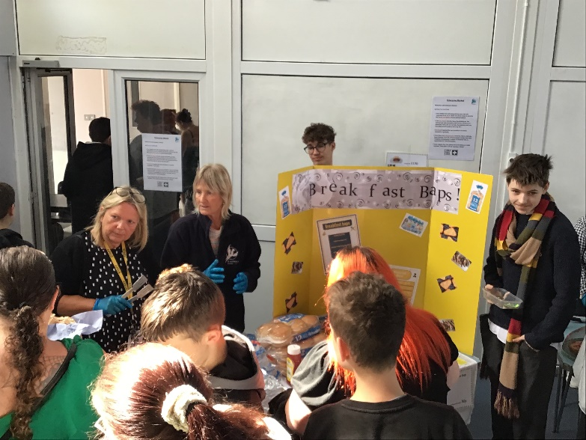  
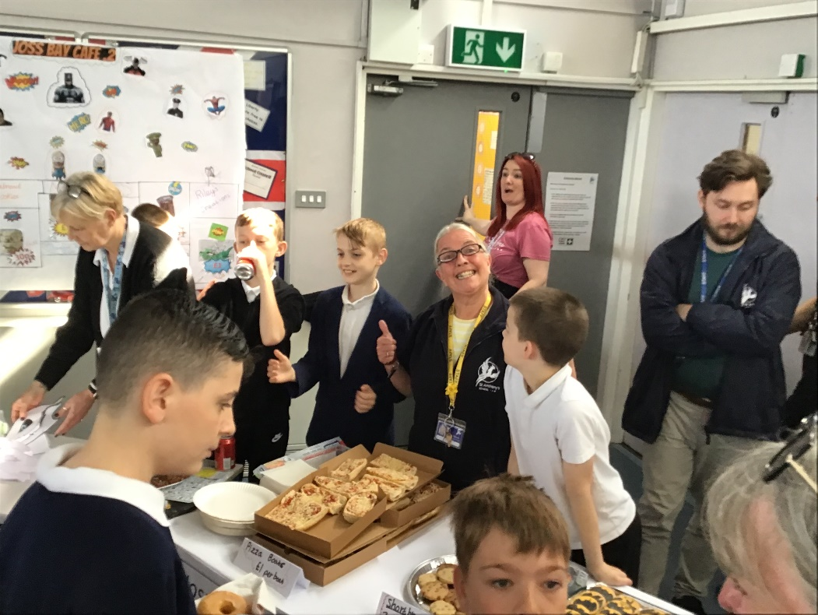  
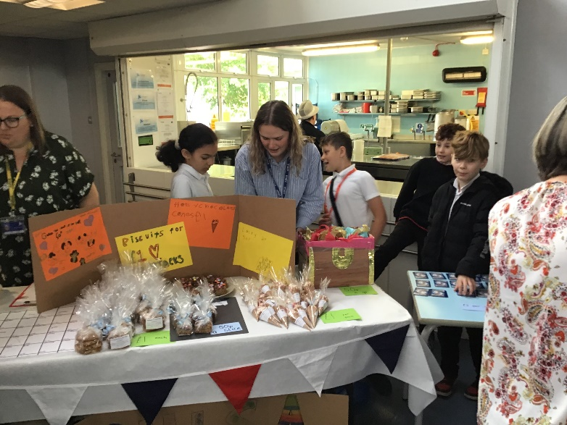

**Kindness Week**

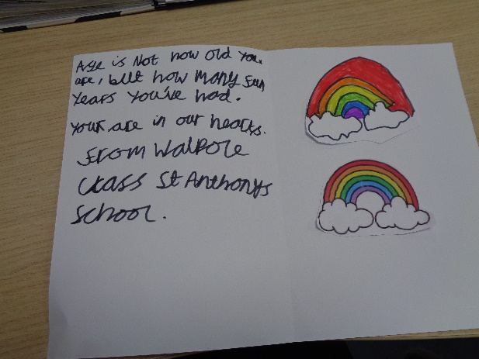For kindness week Walpole class have been thinking about others in the community. We have made cards and some bracelets for care homes to help put a smile on their faces!   
 ***Jodie Whittle – Walpole Teacher***

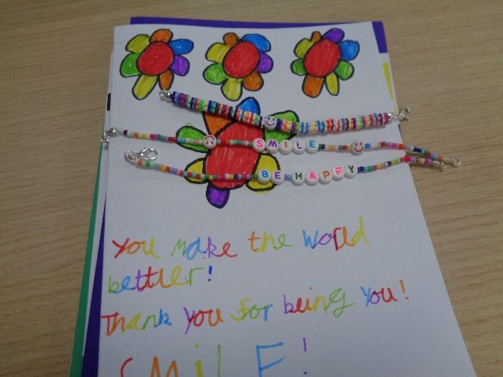



A number of our St Anthony’s staff are taking part in a race for life

It would mean the world to them if you could donate. This can be done via: <https://fundraise.cancerresearchuk.org/team/st-anthonys>   
 ***Rachel Cox, Pegwell Teacher***

**Thanet Schools Art Festival**

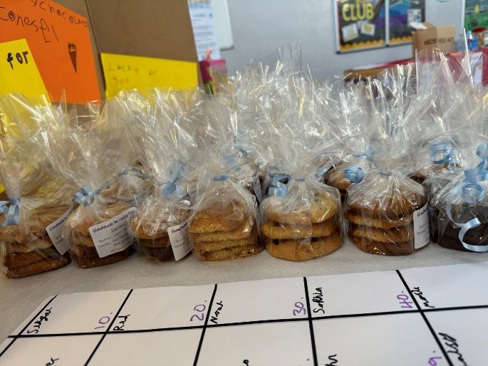As in previous years the school has participated in the Thanet Schools Art Festival.  We submitted 20 pieces of outstanding artwork. One of our GCSE students **Shay-Lee Williams** has won first prize for his age across all the schools in Thanet! This is an outstanding achievement and we could not be prouder. **Jack Warner** has also received a commendation for his work as well, which is outstanding. We noticed that there was also an award given to a St Anthony's alumni too! It is great to see student engaging in art after they leave school as well.

The work was on display at Sainsburys from the 13th -19th May, with the prize giving on the 18th May.  Shay's work will then be put up on display at the Margate Art School in old town from May 21st-May 27th so if you have the chance please do go and have a look at his work and see what he has achieved. It is so great to see our students' work celebrated with so many other schools and students across Thanet. Well done to both **Shay** and **Jack!** This is great news.   
 ***Holly Muxworthy, Art Teacher***

**Cost of Living Support**

With the pressures of costs around us there is a number of services that can support. If you are having troubles please contact them direct or come and talk with us.

A link below is Thanet councils community hub which can sign post to a range of support functions

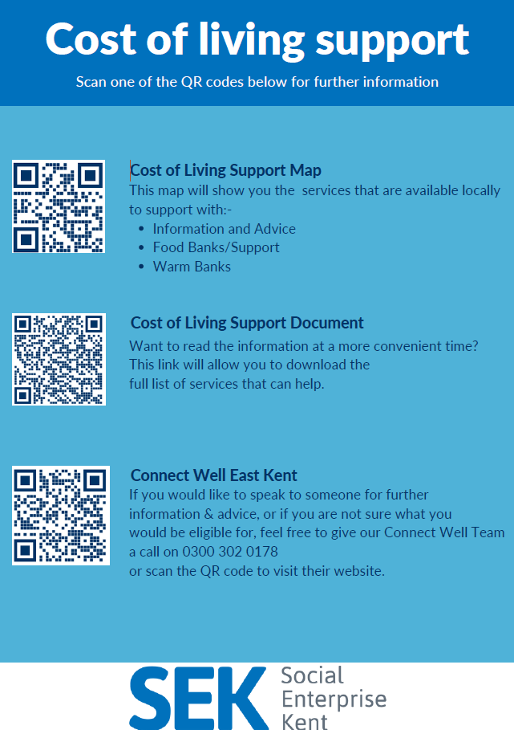

[**https://www.thanet.gov.uk/info-pages/covidcommunityadvice/**](https://www.thanet.gov.uk/info-pages/covidcommunityadvice/)

**DWP - Outreach sessions for families**

Outreach sessions are being held in local venues. Support on hand includes, benefit advice, childcare choices and cost, finding work, cost of living, housing and any queries that our work coach can support the family with.

**Ramsgate** – The Priory Children’s Centre, Cannon Rd, Ramsgate CT11 9SQ

Outreach available every Wednesday between 9am to 12noon. To book a slot to see our adviser at the Priory Children Centre in Ramsgate please contact [jayne.conroy@dwp.gov.uk](mailto:jayne.conroy@dwp.gov.uk)

**Margate**– Six Bells Children Centre, 201 High St, Margate CT9 1WH

Outreach available every Monday between 1pm to 4pm. To book a slot to see our adviser at the Six Bells in Margate please contact

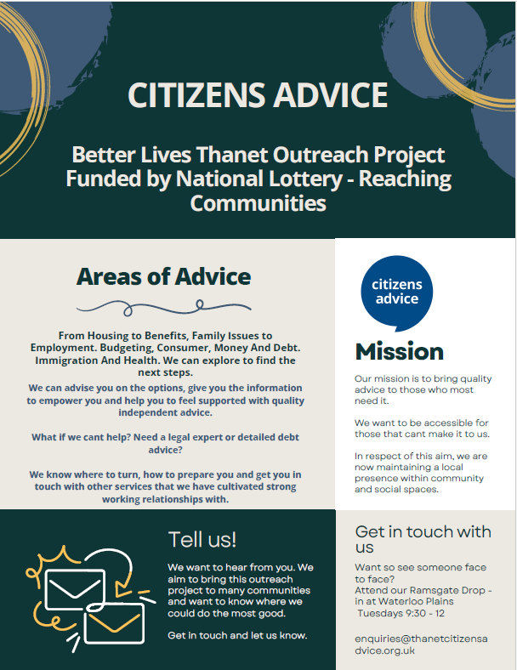[philip.raeburn@dwp.gov.uk](mailto:philip.raeburn@dwp.gov.uk) or [anita.taylor@dwp.gov.uk](mailto:anita.taylor@dwp.gov.uk)

Visit [Kent Resilience Hub](https://kentresiliencehub.org.uk/) where you can increase your understanding, find approaches and tools or navigate your way to support and services relating to resilience and emotional wellbeing.

****[Kooth online](https://www.kooth.com/) support and counselling for 10-25 year olds across Kent and Medway. Offering 1-2-1 counselling, helpful articles, community discussion boards and daily journals.  
[MindEd](https://www.minded.org.uk/) is a free educational resource on children and young people's mental health for all adults.

Find out how to tackle hate online and online trolls with internet matters advice guide for what [online hate](https://www.internetmatters.org/resources/tackling-online-hate-and-trolling/) is and how to support your child. Get tools and tips to support your child’s [digital wellbeing](https://www.internetmatters.org/?gclid=EAIaIQobChMIrbTX5_bt7AIVRuztCh33bQH_EAAYASAAEgLtifD_BwE) on Facebook, Instagram and WhatsApp.

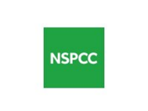Call NSPCC on 0808 800 5000 if you’re worried about the safety of a child. Or call the police on 999 if you think a child is in immediate danger.

Mind's [Action for Children](https://minds.actionforchildren.org.uk/self-esteem) around self esteem and helping your child. Parents with Confidence help your child to emotionally regulate.

Free and confidential advice from [Family Lives](https://www.familylives.org.uk/how-we-can-help/confidential-helpline/) on 0808 800 2222 if you’re finding it hard at home with your child and are struggling to cope**.**

[Young Minds](https://youngminds.org.uk/) have a parent’s helpline, information and resources.