27th January 2023
You should have received a letter yesterday about the schools plan for next week’s Industrial Action. It is a difficult situation that will cause disruption for the school, pupils and parents. A National strike for teachers is unusual. Those teachers choosing to strike, is a decision that they will not have been taken lightly. I would ask you to be understanding and we will hope that a solution will be found quickly. If you have questions please contact me.
Monday 30th January is training day for staff, so no pupils in.
Finally l have spoken to a number of parents who have said they are finding it a challenge to afford lots of things, l would point you to the back of the newsletter as there are a number of agencies that can help so check them out.
Cheers, Mr Page
Forthcoming Dates
- Monday 30th January – training day no pupils
- Wednesday 1st Feb – Strike day
- Friday 10th February last day of Term 3
- Monday 20th February 1st day of Term 4
THRIVE DAY
On Thursday we had a whole day dedicated to THRIVE!
THRIVE is a whole school approach to support our children and young people with developing their social and emotional skills. We do this by engaging the children in lots of activities, which give them time to reflect on positives, look at what they enjoy and even what they don’t. We encouraged them to speak about their feelings and emotions and learn about others in their class.
Some of the activities the children engaged in were; ‘All About Me’ boards, mood boards, under the table drawing, painting, body maps, clay modelling, mindfulness, exploring our senses, scavenger hunts and snack and chat.
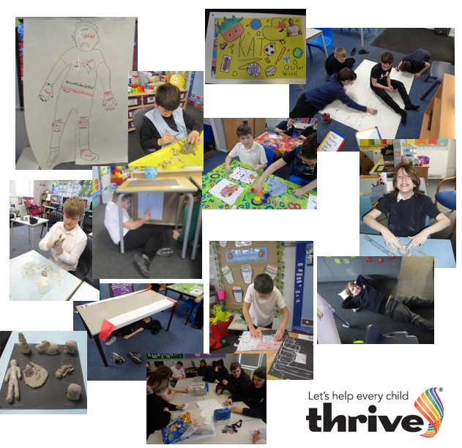
The children had great fun and so did the staff!

Walliams class have been exploring their senses on a scavenger hunt to the Bakery! We have been focusing on what we can smell, hear, taste, see and touch. Obviously, we couldn’t resist the smell of the bakery and came back to school with 10 sausage rolls for the class to share!
We finished the day off with a bit of ‘messy clay’ and made small keepsakes for our loved ones alongside a cuppa with custard creams and bourbons.
A day well spent!
Dahl
George and Finley
Last Tuesday Dahl Class visited Reculver Towers. They had a great time exploring the ruins, even though it was freezing and all the puddles were frozen. They ended their trip with a play in the park and a drink in Hat Hats café. The Caramel lattes were warmly welcomed by all!
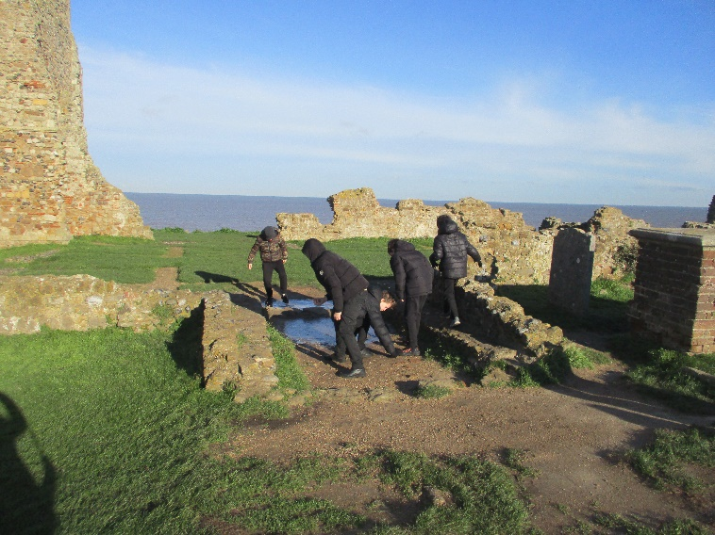
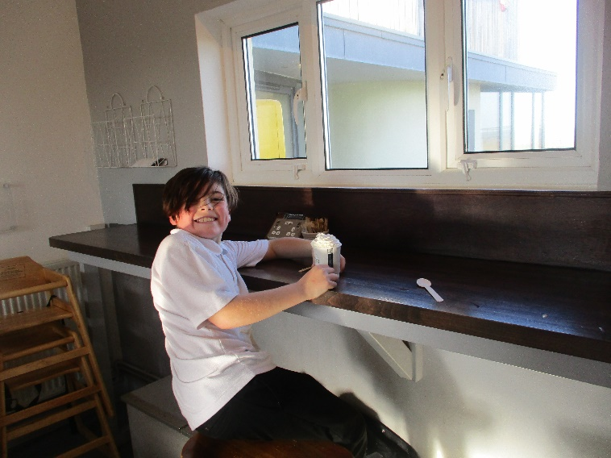
Mason enjoying the view with a cuppa’
Inclusive Games
St Antony’s have played host this term to Inclusive Games sports events. We have welcomed pupils and staff from local special school to compete in a carousel of activities. Last week KS2 CJ, Finley, Jordan, James, Kaitlynn, Martin, Hayden, Drew, Kingsley and Vincent participated.

This week it was the turn for KS3 and
Stanley, Georgia, Macie, Austin, Callum, Bailey, Kaydon, Kacie and Tom E represented the school.
Next week it is KS4 pupils.
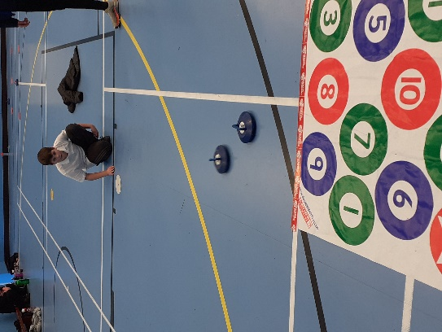

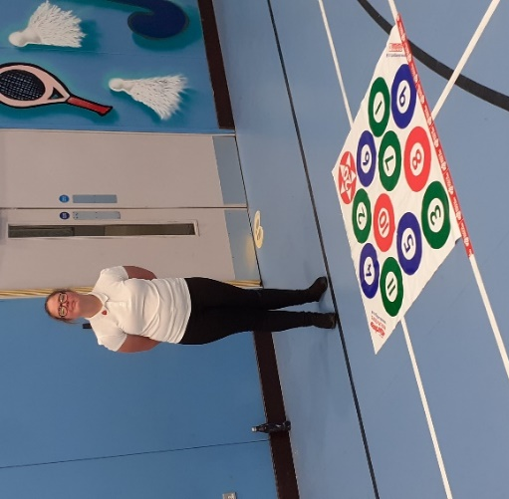

Stanley & Lillie testing out their Kurling capabilities
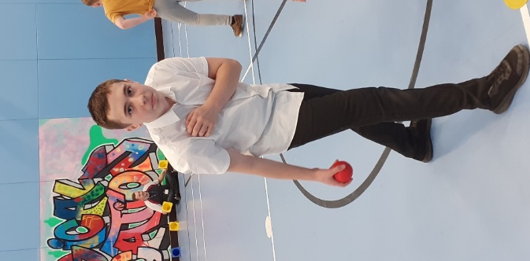

Callum doing St Anthony’s proud with his Boccia skills
Year 11’s
The year 11s have started off the exam season this week with the ‘Speaking Listening and Communication’ section of the English qualification. All the children have done well and could cohesively discuss and ask questions around various topics. They coped especially with adults watching and the additional pressure of being recorded. Olly in Lampard class was pleased it was not as difficult as he had originally anticipated but was relieved when it was over.

Next up, next week, will be the first of two maths papers to sit, followed next term by the second maths paper. We are all feeling confident and ready!
So far, we are on track for most of the Year 11’s to gain Entry Level maths, English, ICT and science. Additionally, a qualification from each of their chosen options groups being either art, cookery, DT, PE or drama.
Lo
Bags of Taste!
Discovery Planet – Science Workshops

– SPORT FOR FUN –
Saturdays (term time) 9.00 - 10.00 at St Anthony's School. A Saturday morning sports club for children with SEND.
BE ACTIVE -SHORT BREAK - Saturdays (term time) 10.30 - 12.00 at Foreland Fields School
BE ACTIVE -SHORT BREAK - Wednesdays (term time) 4.30 - 6.00 at Foreland Fields School
Please read the PDF letter attached for more information and complete the following referral form to declare interest:
https://forms.office.com/r/EZwuMEZmEd
CLIP N CLIMB - Thursdays Session 1: 4.30-5.30pm Session 2: 5.30-6.30pm.
To book please clink on this link: https://forms.gle/EHYHiAtxWfE3XYDz6
MARGATE YOUTH FC KICKS 4 KIDS - Tuesdays 5.00-5.45 at Margate FC
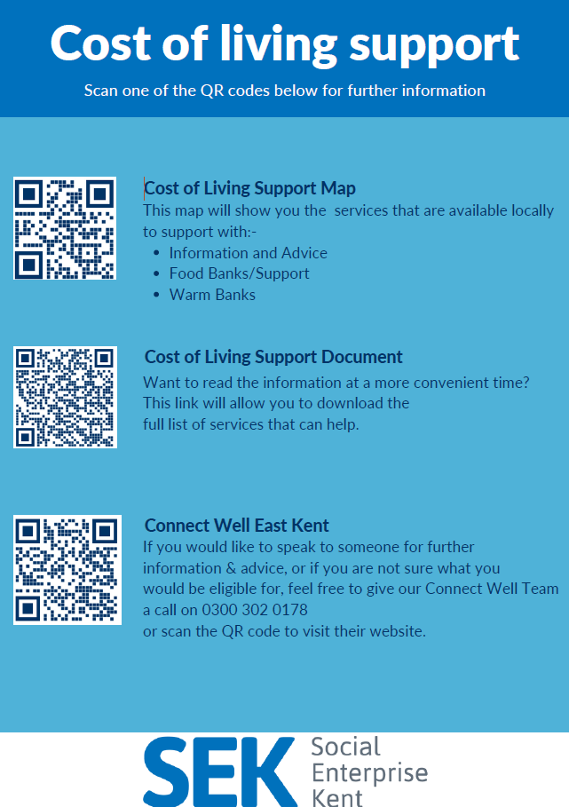
Inclusive football sessions delivered by Inclusive Sport. To register please visit: https://www.margateyouthfc.co.uk/events/kick-inclusive-football-sessions
Cost of Living Support
With the pressures of costs around us there is a number of services that can support. If you are having troubles please contact them direct or come and talk with us. A link below is Thanet councils community hub which can sign post to a range of support functions.
https://www.thanet.gov.uk/info-pages/covidcommunityadvice/
DWP - Outreach sessions for families
Outreach sessions are being held in local venues. Support on hand includes, benefit advice, childcare choices and cost, finding work, cost of living, housing and any queries that our work coach can support the family with.
Ramsgate – The Priory Children’s Centre, Cannon Rd, Ramsgate CT11 9SQ
Outreach available every Wednesday between 9am to 12noon To book a slot to see our adviser at the Priory Children Centre in Ramsgate please contact
jayne.conroy@dwp.gov.uk

Margate – Six Bells Children Centre, 201 High St, Margate CT9 1WH
Outreach available every Monday between 1pm to 4pm To book a slot to see our adviser at the Six Bells in Margate please contact
philip.raeburn@dwp.gov.uk or anita.taylor@dwp.gov.uk
Thanet Children's Centres - Cost of Living Support Sessions
Are you worried about the increasing cost of living and want to know what support is available? Need help liaising with the housing team? Need support with training or employment, struggling with childcare and work or need some help with budgeting?
- Mondays - Six Bells Children's Centre, 201 High Street, Margate CT9 1WH
- Wednesdays - Priory Children's Centre, Ramsgate CT11 9SQ
To book an appointment please email: thanetccevents@kent.gov.uk
Royal British Legion - Energy Support
The Royal British Legion, the UK's largest charity dedicated to supporting the Armed Forces community, has today launched a new grant scheme for veterans and their families who are struggling to pay their energy bills. The initiative will provide non-repayable emergency grants of up to £2,400 a year (£200 a month) and is available across the UK.
In general, the Armed Forces community includes those who have served, or are serving, in the Royal Navy, British Army or Royal Air Force, as well as their families, dependants and carers – which can include children, current and former spouses and partners, widows and widowers.
To apply it's worth checking your eligibility on its website or by calling its helpline on 0808 802 8080.
Visit Kent Resilience Hub where you can increase your understanding, find approaches and tools or navigate your way to support and services relating to resilience and emotional wellbeing.
Kooth online support and counselling for 10-25 year olds across Kent and Medway. Offering 1-2-1 counselling, helpful articles, community discussion boards and daily journals.
MindEd is a free educational resource on children and young people's mental health for all adults.
Find out how to tackle hate online and online trolls with internet matters advice guide for what online hate is and how to support your child. Get tools and tips to support your child’s digital wellbeing on Facebook, Instagram and WhatsApp.
Call NSPCC on 0808 800 5000 if you’re worried about the safety of a child. Or call the police on 999 if you think a child is in immediate danger.
Mind's Action for Children around self esteem and helping your child. Parents with Confidence help your child to emotionally regulate.
Free and confidential advice from Family Lives on 0808 800 2222 if you’re finding it hard at home with your child and are struggling to cope.

