**28th January 2022**

**Dear Parents/Carers**

The first newsletter of the new term starts with the now old story of COVID. St Anthony’s, like the rest of the country, has dealt with very high numbers of both staff and pupils being off this term with COVID, this has meant a significant challenge for school to ensure that the risk to pupils and staff is minimised. So a very big thank you to parents and carers for your continued support and understanding, I would like to think the need for early morning phone calls is now past.

The resilience we have seen from children has been amazing, they have dealt with the many changes of staff, adaptions of their timetables with only minor issues. Finally, a big thank you to the school staff who have pitched in to ensure that those pupils able to attend school, carry on with a wonderful range of learning opportunities.

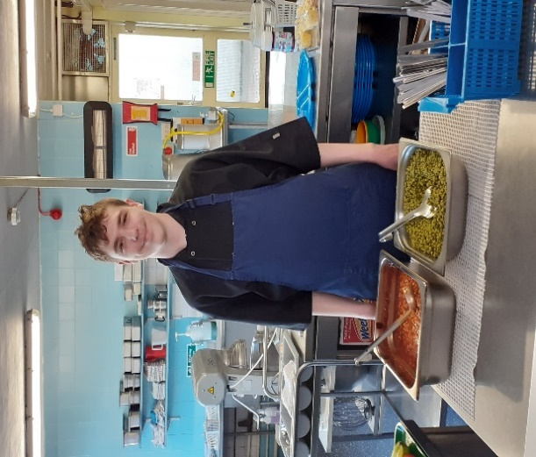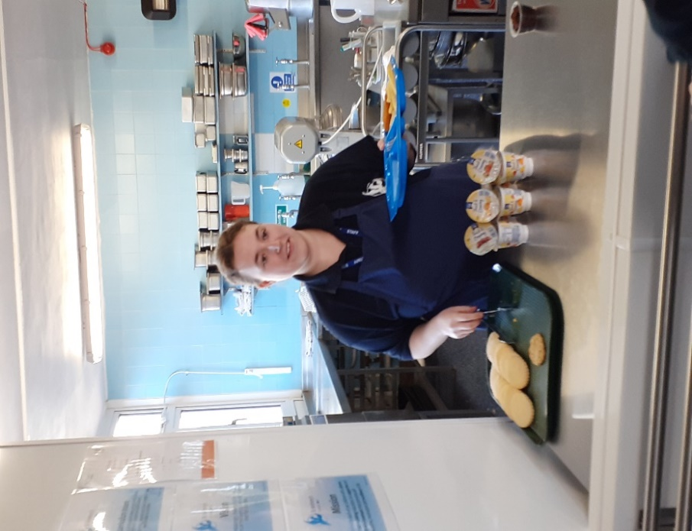

When we were short staff in the kitchen, Bradley applied his

skills learnt in Food technology

to step in and help serve lunch.

He then did a brilliant job in

helping Liz to wash and clean up.

Jade over the past couple of

weeks has not only taught a

number of classes across the

school but also stepped up to

help in the kitchen.

**HELPING HANDS**

**COVID**With the high number of cases in school, your continued support to test secondary pupils twice a week is very much appreciated. If you child tests positive the current guidance is to isolate for 5 days. Test on day 5 is negative lateral flow test, test again on morning day 6, if this is also negative they are welcome to return to school. If you child has been in a class with a positive test, they would be deemed close contact and would need to test each day for five days but as long as negative test results can come into school. If you need tests, please ask your child’s teacher as the school has tests to share. The current variant as we have seen is very infectious, so if your child shows any symptoms

**New Staff**

This term we welcomed three new teachers to the school community.

**Rachel Cox**

Rachel joins the school after working in a number of local primary schools. She will be teaching in Potter Class.

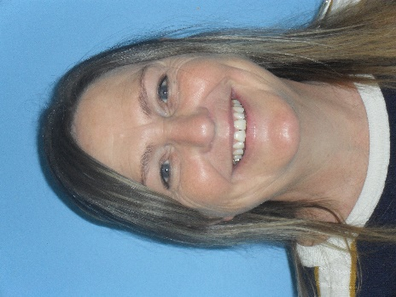

**Jodie Whittle**

Jodie joined at the end of last term and is teaching our Donaldson Class. Initially coming to the school as a Student at Canterbury Christchurch University and clearly was so impressed she wish to come back and work with us!



**Claire Foley**

Claire joined the school from Bower Grove School in Maidstone to cover Amy’s maternity in term 4 but with all the staffing challenges at the start of term, she began teaching Morpurgo Class this term.

We also have several new Learning Support Assistants working in the school this term, they are ***Carol Piper*** in Milne Class, ***Nargis Syed*** supporting Walliams and ***Terry Taylor*** supporting Morpurgo.

We also have two students from Canterbury Christchurch University doing their placements with us for the next two terms. ***Bradley Slade*** is working in Blyton Class and ***Kate Farrer*** is working in Dahl.

A warm welcome to you all!

**Key Stage 4 Qualifications**

This term our year 11 students have been attempting their Early Entry Maths and

English exams.

We are all very proud of the mature attitude they have shown on exam days, and we

have enjoyed seeing their joy and pride at

achieving passes in these subjects.

This school year, we have introduced a new Science qualification in KS4, which will include exams in Biology, Chemistry and Physics.

We are already achieving passes in these subjects for some students.

We are looking forward to seeing how proud you will all be at the leavers day assembly.

**Donaldson Reward Class Trip**

On Thursday 27th January the pupils in Donaldson enjoyed a day out at Flip Out. They managed to gain this reward through their good behaviour and effort in class. The day was enjoyed by all (staff and pupils) and we had a ‘flipping’ great time.



**Forest School**

Milton class forest school group were involved in preparing and cooking a huge chicken and vegetable curry with garlic naan breads last week. All the children were involved in lighting and maintaining the fire, stirring, adding spices and other ingredients. The curry was then shared between all the classes throughout the school, but sadly not with the Headteacher.

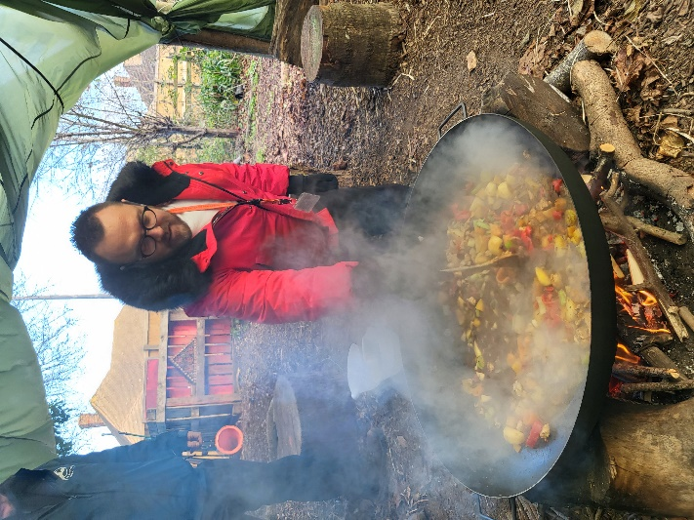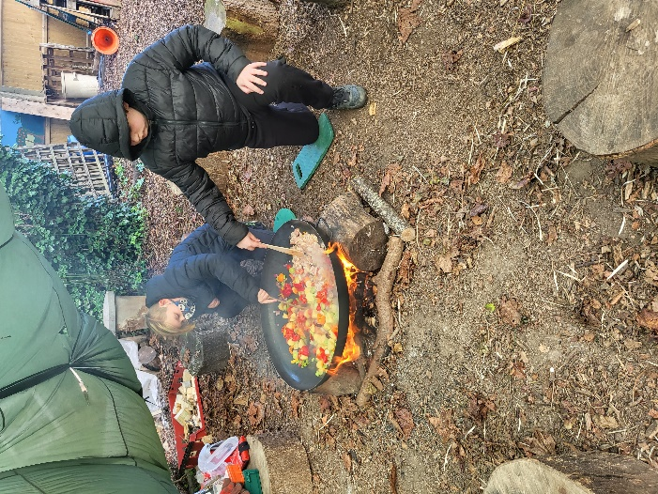

*Gavin, Austin & Taylor cooking up a storm with their vegetable curry!*

**St Anthony’s Sports**

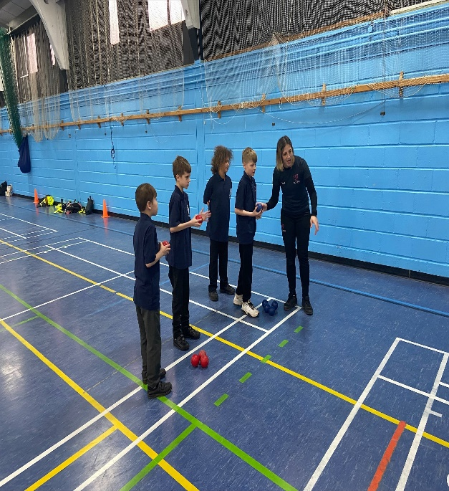

KS2 were able to attend a Boccia/Kurling

event held by Inclusive Sport at

Baypoint Sports Club.

All four pupils loved the event and took

part with smiles on their faces through-out.

Pupils left with brand new skills in a fun

packed afternoon as well as a certificate

and wrist band to reward their efforts.

**Well done!**

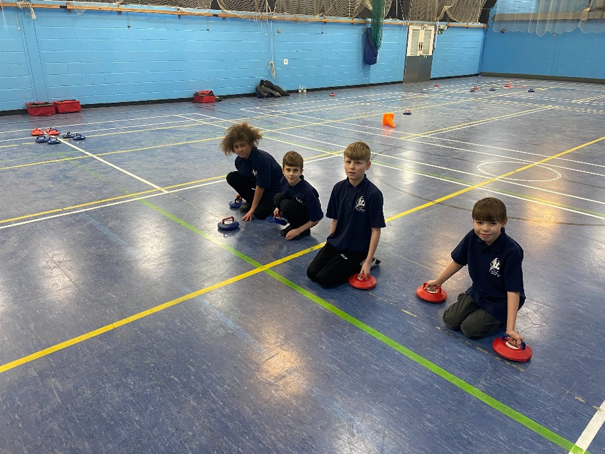



**World Book Day 2022**



Just a reminder that World Book Day is coming up on   
**Thursday 3rd March 2022.** 

Start planning a costume. It would be great to see pupils dressed up as book characters.

The best costumes have always been homemade. Here are two   
wonderful examples of homemade costumes from previous years!

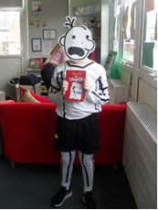

Mr R Page *Headteacher*

**Dates**

* Monday 31st January – Training Day *(no pupils)*
* Tuesday 8th February – Online Safety Day
* Friday 11th February – Last Day term 3
* Monday 21st February – First Day term 4
* Thursday 3rd March –World Book Day
* Monday 14th March – Training Day *(no pupils)*
* Friday 1st April – Last day term 4 early finish

*Final thoughts…*

[Kent Parents and Carers Together (PACT)](https://www.kentpact.org.uk/)  
Kent PACT is a way to empower you as parents and carers and enable you to have your say. The combined voices of Kent PACT are fed into how services are designed and delivered in Kent. <https://www.kentpact.org.uk/>



As a parent or carer of a young person, you are extremely influential to their resilience journey. Visit [Draw Your Own Solution](https://kentresiliencehub.org.uk/parent-carers/draw-your-own-solution-parents-campaign-page/) for more information.



Developed by the NHS in Kent, [Good Mental Health Matters](https://www.goodmentalhealthmatters.com/) is a free resource for primary and secondary parents and young people. Online resources include educational videos and online quizzes.



[Kent Community Health NHS Foundation Trust (KCHFT)](https://www.kentcht.nhs.uk/2020/11/06/online-solihull-approach-parenting-courses-for-anyone-caring-for-a-child-in-kent-and-medway/) are offering online ‘Solihull approach’ parenting courses for anyone caring for a child in Kent and Medway.



Visit [Kent Resilience Hub](https://kentresiliencehub.org.uk/) where you can increase your understanding, find

approaches and tools or navigate your way to support and services relating to resilience and emotional wellbeing.



[Kooth online](https://www.kooth.com/) support and counselling for 10-25 year olds across Kent and Medway. Offering 1-2-1 counselling, helpful articles, community iscussion boards and daily journals.



[MindEd](https://www.minded.org.uk/) is a free educational resource on children and young people's mental health for all adults.



Find out how to tackle hate online and online trolls with Internet matters advice guide for what [online hate](https://www.internetmatters.org/resources/tackling-online-hate-and-trolling/) is and how to support your child. Get tools and tips to support your child’s [digital wellbeing](https://www.internetmatters.org/?gclid=EAIaIQobChMIrbTX5_bt7AIVRuztCh33bQH_EAAYASAAEgLtifD_BwE) on Facebook, Instagram and WhatsApp.



Call NSPCC on 0808 800 5000 if you’re worried about the safety of a child. Or call the police on 999 if you think a child is in immediate danger.



Mind's [Action for Children](https://minds.actionforchildren.org.uk/self-esteem) around self esteem and helping your child. Parents with Confidence help your child to emotionally regulate.



Free and confidential advice from [Family Lives](https://www.familylives.org.uk/how-we-can-help/confidential-helpline/) on 0808 800 2222 if you’re finding it hard at home with your child and are struggling to cope**.**



[Young Minds](https://youngminds.org.uk/) have a parent’s helpline, information and resources.