Friday 29th April 2022

Term 5 has started well; the sun continues to shine, but it would be nice to feel just a bit warmer with the wind. Pupils are hard at work, as you will see in this newsletter.

Don’t forget Monday 2nd May is a Bank Holiday!
Have a lovely long weekend.

Food Hygiene Inspector Report
Thanet’s District Food Hygiene Inspector recently visited the school. The report highlighted excellent standards throughout the kitchen. A big well done to Liz, Andrew and Imogen.

Milne Tidy Up
The poor weather at the end of the last term meant that Milne were not able to do their litter pick, so they have completed their pledge this week. Walking around the school, they found several bags of rubbish in one hedge alone. Well done Milne.

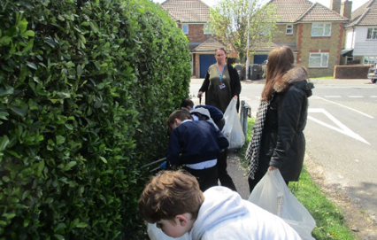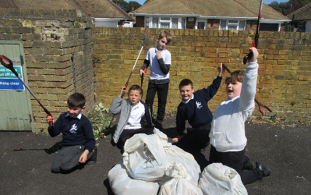

Celebrating 10th Birthday of 'The Daily Mile'

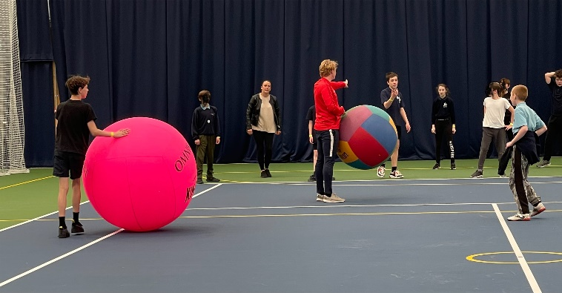
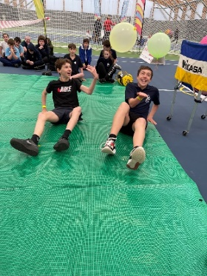
The aim of The Daily Mile is to improve the physical, social, emotional and mental health and wellbeing of our children – regardless of age, ability or personal circumstances.

Pupils from Cowell Class visited The University of Kent for the day on Thursday 28th April and competed in many different alternative ball-based sports, led by Olympian trainers and other experts.

Cowell demonstrated great sportsmanship and teamwork working alongside and competing against other schools.

Lampard Class Trip
On 21st April Lampard class visited Dover Castle, where we were able to join in with a 'code and cipher' session. We had to enter the underground tunnels and walk through the 'hospital section' to get to the code room. We had to complete ID cards, so that we could prove that we were allowed to be in the cipher room. We were able to use some of the equipment in the room, and try on a uniform jacket and hat.
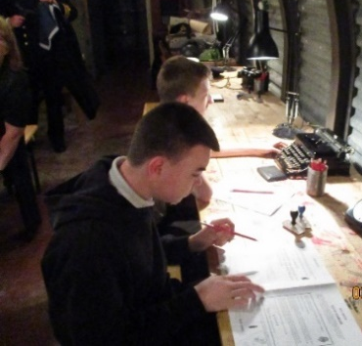
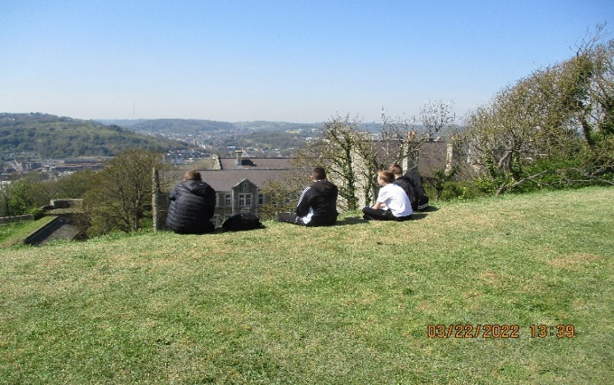
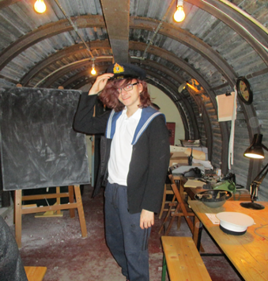
There was a coded message on a board at the front of the room which we had fun solving. Then the hard work started - we had to find out the name of the spy that was in the castle.

We were able to work in small groups if we wanted and Commander Walker was very good at helping us when we were stuck. We were all, eventually, able to solve the clues and name the spy. We were led out through another part of the tunnels so we were able to walk through the 'kitchen' which was amazing as there were plates of food and loaves of bread laid out which looked really realistic. Once we left the tunnels, we were allowed to spend the rest of the day at the site to visit all the other interesting buildings. Gill was keen to show us the Roman Lighthouse - when we got there we found that it was right next to the Saxon Church - obviously Gill must have known and actually that was what she wanted us to see, as Saxons are so good!!

Fishing – New Record
Taylor caught a carp and set a new lake record of 11lb 3oz right at the end of his fishing session Thursday. The fish had the name ‘Split Fin’ due to it having a split dorsal fin.

Marcus M is a Master Chef at Home!
After cooking calzone in his cookery lesson, he went home and made it with his Mum. It looks amazing! Can you recreate any dishes you have learnt at school?

Coffee & Chat
STARTING SOON!
St. Anthony's Coffee and Chat. Please come and join us for a coffee morning. We will be holding St. Anthony's Coffee and Chat every
Month on a Monday morning 9.15 until 10.30. All parents and carers welcome. Initially this will be informal chat lead by you the parents and carers.

This will be run by Kirstie and Amy, the Emotional Wellbeing Worker who is now in school every
Monday. We look forward to seeing you.
- Monday 23rd May
- Monday 13th June
- Monday 11th July

Mental Health Awareness Week
Mental Health Awareness Week will run from
Monday 9th -15th May. The theme for this year is loneliness, the effect it can have on mental health and what we can do to reduce loneliness in our communities.

The Mental Health Foundation have identified loneliness as one of the most prominent issues that the public feels need to be addressed; particularly as feelings of loneliness and isolation have increased significantly since the beginning of the COVID-19 pandemic.

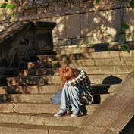
According to a recent article by Siva (2020), it is easy to overlook the concept of children and young people feeling lonely as they are usually surrounded by other children, teachers, family, or carers. However, it is important to keep in mind that being surrounded by others does not necessarily mean that you are experiencing a connection with another person or group of people.

Loneliness in children and young people has been linked to various health problems including poor sleep, poor mental health, and poor cognitive functioning (Siva, 2022). Therefore, it is an important issue to tackle.

Research tells us that since the start of the COVID-19 pandemic and the subsequent change in how we have been able to interact with one another, feelings of loneliness in children and young people have increased. Although young people could connect virtually with one another, many reported that it just was not the same as face-to-face interactions (Watson et al., 2021), and did not ease feelings of loneliness.

1. Reach out to others wherever possible.

2. Build the relationships that you want with other people, whatever this may look like!

3. Identify what things make you feel connected to others. Try to incorporate more of this into your daily life.

4. Don’t be afraid to try different things and work out what works for you!

5. It can be hard maintaining friendships and relationships but it is worth it! Don’t give up.

Helping Hands - Fuel Support Scheme
The ‘Helping Hands’ scheme offers fuel vouchers towards the cost of heating bills and essential items related to keeping warm. The vouchers will support households facing financial hardship as a direct result of coronavirus (COVID-19). Applicants can apply for up to three vouchers towards heating bills (must have a top-up meter) or essential items such as:
• boiler repairs
• temporary heaters
Referrals can only be made by professionals or trusted partners. Call: 0800 233 5255 Visit:
https://south.greendoctors.org.uk/

Energy Advice
Access to schemes to install insulation and low carbon heating: Energy in the Home Advice or email energysaving@thanet.gov.uk

Dates
- Monday 2nd May – Bank holiday
- Friday 27th May – Last Day of Term 5
- Monday 6th June – First Day of Term 6
- Thurs 21st July - Last Day of Term 6
Visit Kent Resilience Hub where you can increase your understanding, find approaches and tools or navigate your way to support and services relating to resilience and emotional wellbeing.
Kooth online support and counselling for 10-25 year olds across Kent and Medway. Offering 1-2-1 counselling, helpful articles, community discussion boards and daily journals.
MindEd is a free educational resource on children and young people's mental health for all adults.
Find out how to tackle hate online and online trolls with internet matters advice guide for
what online hate is and how to support your child. Get tools and tips to support your child’s digital wellbeing on Facebook, Instagram and WhatsApp.

Call NSPCC on 0808 800 5000 if you’re worried about the safety of a child. Or call the police on 999 if you think a child is in immediate danger.
Mind's Action for Children around self esteem and helping your child. Parents with Confidence help your child to emotionally regulate.

Free and confidential advice from Family Lives on 0808 800 2222 if you’re finding it hard at home with your child and are struggling to cope.
Young Minds have a parent’s helpline, information and resources.

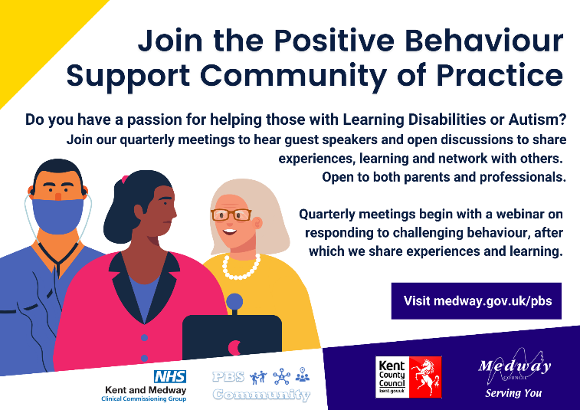
COMMUNITY CLOTHES BANK
