**31st March 2023**

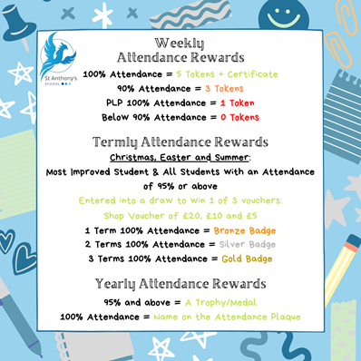Just like that another term is over, the pupils have had some wonderful experiences this term and as the weather gets warmer, I am sure many more will be enjoyed.   
  
This Friday pupils will be finishing at **1:30pm** so please add to your diaries!

Have a wonderful spring break, take time to rest and explore the local sites and scenes. Flowers are blooming, the sun is appearing more and vitamin D makes a world of difference to our body and mental health.   
  
The longer evenings gives us a little bit more time to spend with family, friends or doing the things we love. *Take time, take care.*

See you all in Term 5!  
  
**Dates for the diary**

* **Mon 17th April** first day term 5
* **Friday April 28th** training day (no pupils)
* **Mon 1st** **May** Bank Holiday
* **Mon 8th** **May** Kings Coronation

**British Values**



**Attendance**Well done to all the children who consistently achieve a weekly attendance of 100%. We monitor attendance from Friday-Thursday allowing us to celebrate those children in our Friday Morning Assembly for their 100% attendance.   
  
Each child who achieves 100% attendance for the week gets a certificate and **5** tokens, any child who achieves 90% attendance will receive **3** tokens for the reward Shop.   
  
We also celebrate our students on a personal learning plan, these students are highly unlikely to achieve an attendance of 90% due to the nature of their timetable, therefore those students on PLP’s who attend 100% of their timetable that week will also receive a certificate and **1** token to spend in the reward shop.

**Spring Term Reward Trip**

20 children were chosen to go on the Spring reward trip for a range of different reasons.   
The trip was a huge success and lots of the children really pushed themselves to take part in both the climbing and the Scooters.   
A shout out to ***Tyler*** and ***Cody*** who really excelled at the activities and ***Fraser, Taylor G***, and ***Lillie*** who tried really hard. All the hard work meant there was not much energy left to eat all the pizza but with help from a couple of staff, everything was finished off and tidied away. As usual St. Anthony's young people were a credit to the school, they were polite and engaged with the instructors really well. The next reward trip will be in the summer, and this will be based on class points.

****



****

****

****

****

**DT Visit to Hornby**

The DT after school club pupils visited Hornby to see layouts, available resources and engines, as they are making our own scenery for the school Hornby Rail Track lay out in DT. This is an ongoing project that will continue to be expanded year after year once the initial set up is finished by the end of this school year, ready for the summer fair.

**** ****

**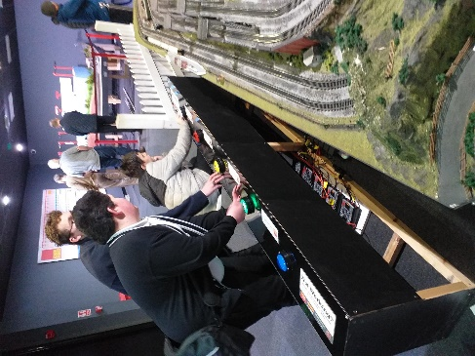** ****

**Dahl - Monkton Nature Reserve**Dahl visited Monkton Nature Reserve last week: the children thoroughly enjoy investigating the animal skeletons and fossils. We all enjoyed the walk and beautiful views. A fun morning out for all. We really recommend a visit.

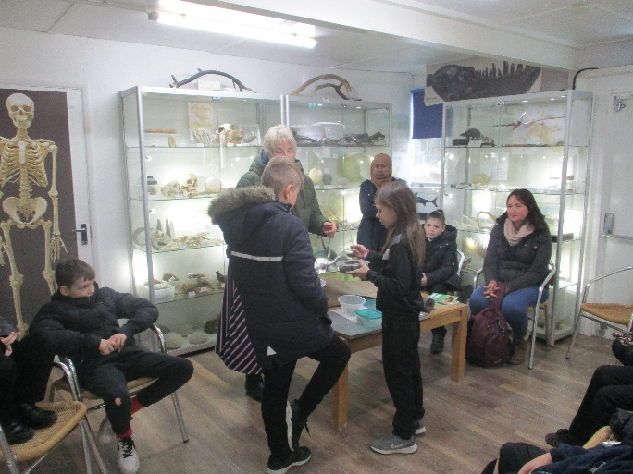

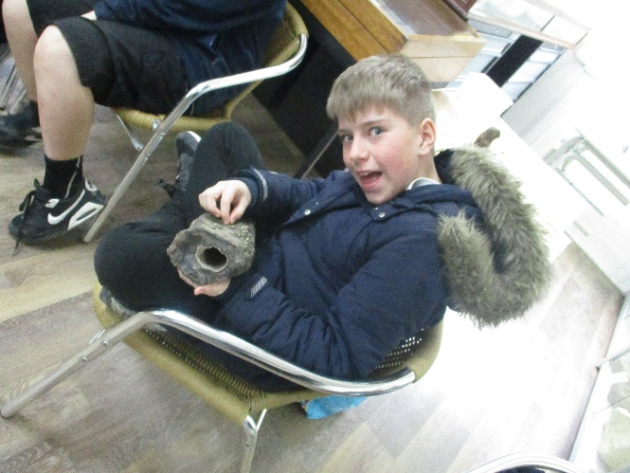

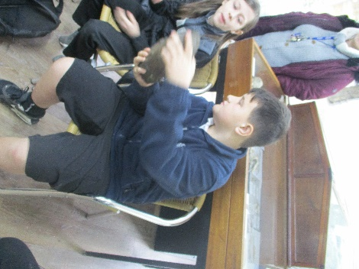

**Litter Picking**

Blyton class went out on a walk around our local neighbourhood to clean up all the trash that we could find. We made it into a competition between us in small groups to see who could collect the most trash. We also kept a tally chart to link in with our Maths. Between the 6 children that took part – they collected **463** pieces of rubbish.

**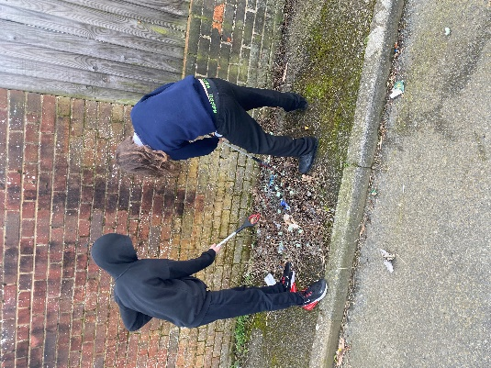**

**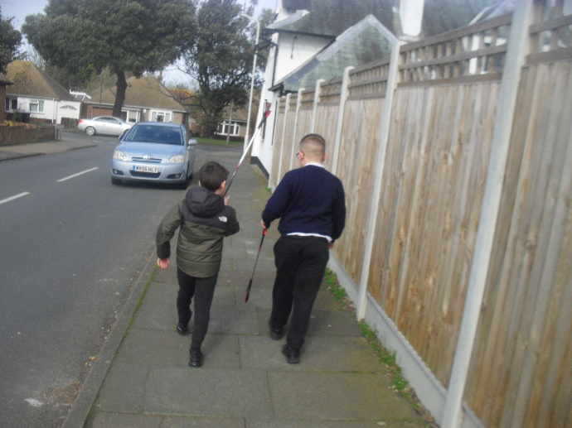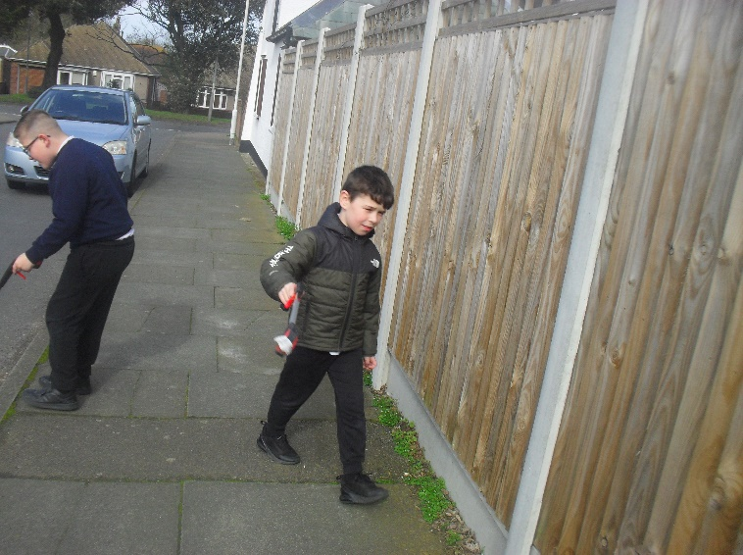**



**Matchbox Challenge**

****Could you win our Maths Matchbox Challenge?  
  
Take part in our Easter holiday Maths Matchbox Challenge. It’s easy! All you need to do is fill the matchbox with DIFFERENT items. Then return it to the office, at the latest on **21st April 2023.**

**Eggcellecent Easter Facts**

**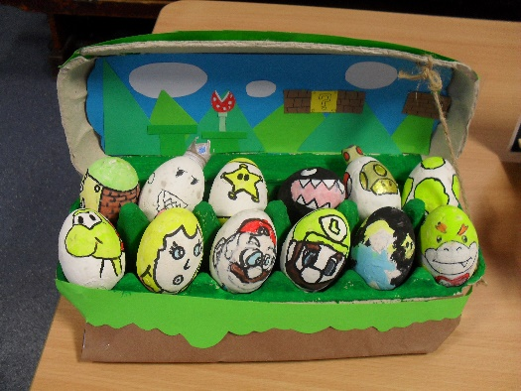**

## The holiday was named after the Anglo-Saxon Goddess, Eostre

## More than 1.5 million Cadbury Creme Eggs are produced every day

## The act of painting eggs originates from a Ukrainian tradition

## The UK’s first chocolate egg was produced in Bristol in 1873

## Germany has an Easter tradition called the egg dance. People put eggs on the floor and dance around them, trying not to break any.

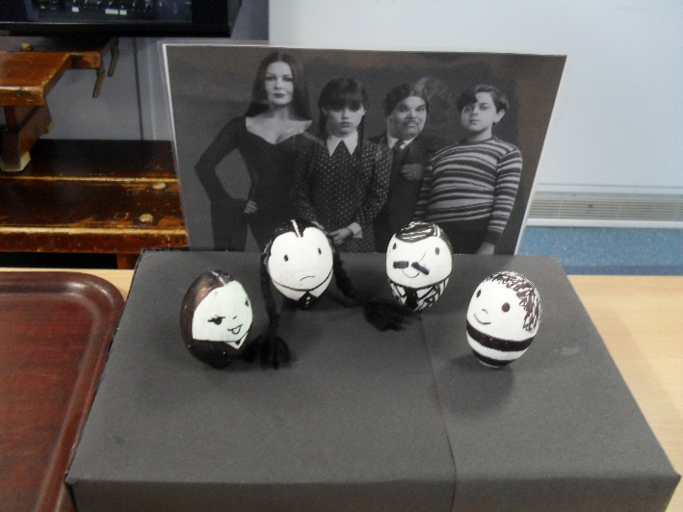**Easter Egg Competition**

This week the pupils took part in our first Easter Egg competition. The eggs were creative, well thought and beautifully executed.   
A huge thank you to Rachel for organising such a wonderful idea

The winners were: 1st – Fraser, 2nd Leo & 3rd Taylor.

**1st 2nd**



**3rd**

**Best Class – Morpurgo**

The other amazing entry’s…

**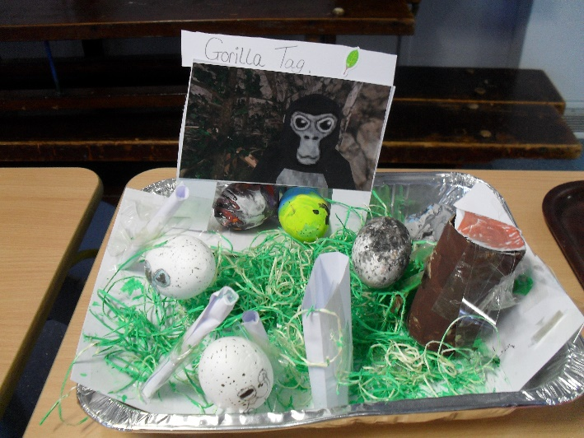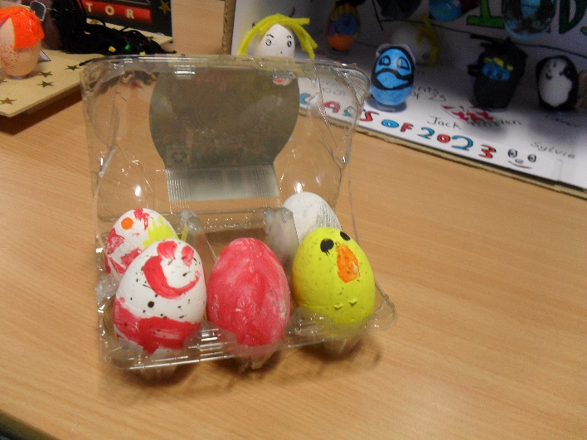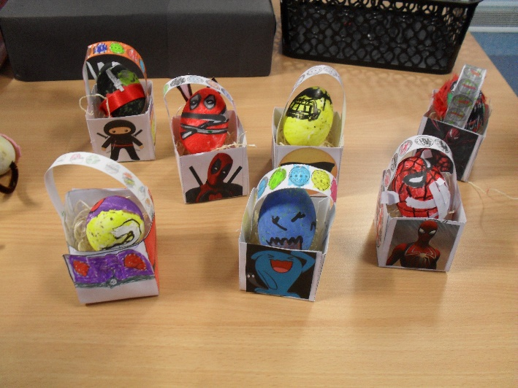****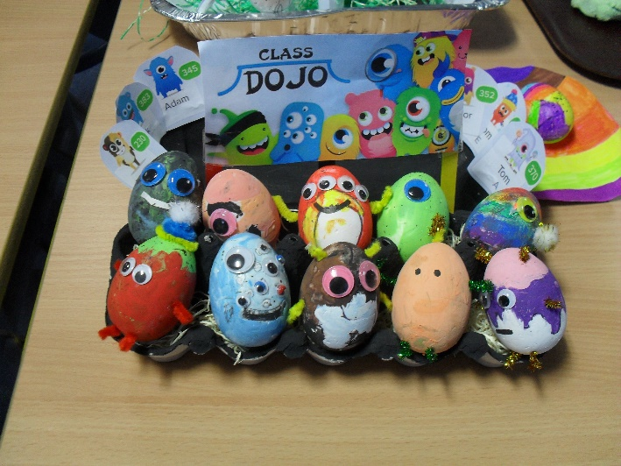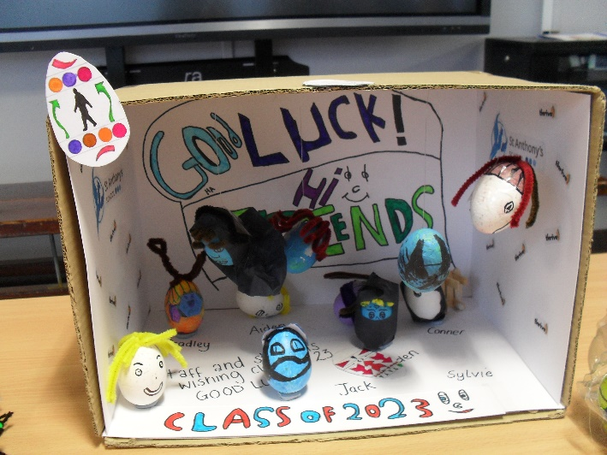**

**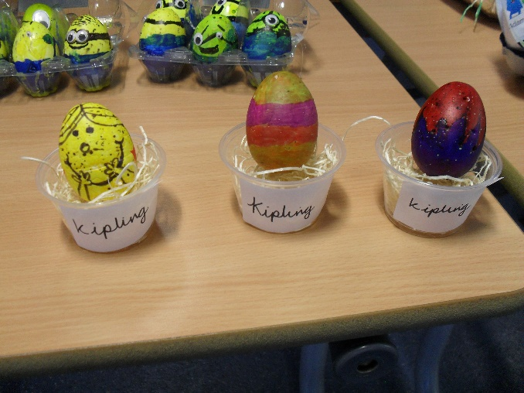**

**Rascal Bay Mini Golf – Manston**

Kids go FREE before 11:00 - offer applies weekdays only and is online prebook only. One free child per paying adult. Book online via [www.rascalbaymanston.setmore.com](http://www.rascalbaymanston.setmore.com)



Friday 7th – Sun 9th April 202  
10:00am – 5:00pm  
  
80+ stalls of produce and hot food at Victoria Gardens over the Easter weekend, with independent producers offering everything from preserves and pickles, bread and bakery, wines and spirits.

There will be live music on the bandstand, and visitors can sample the produce and chat to the food producers.

Easter Market – Sunday 1st April 2023  
10:00am – 2:00pm

Come along to our Easter Market, where there is something for everyone! Books, China, Bric a Brac, Linens, Bake Stall, Raffle, Crafts, Plants. Refreshments and light lunches served throughout the day.



Friday 7th – Monday 10th April – 11:00 – 4:00pm

Get crafty designing your own bug magnet**\*** or get competitive playing bug-bingo and memory-match ‘bug’ edition.

Can you find our naughty gem bugs in the museum? Last night, some of them went exploring and got lost! Can you tell us which cheeky gems have escaped?

Take a closer look at some of our historic trees in Quex garden by adventuring on your own tree walk. For our younger guests, use your scavenger wheel to forage for spring colours and smells.

Pick up one of our free animal-buddy backpacks full of activities and games to enjoy all day!

**\***£1 charge per magnet craft. All other activities are included in your standard admission ticket.

Head to Betteshanger Park this Easter for our legendary Easter Egg Trail

With lots of fun for the family, follow the carrots to meet our very special guest rabbit!

• £10 per child, £3 per adult  
• Recommended for children aged aged 2 - 10 years



HatHats Coffee Company - Reculver   
  
Friday 7th – Sunday 9th April – 10:00 – 5:00pm  
£5 per child

------------------------------------------------------

***If you still need more inspiration please visit the below site for 21 Easter activities…***

<https://theisleofthanetnews.com/2023/03/27/21-easter-things-to-see-and-do-it-thanet-2023/>



**SPORT FOR FUN –** Saturdays (term time) 9.00 - 10.00 at St Anthony's School. A Saturday morning sports club for children with SEND.

**BE ACTIVE -SHORT BREAK** - Saturdays (term time) 10.30 - 12.00 at Foreland Fields School

**BE ACTIVE -SHORT BREAK** - Wednesdays (term time) 4.30 - 6.00 at Foreland Fields School

Please read the PDF letter attached for more information and complete the following referral form to declare interest:

<https://forms.office.com/r/EZwuMEZmEd>

**CLIP N CLIMB** - Thursdays Session 1: 4.30-5.30pm Session 2: 5.30-6.30pm.

To book please clink on this link: <https://forms.gle/EHYHiAtxWfE3XYDz6>

**MARGATE YOUTH FC KICKS 4 KIDS** - Tuesdays 5.00-5.45 at Margate FC

Inclusive football sessions delivered by Inclusive Sport. To register please visit: <https://www.margateyouthfc.co.uk/events/kick-inclusive-football-sessions>



**Cost of Living Support**

With the pressures of costs around us there is a number of services that can support. If you are having troubles please contact them direct or come and talk with us.

A link below is Thanet councils community hub which can sign post to a range of support functions.

[**https://www.thanet.gov.uk/info-pages/covidcommunityadvice/**](https://www.thanet.gov.uk/info-pages/covidcommunityadvice/)

**DWP - Outreach sessions for families**

Outreach sessions are being held in local venues. Support on hand includes, benefit advice, childcare choices and cost, finding work, cost of living, housing and any queries that our work coach can support the family with.

**Ramsgate** – The Priory Children’s Centre, Cannon Rd, Ramsgate CT11 9SQ

Outreach available every Wednesday between 9am to 12noon To book a slot to see our adviser at the Priory Children Centre in Ramsgate please contact

[jayne.conroy@dwp.gov.uk](mailto:jayne.conroy@dwp.gov.uk)

**Margate**– Six Bells Children Centre, 201 High St, Margate CT9 1WH

Outreach available every Monday between 1pm to 4pm To book a slot to see our adviser at the Six Bells in Margate please contact

[philip.raeburn@dwp.gov.uk](mailto:philip.raeburn@dwp.gov.uk) or [anita.taylor@dwp.gov.uk](mailto:anita.taylor@dwp.gov.uk" \t "_blank)

**Royal British Legion - Energy Support**

The Royal British Legion, the UK's largest charity dedicated to supporting the Armed Forces community, has today launched a new grant scheme for veterans and their families who are struggling to pay their energy bills. The initiative will provide non-repayable emergency grants of up to £2,400 a year (£200 a month) and is available across the UK.

In general, the Armed Forces community includes those who have served, or are serving, in the Royal Navy, British Army or Royal Air Force, as well as their families, dependants and carers – which can include children, current and former spouses and partners, widows and widowers.

To apply it's worth [checking your eligibility on its website](https://eur01.safelinks.protection.outlook.com/?url=https%3A%2F%2Fwww.britishlegion.org.uk%2Fget-support%2Fwho-we-help&data=05%7C01%7CJenny.Hanna%40kent.gov.uk%7C0e5a983faa7040ba13ee08dab3399c0f%7C3253a20dc7354bfea8b73e6ab37f5f90%7C0%7C0%7C638019357270836664%7CUnknown%7CTWFpbGZsb3d8eyJWIjoiMC4wLjAwMDAiLCJQIjoiV2luMzIiLCJBTiI6Ik1haWwiLCJXVCI6Mn0%3D%7C3000%7C%7C%7C&sdata=3atnAtHJUwgEaZz76bOScnj82DDHbKKLWrCX4kciIcY%3D&reserved=0) or by calling its helpline on 0808 802 8080.



Visit [Kent Resilience Hub](https://kentresiliencehub.org.uk/) where you can increase your understanding, find approaches and tools or navigate your way to support and services relating to resilience and emotional wellbeing.

[Kooth online](https://www.kooth.com/) support and counselling for 10-25 year olds across Kent and Medway. Offering 1-2-1 counselling, helpful articles, community discussion boards and daily journals.

****[MindEd](https://www.minded.org.uk/) is a free educational resource on children and young people's mental health for all adults.

Find out how to tackle hate online and online trolls with internet matters advice guide for what [online hate](https://www.internetmatters.org/resources/tackling-online-hate-and-trolling/) is and how to support your child. Get tools and tips to support your child’s [digital wellbeing](https://www.internetmatters.org/?gclid=EAIaIQobChMIrbTX5_bt7AIVRuztCh33bQH_EAAYASAAEgLtifD_BwE) on Facebook, Instagram and WhatsApp.

Call NSPCC on 0808 800 5000 if you’re worried about the safety of a child. Or call the police on 999 if you think a child is in immediate danger.

Mind's [Action for Children](https://minds.actionforchildren.org.uk/self-esteem) around self esteem and helping your child. Parents with Confidence help your child to emotionally regulate.

Free and confidential advice from [Family Lives](https://www.familylives.org.uk/how-we-can-help/confidential-helpline/) on 0808 800 2222 if you’re finding it hard at home with your child and are struggling to cope**.**[Young Minds](https://youngminds.org.uk/) have a parent’s helpline, information and resources.