16th December 2022
It has been a hectic end of term with the excitement of the season building. The school have had lots of fun in the run up to the end of term as you will read.
In talking with parents and carers, we are fully aware of the challenges of rising food costs, heating costs and the pressure of feeling the need to buy presents at this time of year. The school has been made aware of a number of local groups that are able to help. I have included these at the back of the newsletter so please look, but also do feel free to contact Kirstie or myself for additional information.
Wishing you all a Merry Christmas and Happy New Year.
Mr Page
Attendance
Whilst in mainstream schools, a Whole School Attendance of 95% is generally considered good, here at St Anthony’s we are appreciative that our pupil’s needs are likely to affect their attendance at times.
Therefore, we have set ourselves a Whole School Attendance target of 85%. We are just two terms in and we are currently sitting at 81.72%.
Whilst we are pleased that we are so close to our target, we would love to be able to report at the end of Term 3 that we have indeed reached our target.
As well as having a Whole School Attendance target, we also have individual targets for our pupils. Attendance is monitored weekly from Friday-Thursday and rewarded in stages:
• 90% attendance = 3 Tokens
• 100% attendance = 5 Tokens, Certificate and a shout out on DOJO.
The tokens can be exchanged in our Reward Shop, which is run by Phoenix, if there is nothing that your child wants to spend their tokens on, they can speak to a member of staff either from Phoenix or from SLT, about sourcing something that interests them and agree a target number of Tokens.
In order to gain a weekly attendance of 90%, your child needs to be in school for 9 half-day sessions out of 10 each week.
If your child is late and arrives after the register closes at 09:20am then this is marked as a U, this is an unexplained absence and will go against your child’s attendance record.
Information about attendance can be found in our Attendance Leaflet which you can pick up at reception, an online version will be made available via Class Dojo and our Website in the upcoming months. If you have any questions about your child’s attendance please get in touch with the School Office, who can direct your call to the appropriate personnel.
Goodbye Craig
Craig Kelly the school’s PE teacher is leaving us at the end of this term for pastures new. Craig joined the school over six years ago, as an unqualified teacher, but he then completed his teaching qualifications with us. Since then he has helped pupils develop their sporting skills and knowledge. We wish him well in his new post.
Forthcoming Dates
Tuesday 3rd January 1st day Term 3
Monday 30th January – training day no pupils
Friday 10th February last day of Term 3
Monday 20th February 1st day of Term 4
Watson Cup Winner
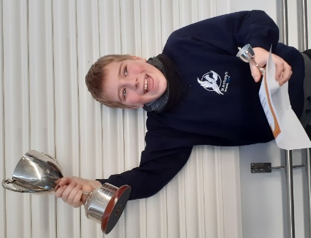
Rayven from Dahl Class. He does not always find school easy, and he often struggles with peers, however: he is kind and caring and has really improved his focus and behaviour this year. He works hard and often independently now. He has made small steps of progress in all areas.
Burney Shield Winner
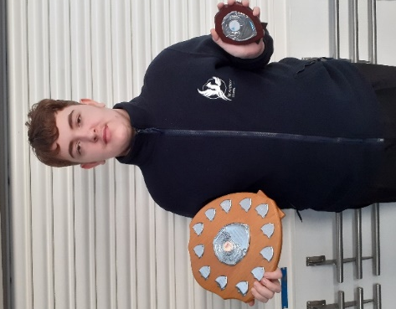
Shay-Lee from Morpurgo Class. For settling so well into KS4. This has been a significant change from his previous class but he has taken it all in his stride. His attendance still not perfect but much improved.

Headteacher Award
Jayden Carew from Lampard Class. For his dedication to embracing his learning in DT and Construction, course always happy and passionate about building school resources and projects such as the Drama Boxes and the Remembrance Display. He has individually designed and made the washing-line learning resource for Milne Class and the scoreboard Christmas lunch table display. He designed and made these applying the skills he has worked so hard to perfect with practice during the last few months. He has applied himself to retain the knowledge gained and always asks good question of which he will discuss until he fully understands.

St Anthony’s has Talent!
On Thursday 15th December we had a talent show. Judges Ame, Heather and Kevin had a difficult time choosing the winners but decided on –
4th prize- A still anonymous piano player who showed terrific piano playing skills in the video

3rd prize- Adam B from Rowling drumming, the judges said ‘what a performance, great timing and we loved the cheeky ending’

2nd prize- Rowling class. A great class effort which made us all laugh throughout your performance of Slade’s Merry Christmas.

1st prize- Cloud W, Judges were very impressed with the only live performance and even though he was very nervous he was still able to get up on stage to perform. Beautiful singing voice.
Well done to all who participated as everyone who took part received a prize.
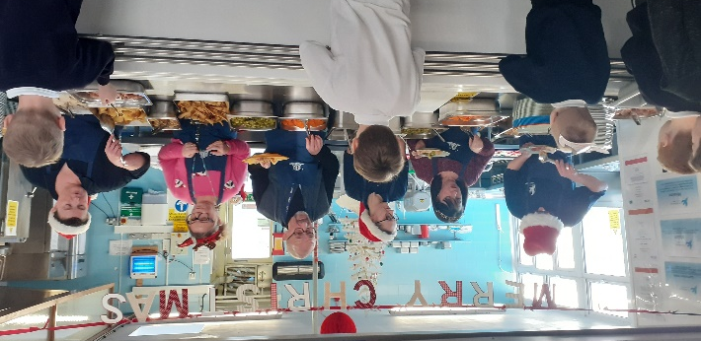
Christmas Lunch
It was wonderful to be able for the whole school to come together for Christmas lunch for the first time in three years. The kitchen team consisting of our cook Liz, Andrew and Imogen did a wonderful lunch for us all.
Classes used their creative skills to design their tables for the occasion, which made the lunch hall come alive for lunch. School governors had a very difficult job in choosing the winners this year as some many excellent designs but went with Lampard Class for their snooker themed table, with masks of snooker legends and Rowling Class for a simple but traditional Christmas theme.
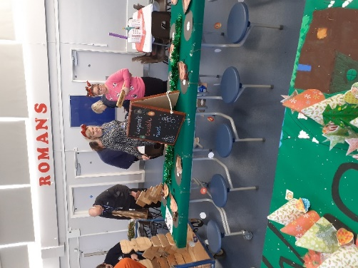
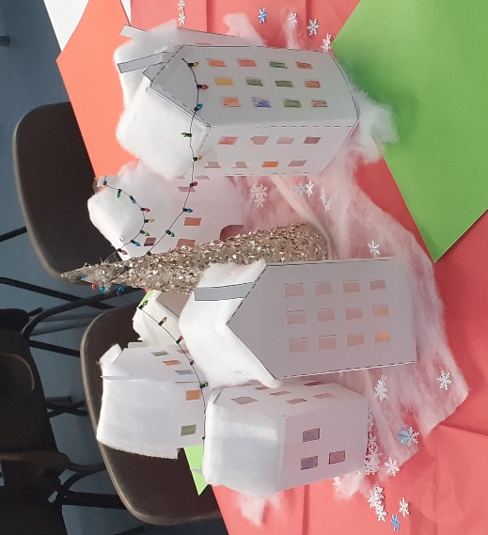
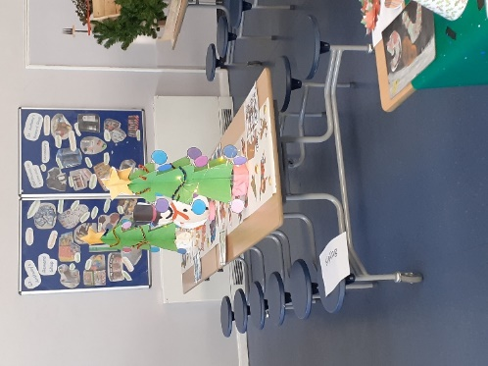
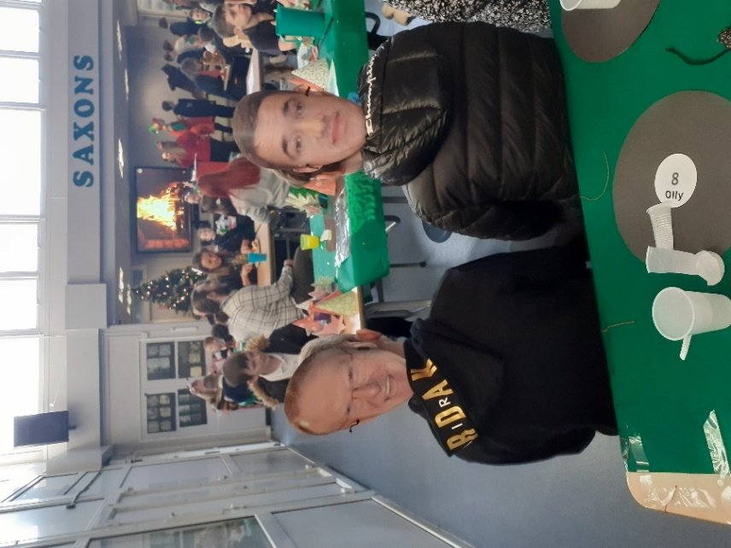
Lampard Table Winners
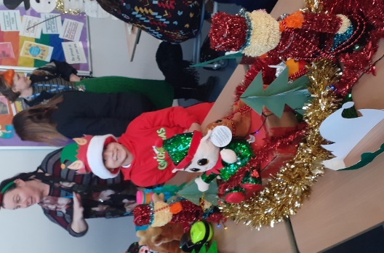
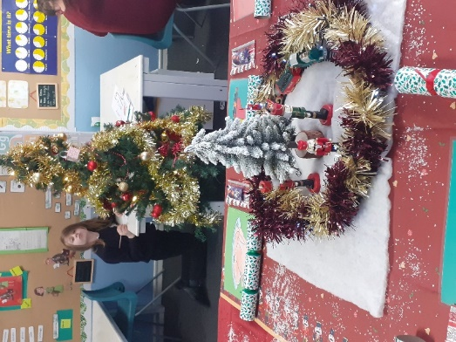
Rowling Class Table
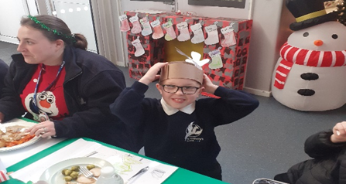
I liked Blyton’s as they even brought a fireplace hung with stockings. Well done to all for your efforts, which was supported with our pupils displaying impeccable behaviour that made for a very enjoyable lunch.
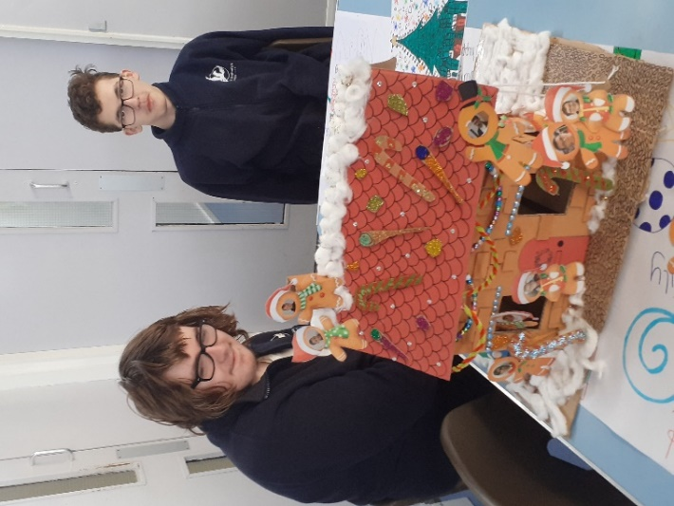

Lo

Tal

Primary Pantomime Trip
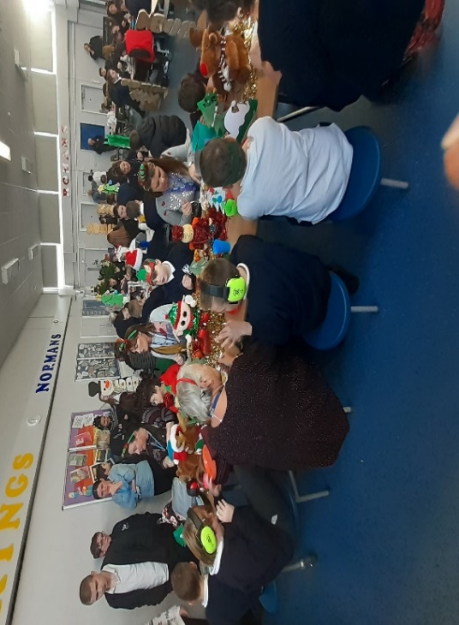
All of our primary department had an early Christmas treat and went to the pantomime on Wednesday 7th December, 'Oh no they didn't', 'Oh yes, they did' and they had a fantastic time!
As always when we have these trips, pupils were well behaved, and all joined in with the interactive 'It's behind you' parts of the show.
We even had the theatre sing Happy Birthday to Blaine and Corey!
Secondary KS4 Panto
Oh no, they didn’t! …Oh yes, they did!
The Drama students in KS4 enjoyed a trip to the Marlowe Theatre to watch Sleeping beauty, the pantomime. It was all laughs and jokes until they were drenched by the actor's water guns! A perfect example of ‘slap stick’ for the students to use in lessons!
All finished off with a lovely McDonalds.
A brilliant time had by all.
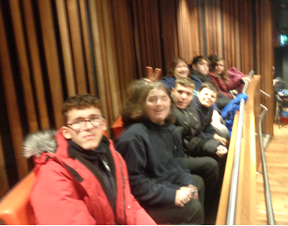
RE Day
On Wednesday 7th December, all classes participated in RE Day learning all about why Christmas is important to Christians. Primary did lots of learning about why Christian's give gifts at Christmas and Christmas celebrations. Secondary enjoyed learning about Christmas Journeys and Christmas celebrations all around the world. A part of the day for everyone was learning all about the meaning of Christingle and why it is important to Christians, as well making their own Christingles to take home. Lots of pupils were able to remember what the candle, orange, red ribbon and four sticks of sweets and dried fruit represented on a Christingle!

Winter Fayre
On Friday 2nd December, our Winter Fayre was held in the school hall. This was a very well attended event, with many parents and pupils, both current and previous, attending along with their families. Many ex staff also put in an appearance and many staff members brought along their own children to take part in the fun. There were many games to keep people occupied and plenty of food and sweets and drinks to keep everyone refreshed. Santa and his elves also put in an appearance in Santa’s Grotto. Due to the many donations received, we were able to hold a raffle with 40 prizes and a tombola with 100 prizes. The final total raised at the end of the evening was an amazing £660, which will go towards reward trips and lovely things for all the pupils to enjoy. A huge thank you to all who came along to support this event or who supported us by donating prizes/toys/cakes etc and we look forward to seeing you all at our Summer Fayre
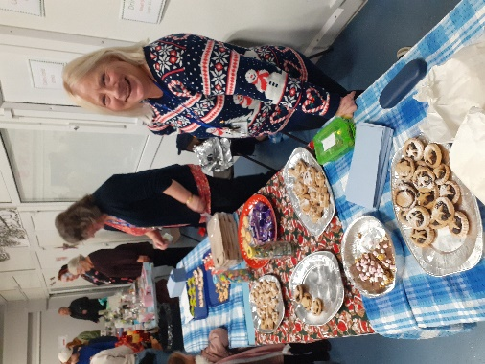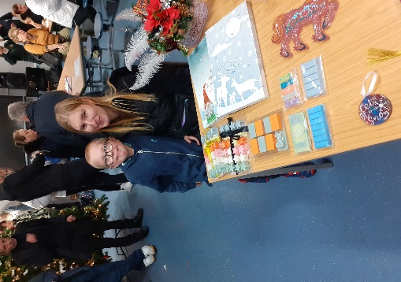
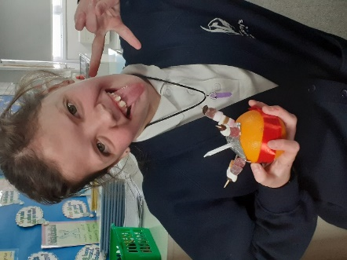
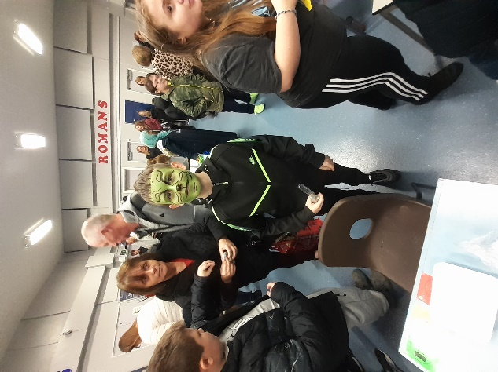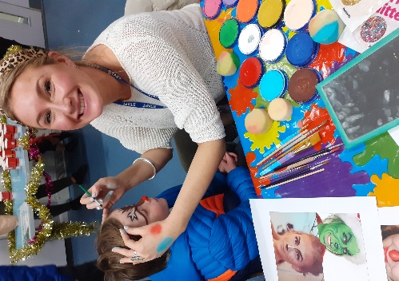
History Trip to RAF Manston
On Tuesday 29th November, Dahl class visited the RAF Museum, Manston. There was so much to see and do. The children were extremely lucky to be able to get inside jets, planes, tanks, helicopters, flight simulators and even got to see bouncing bombs. Rayven even had the opportunity to handle WWII guns. Dahl class’ visited enabled them to have hands-on experiences to support their learning of WWII.
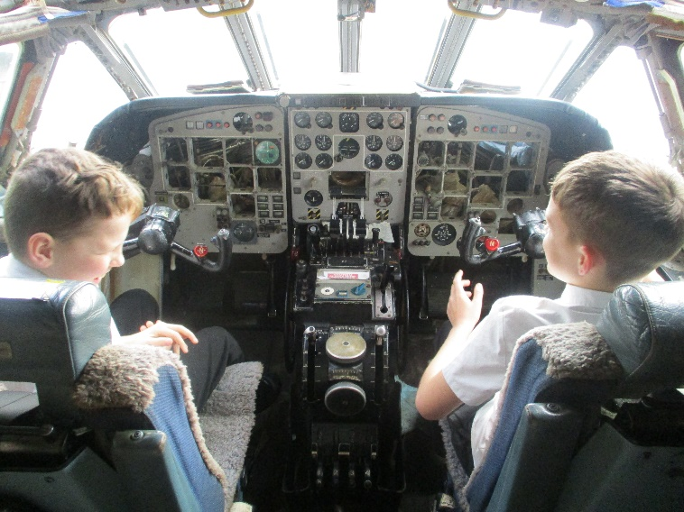

Discovery Planet
SPORT FOR FUN –
Saturdays (term time) 9.00 - 10.00 at St Anthony's School. A Saturday morning sports club for children with SEND.
BE ACTIVE -SHORT BREAK - Saturdays (term time) 10.30 - 12.00 at Foreland Fields School
BE ACTIVE -SHORT BREAK - Wednesdays (term time) 4.30 - 6.00 at Foreland Fields School
Please read the PDF letter attached for more information and complete the following referral form to declare interest:
https://forms.office.com/r/EZwuMEZmEd
CLIP N CLIMB - Thursdays Session 1: 4.30-5.30pm Session 2: 5.30-6.30pm.
To book please clink on this link: https://forms.gle/EHYHiAtxWfE3XYDz6
MARGATE YOUTH FC KICKS 4 KIDS - Tuesdays 5.00-5.45 at Margate FC
Inclusive football sessions delivered by Inclusive Sport. To register please visit: https://www.margateyouthfc.co.uk/events/kick-inclusive-football-sessions
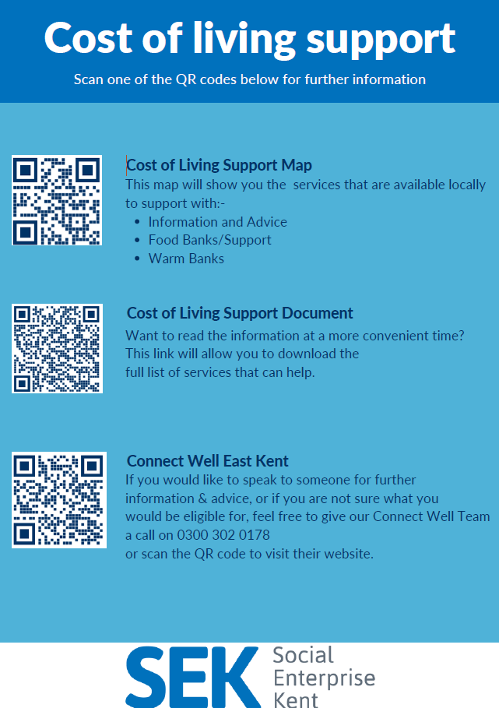
Cost of Living Support
With the pressures of costs around us there is a number of services that can support. If you are having troubles please contact them direct or come and talk with us.
A link below is Thanet councils community hub which can sign post to a range of support functions.
https://www.thanet.gov.uk/info-pages/covidcommunityadvice/
Dane Valley Residents Association - Cost of living support cafe
Dane Valley Residents Association is organising a cost of living and support café for the residents in Dane Valley. This will be held at Millmead Hall (Next to Northdown School) on the dates and times outlined below.
Wednesday 21st December - 7pm - 10pm

Venue - Millmead Hall, 115 Millmead Rd, Dane Valley, Margate CT9 3QN
The purpose of the sessions is to take services to the residents in Dane Valley. But, any
resident living in Thanet will be able to come along and access the support available. There
will be refreshments available for all partners and residents. Contact Jack Packman: info@jackpackman.co.uk
DWP - Outreach sessions for families
Outreach sessions are being held in local venues. Support on hand includes, benefit
advice, childcare choices and cost, finding work, cost of living, housing and any queries that our work coach can support the family with.
Ramsgate – The Priory Children’s Centre, Cannon Rd, Ramsgate CT11 9SQ
Outreach available every Wednesday between 9am to 12noon To book a slot to see our adviser at the Priory Children Centre in Ramsgate please contact
jayne.conroy@dwp.gov.uk

Margate – Six Bells Children Centre, 201 High St, Margate CT9 1WH
Outreach available every Monday between 1pm to 4pm To book a slot to see our adviser at the Six Bells in Margate please contact
philip.raeburn@dwp.gov.uk or anita.taylor@dwp.gov.uk
Royal British Legion - Energy Support
The Royal British Legion, the UK's largest charity dedicated to supporting the Armed Forces community, has today launched a new grant scheme for veterans and their families who are struggling to pay their energy bills. The initiative will provide non-repayable emergency grants of up to £2,400 a year (£200 a month) and is available across the UK.
In general, the Armed Forces community includes those who have served, or are serving, in the Royal Navy, British Army or Royal Air Force, as well as their families, dependants and carers – which can include children, current and former spouses and partners, widows and widowers.
To apply it's worth checking your eligibility on its website or by calling its helpline on 0808 802 8080.

Visit Kent Resilience Hub where you can increase your understanding, find approaches and tools or navigate your way to support and services relating to resilience and emotional wellbeing.

Kooth online support and counselling for 10-25 year olds across Kent and Medway. Offering 1-2-1 counselling, helpful articles, community discussion boards and daily journals.
MindEd is a free educational resource on children and young people's mental health for all adults.

Find out how to tackle hate online and online trolls with internet matters advice guide for what online hate is and how to support your child. Get tools and tips to support your child’s digital wellbeing on Facebook, Instagram and WhatsApp.
Call NSPCC on 0808 800 5000 if you’re worried about the safety of a child. Or call the police on 999 if you think a child is in immediate danger.
Mind's Action for Children around self esteem and helping your child. Parents with Confidence help your child to emotionally regulate.

Free and confidential advice from Family Lives on 0808 800 2222 if you’re finding it hard at home with your child and are struggling to cope.
Young Minds have a parent’s helpline, information and resources.

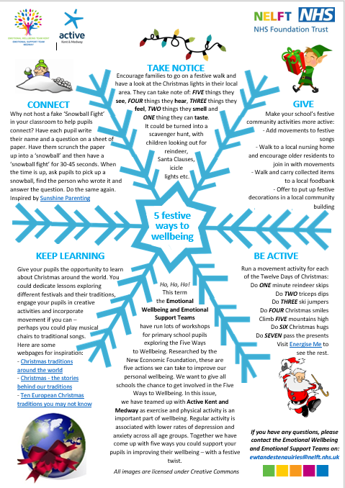
Food Menu
