1st July 2022 Newsletter

Summer Fayre
On Friday 24th June, after several cancelations due to Covid stopping all social events, we were finally able to hold our Summer Fair. Due to the amazing weather, we were able to hold it outside on the primary playground; with the majority of the stalls outside, and a few indoors. It was a very well attended event, with many parents, carers and pupils, both current and previous, attending with their families. Several staff members also brought along their own children to take part in the fun. There were lots of games to keep people occupied and plenty of food and sweets and drinks to keep everyone refreshed. Due to the many donations received from the local business community, we were able to hold a raffle with 30 prizes and a tombola with 100 prizes. The final total raised at the end of the evening was an amazing £1149.76, which will go towards reward trips and lovely things for all the pupils to enjoy. A huge thank you to all who came along to support this event or who supported us by donating prizes, toys, cakes etc and we look forward to seeing you all at our Christmas Fair.
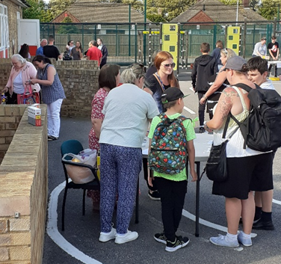
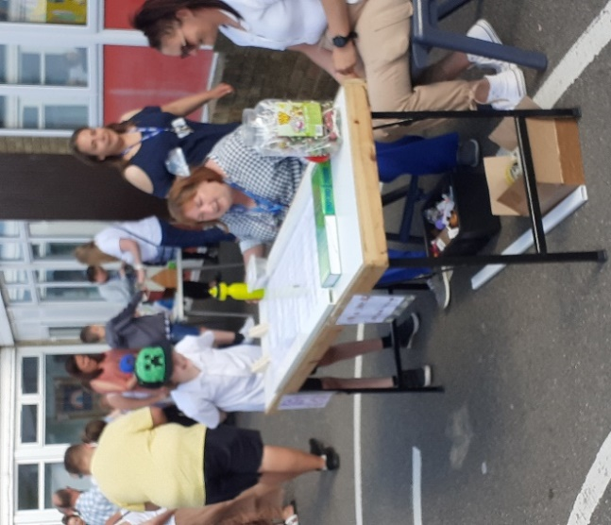
Dates
- Friday 8th July Sports Day Parents/carers welcome to attend from 12:25 pm
- Tues 19th July Reward Trips
- Wed 20th St Anthony’s Has Talent Show
- Thurs 21st July - Last Day of term 6 1:30 finish

Year 11’s Leavers
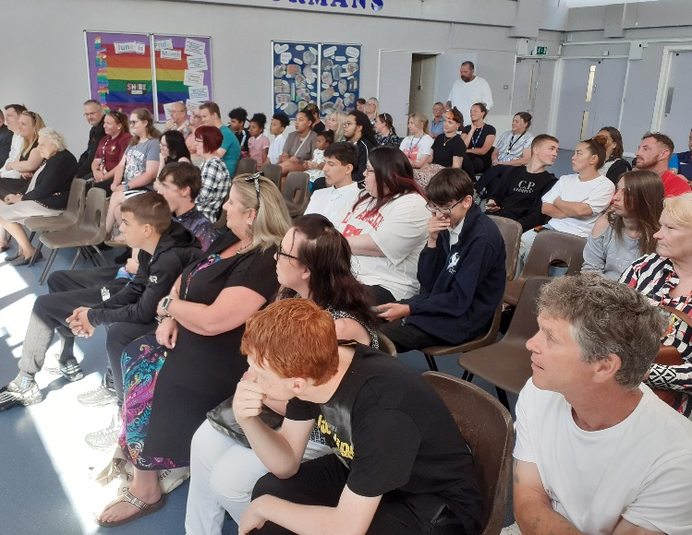
Once our Year 11s completed their two weeks of work experience it was time to say goodbye to them. We held a Leaver’s assembly on Wednesday 22nd June, where we celebrated their acheivements at St Anthony’s. The assembly was very well attended by pupils and their families. Year 11 teachers made witty speeches about their pupils and Mr Page provided them with some words of wisdom.
On Thursday 23rd the pupils had their last outings with the school with a large group of pupils and staff going paintballing, Ben was pleased to escape with only a few welts. The other trip was to an esacpe room. Gill was very pleased that Daniel B attended as she didn’t think she would have ever gotten out otherwise.
Both groups then meet up for a meal at the Hungry Horse.
We wish our Year 11s a wonderful summer before they continue with their education in September.
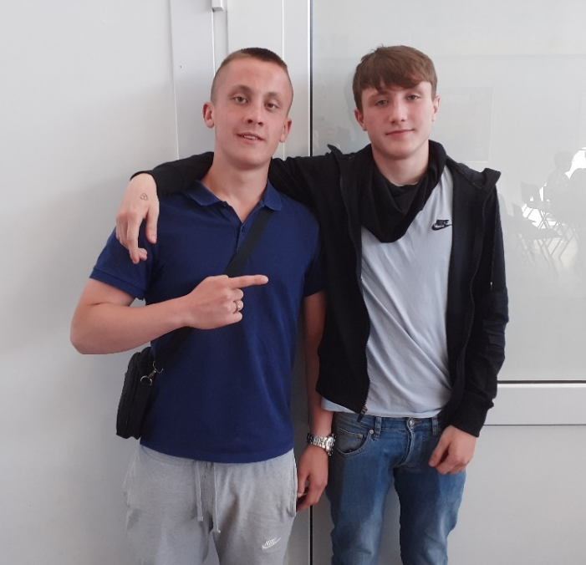
Ben and Connor have left the building!
Free Parent and Carer webinars on Kooth
This session is designed to let parents and carers know how Kooth can support their children with their mental health and wellbeing.
If parents or carers have any questions, they can email parentsandcarers@kooth.com.
- Wednesday 27 July from 6pm to 7pm
Attendance
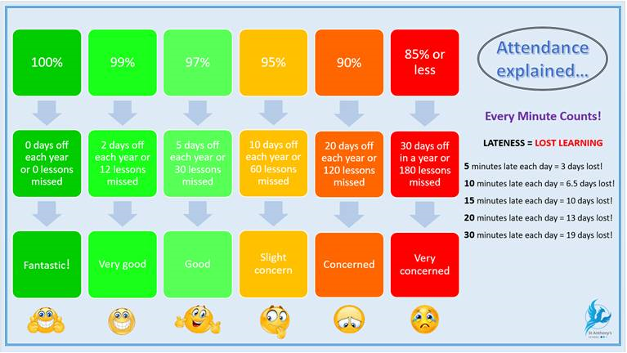
KCC - Free School Meals update
As the current cost of living crisis begins to bite even further into family budgets, Kent are providing more targeted support for some of the most vulnerable in the county. Families whose children are entitled to benefits-related free school meals will be provided with food vouchers over the forthcoming school half-term holiday. The school office will distribute the vouchers as soon as they are available to do so. Families with limited resources face extra challenges, especially with the cost of providing more meals for their children, during the school holidays, so these vouchers help to ease the pressure on parents and carers in this position. That support originally came from our Kent Together scheme. The current funding comes from our allocation from the government’s Household Support Fund, which was launched in September to help local authorities support some of their most vulnerable households, originally to help over the winter period. We have allocated the vouchers as we have done during previous holiday periods, please contact Kimmy in the office if you have problems.
Reconnect: Kent children and young people
Reconnect is a Kent County Council led, community based programme designed to get Kent’s children and young people thriving following the pandemic.
Clubs, businesses and organisations have come together to create fabulous opportunities for children and young people. Together they can have fun, catch up on missed learning, engage in sports and activities, trips and experiences, receive mental health support, regain their confidence and gain access to career development opportunities.
The Reconnect free bus pass is back for summer 2022! They will be distributed to Years 6 – 11 the week commencing the 11th July.
Thanks to Kent’s local bus operators, young people and families with children can enjoy this summer holiday with free bus travel between 23 July and 31 August 2022.

A reminder for parents and carers of the importance of routine immunisations for your teens

The national routine childhood immunisation programme has a direct positive impact on the health and wellbeing of children and communities and is vital to reduce the spread of infection and prevent outbreaks.

In addition to the flu and COVID-19 vaccines that have been offered to school-aged children this academic year, teenagers are routinely offered 3 vaccines in secondary schools:

human papillomavirus (HPV) vaccine Yr 8 and 9
menACWY vaccine in Year 9
Td/IPV (3-in-1 booster) in Year 9

The delivery of these routine adolescent immunisation programmes has been significantly impacted by the COVID-19 pandemic and vaccine coverage is still not at pre-pandemic levels. The UK Health Security Agency (UKHSA) and NHS England and NHS Improvement (NHSEI) are reminding parents and carers about the important protection these immunisations provide. They are also encouraging take up and catch up of vaccinations for anybody who has missed out.

Education and childcare settings have a vital role to play in supporting the routine immunisation programme. It would be very helpful for settings to share information with parents. Further information can be found in the UKHSA immunisation guidance.

A wide range of immunisation support resources for educational settings are available which can be shared with parents. They can be ordered on the health publications website or by calling 0300 123 1002. For further information, please email immunisations@phe.gov.uk

Upcoming Courses at Thanet Trust
These courses are free and for those that need to get public transport, we will be able to provide reimbursement of these costs.
- 27 - 29 July and 2 - 5 August: New Beginnings This course will be held at the Hereson Family and Community Centre, Ramsgate. This course will help people seeking employment by helping them gain accredited qualifications, soft-skills training, and guidance on the job application process.
Application for these courses must be via email or telephone at admin@tcdt.org.uk / 01843
855155.
25 - 26 July: Build a Future (Fast track)
This course will be on Monday, Tuesday, and Wednesdays. Held at the Hereson Family and
Community Centre, Ramsgate. This course gives people the skills and qualifications they
need to find employment in the construction industry.
Application for these courses must be via email or telephone at admin@tcdt.org.uk / 01843
855155.

KCC - SEND Information Hub (Kent’s Local Offer)
https://issuu.com/theeducationpeople7/docs/tep_newsletter_summer_22_single_pages_for_issuu_?fr=sNTJiZDUwODgzNjg&dm_i=2MHG,1VPZO,ANMO9F,6K4Y2,1

The SEND Information Hub (Kent’s Local Offer) is a website about all the services and
support available for children from 0 to 25 and their families, with special educational needs
and disabilities (SEND) from the local area and outside the area.

The website includes a directory, which is a database containing a wide range of activities,
events and support services available to families with SEND in their local communities. This
directory is ever changing and continuously monitored and reviewed by the SEND
Partnership and Engagement Team. This means there will always be new things added and
updates to current records.

This SEND promotional poster can be used as a handout by KCC staff to inform and
signpost families with SEND to the relevant support and guidance.

Please contact our SEND Partnership and Engagement Team at yourvoice2@kent.gov.uk if you have any queries about the SEND Information Hub website or any tips on how to get the word out about this!

Visit Kent Resilience Hub where you can increase your understanding, find approaches and tools or navigate your way to support and services relating to resilience and emotional wellbeing.

Kooth online support and counselling for 10-25 year olds across Kent and Medway. Offering 1-2-1 counselling, helpful articles, community discussion boards and daily journals.

MindEd is a free educational resource on children and young people's mental health for all adults.

Find out how to tackle hate online and online trolls with internet matters advice guide for what online hate is and how to support your child. Get tools and tips to support your child’s digital wellbeing on Facebook, Instagram and WhatsApp.
Call NSPCC on 0808 800 5000 if you’re worried about the safety of a child. Or call the police on 999 if you think a child is in immediate danger.

Mind's Action for Children around self esteem and helping your child. Parents with Confidence help your child to emotionally regulate.

Free and confidential advice from Family Lives on 0808 800 2222 if you’re finding it hard at home with your child and are struggling to cope.

Young Minds have a parent’s helpline, information and resources.

