**10th December 2021**

**Dear Parents/Carers**

As we come towards the end of term 2 the joys of COVID remain with us. After an outbreak at the end of November, we took advice from Public Health England and made the difficult decision to input bubbles and return to remote learning for a couple of classes. We also made the decision to not have any whole school events, which would bring all staff and pupils together, to reduce the opportunities for COVID to spread. This sadly meant the cancellation of many Christmas events – School Fayre, Panto, Christmas Lunch and the end of term assembly – which are traditionally wonderful events in the school year. We are working to provide pupils safe options so that we can still enjoy the season.

On a positive note since we have put these additional measures in place we have not had any additional positive cases in school.

Pupils and staff have been busy so please read on.

**Departing Staff**

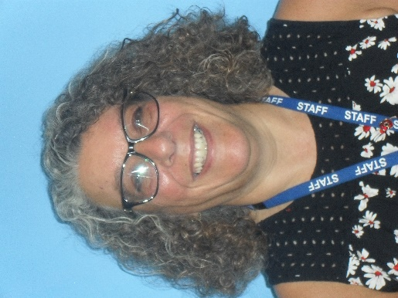 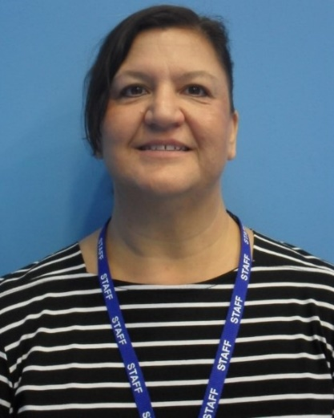  

We sadly have a number of staff leaving at the end of this term.

Rachel Beecham has worked in the office for the past seven years.

Sally O’Connor has taught primary in Potter class for the past four years, she is moving to teach in a new special school.

Josh Steele has taught KS3 since joining the school, but has always wished to be a fireman and work with the Kent Fire and Rescue Service. After much training he has been successful and will join the service in January.

Jon Adams has been an excellent Learning Support Assistant in primary classes and is leaving the school to be a teacher in another local special school.

We wish them all the best in their new posts.

Staff have been recruited to replace these members of staff.

**Reporting test results**

Thank you to those parents and carers who are continuing to support our pupils to test twice weekly for COVID-19 at home. Reporting your tests, whether positive, negative or void, is as important as taking the test itself, as reporting results helps us understand the spread of the virus in local areas.

Lateral flow device (LFD) tests have been widely and successfully used to detect asymptomatic COVID-19 cases. A recent [report](https://www.dovepress.com/getfile.php?fileID=74968) has shown that the accuracy of LFD tests was more than 80% effective at detecting any level of COVID-19 infection and likely to be more than 90% effective at detecting the most infectious people at the point of testing.

On Wednesday 15th December Public Health Nurses are coming into school to provide vaccines for those children who are eligible and whose parents/carers have given permission. If you would like your child vaccinated and have not given consent yet, please contact the school and speak with Kirstie Phippin, as there is still time to register for the vaccine.

The government has asked schools to test secondary aged pupils in school on their return in term 3.

We are developing plans to test pupils on their first day back. If you have any questions please do not hesitate to contact the school.

**PTFA Raffle**

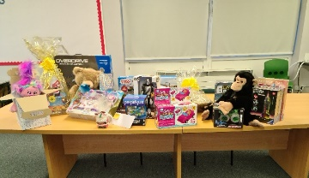

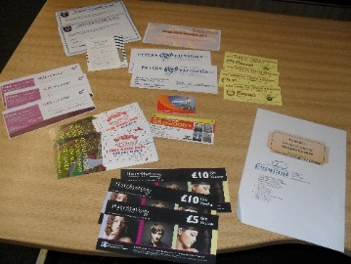As we had to cancel the Winter Fayre, we will be holding a virtual raffle on Wednesday 15th December at 3pm. We will send a Teams invite so you can all watch the draw and see if you have won a prize. We will call you if you have won a prize and arrange for you to collect it. Tickets are still on sale from the office, if you would like to send the money in with your name and number and we will post your tickets out to you.

**Science Trips**

On Friday 12th November, Rowling class went to the old fire station in Ramsgate for a ‘Go for Green’ workshop. Pupils saw a bike machine that powered a dolls house which they had to pedal very hard to make it light up. We had to make sure that we pedalled quickly to stop the light from flickering. We also had fun spinning the wind turbine that also turned on a light. We learnt that when we look out to sea, we could see the red lights flickering because the wind is turning the wind turbine. The wind turbines out at sea are about 100m tall and they store energy in the turbines, which goes down the pipe under the ocean and back to the mainland. The wind turbines can power over 2800 phones.

We all received a goody bag at the end and inside the bag, there was a windmill that we had to make. There was also a leaflet and a magazine providing more information about wind turbines. We loved the colourful highlighters the most as they looked like a flower!

**Into Film Festival**

All of the Primary Department enjoyed taking part in this year’s Into Film Festival. They watched the film 'A Dog's Way Home' which they really enjoyed from the discussion l heard on their return.

****Pupils also enjoyed a cinema snack bag, provided by the wonderful PTFA. All pupils behaved perfectly and one of our young pupils even had the opportunity to go into the projection room which he really liked. A great success! We cannot wait for next year’s festival.

**MFL Day**

On Wednesday 17th November, all of St Anthony's school took part in a Modern Foreign languages day. Each class was given a different country to research and learn about for the day. We had countries from all around the world from Brazil to New Zealand. During the day children took part in a variety of activities such as trying a new food to learning about a local festival. The students managed to even practice some of the language from their selected country.  Each class made a floor mat filled with information and pictures that they had learnt from the day.

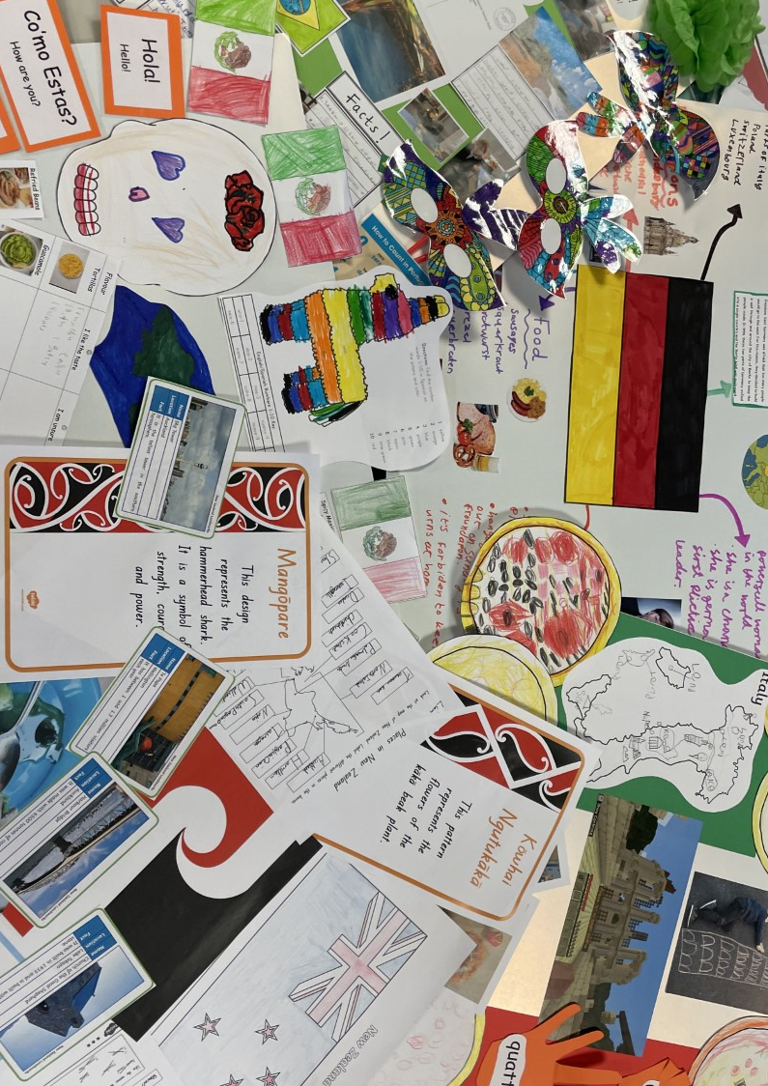

**Litter Picking Tivoli Woods – Potter Class**

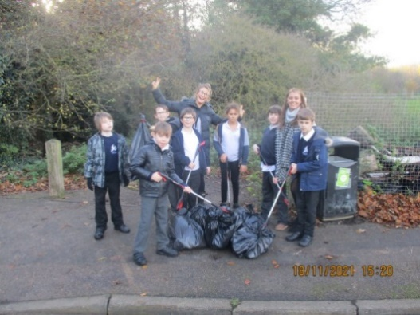 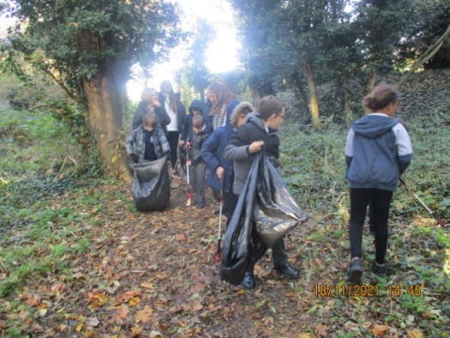 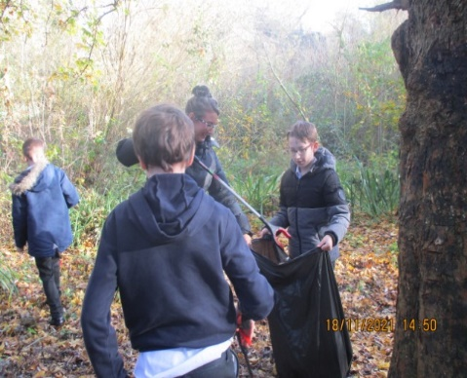

Over the past year, Potter Class have been learning about our environment and how we as individuals can help to look after the world around us. The class have been out and about, litter picking around our school a few times since September. However, in conjunction with Thanet District Council, Potter Class went to Tivoli Woods in Margate.

The children explored the woods enthusiastically searching for litter. As a class, we were all shocked at how much there was! Unfortunately, some of the rubbish was too large and inaccessible for us to collect.

We went armed with litter pickers and bags and within a short period of time collected a lot of rubbish. We intend to return during our Prep4life lessons to continue to help our local community and help keep our environment safe and clean for all.

**Children in Need**

On Friday 19th November we supported Children in Need with a non-uniform day and raised **£153.71!!!!**

Mr R Page

Headteacher

**Dates**

Wednesday 15th December – Christmas Lunch and Christmas jumper day

Friday 17th December last day of term – **pupils finish 1:30pm**

Tuesday 4th January – first day of Term 3

Monday 31st January – Training Day no pupils



As a parent or carer of a young person, you are extremely influential to their resilience journey. Visit [Draw Your Own Solution](https://kentresiliencehub.org.uk/parent-carers/draw-your-own-solution-parents-campaign-page/) for more information.



Developed by the NHS in Kent, [Good Mental Health Matters](https://www.goodmentalhealthmatters.com/) is a free resource for primary and secondary parents and young people. Online resources include educational videos and online quizzes.



[Kent Community Health NHS Foundation Trust (KCHFT)](https://www.kentcht.nhs.uk/2020/11/06/online-solihull-approach-parenting-courses-for-anyone-caring-for-a-child-in-kent-and-medway/) are offering online ‘Solihull approach’ parenting courses for anyone caring for a child in Kent and Medway.

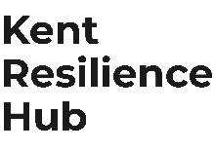

Visit [Kent Resilience Hub](https://kentresiliencehub.org.uk/) where you can increase your understanding, find approaches and tools or navigate your way to support and services relating to resilience and emotional wellbeing.



[Kooth online](https://www.kooth.com/) support and counselling for 10-25 year olds across Kent and Medway. Offering 1-2-1 counselling, helpful articles, community discussion boards and daily journals.



[MindEd](https://www.minded.org.uk/) is a free educational resource on children and young people's mental health for all adults.

****Find out how to tackle hate online and online trolls with Internet matters advice guide for what [online hate](https://www.internetmatters.org/resources/tackling-online-hate-and-trolling/) is and how to support your child. Get tools and tips to support your child’s [digital wellbeing](https://www.internetmatters.org/?gclid=EAIaIQobChMIrbTX5_bt7AIVRuztCh33bQH_EAAYASAAEgLtifD_BwE) on Facebook, Instagram and WhatsApp.

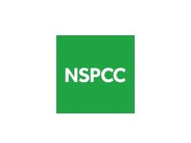

Call NSPCC on 0808 800 5000 if you are worried about the safety of a child. If you think a child is in immediate danger, call the police on 999.



Mind's [Action for Children](https://minds.actionforchildren.org.uk/self-esteem) around self-esteem and helping your child. Parents with Confidence help your child to emotionally regulate.

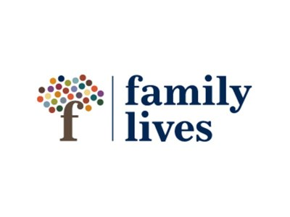

Free and confidential advice from [Family Lives](https://www.familylives.org.uk/how-we-can-help/confidential-helpline/) on 0808 800 2222 if you are finding it hard at home with your child and are struggling to cope**.**



[Young Minds](https://youngminds.org.uk/) have a parent’s helpline, information and resources.