Newsletter 6th October 2022
It is amazing how quickly time goes as we have now finished the first month of the new school year. Pupils have been working hard in their classes and l have seen some wonderful work produced in all areas of the school curriculum.
With the mornings becoming crisp, can l ask pupils to come to school with suitable uniform for the weather, such as a school sweatshirt or fleece. We wish to ensure pupils are ready and able to learn.
If you are struggling to afford school uniform please come and speak with us, we can help.
Parent Governor
St Anthony’s currently has a vacancy for a parent governor. Together with the Headteacher, the Governing Body has overall responsibility for the running of the school; amongst its many duties, Governors are involved in deciding school policies, allocating the school’s budget and appointing senior staff.
The Governing Body has 3 core functions:
- Ensuring clarity of vision, ethos and strategic direction;
- Holding executive leaders to account for the educational performance of the organisation and its pupils, and the effective and efficient performance management of staff; and
- Overseeing the financial performance of the organisation and making sure its money is well spent.
Governors meet as a full board 6 times a year, usually on a Tuesday at 3pm. There is also an expectation that governors can visit the school, during the school day, by arrangement with school staff. Training can be provided and governors are required to attend induction training and additional training as required.
If you are interested in this role please contact me. Robert.page@st-anthonys.kent.sch.uk

Dover Castle Visit – Walliams Class
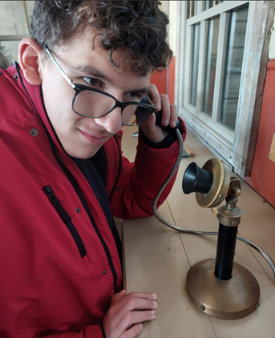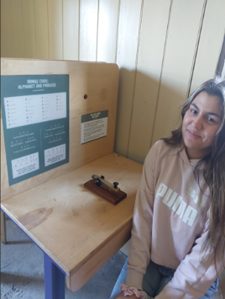
A fantastic time was had by all in Walliams class who visited Dover Castle on Thursday. The visit focused on the Second World War tunnels for our English project this term.
We are studying Anne Frank and by visiting these tunnels, we can really expand our vocabulary and adjectives by incorporating our senses in to our writing! Of course, we couldn’t help but check out the rest of the castle!
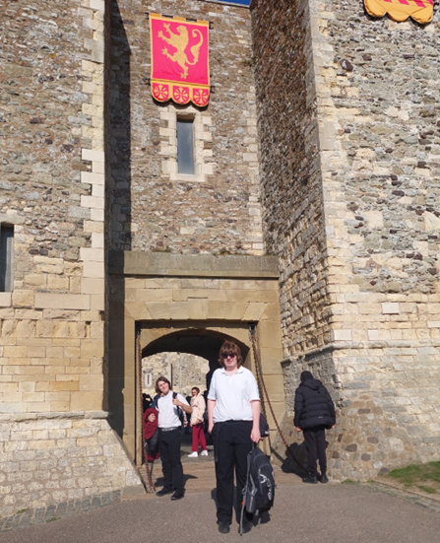

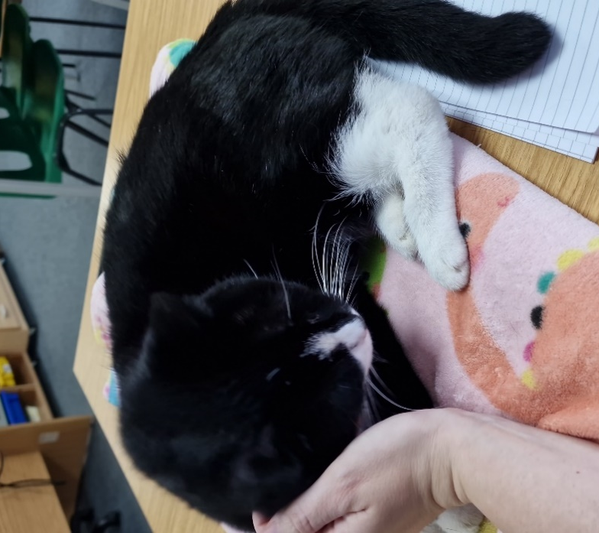
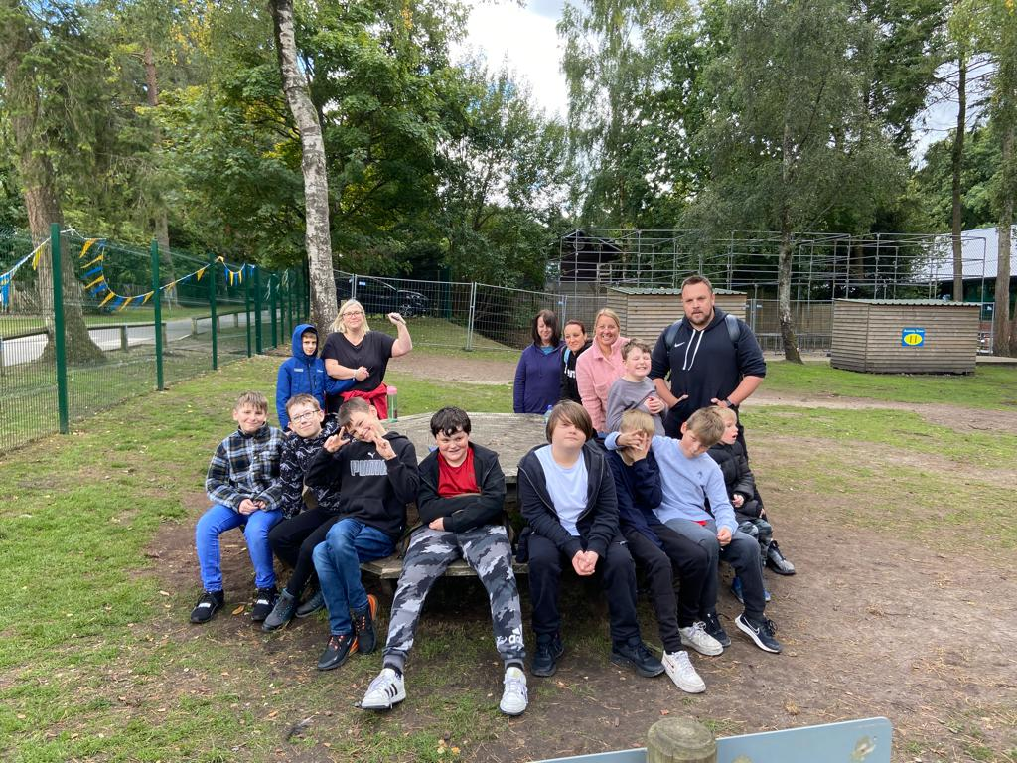
Pearl –the Cat
Making memories to last a lifetime…

We recently read about a school in Wales, which made parents laugh with a cat joining in on school picture day.
We at St Anthony's have a similar situation, Pearl joins us daily, despite not being an official school cat. She belongs to one of our nearby neighbours (or do they belong to her?) but she makes her way into school at the same time as the students in the morning. As those parents and carers can attest when dropping off as she lounges in the drive.
We have given up shooing her away and adopted her as an extra staff member. She is a great comfort to the students and staff alike, most of the school community love having her around.

PGL Residential Trip

Ten pupils and five members of staff had a wonderful experience on the annual residential trip to PGL Marchants Hill, Hindhead.
Pupils experience a range of outdoor activities, which we will hear and see about in the next newsletter.

SPORT FOR FUN –
Saturdays (term time) 9.00 - 10.00am at St Anthony's School.
A Saturday morning sports club for children with SEND.
BE ACTIVE -SHORT BREAK - Saturdays (term time) 10.30 - 12.00 at Foreland Fields School
BE ACTIVE -SHORT BREAK - Wednesdays (term time) 4.30 - 6.00 at Foreland Fields School
Please read the PDF letter attached for more information and complete the following referral form to declare interest: https://forms.office.com/r/EZwuMEZmEd
CLIP N CLIMB - Thursdays Session 1: 4.30-5.30pm Session 2: 5.30-6.30pm. Due to restart Thursday 29th September.

A Clip n Climb session for children with SENDTo book please clink on this link: https://forms.gle/EHYHiAtxWfE3XYDz6
MARGATE YOUTH FC KICKS 4 KIDS - Tuesdays 5.00-5.45 at Margate FC
Inclusive football sessions delivered by Inclusive Sport.
To register please visit: https://www.margateyouthfc.co.uk/events/kick-inclusive-football-sessions
Please visit our website where you can view all our sessions in all areas
Book Online - Inclusive Sport

Visit Kent Resilience Hub where you can increase your understanding, find approaches and tools or navigate your way to support and services relating to resilience and emotional wellbeing.

Kooth online support and counselling for 10-25 year olds across Kent and Medway. Offering 1-2-1 counselling, helpful articles, community discussion boards and daily journals.

MindEd is a free educational resource on children and young people's mental health for all adults.
Find out how to tackle hate online and online trolls with internet matters advice guide for what online hate is and how to support your child. Get tools and tips to support your child’s digital wellbeing on Facebook, Instagram and WhatsApp.
Call NSPCC on 0808 800 5000 if you’re worried about the safety of a child. Or call the police on 999 if you think a child is in immediate danger.
Mind's Action for Children around self esteem and helping your child. Parents with Confidence help your child to emotionally regulate.

Free and confidential advice from Family Lives on 0808 800 2222 if you’re finding it hard at home with your child and are struggling to cope.
Young Minds have a parent’s helpline, information and resources.

