

Attendance Policy

March 2026

Contents

1. Aims 3
2. Legislation and Guidance 3
3. Roles and Responsibilities 3
4. Recording Attendance 5
5. Authorised and Unauthorised Absence 8
6. Strategies for Promoting Attendance 9
7. Attendance Monitoring 9
8. Links with Policies 10
9. Attendance Codes 12
10. Appendix/Letter Contents 13
11. Appendix 1/Letter 1 14
12. Appendix 2/Letter 2 15
13. Appendix 3/Letter 2a 16
13. Appendix 4/Letter 3 17
14. Appendix 5/Letter 4 18
15. Appendix 6/Letter 5 19
15. Appendix/Letter 5 continued 20
16. Appendix 7/Letter 6a 21
17. Appendix 8/Letter 6b 22
18. Appendix 9/Letter 6c 23
20. Appendix 10/Letter 7a 24
21. Appendix 11/Letter 7b 25
22. Appendix 12/Letter 8 26
23. Appendix 13/Letter 9 27
24. Appendix 14 /Letter 10 28
25. Appendix 15/Flowchart: Absences 29
26. Appendix 16/Flowchart: Lateness 30
27. Appendix 17/Flowchart: Holiday Request 31
28. Appendix 18/ School Referral Pathway 31

1. Aims
St Anthony’s School is committed to the continuous raising of achievement for all our pupils. Regular attendance is critical if our pupils are to be successful and benefit from the opportunities presented to them. As a Specialist provision for children with educational health care plans (EHCP) who are dealing with ASC and SEMH diagnosis we aim to help each individual achieve their personal best. Prior to placement at St Anthony’s, pupils experience of education has been mixed with limited attendance, suspensions and exclusions. So, we will support our pupil’s attendance with a flexible approach that could involve personalised learning plans and tailored support plans, by accommodating our individual pupils needs and circumstances we can foster a more inclusive environment that encourages attendance and engagement.

Our aims:
- Promoting good attendance
- Reducing absences, including persistent and severe absence
- Ensuring every pupil has access to the full-time education to which they are entitled
- Acting early to address patterns of absences
- Building strong relationships with families to ensure pupils have the support in place to attend school.
- Promoting and supporting punctuality in attending school and classes.

2. Legislation and Guidance
This policy meets the requirements of the working together to improve school attendance from the Department for Education (DfE) and refers to the DfE’s statutory guidance on School Attendance Parental Responsibility Measures. These documents are drawn from the following legislation setting out the legal powers and duties that govern school attendance:
- Part 6 of The Education Act 1996
- Part 3 of The Education Act 2002
- Part 7 of The Education and Inspections Act 2006
- The Education (Pupil Registration) (England) Regulations 2006 (and 2010, 2011, 2013, 2016 amendments)
- The Education (Penalty Notices) (England) (Amendment) Regulations 2013
- It also refers to:
- School census guidance
- Keeping Children Safe in Education
- Mental health issues affecting a pupil's attendance: guidance for schools

3. Roles and Responsibilities
3.1 The governing board
The governing board is responsible for:
- Promoting the importance of school attendance across the school’s policies and ethos
- Making sure school leaders fulfil expectations and statutory duties
- Regularly reviewing and challenging attendance data
- Monitoring attendance figures for the whole school
- Making sure staff receive adequate training on attendance
- Holding the headteacher to account for the implementation of this policy
3.2 The headteacher
The headteacher is responsible for:
- Implementation of this policy at the school
- Monitoring school-level absence data and reporting it to governors
- Supporting staff with monitoring the attendance of individual pupils
- Monitoring the impact of any implemented attendance strategies
- Issuing fixed-penalty notices, where necessary
3.3 The designated senior leader responsible for attendance
The designated senior leader is responsible for:
- Leading attendance across the school
- Offering a clear vision for attendance improvement
- Evaluating and monitoring expectations and processes
- Having an oversight of data analysis
- Devising specific strategies to address areas of poor attendance identified through data
- Building relationships with parents/carers to discuss and tackle attendance issues
- Creating intervention reintegration plans in partnership with pupils and their parents/carers
- Delivering targeted intervention and support to pupils and families
The designated senior leader responsible for attendance is Kirstie Phippin and can be contacted via 01843 292015.
3.4 The attendance officer
The school attendance officer is responsible for:
- Monitoring and analysing attendance data (see section 7)
- Benchmarking attendance data to identify areas of focus for improvement
- Providing regular attendance reports to school staff and reporting concerns about attendance to the designated senior leader responsible for attendance and the headteacher
- Working with education welfare officers to tackle persistent absence
- Advising the DSL (authorised by the headteacher) when to issue fixed-penalty notices
- The attendance officer is Vickie Fairhurst and can be contacted via 01843 292015.
3.5 Class Teachers
Class Teachers are responsible for recording attendance daily, using the correct codes, and submitting this information to the school office by 09:10am and 12:55pm.
3.6 School Administrative Staff
School Administrative staff will:
- Take calls from parents/carers about absence on a day-to-day basis and record it on the school system
- Transfer calls from parents/carers to a member of the Senior Leadership Team in order to provide them with more detailed support on attendance
3.7 Parents/carers
Parents/carers are expected to:
- Make sure their child attends every day on time
- Contact; via telephone or voicemail, the school to report their child’s absence before 08:50 am on the day of the absence and each subsequent day of absence, and advise when they are expected to return
- Provide the school with more than 1 emergency contact number for their child
- Ensure that, where possible, appointments for their child are made outside of the school day
3.8 Pupils
Pupils are expected to:
- Attend school every day on time
- Attend every timetabled session on time

4. Recording Attendance
4.1 Attendance register
We will keep an attendance register and place all pupils onto this register. We will take our attendance register at the start of the first session of each school day and once during the second session.

It will mark whether every pupil is:
- Present
- Attending an approved off-site educational activity
- Absent
- Unable to attend due to exceptional circumstances
Any amendment to the attendance register will include:
- The original entry
- The amended entry
- The reason for the amendment
- The date on which the amendment was made
- The name and position of the person who made the amendment
Please see Section 9. Attendance Codes for a detailed outline of how we record attendance.

We will also record:
- Whether the absence is authorised or not
- The nature of the activity if a pupil is attending an approved educational activity
- The nature of circumstances where a pupil is unable to attend due to exceptional circumstances
- We will keep every entry on the attendance register for 3 years after the date on which the entry was made.

Pupils must arrive in school by 09:00 am on each school day. The register for the first session will be taken at 09:00 am and will be kept open until 09:10 am The register for the second session will be taken at 12:55 pm and will be kept open until 13:05 pm.
4.2 Unplanned absence
The pupil’s parent/carer must notify the school of the reason for the absence on the first day of an unplanned absence before 09:00 am or as soon as practically possible by contacting the school in the approved methods as stated in section 3.4.

Parent/Carers are to call 01843 292015 and select Option 1 Report an Absence. Parent/Carers need to leave a voicemail including their name, child’s name and the reason for absence. Alternatively, Parents/Carers can hold the line to reach the School Office if a detailed conversation needs to be had.

Whilst we encourage Parents/Carers to use DOJO to contact the class teacher directly, especially when more details are needed, we MUST insist that all absences are reported to the School Office either by our voicemail service or speaking to the School Administrative Staff.

If the School Office do not receive confirmation of your child’s absence by 09:10 am, then a call home to Parents/Carers will be made. In the event that no contact is made with Parent/Carers then a follow up email is sent to the Primary Guardians of the child asking them to contact the school regarding their child’s absence.

If your child is absent due to a medical appointment the School Office will send an email to the Primary Guardians asking for “proof” of medical appointment. We will ask for “proof” of illness if your child has attended a GP or Pharmacy appointment, “proof” can come in the form of a text message notification or prescription.

We will mark absence due to physical or mental illness as authorised unless the school has a genuine concern about the authenticity or length of the illness.

Where the absence is longer than 2 days or there are doubts about the authenticity of the illness, the school will ask for medical evidence, such as a doctor’s note, prescription, appointment card or other appropriate form of evidence. We will not ask for medical evidence unnecessarily.

If the school is not satisfied about the authenticity of the illness, the absence will be recorded as unauthorised and parents/carers will be notified of this in advance.
4.3 Planned absence
Attending a medical or dental appointment will be counted as authorised if the pupil’s parent/carer notifies the school in advance of the appointment with “proof of appointment”.

If you have a pre-planned medical appointment Parents/Carers should complete a “Request for Absence Form” and attach any medical documentation to the form and return to the school office as soon as possible, but with at least 1 weeks’ notice.

However, we encourage parents/carers to make medical and dental appointments out of school hours where possible. Where this is not possible, the pupil should be out of school for the minimum amount of time necessary.

The pupil’s parent/carer must also apply for other types of term-time absence as far in advance as possible of the requested absence. Go to section 5 to find out which term-time absences the school can authorise.
4.4 Lateness and punctuality
A pupil who arrives late:

- Before the register has closed will be marked as late, using the code L.
- After the register has closed will be marked as absent, using the code U.
Each day that your child is late to school, the School Administrative Staff will email you to notify you of your child’s late arrival. This will include the number of minutes late and which Attendance Code has been assigned. If your child accumulates at total of 25 minutes or more of missed education during one school week, Appendix/Letter 1 will be sent home to parents/carers to express the school’s concern. If the lateness continues over a second week then Appendix/Letter 2 will be sent home, reminding parents/carers of the effect lateness has on your child’s education. If a 3rd week of lateness occurs, Appendix/Letter 2a will be sent home to parent/carers, inviting them to a meeting with Kirstie Phippin the Designated Safeguarding Lead to discuss barriers and targets.
4.5 Following up unexplained absence
Where any pupil we expect to attend school does not attend, or stops attending, without reason, the school will:
- Call the pupil’s parent/carer on the morning of the first day of unexplained absence to ascertain the reason. If the school cannot reach any of the pupil’s emergency contacts by phone, the school will follow up with an email requesting the primary guardian to get in touch with the school. The school may also perform a home visit or get in touch with outside services such as the Police.
- Identify whether the absence is approved or not.
- Identify the correct attendance code to use and input it as soon as the reason for absence is ascertained – this will be no later than 5 working days after the session
- Call the parent/carer on each day that the absence continues without explanation to ensure proper safeguarding action is taken where necessary. If absence continues, the school will consider involving a Local Authority KPAS attendance officer.
4.6 Reporting to parents/carers
The school will regularly inform parents/carers about their child’s attendance and absence levels via written reports 3 times per year, Winter Break, Spring Break, and Summer Break.

5. Authorised and Unauthorised Absence
5.1 Approval for term-time absence
The headteacher will only grant a leave of absence to a pupil during term time if they consider there to be 'exceptional circumstances'. A leave of absence is granted at the headteacher’s discretion, including the length of time the pupil is authorised to be absent for.
Exceptional circumstances could include:
- Service personnel returning from a tour of duty abroad where it is evidenced the parent will not be in receipt of any leave in the near future that coincides with school holidays.
- Where an absence from school is recommended by a health professional as part of a parent’s or child’s rehabilitation from a medical or emotional issue.
- The death or terminal illness of a person in the immediate family.
- To attend a wedding or funeral of a person in the immediate family.
The school considers each application for term-time absence individually, considering the specific facts, circumstances and relevant context behind the request.

Any request should be submitted as soon as it is anticipated and, where possible, at least 1 week before the absence, and in accordance with any leave of absence request form, accessible via the School Website under Parents, this will be live from September 2024. The headteacher may require evidence to support any request for leave of absence.

Valid reasons for authorised absence include:
- Illness (including mental illness) and medical/dental appointments (see sections 4.2 and 4.3 for more detail)
- Religious observance – where the day is exclusively set apart for religious observance by the religious body to which the pupil’s parents/carers belong. If necessary, the school will seek advice from the parents’/carers’ religious body to confirm whether the day is set apart
- Traveller pupils travelling for occupational purposes – this covers Roma, English and Welsh gypsies, Irish and Scottish travellers, showmen (fairground people) and circus people, bargees (occupational boat dwellers) and new travellers. Absence may be authorised only when a traveller family is known to be travelling for occupational purposes and has agreed this with the school, but it is not known whether the pupil is attending educational provision
- Personal Learning Plans – these are plans that are agreed between the school and parents/carers when a child is struggling in school.
5.2 Legal sanctions
The school or local authority can fine parents/carers for the unauthorised absence of their child from school, where the child is of compulsory school age.

If issued with a fine, or penalty notice, each parent/carer must pay £80 within 21 days or £160 within 28 days. The payment must be made directly to the local authority. Penalty notices can be issued by a headteacher, local authority officer or the police.

The decision on whether or not to issue a penalty notice may consider:
- The number of unauthorised absences occurring within a rolling academic year
- One-off instances of irregular attendance, such as holidays taken in term time without permission
- Where an excluded pupil is found in a public place during school hours without a justifiable reason
If the payment has not been made after 28 days, the local authority can decide whether to prosecute or withdraw the notice.

6. Strategies for Promoting Attendance
6.1 Display Boards
We have an Attendance Display Board within the school promoting the effects of missed education and our rewards schemes, which is located in the School Reception building.
6.2 Class Dojo
At the start of each week we post a rotation of eye-catching Attendance Posts, expressing our views on good attendance and how this benefits your child’s growth. However, we
6.3 Weekly Attendance
On a weekly basis (Fridays-Thursdays) we reward attendance in 3 stages:
- 100% Attendance – Certificate and 5 Reward Shop Tokens
- 90% + Attendance – 3 Reward Shop Tokens
- Personal Learning Plans 100% Attendance – Certificate and 1 Reward Shop Token.
6.4 Termly Attendance
Before the Christmas, Easter and Summer Holidays we reward attendance as follows:
- Gift Card Reward Draw – All students which have achieved an attendance of 95% or more and the child with the most improved attendance compared to the previous term are entered to a draw for the chance to win one of 3 gift cards worth £20, £10 and £5.
- 100% Attendance Badges: Children who obtain 100% attendance for 1 out of 3 Terms receive a Bronze Pin Badge, children who obtain 100% attendance for 2 out of 3 Terms receive a Silver Pin Badge, Children who obtain 100% for 3 out of 3 Terms receive a Gold Pin Badge.
6.5 Yearly Attendance
- 95% or more Attendance: children are reward with a trophy or medal for their attendance achievement for the entire school year.
- 100% Attendance: Children are rewarded with their name etched onto the Attendance Plaque. Let's work together to celebrate and encourage regular attendance.

7. Attendance Monitoring
7.1 Monitoring attendance
The School will:
- Monitor attendance and absence data half-termly, termly and yearly across the school and at an individual pupil level
- Identify whether or not there are particular groups of children whose absences may be a cause for concern
Pupil-level absence data will be collected each term and published at national and local authority level through the DfE's school absence national statistics releases. The underlying school-level absence data is published alongside the national statistics. The school will compare attendance data to the national average, and share this with the governing board.
Attendance governor is Linda Sampson.
The expected level of attendance at St Anthony’s school is 95%.
When issuing a PN for holiday – student must be G code for minimum of 10 sessions (1week) to qualify.
7.3 Analysing attendance
The School will:
- Weekly meetings are held by the school’s attendance team to discuss each individual student whose recent absences have been unauthorised.
- Analyse attendance and absence data regularly to identify pupils or cohorts that need additional support with their attendance, and use this analysis to provide targeted support to these pupils and their families
- Look at historic and emerging patterns of attendance and absence, and then develop strategies to address these patterns
7.3 Using data to improve attendance
The School will:
- Provide regular attendance reports to other school leaders, to facilitate discussions with pupils and families
- Use data to monitor and evaluate the impact of any interventions put in place in order to modify them and inform future strategies
7.4 Reducing persistent and severe absence
Persistent absence is where a pupil misses 10% or more of school, and severe absence is where a pupil misses 50% or more of school.
The school will:
- Use attendance data to find patterns and trends of persistent and severe absence
- Hold regular meetings with the parents/carers of pupils who the school (and/or local authority) considers to be vulnerable, or are persistently or severely absent, to discuss attendance and engagement at school
- Provide access to wider support services to remove the barriers to attendance
Please see section 22, 23 and 24 for a flow chart of events that results in the appendix/letters sent home.

8. Links with Policies
This policy links to the following policies:
- Child protection and safeguarding policy
- Behavior policy

9. Attendance Codes
The following codes are taken from the DfE’s guidance on school attendance.

Code | Reason | Code | Reason
/ | Present morning session | R | Religious Observance
\ | present afternoon session | I | Illness
L | Late arriving before register closes at 09:20 am | E | Suspended or Permanently Excluded
K | Attending education provision off site arranged by the Local Authority | Q | Unable to attend due to lack of access arrangements
V | Attending an educational trip/visit | Y1 | Unable to attend due to transport normally provided not being available
P | Participating in a sporting activity | Y2 | Unable to attend due to widespread disruption of travel
W | Attending work experience | Y3 | Unable to attend due to part of the school premises being closed
B | Attending education provision off-site arranged by the School | Y4 | Unable to attend due to the whole school site being closed
D | Dual registered at another school | Y5 | Unable to attend as pupil is in Criminal Justice Detention
C1 | Leave of absence for the purpose of participating in a regulated performance or undertaking regulated employment abroad | Y6 | Unable to attend in accordance with Public Health Guidance Law
M | Medical or Dental appointment | Y7 | Unable to attend because of any other unavoidable cause
J1 | Employment or further education interview | G | Holiday not granted by the school
S | Study Leave | N | No reason given/yet established
X | Non-Compulsory school age pupil | O | Absent in other or unknown circumstances
C2 | Part-time Timetable / Personal Learning Plans | U | Arrived in school after registration closed (after 09:20)
C | Leave of absence for exceptional circumstance at the discretion of the head teacher. | Z | Prospective pupil not on admission register
T | Parent travelling for occupational purposes | # | Planned whole school closure

10. Appendix/Letter Contents

Appendix 1 Late letter – Total Minutes Late
Appendix 2 Late letter – Reminder Letter
Appendix 3 Late Letter – Meeting Letter

Appendix 4 Absence Letter
Appendix 5 School Attendance Meeting Letter
Appendix 6 Notice to improve letter

Appendix 7 School Letter Warning re: Penalty Notice Referral
Appendix 8 Penalty notice decision: refer
Appendix 9 Penalty notice decision: withdraw

Appendix 10 Request for leave during term time
Appendix 11 Response to Leave Request submitted retrospectively
Appendix 12 Unauthorised leave during term time penalty notice

Appendix 13 Traveller Attendance letter
Appendix 14 Traveller Absence due to travelling

Appendix 15 Flowchart – Absences
Appendix 16 Flowchart – Lateness
Appendix 17 Flowchart – Holiday request
Appendix 18 Kent school referral pathway

11. Appendix 1/Letter 1

Parent/Carer of
Address Line 1
Address Line 2
Address Line 3

Date

Dear (Name)

RE: (Forename – Surname)

I am writing to express my concern over the number of minutes that (forename) has missed of school this week due to arriving late to school. Below is a summary of this week’s attendance codes, arrival time and minutes missed:

(Dates of lates / minutes misses)

Total minutes missed: (total minutes missed)

At St Anthony’s the register takes place twice a day, AM registration takes place between 08:50-09:10am and the PM registration takes place between 12:55-13:05pm. If your child arrives after 09:10 am or 13:05 pm they are considered late.

A pupil’s lateness will seriously disrupt their learning and can be embarrassing for your child.

I am sure you share my concern and would wish to work with the school to improve punctuality. If we can help in any way, perhaps via our School Medical Team or Designated safeguarding leads, please do not hesitate to contact us.

Yours Sincerely

Mr Antony Curry
Head Teacher

12. Appendix 2/Letter 2

Parent/Carer of
Address Line 1
Address Line 2
Address Line 3

Date

Dear (Name)

RE: (Forename – Surname)

I wrote a letter to you dated (enter date) regarding my concern over the number of minutes that (forename) has missed of school during the week of (enter week commencing date) due to arriving late to school. I am afraid to say that we haven’t seen an improvement in (forenames) punctuality.

(Dates of lates / minutes misses)

Total minutes missed: (total minutes missed)

Being 10 minutes late every day, over the course of a year is the same as missing 6.5 days of school. This significantly drops your child’s attendance from 100% to 96.99%. As a school we aim for each student to complete the school year with a minimum individual attendance of 95%. Although being 10 minutes late every day may not seem like a significant amount at the time, over the course of the school year that accounts for 3% attendance on its own.

A pupil’s lateness can seriously disrupt their learning, and can be a cause of embarrassment for your child.

I am sure you share my concern and would wish to work with the school to improve punctuality. If we can help in any way, perhaps via our School Medical Team or Designated safeguarding leads, please do not hesitate to contact us.

Yours Sincerely

Mr Antony Curry
Head Teacher

13. Appendix 3/Letter 2a

Parent/Carer of
Address Line 1
Address Line 2
Address Line 3

Date

Dear (Name)

RE: (Forename – Surname)

I have written to you on two occasions regarding (forename)’s late arrivals to school. The first letter dated (date) and the second letter dated (date). We are yet to see an improvement in (forename)’s punctuality and therefore would like to arrange a meeting with you both, to discuss the barriers that (forename) is facing which is causing them to continuously be late to school.

As you are aware from my previous letters, lateness can seriously disrupt your child’s learning especially if they are continuously late, accumulating a large number of minutes missed. As a school we would like to work with you and (forename) to understand why this is happening.

This is an opportunity for us to work together to highlight any barriers and to understand how they affect (forename) and where possible create a plan going forward to address any such barriers and improve (forename)’s punctuality so that they are not missing out on their education.

I would like to invite you to a meeting with Kirstie Phippin, our Designated Safeguarding Lead who oversees attendance, on (date) at (time). If you are unavailable to make this appointment, please get in touch with the school office and we can arrange an alternative date and time.

We look forward to working with you and (forename) on this issue.

Yours Sincerely

Mr Antony Curry
Head Teacher

13. Appendix 4/Letter 3

Parent/Carer of
Address Line 1
Address Line 2
Address Line 3

Date

Dear (Name)

RE: (Forename – Surname)

I am writing to express my concern over the number of occasions that (forename) has been absent from school. I attach for your information a summary of attendance indicating the days (forename) was absent.

A pupil’s absence can seriously disrupt their learning, not only do they miss-out on teaching while they are away, but they are also less prepared for future lessons when they return.

I am sure you share my concern and would wish to work with the school to improve (forename)’s attendance. If we can help in any way, please do not hesitate to contact us.

Yours Sincerely

Mr Antony Curry
Head Teacher

14. Appendix 5/Letter 4

Parent/Carer of
Address Line 1
Address Line 2
Address Line 3

Date

Dear (Name)

RE: (Forename – Surname)

Despite previous warnings, I note with concern that your child’s attendance at school has made no significant improvement. (Forename)’s attendance at school is currently (Percentage attendance) % which means he/she has missed (total authorised absences) half-day sessions for authorised absence and (total unauthorised absences) half-day sessions for unauthorised absence. This will have an impact on your child’s education, which we cannot ignore.

As there has been no significant improvement in (forename)’s attendance, I must advise you that further absences from school as a result of illness may require medical evidence, such as copy of a prescription or a medical appointment card. If medical evidence is not provided when required, further absences will be marked as unauthorised.

I am inviting you to attend a School Attendance Meeting on (date) at (time). It is important that you and (forename) attend this meeting for us to explore the issues around poor attendance. The meeting will be attended by:
- Name
- Name
If this appointment is inconvenient, I would be grateful if you could contact me so that an alternative time can be arranged.

If you do not attend this meeting and (forename)’s absence continues to deteriorate, a referral may be made to the Local Authority KPAS attendance officer for further action and possible prosecution.

Thank you for your co-operation.

Yours Sincerely

Mr Antony Curry
Head Teacher

15. Appendix 6/Letter 5

Parent/Carer of
Address Line 1
Address Line 2
Address Line 3

Date
Dear Parent/Carer

Student Name – Notice to Improve
Current Attendance: (((Current Attendance %))) – Please see the enclosed attendance certificate.

(((NAME))) accumulated 10 unauthorised absences during the date range of (((INSERT DATE RANGE))).

As a result of our Attendance Meeting on (((DATE))), we set out targets that (((NAME))) would need to meet in order to improve their attendance. Unfortunately, (((NAME))) has not met those targets and I would like to inform you of our decision to put a monitoring period in place for (((NAME))). The monitoring period is for 20 School Days: (((START DATE to END DATE))) during this period we expect to see (((NAME))) (((INSERT TARGET))) days out of 20. This means we do not expect (((NAME))) to accrue any unauthorised absence during this period. In the event of a medical issue during this timeframe for (((NAME))), medical proof will need to be provided to the school for the absence to be authorised.

I would like to take this opportunity to remind you that, Section 7 of the Education Act 1996 places a duty on parents to ensure their child, of compulsory school age, receives a suitable education, either by regular attendance at school or otherwise. Regular school attendance is important to your child’s academic achievement, well-being and wider development. There is evidence that supports, that regular school attendance is vital to support children and young people’s educational, economic and social outcomes. School attendance is crucial to prepare young people for a successful transition into adulthood.

So far, we have offered the following support, with (((NAME)))’s attendance:
- (List the support provided to the child and their interaction with the support put in place)
The following support is still available to (((NAME))):
- (List the support that is still available)

Please note this is a warning letter that a Penalty Notice could be requested if (((NAME))) does not attend school (((INSERT TARGET))) days out of 20. Penalty Notices are issued to each parent of each child and the amount will be £160 if paid within 28 days, reduced to £80 if paid within 21 days. If it becomes clear that an improvement in (((NAME)))’s attendance is not being made, it may be appropriate to issue a Penalty Notice before the monitoring period has ended. In the event that we issue a Penalty Notice before the end of the monitoring period, I will inform you in writing, before we process the Penalty Notice.

If a second penalty notice is issued within a rolling 3-year period, then the charge will be a flat rate of £160 per parent per child if paid within 28 days. In both instances failure to pay the penalty in full at the end of the 28 days period may result in prosecution by the Kent PRU and Attendance Service.
In the event of three or more periods of unauthorised absence within a 3-year rolling period, a penalty notice will not be issued. A referral will be made to Kent

15. Appendix/Letter 5 continued

PRU and Attendance Service Courts Team who will consider the case for prosecution.

During this monitoring period any absences will still need to be reported to the School Office on 01843 292015

If you have any concerns or queries please contact Kirstie Phippin, Designated Safeguarding Lead and Attendance Champion, via the School Office.

Yours Sincerely

Mr Antony Curry
Head Teacher

16. Appendix 7/Letter 6a

Parent/Carer of
Address Line 1
Address Line 2
Address Line 3

Date
Dear (Name)

RE: Penalty Notice Warning

At St Anthony’s School we consider attendance of upmost importance and I am therefore wanting to bring this to your attention.

I sent a Notice to Improve Period Letter on (((DATE))), outlining our attendance expectations during the 20-day period. During this time, (((NAME))) has been absent from school for a total of (((NUMBER of absences))) unauthorised half day sessions. I refer you to legislation regarding Penalty Notices:

“As from 2005, Kent Local Authority (LA) introduced Penalty Notices for unauthorised absence from school of at least 10 sessions (5 days) during any 100 possible school sessions.” A separate Penalty Notice can be issued to each parent and for each child.

On receipt of the Notice, the penalty will be £160, issued to each parent, reduced to £80 if paid within 21 days. Failure to pay the penalty in full at the end of the 28-day period may result in prosecution by the LA.

I will now review all the information and data regarding (((NAME)))’s attendance to determine if I will be pursuing a Penalty Notice for (((NAME)))’s absences, I will inform you of my decision in writing by (((DATE))).

Should you wish to discuss this matter further please do not hesitate to contact me.

Yours Sincerely

Mr Antony Curry
Head Teacher

17. Appendix 8/Letter 6b

Parent/Carer of
Address Line 1
Address Line 2
Address Line 3

Date
Dear (Name)

RE: Penalty Notice

With reference to our Penalty Notice Warning Letter dated (((INSERT DATE OF LETTER))), I have taken the decision to refer (((NAME))) to the Local Authority School Attendance Officer. (((NAME))) has reached a total of (((UNAUTHORISED ABSENCE NUMBER))) half day sessions of unauthorised absences, their current attendance is (((INSERT %)))%. As a result, we will now be requesting a Penalty Notice from the Local Authority.

A separate Penalty Notice can be issued to each parent and for each child. On receipt of the Notice, the penalty will be £180, reduced to £80 if paid within 21 days. Failure to pay the penalty in full at the end of the 28-day period may result in prosecution by the LA.

Yours Sincerely

Mr Antony Curry
Head Teacher

18. Appendix 9/Letter 6c

Parent/Carer of
Address Line 1
Address Line 2
Address Line 3

Date
Dear (Name)

RE: Penalty Notice

With reference to our Penalty Notice Warning Letter dated (((INSERT DATE OF LETTER))), I have taken the decision not to refer (((NAME))) to the Local Authority School Attendance Officer. (((NAME))) has reached a total of (((UNAUTHORISED ABSENCE NUMBER))) half day sessions of unauthorised absences, their current attendance is (((INSERT %)))%.

Although we will not be referring (((NAME))) at this stage, we will continue to closely monitor their attendance.

Yours Sincerely

Mr Antony Curry
Head Teacher

20. Appendix 10/Letter 7a

Parent/Carer of
Address Line 1
Address Line 2
Address Line 3
Date

Dear Parent/Carer

RE: Request for leave during Term-Time.
For the attention of the parents/carers of (Forename – Surname)
I have received your request to take (Forename) out of school for a (reason) between (dates), a total of (number of sessions) school sessions.

From September 2013 the Department for Education has amended the Education (Pupil Registration) (England) Regulations 2006 removing the Head Teacher’s ability to authorise leave of absence for a family holiday. Requests for holidays in term-time will not be authorised as the Regulations only allow me to authorise absence (leave) in “exceptional circumstances”.

The School’s Attendance Policy confirms that:
• Agreement to each request is at my discretion, acting on behalf of the Governing Body.
• Each case will be judged on its merits.
• My decision is final.
• Leave cannot be authorised retrospectively.

I have considered your request but I am writing to confirm that on this occasion the leave will not be authorised. If you decide to take (forename) out of school, I may make a request for a Penalty Notice to be issued.

Penalty Notices are issued to each parent of each child and the amount of the penalty will be £160 to be paid within 28 days, reduced to £80 if paid within 21 days. Failure to pay the penalty in full at the end of the 28-day period may result in prosecution by the Attendance Service.

Yours Sincerely

Mr Antony Curry
Head Teacher

21. Appendix 11/Letter 7b

Parent/Carer of
Address Line 1
Address Line 2
Address Line 3

Date

Dear Parent/Carer

RE: Leave during Term-Time.
You failed to apply in advance for permission for (forename) to be absent from school. From September 2013 the Department for Education has amended the Education (Pupil Register) (England) Regulations 2006 removing the Head Teacher’s ability to authorise leave of absence for a family holiday. Requests for holidays in term-time will not be authorised as Regulations only allow me to authorise absence (leave) in “exceptional circumstances”.
The School’s Attendance Policy confirms that:
- Agreement to each request is at my discretion, acting on behalf of the Governing Body
- Each case will be judged on its merits
- My decision is final
- Leave cannot be authorised retrospectively

As stated above, I am unable to authorise leave retrospectively and I will be making a request for a Penalty Notice to be issued.

Penalty Notices are issued to each parent of each child and the amount of the penalty will be £160 to be paid within 28 days, reduced to £80 if paid within 21 days. Failure to pay the penalty in full at the end of the 28-day period may result in prosecution by the Attendance Service.

Yours Sincerely

Mr Antony Curry
Head Teacher

22. Appendix 12/Letter 8

Parent/Carer of
Address Line 1
Address Line 2
Address Line 3

Date

R.E Unauthorised leave during term time

Dear (Name)

RE: (Forename – Surname)

With reference to our letter dated (date), the leave of absence taken between (date) and (date) has now been recorded as an Unauthorised Absence and as a result a Penalty Notice has been requested.

A separate Penalty Notice can be issued to each parent and for each child.

Yours Sincerely

Mr Antony Curry
Head Teacher

23. Appendix 13/Letter 9

Parent/Carer of
Address Line 1
Address Line 2
Address Line 3

Date

Dear Parent/Carer

RE: Traveller Absence (forename) (surname).

I am writing to say how concerned I am over the number of times «forename» has been absent from school. This academic year (forename) has missed (total authorised absences) authorised half day sessions and (total unauthorised absences) unauthorised half day sessions achieving an overall attendance rate of (percentage attendance)%.

Traveller children have to attend school for 380 sessions (190 days) each year, which is the same for all children and you are at risk of being referred to the Local Authority KPAS attendance officer if (forename)’s attendance falls below 90%. I am unable to authorise any absence during term time unless there are exceptional circumstances or if you will be travelling for occupational purposes and agree this with the school in advance.

If you would like to speak to me about (forename)’s attendance, please telephone the school to make an appointment.

Yours sincerely

Mr Antony Curry
Head Teacher

24. Appendix 14 /Letter 10

Parent/Carer of
Address Line 1
Address Line 2
Address Line 3

Date

Dear Parent/Carer

RE: Traveller Absence due to travel(forename) (surname).

Thank you for contacting me to say that (forename) will be absent from school from (date) as you will be travelling due to your work.

The law allows me to authorise (forename)’s absence if your trade or business means that you have to travel from place to place. However, you have not let me know when (forename) is likely to return to school. Unless you contact me during the next 10 school days to confirm a date, I will refer (forename) to the Local Authority as a Child Missing Education.

After 20 days absence, there may be grounds to take (forename)’s name, off the school roll and you will have to re-apply for a school place when you return.

Yours sincerely

Mr Antony Curry
Head Teacher

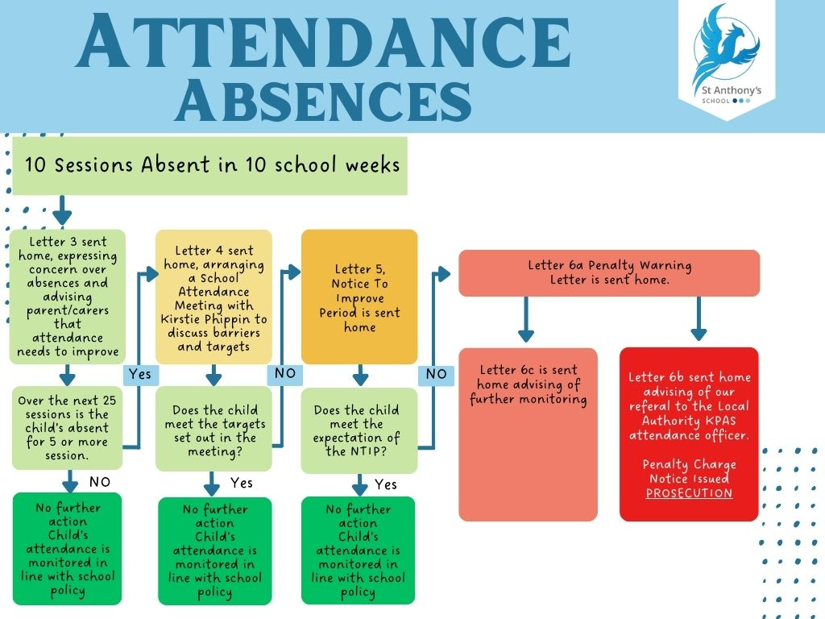
25. Appendix 15/Flowchart: Absences

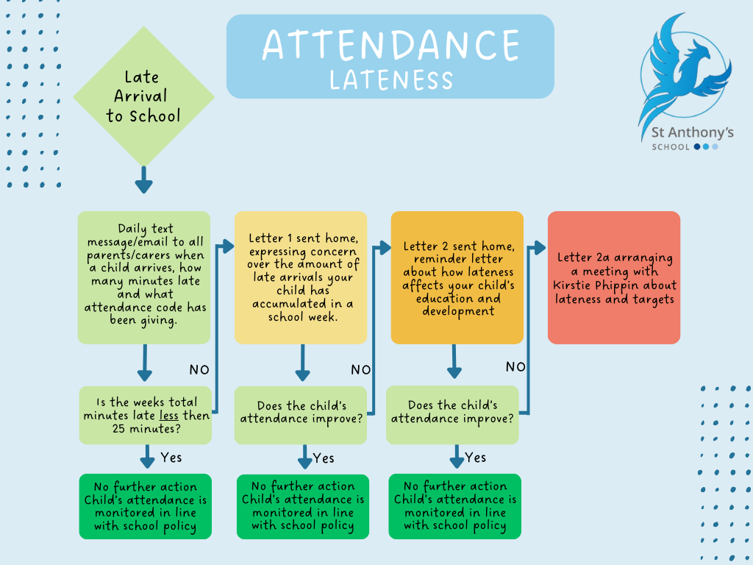
26. Appendix 16/Flowchart: Lateness

27. Appendix 17/Flowchart: Holiday Request

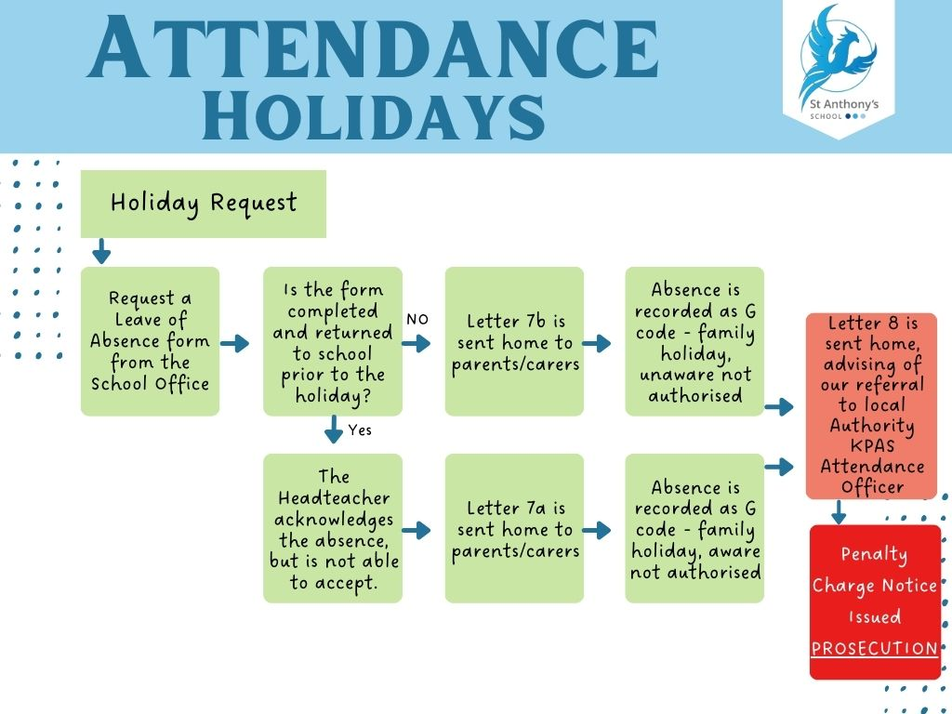
28. Appendix 18/ School Referral Pathway

Document Title: | Attendance
Version: | K-SENT Version 8
Prepared by: | Antony Curry and Kirstie Phippin
Date for Next Review: | March 2027
Link on School Website | Yes

